UNITED STATES
SECURITIES AND EXCHANGE COMMISSION
WASHINGTON, D.C. 20549

FORM 6-K

REPORT OF FOREIGN PRIVATE ISSUER
PURSUANT TO RULE 13a-16 OR 15d-16
UNDER THE SECURITIES EXCHANGE ACT OF 1934
For the month of August 2023
Commission File Number: 001-41431

Polestar Automotive Holding UK PLC

Assar Gabrielssons Väg 9
405 31 Göteborg, Sweden
(Address of principal executive office)

Indicate by check mark whether the registrant files or will file annual reports under cover of Form 20-F or Form 40-F.
Form 20-F ☒ Form 40-F ☐
Indicate by check mark if the registrant is submitting the Form 6-K in paper as permitted by Regulation S-T Rule 101(b)(1): ☐
Indicate by check mark if the registrant is submitting the Form 6-K in paper as permitted by Regulation S-T Rule 101(b)(7): ☐

INFORMATION CONTAINED IN THIS REPORT ON FORM 6-K
A copy of the investor update presentation that was posted by Polestar Automotive Holdings UK PLC (Polestar) on its investor relations website in connection with the announcement of Polestars financial results for the second quarter ended June 30, 2023 is attached hereto as Exhibit 99.1.
Exhibit 99.1 to this Report on Form 6-K shall not be deemed filed for purposes of Section 18 of the Securities Exchange Act of 1934 (the Exchange Act) or otherwise subject to the liabilities of that section, nor shall it be deemed incorporated by reference in any filing under the Securities Act of 1933 or the Exchange Act.

2

EXHIBIT INDEX

Exhibit  No. |  | Description of Exhibit
99.1 |  | Investor Update, dated August 31, 2023.

3

SIGNATURES
Pursuant to the requirements of the Securities Exchange Act of 1934, the registrant has duly caused this report to be signed on its behalf by the undersigned, thereunto duly authorized.

 |  | POLESTAR AUTOMOTIVE HOLDING UK PLC
Date: August 31, 2023 |  | By: |  | /s/ Thomas Ingenlath
 |  | Name: |  | Thomas Ingenlath
 |  | Title: |  | Chief Executive Officer
 |  | By: |  | /s/ Johan Malmqvist
 |  | Name: |  | Johan Malmqvist
 |  | Title: |  | Chief Financial Officer

4
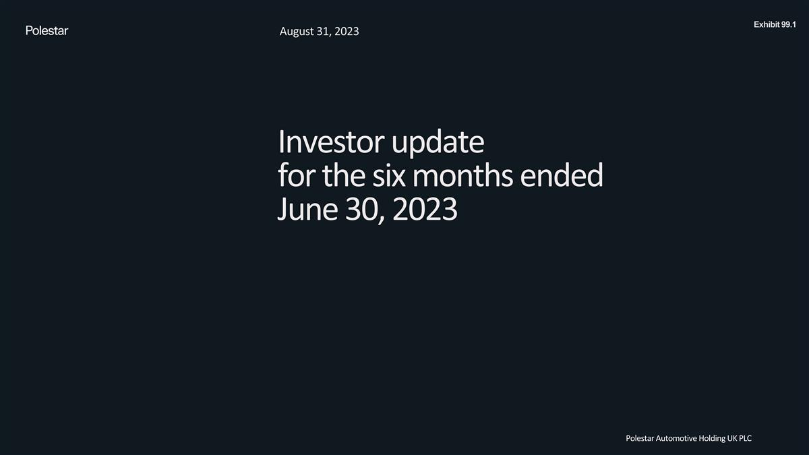
Investor update for the six months ended June 30, 2023 August 31, 2023 Polestar Automotive Holding UK PLC Exhibit 99.1

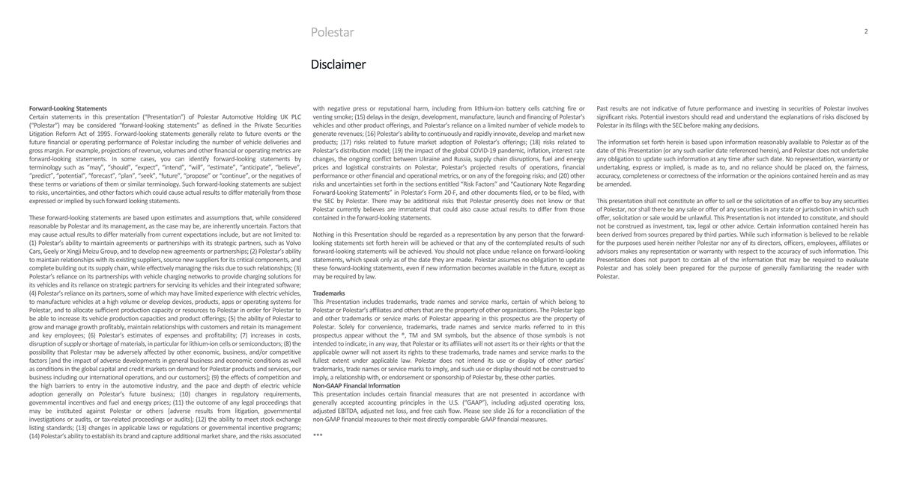
Polestar Disclaimer Forward-Looking Statements Certain statements in this presentation (“Presentation”) of Polestar Automotive Holding UK PLC (“Polestar”) may be considered “forward-looking statements” as defined in the Private Securities Litigation Reform Act of 1995. Forward-looking statements generally relate to future events or the future financial or operating performance of Polestar including the number of vehicle deliveries and gross margin. For example, projections of revenue, volumes and other financial or operating metrics are forward-looking statements. In some cases, you can identify forward-looking statements by terminology such as “may”, “should”, “expect”, “intend”, “will”, “estimate”, “anticipate”, “believe”, “predict”, “potential”, “forecast”, “plan”, “seek”, “future”, “propose” or “continue”, or the negatives of these terms or variations of them or similar terminology. Such forward-looking statements are subject to risks, uncertainties, and other factors which could cause actual results to differ materially from those expressed or implied by such forward looking statements. These forward-looking statements are based upon estimates and assumptions that, while considered reasonable by Polestar and its management, as the case may be, are inherently uncertain. Factors that may cause actual results to differ materially from current expectations include, but are not limited to: (1) Polestar’s ability to maintain agreements or partnerships with its strategic partners, such as Volvo Cars, Geely or Xingji Meizu Group, and to develop new agreements or partnerships; (2) Polestar’s ability to maintain relationships with its existing suppliers, source new suppliers for its critical components, and complete building out its supply chain, while effectively managing the risks due to such relationships; (3) Polestar’s reliance on its partnerships with vehicle charging networks to provide charging solutions for its vehicles and its reliance on strategic partners for servicing its vehicles and their integrated software; (4) Polestar’s reliance on its partners, some of which may have limited experience with electric vehicles, to manufacture vehicles at a high volume or develop devices, products, apps or operating systems for Polestar, and to allocate sufficient production capacity or resources to Polestar in order for Polestar to be able to increase its vehicle production capacities and product offerings; (5) the ability of Polestar to grow and manage growth profitably, maintain relationships with customers and retain its management and key employees; (6) Polestar’s estimates of expenses and profitability; (7) increases in costs, disruption of supply or shortage of materials, in particular for lithium-ion cells or semiconductors; (8) the possibility that Polestar may be adversely affected by other economic, business, and/or competitive factors [and the impact of adverse developments in general business and economic conditions as well as conditions in the global capital and credit markets on demand for Polestar products and services, our business including our international operations, and our customers]; (9) the effects of competition and the high barriers to entry in the automotive industry, and the pace and depth of electric vehicle adoption generally on Polestar’s future business; (10) changes in regulatory requirements, governmental incentives and fuel and energy prices; (11) the outcome of any legal proceedings that may be instituted against Polestar or others [adverse results from litigation, governmental investigations or audits, or tax-related proceedings or audits]; (12) the ability to meet stock exchange listing standards; (13) changes in applicable laws or regulations or governmental incentive programs; (14) Polestar’s ability to establish its brand and capture additional market share, and the risks associated with negative press or reputational harm, including from lithium-ion battery cells catching fire or venting smoke; (15) delays in the design, development, manufacture, launch and financing of Polestar’s vehicles and other product offerings, and Polestar’s reliance on a limited number of vehicle models to generate revenues; (16) Polestar’s ability to continuously and rapidly innovate, develop and market new products; (17) risks related to future market adoption of Polestar’s offerings; (18) risks related to Polestar’s distribution model; (19) the impact of the global COVID-19 pandemic, inflation, interest rate changes, the ongoing conflict between Ukraine and Russia, supply chain disruptions, fuel and energy prices and logistical constraints on Polestar, Polestar’s projected results of operations, financial performance or other financial and operational metrics, or on any of the foregoing risks; and (20) other risks and uncertainties set forth in the sections entitled “Risk Factors” and “Cautionary Note Regarding Forward-Looking Statements” in Polestar’s Form 20-F, and other documents filed, or to be filed, with the SEC by Polestar. There may be additional risks that Polestar presently does not know or that Polestar currently believes are immaterial that could also cause actual results to differ from those contained in the forward-looking statements. Nothing in this Presentation should be regarded as a representation by any person that the forward-looking statements set forth herein will be achieved or that any of the contemplated results of such forward-looking statements will be achieved. You should not place undue reliance on forward-looking statements, which speak only as of the date they are made. Polestar assumes no obligation to update these forward-looking statements, even if new information becomes available in the future, except as may be required by law. Trademarks This Presentation includes trademarks, trade names and service marks, certain of which belong to Polestar or Polestar’s affiliates and others that are the property of other organizations. The Polestar logo and other trademarks or service marks of Polestar appearing in this prospectus are the property of Polestar. Solely for convenience, trademarks, trade names and service marks referred to in this prospectus appear without the ®, TM and SM symbols, but the absence of those symbols is not intended to indicate, in any way, that Polestar or its affiliates will not assert its or their rights or that the applicable owner will not assert its rights to these trademarks, trade names and service marks to the fullest extent under applicable law. Polestar does not intend its use or display of other parties’ trademarks, trade names or service marks to imply, and such use or display should not be construed to imply, a relationship with, or endorsement or sponsorship of Polestar by, these other parties. Non-GAAP Financial Information This presentation includes certain financial measures that are not presented in accordance with generally accepted accounting principles in the U.S. (“GAAP”), including adjusted operating loss, adjusted EBITDA, adjusted net loss, and free cash flow. Please see slide 26 for a reconciliation of the non-GAAP financial measures to their most directly comparable GAAP financial measures. *** Past results are not indicative of future performance and investing in securities of Polestar involves significant risks. Potential investors should read and understand the explanations of risks disclosed by Polestar in its filings with the SEC before making any decisions. The information set forth herein is based upon information reasonably available to Polestar as of the date of this Presentation (or any such earlier date referenced herein), and Polestar does not undertake any obligation to update such information at any time after such date. No representation, warranty or undertaking, express or implied, is made as to, and no reliance should be placed on, the fairness, accuracy, completeness or correctness of the information or the opinions contained herein and as may be amended. This presentation shall not constitute an offer to sell or the solicitation of an offer to buy any securities of Polestar, nor shall there be any sale or offer of any securities in any state or jurisdiction in which such offer, solicitation or sale would be unlawful. This Presentation is not intended to constitute, and should not be construed as investment, tax, legal or other advice. Certain information contained herein has been derived from sources prepared by third parties. While such information is believed to be reliable for the purposes used herein neither Polestar nor any of its directors, officers, employees, affiliates or advisors makes any representation or warranty with respect to the accuracy of such information. This Presentation does not purport to contain all of the information that may be required to evaluate Polestar and has solely been prepared for the purpose of generally familiarizing the reader with Polestar.


Polestar

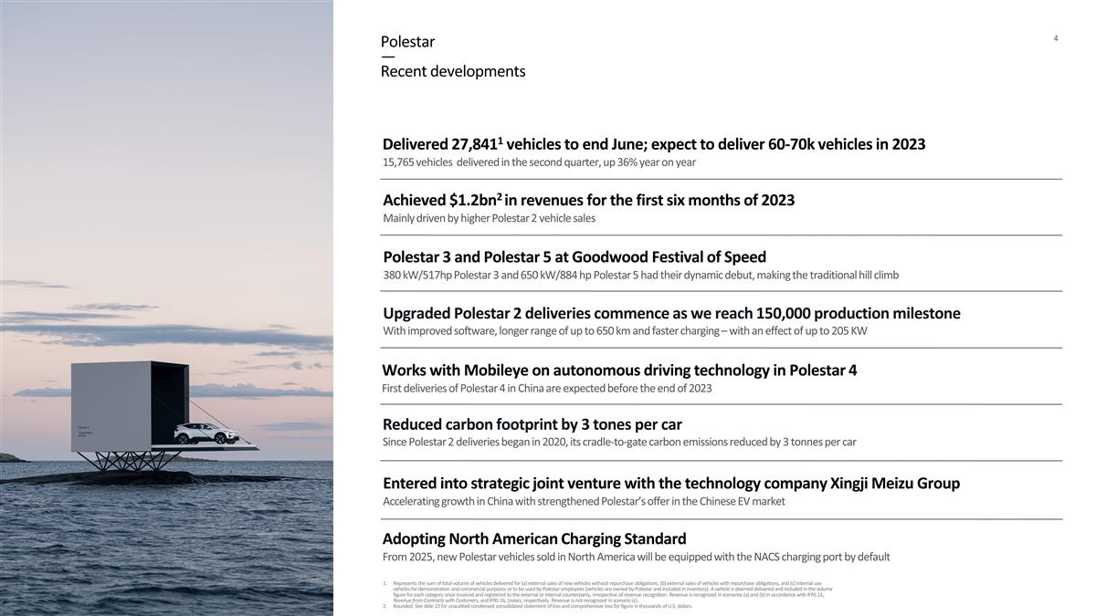
Reduced carbon footprint by 3 tones per car Since Polestar 2 deliveries began in 2020, its cradle-to-gate carbon emissions reduced by 3 tonnes per car Polestar — Recent developments Delivered 27,8411 vehicles to end June; expect to deliver 60-70k vehicles in 2023 15,765 vehicles delivered in the second quarter, up 36% year on year Entered into strategic joint venture with the technology company Xingji Meizu Group Accelerating growth in China with strengthened Polestar’s offer in the Chinese EV market Upgraded Polestar 2 deliveries commence as we reach 150,000 production milestone With improved software, longer range of up to 650 km and faster charging – with an effect of up to 205 KW Adopting North American Charging Standard From 2025, new Polestar vehicles sold in North America will be equipped with the NACS charging port by default Achieved $1.2bn2 in revenues for the first six months of 2023 Mainly driven by higher Polestar 2 vehicle sales Represents the sum of total volume of vehicles delivered for (a) external sales of new vehicles without repurchase obligations, (b) external sales of vehicles with repurchase obligations, and (c) internal use vehicles for demonstration and commercial purposes or to be used by Polestar employees (vehicles are owned by Polestar and included in inventory). A vehicle is deemed delivered and included in the volume figure for each category once invoiced and registered to the external or internal counterparty, irrespective of revenue recognition. Revenue is recognized in scenarios (a) and (b) in accordance with IFRS 15, Revenue from Contracts with Customers, and IFRS 16, Leases, respectively. Revenue is not recognized in scenario (c). Rounded. See slide 23 for unaudited condensed consolidated statement of loss and comprehensive loss for figure in thousands of U.S. dollars. Polestar 3 and Polestar 5 at Goodwood Festival of Speed 380 kW/517hp Polestar 3 and 650 kW/884 hp Polestar 5 had their dynamic debut, making the traditional hill climb Works with Mobileye on autonomous driving technology in Polestar 4 First deliveries of Polestar 4 in China are expected before the end of 2023

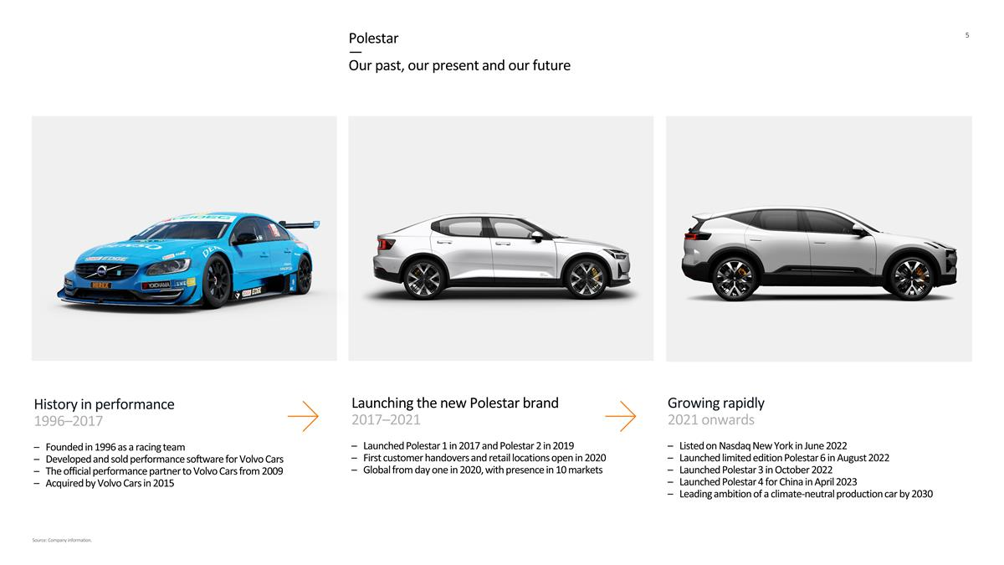
History in performance 1996–2017 Founded in 1996 as a racing team Developed and sold performance software for Volvo Cars The official performance partner to Volvo Cars from 2009 Acquired by Volvo Cars in 2015 Polestar — Our past, our present and our future Launching the new Polestar brand 2017–2021 Launched Polestar 1 in 2017 and Polestar 2 in 2019 First customer handovers and retail locations open in 2020 Global from day one in 2020, with presence in 10 markets Growing rapidly 2021 onwards Listed on Nasdaq New York in June 2022 Launched limited edition Polestar 6 in August 2022 Launched Polestar 3 in October 2022 Launched Polestar 4 for China in April 2023 Leading ambition of a climate-neutral production car by 2030 Source: Company information.

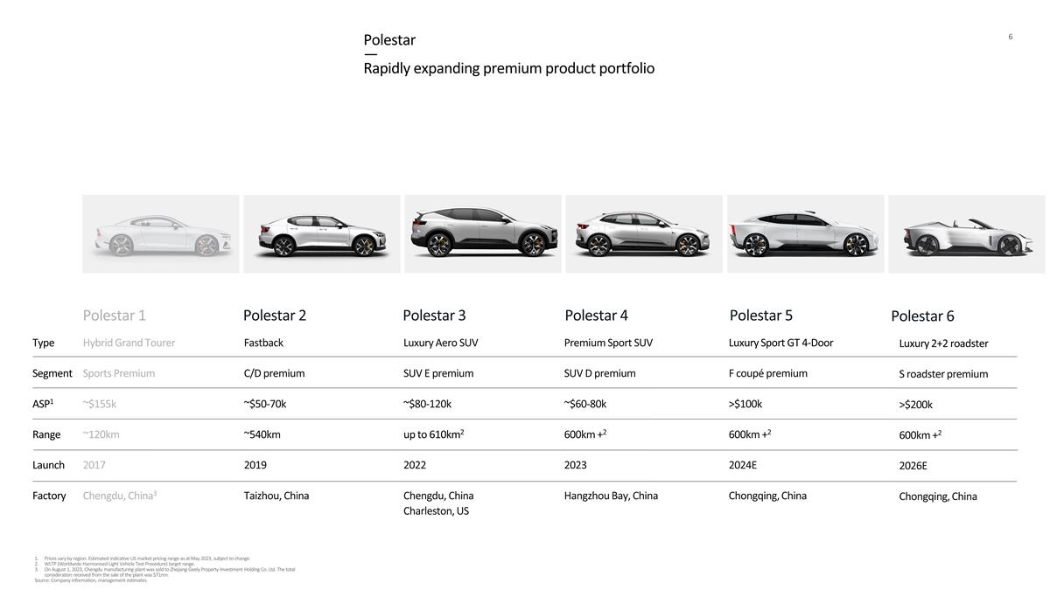
Polestar 1 Polestar 2 Polestar 3 Polestar 4 Polestar 5 Type Segment ASP1 Range Launch Factory Hybrid Grand Tourer Sports Premium ~$155k ~120km 2017 Chengdu, China3 Fastback C/D premium ~$50-70k ~540km 2019 Taizhou, China Luxury Aero SUV SUV E premium ~$80-120k up to 610km2 2022 Chengdu, China Charleston, US Premium Sport SUV SUV D premium ~$60-80k 600km +2 2023 Hangzhou Bay, China Luxury Sport GT 4-Door F coupé premium >$100k 600km +2 2024E Chongqing, China Polestar — Rapidly expanding premium product portfolio Polestar 6 Luxury 2+2 roadster S roadster premium >$200k 600km +2 2026E Chongqing, China Prices vary by region. Estimated indicative US market pricing range as at May 2023, subject to change. WLTP (Worldwide Harmonised Light Vehicle Test Procedure) target range. On August 1, 2023, Chengdu manufacturing plant was sold to Zhejiang Geely Property Investment Holding Co. Ltd. The total consideration received from the sale of the plant was $71mn. Source: Company information, management estimates.

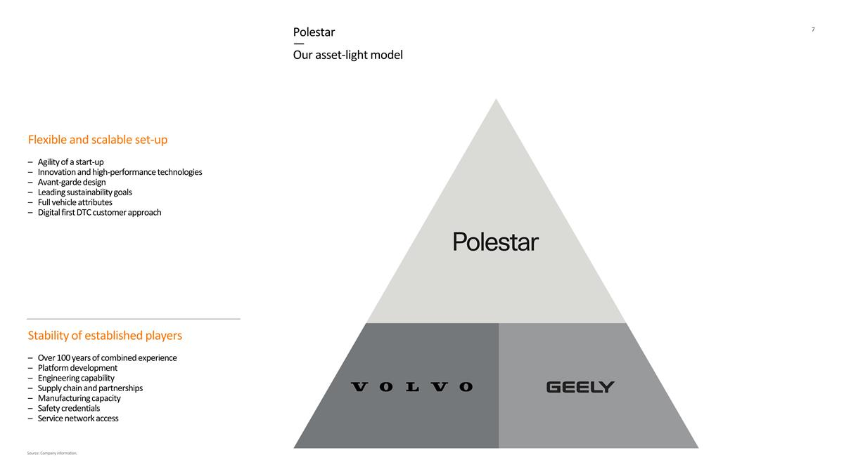
Flexible and scalable set-up Agility of a start-up Innovation and high-performance technologies Avant-garde design Leading sustainability goals Full vehicle attributes Digital first DTC customer approach Stability of established players Over 100 years of combined experience Platform development Engineering capability Supply chain and partnerships Manufacturing capacity Safety credentials Service network access Source: Company information. Polestar — Our asset-light model

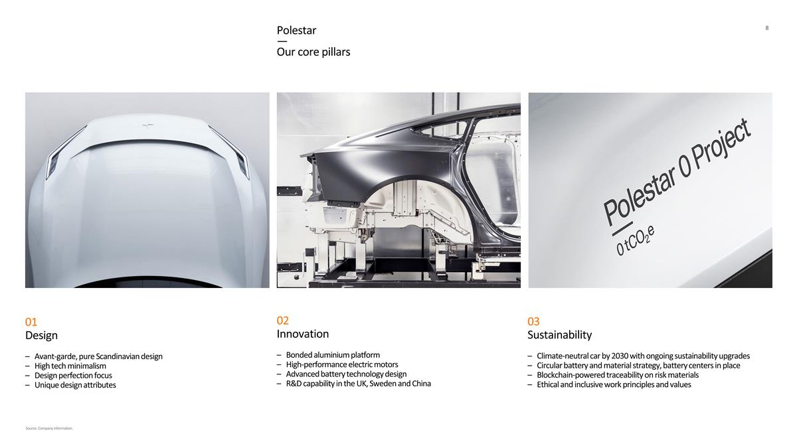
01 Design Avant-garde, pure Scandinavian design High tech minimalism Design perfection focus Unique design attributes 03 Sustainability Climate-neutral car by 2030 with ongoing sustainability upgrades Circular battery and material strategy, battery centers in place Blockchain-powered traceability on risk materials Ethical and inclusive work principles and values 02 Innovation Bonded aluminium platform High-performance electric motors Advanced battery technology design R&D capability in the UK, Sweden and China Polestar — Our core pillars Source: Company information.

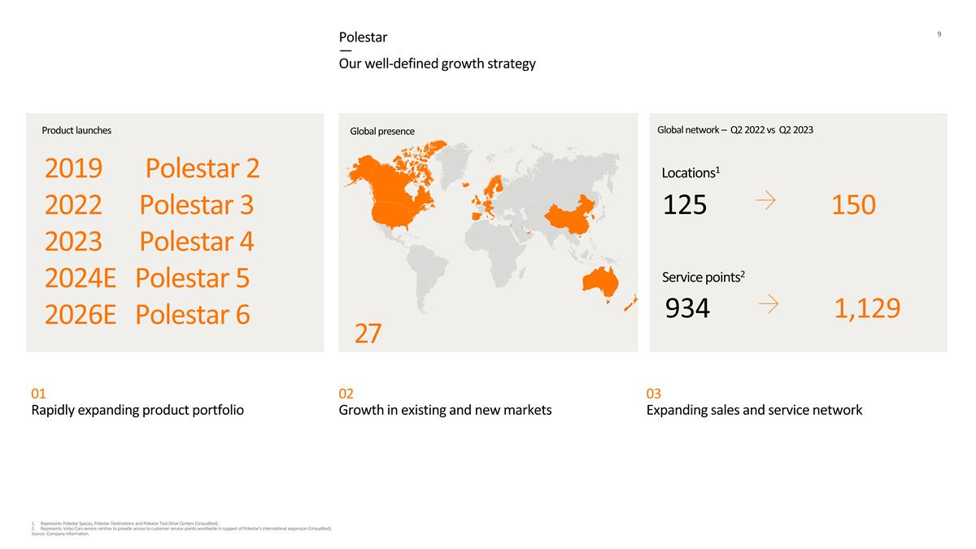
01 Rapidly expanding product portfolio 02 Growth in existing and new markets 03 Expanding sales and service network Polestar — Our well-defined growth strategy 2019 Polestar 2 2022 Polestar 3 2023 Polestar 4 2024E Polestar 5 2026E Polestar 6 Product launches Global network – Q2 2022 vs Q2 2023 Global presence 27 Represents Polestar Spaces, Polestar Destinations and Polestar Test Drive Centers (Unaudited). Represents Volvo Cars service centres to provide access to customer service points worldwide in support of Polestar’s international expansion (Unaudited). Source: Company information. Locations1 150 125 Service points2 1,129 934

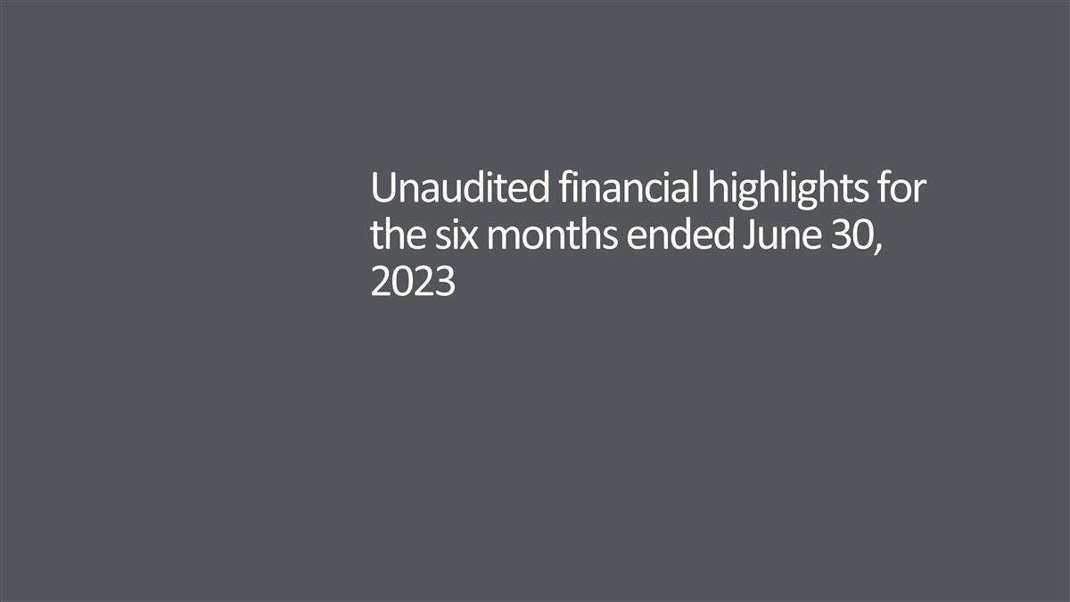
Unaudited financial highlights for the six months ended June 30, 2023

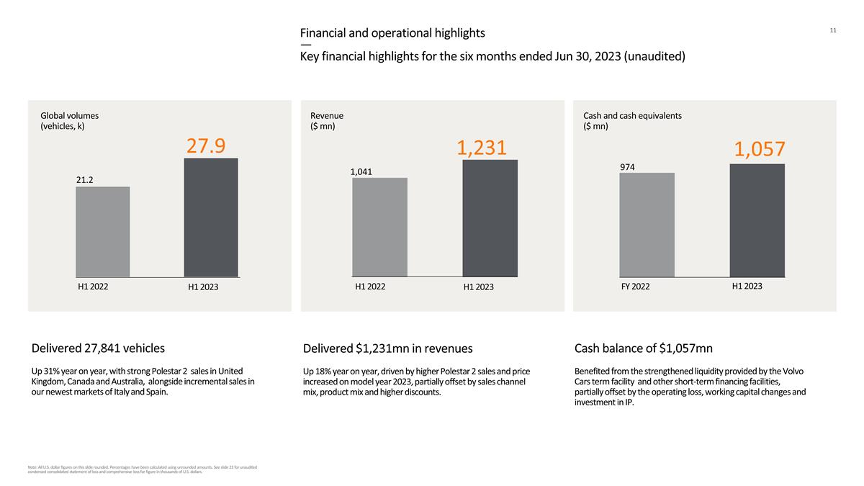
. Financial and operational highlights — Key financial highlights for the six months ended Jun 30, 2023 (unaudited) Global volumes (vehicles, k) Revenue ($ mn) H1 2022 H1 2023 21.2 H1 2022 H1 2023 Delivered $1,231mn in revenues Up 18% year on year, driven by higher Polestar 2 sales and price increased on model year 2023, partially offset by sales channel mix, product mix and higher discounts. Delivered 27,841 vehicles Up 31% year on year, with strong Polestar 2 sales in United Kingdom, Canada and Australia, alongside incremental sales in our newest markets of Italy and Spain. Cash and cash equivalents ($ mn) FY 2022 1,057 974 Cash balance of $1,057mn Benefited from the strengthened liquidity provided by the Volvo Cars term facility and other short-term financing facilities, partially offset by the operating loss, working capital changes and investment in IP. H1 2023 1,231 Note: All U.S. dollar figures on this slide rounded. Percentages have been calculated using unrounded amounts. See slide 23 for unaudited condensed consolidated statement of loss and comprehensive loss for figure in thousands of U.S. dollars. 1,041 27.9

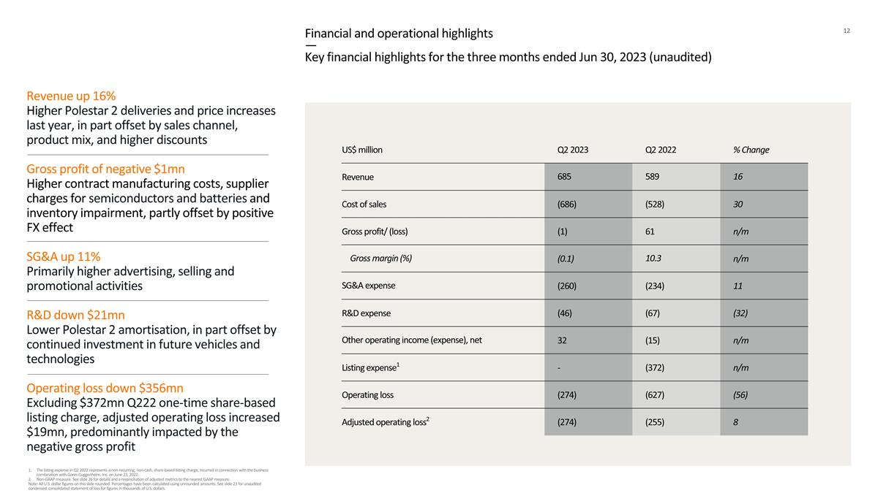
Financial and operational highlights — Key financial highlights for the three months ended Jun 30, 2023 (unaudited) US$ million Q2 2023 Q2 2022 % Change Revenue 685 589 16 Cost of sales (686) (528) 30 Gross profit/ (loss) (1) 61 n/m Gross margin (%) (0.1) 10.3 n/m SG&A expense (260) (234) 11 R&D expense (46) (67) (32) Other operating income (expense), net 32 (15) n/m Listing expense1 - (372) n/m Operating loss (274) (627) (56) Adjusted operating loss2 (274) (255) 8 Revenue up 16% Higher Polestar 2 deliveries and price increases last year, in part offset by sales channel, product mix, and higher discounts Gross profit of negative $1mn Higher contract manufacturing costs, supplier charges for semiconductors and batteries and inventory impairment, partly offset by positive FX effect SG&A up 11% Primarily higher advertising, selling and promotional activities R&D down $21mn Lower Polestar 2 amortisation, in part offset by continued investment in future vehicles and technologies Operating loss down $356mn Excluding $372mn Q222 one-time share-based listing charge, adjusted operating loss increased $19mn, predominantly impacted by the negative gross profit The listing expense in Q2 2022 represents a non-recurring, non-cash, share-based listing charge, incurred in connection with the business combination with Gores Guggenheim, Inc. on June 23, 2022. Non-GAAP measure. See slide 26 for details and a reconciliation of adjusted metrics to the nearest GAAP measure. Note: All U.S. dollar figures on this slide rounded. Percentages have been calculated using unrounded amounts. See slide 23 for unaudited condensed consolidated statement of loss for figures in thousands of U.S. dollars.

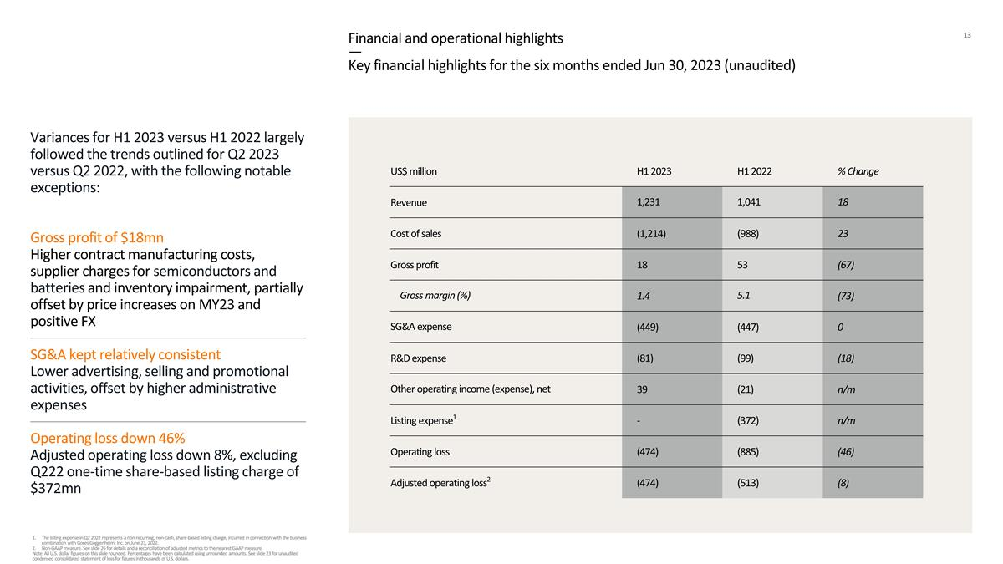
Financial and operational highlights — Key financial highlights for the six months ended Jun 30, 2023 (unaudited) US$ million H1 2023 H1 2022 % Change Revenue 1,231 1,041 18 Cost of sales (1,214) (988) 23 Gross profit 18 53 (67) Gross margin (%) 1.4 5.1 (73) SG&A expense (449) (447) 0 R&D expense (81) (99) (18) Other operating income (expense), net 39 (21) n/m Listing expense1 - (372) n/m Operating loss (474) (885) (46) Adjusted operating loss2 (474) (513) (8) Variances for H1 2023 versus H1 2022 largely followed the trends outlined for Q2 2023 versus Q2 2022, with the following notable exceptions: Gross profit of $18mn Higher contract manufacturing costs, supplier charges for semiconductors and batteries and inventory impairment, partially offset by price increases on MY23 and positive FX SG&A kept relatively consistent Lower advertising, selling and promotional activities, offset by higher administrative expenses Operating loss down 46% Adjusted operating loss down 8%, excluding Q222 one-time share-based listing charge of $372mn The listing expense in Q2 2022 represents a non-recurring, non-cash, share-based listing charge, incurred in connection with the business combination with Gores Guggenheim, Inc. on June 23, 2022. Non-GAAP measure. See slide 26 for details and a reconciliation of adjusted metrics to the nearest GAAP measure. Note: All U.S. dollar figures on this slide rounded. Percentages have been calculated using unrounded amounts. See slide 23 for unaudited condensed consolidated statement of loss for figures in thousands of U.S. dollars.

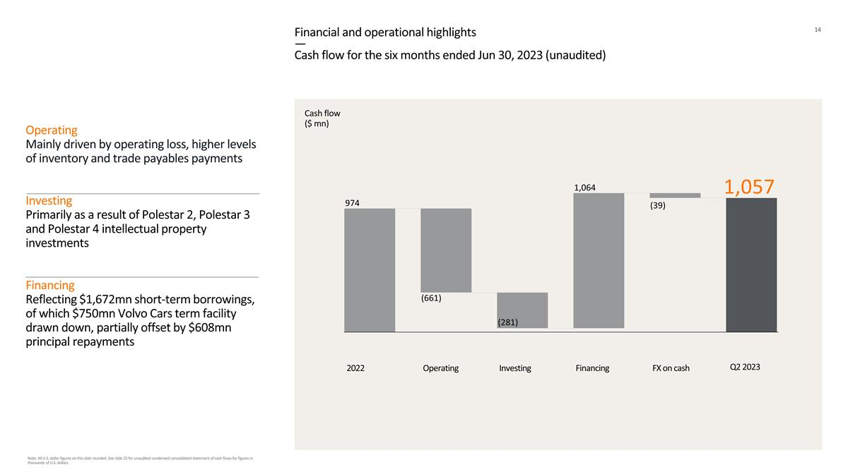
Financial and operational highlights — Cash flow for the six months ended Jun 30, 2023 (unaudited) Cash flow ($ mn) 2022 Operating Investing FX on cash Q2 2023 Operating Mainly driven by operating loss, higher levels of inventory and trade payables payments Investing Primarily as a result of Polestar 2, Polestar 3 and Polestar 4 intellectual property investments Financing Reflecting $1,672mn short-term borrowings, of which $750mn Volvo Cars term facility drawn down, partially offset by $608mn principal repayments Financing Note: All U.S. dollar figures on this slide rounded. See slide 25 for unaudited condensed consolidated statement of cash flows for figures in thousands of U.S. dollars. 1,064 (39) 1,057 (281) (661) 974

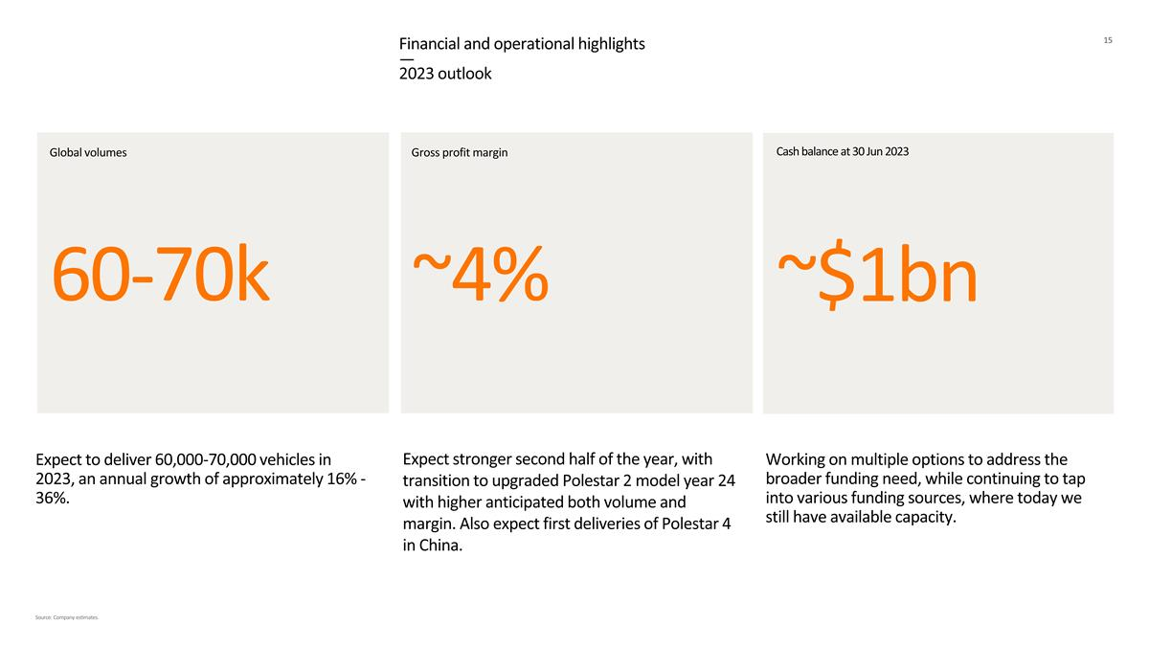
Financial and operational highlights — 2023 outlook Cash balance at 30 Jun 2023 Global volumes Gross profit margin 60-70k Working on multiple options to address the broader funding need, while continuing to tap into various funding sources, where today we still have available capacity. Expect to deliver 60,000-70,000 vehicles in 2023, an annual growth of approximately 16% - 36%. Expect stronger second half of the year, with transition to upgraded Polestar 2 model year 24 with higher anticipated both volume and margin. Also expect first deliveries of Polestar 4 in China. ~$1bn Source: Company estimates. ~4%


Imagery

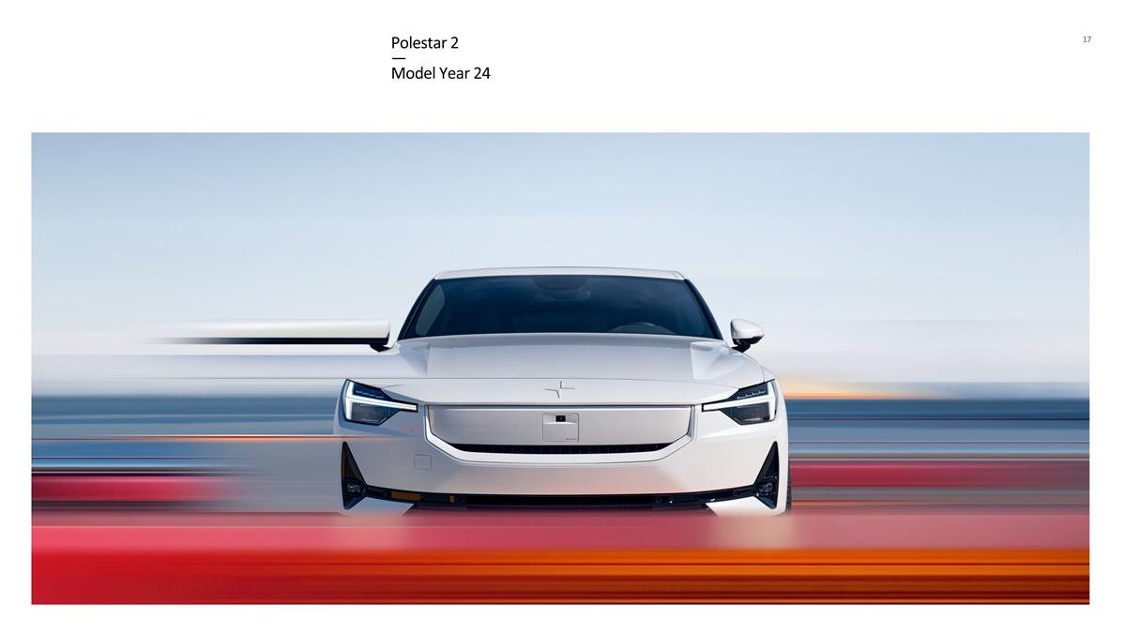
Polestar 2 — Model Year 24

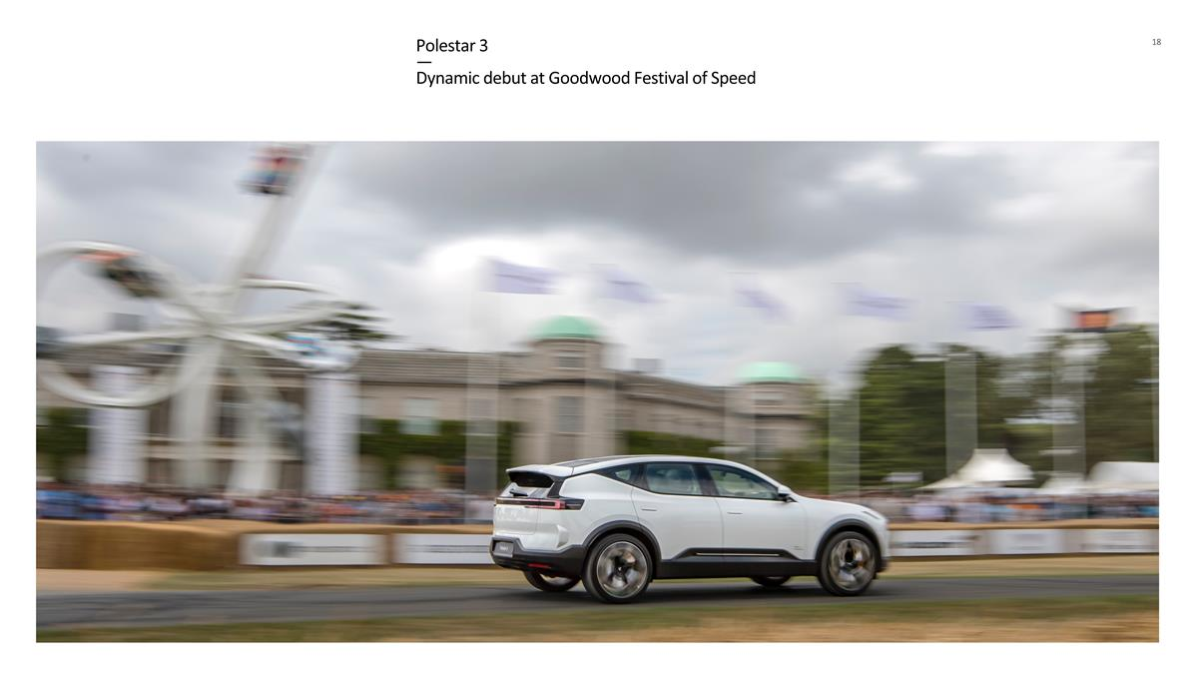
Polestar 3 — Dynamic debut at Goodwood Festival of Speed

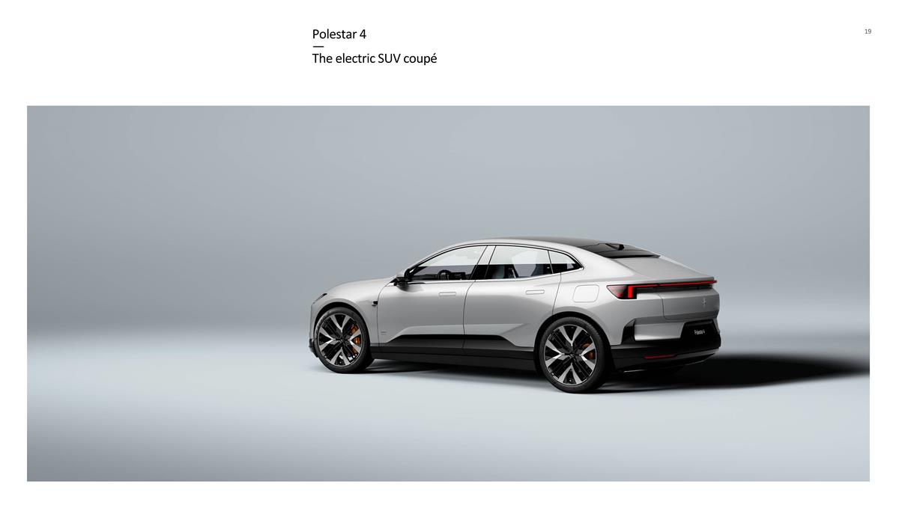
Polestar 4 — The electric SUV coupé

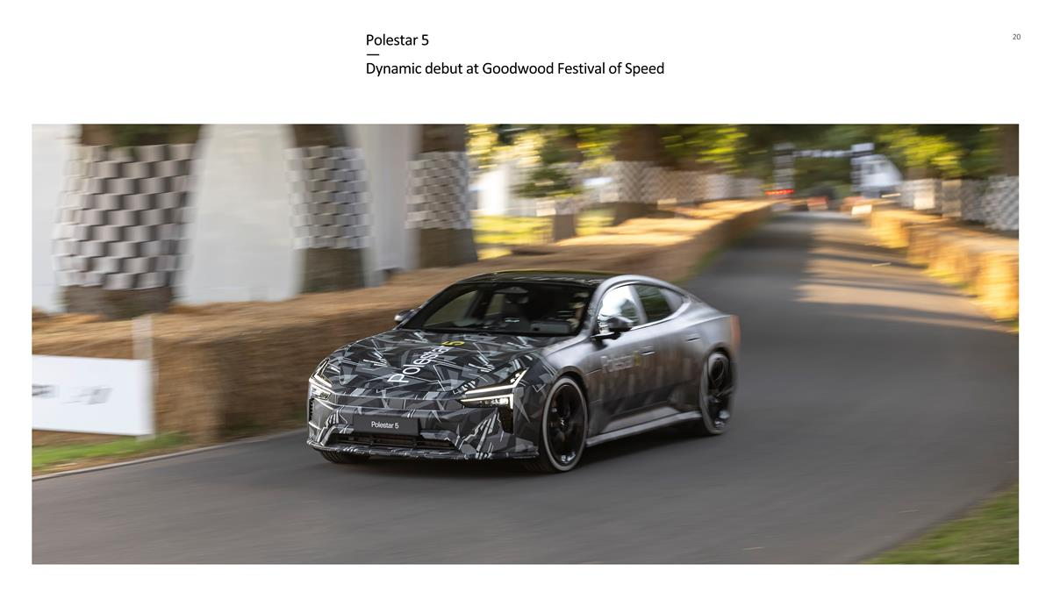
Polestar 5 — Dynamic debut at Goodwood Festival of Speed

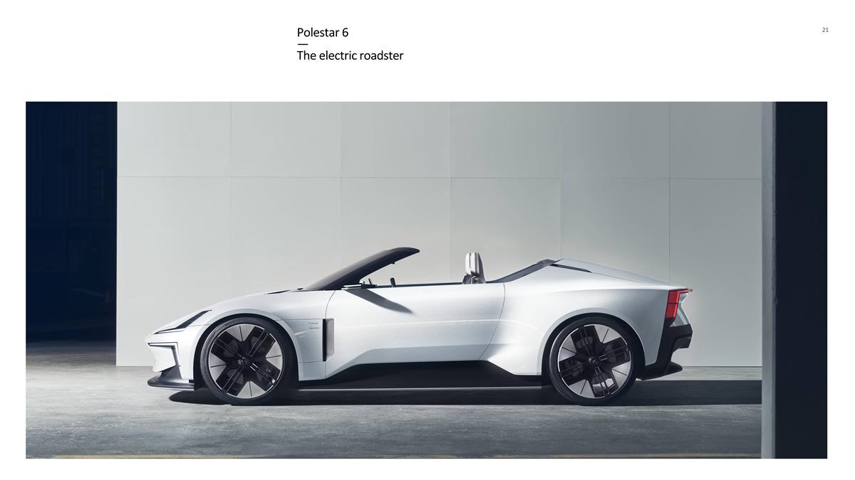
Polestar 6 — The electric roadster


Appendix

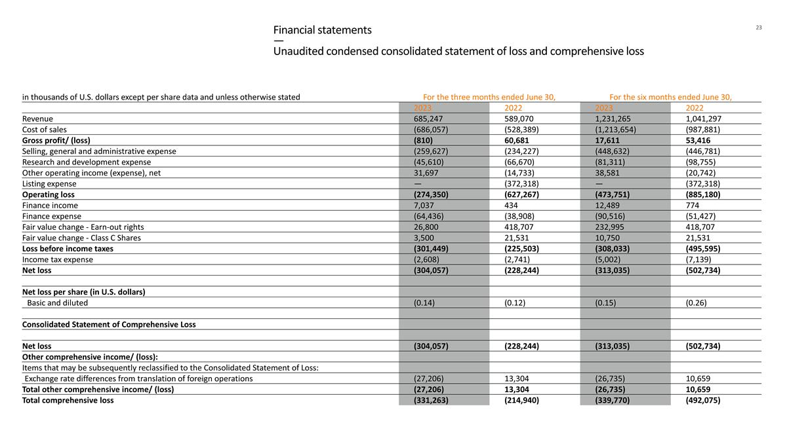
Financial statements — Unaudited condensed consolidated statement of loss and comprehensive loss in thousands of U.S. dollars except per share data and unless otherwise stated For the three months ended June 30, For the six months ended June 30, 2023 2022 2023 2022 Revenue 685,247 589,070 1,231,265 1,041,297 Cost of sales (686,057) (528,389) (1,213,654) (987,881) Gross profit/ (loss) (810) 60,681 17,611 53,416 Selling, general and administrative expense (259,627) (234,227) (448,632) (446,781) Research and development expense (45,610) (66,670) (81,311) (98,755) Other operating income (expense), net 31,697 (14,733) 38,581 (20,742) Listing expense — (372,318) — (372,318) Operating loss (274,350) (627,267) (473,751) (885,180) Finance income 7,037 434 12,489 774 Finance expense (64,436) (38,908) (90,516) (51,427) Fair value change - Earn-out rights 26,800 418,707 232,995 418,707 Fair value change - Class C Shares 3,500 21,531 10,750 21,531 Loss before income taxes (301,449) (225,503) (308,033) (495,595) Income tax expense (2,608) (2,741) (5,002) (7,139) Net loss (304,057) (228,244) (313,035) (502,734) Net loss per share (in U.S. dollars) Basic and diluted (0.14) (0.12) (0.15) (0.26) Consolidated Statement of Comprehensive Loss Net loss (304,057) (228,244) (313,035) (502,734) Other comprehensive income/ (loss): Items that may be subsequently reclassified to the Consolidated Statement of Loss: Exchange rate differences from translation of foreign operations (27,206) 13,304 (26,735) 10,659 Total other comprehensive income/ (loss) (27,206) 13,304 (26,735) 10,659 Total comprehensive loss (331,263) (214,940) (339,770) (492,075)

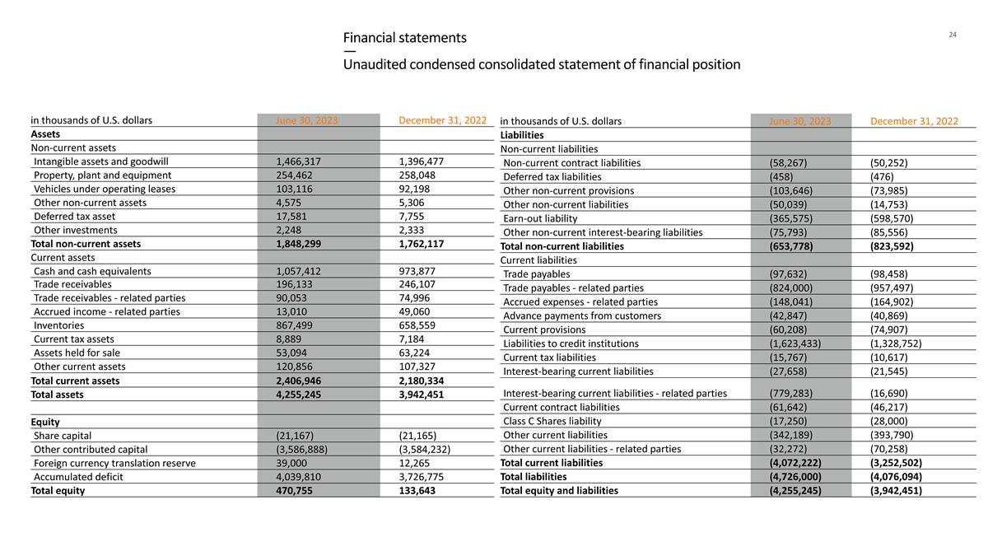
Financial statements — Unaudited condensed consolidated statement of financial position in thousands of U.S. dollars June 30, 2023 December 31, 2022 Assets Non-current assets Intangible assets and goodwill 1,466,317 1,396,477 Property, plant and equipment 254,462 258,048 Vehicles under operating leases 103,116 92,198 Other non-current assets 4,575 5,306 Deferred tax asset 17,581 7,755 Other investments 2,248 2,333 Total non-current assets 1,848,299 1,762,117 Current assets Cash and cash equivalents 1,057,412 973,877 Trade receivables 196,133 246,107 Trade receivables - related parties 90,053 74,996 Accrued income - related parties 13,010 49,060 Inventories 867,499 658,559 Current tax assets 8,889 7,184 Assets held for sale 53,094 63,224 Other current assets 120,856 107,327 Total current assets 2,406,946 2,180,334 Total assets 4,255,245 3,942,451 Equity Share capital (21,167) (21,165) Other contributed capital (3,586,888) (3,584,232) Foreign currency translation reserve 39,000 12,265 Accumulated deficit 4,039,810 3,726,775 Total equity 470,755 133,643 in thousands of U.S. dollars June 30, 2023 December 31, 2022 Liabilities Non-current liabilities Non-current contract liabilities (58,267) (50,252) Deferred tax liabilities (458) (476) Other non-current provisions (103,646) (73,985) Other non-current liabilities (50,039) (14,753) Earn-out liability (365,575) (598,570) Other non-current interest-bearing liabilities (75,793) (85,556) Total non-current liabilities (653,778) (823,592) Current liabilities Trade payables (97,632) (98,458) Trade payables - related parties (824,000) (957,497) Accrued expenses - related parties (148,041) (164,902) Advance payments from customers (42,847) (40,869) Current provisions (60,208) (74,907) Liabilities to credit institutions (1,623,433) (1,328,752) Current tax liabilities (15,767) (10,617) Interest-bearing current liabilities (27,658) (21,545) Interest-bearing current liabilities - related parties (779,283) (16,690) Current contract liabilities (61,642) (46,217) Class C Shares liability (17,250) (28,000) Other current liabilities (342,189) (393,790) Other current liabilities - related parties (32,272) (70,258) Total current liabilities (4,072,222) (3,252,502) Total liabilities (4,726,000) (4,076,094) Total equity and liabilities (4,255,245) (3,942,451)

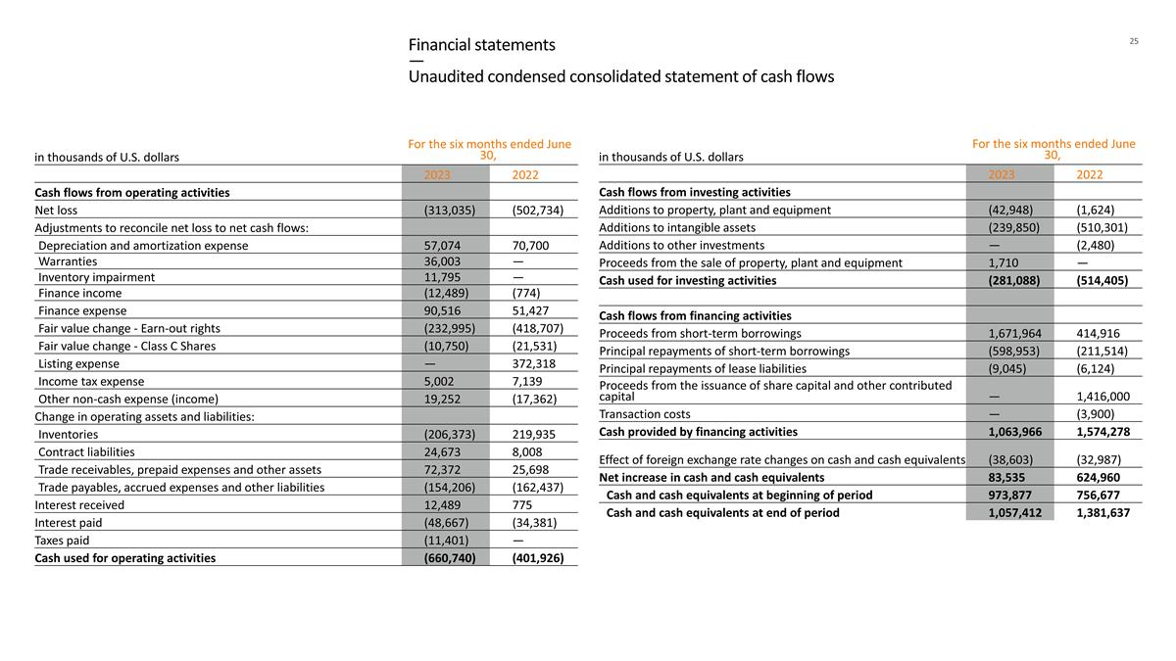
Financial statements — Unaudited condensed consolidated statement of cash flows in thousands of U.S. dollars For the six months ended June 30, 2023 2022 Cash flows from operating activities Net loss (313,035) (502,734) Adjustments to reconcile net loss to net cash flows: Depreciation and amortization expense 57,074 70,700 Warranties 36,003 — Inventory impairment 11,795 — Finance income (12,489) (774) Finance expense 90,516 51,427 Fair value change - Earn-out rights (232,995) (418,707) Fair value change - Class C Shares (10,750) (21,531) Listing expense — 372,318 Income tax expense 5,002 7,139 Other non-cash expense (income) 19,252 (17,362) Change in operating assets and liabilities: Inventories (206,373) 219,935 Contract liabilities 24,673 8,008 Trade receivables, prepaid expenses and other assets 72,372 25,698 Trade payables, accrued expenses and other liabilities (154,206) (162,437) Interest received 12,489 775 Interest paid (48,667) (34,381) Taxes paid (11,401) — Cash used for operating activities (660,740) (401,926) in thousands of U.S. dollars For the six months ended June 30, 2023 2022 Cash flows from investing activities Additions to property, plant and equipment (42,948) (1,624) Additions to intangible assets (239,850) (510,301) Additions to other investments — (2,480) Proceeds from the sale of property, plant and equipment 1,710 — Cash used for investing activities (281,088) (514,405) Cash flows from financing activities Proceeds from short-term borrowings 1,671,964 414,916 Principal repayments of short-term borrowings (598,953) (211,514) Principal repayments of lease liabilities (9,045) (6,124) Proceeds from the issuance of share capital and other contributed capital — 1,416,000 Transaction costs — (3,900) Cash provided by financing activities 1,063,966 1,574,278 Effect of foreign exchange rate changes on cash and cash equivalents (38,603) (32,987) Net increase in cash and cash equivalents 83,535 624,960 Cash and cash equivalents at beginning of period 973,877 756,677 Cash and cash equivalents at end of period 1,057,412 1,381,637

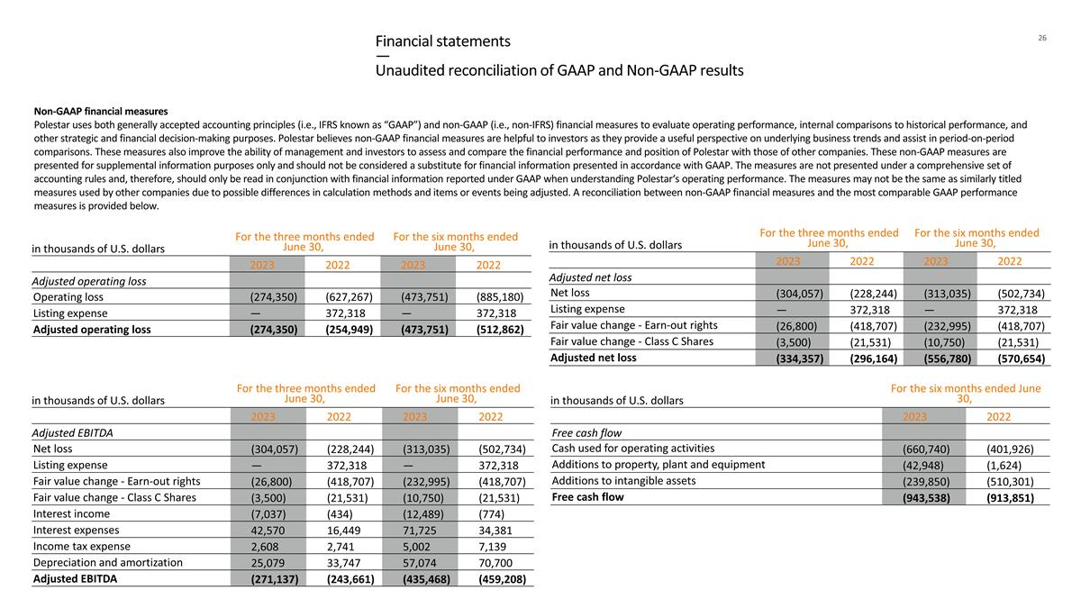
Financial statements — Unaudited reconciliation of GAAP and Non-GAAP results in thousands of U.S. dollars For the three months ended June 30, For the six months ended June 30, 2023 2022 2023 2022 Adjusted EBITDA Net loss (304,057) (228,244) (313,035) (502,734) Listing expense — 372,318 — 372,318 Fair value change - Earn-out rights (26,800) (418,707) (232,995) (418,707) Fair value change - Class C Shares (3,500) (21,531) (10,750) (21,531) Interest income (7,037) (434) (12,489) (774) Interest expenses 42,570 16,449 71,725 34,381 Income tax expense 2,608 2,741 5,002 7,139 Depreciation and amortization 25,079 33,747 57,074 70,700 Adjusted EBITDA (271,137) (243,661) (435,468) (459,208) in thousands of U.S. dollars For the three months ended June 30, For the six months ended June 30, 2023 2022 2023 2022 Adjusted net loss Net loss (304,057) (228,244) (313,035) (502,734) Listing expense — 372,318 — 372,318 Fair value change - Earn-out rights (26,800) (418,707) (232,995) (418,707) Fair value change - Class C Shares (3,500) (21,531) (10,750) (21,531) Adjusted net loss (334,357) (296,164) (556,780) (570,654) in thousands of U.S. dollars For the three months ended June 30, For the six months ended June 30, 2023 2022 2023 2022 Adjusted operating loss Operating loss (274,350) (627,267) (473,751) (885,180) Listing expense — 372,318 — 372,318 Adjusted operating loss (274,350) (254,949) (473,751) (512,862) in thousands of U.S. dollars For the six months ended June 30, 2023 2022 Free cash flow Cash used for operating activities (660,740) (401,926) Additions to property, plant and equipment (42,948) (1,624) Additions to intangible assets (239,850) (510,301) Free cash flow (943,538) (913,851) Non-GAAP financial measures Polestar uses both generally accepted accounting principles (i.e., IFRS known as “GAAP”) and non-GAAP (i.e., non-IFRS) financial measures to evaluate operating performance, internal comparisons to historical performance, and other strategic and financial decision-making purposes. Polestar believes non-GAAP financial measures are helpful to investors as they provide a useful perspective on underlying business trends and assist in period-on-period comparisons. These measures also improve the ability of management and investors to assess and compare the financial performance and position of Polestar with those of other companies. These non-GAAP measures are presented for supplemental information purposes only and should not be considered a substitute for financial information presented in accordance with GAAP. The measures are not presented under a comprehensive set of accounting rules and, therefore, should only be read in conjunction with financial information reported under GAAP when understanding Polestar‘s operating performance. The measures may not be the same as similarly titled measures used by other companies due to possible differences in calculation methods and items or events being adjusted. A reconciliation between non-GAAP financial measures and the most comparable GAAP performance measures is provided below.

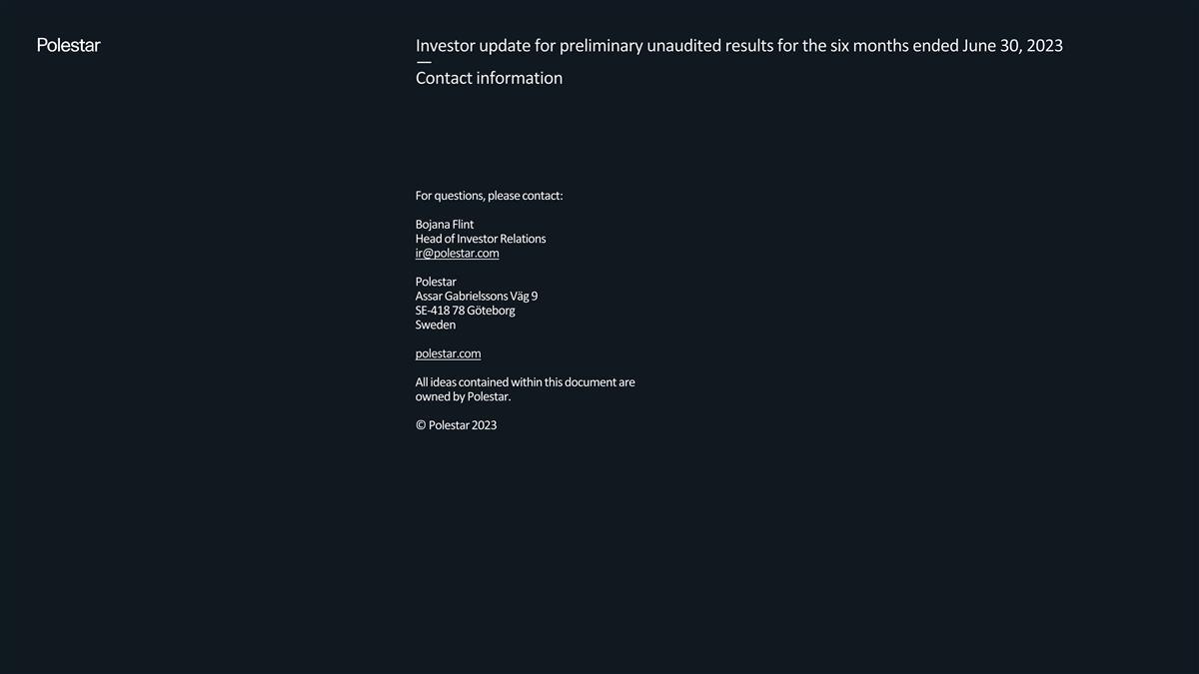
For questions, please contact: Bojana Flint Head of Investor Relations ir@polestar.com Polestar Assar Gabrielssons Väg 9 SE-418 78 Göteborg Sweden polestar.com All ideas contained within this document are owned by Polestar. © Polestar 2023 Investor update for preliminary unaudited results for the six months ended June 30, 2023 — Contact information

