UNITED STATES

SECURITIES AND EXCHANGE COMMISSION
WASHINGTON, D.C. 20549

FORM 6-K

REPORT OF FOREIGN PRIVATE ISSUER

PURSUANT TO RULE 13a-16 OR 15d-16
UNDER THE SECURITIES EXCHANGE ACT OF 1934

For the month of November 2022

Commission File Number: 001-41431

Polestar Automotive Holding UK PLC

Assar Gabrielssons Väg 9

405 31 Göteborg, Sweden
(Address of principal executive office)

Indicate by check mark whether the registrant files or will file annual reports under cover of Form 20-F or Form 40-F.

Form 20-F ☒ Form 40-F ☐

Indicate by check mark if the registrant is submitting the Form 6-K in paper as permitted by Regulation S-T Rule 101(b)(1): ☐

Indicate by check mark if the registrant is submitting the Form 6-K in paper as permitted by Regulation S-T Rule 101(b)(7): ☐

INFORMATION CONTAINED IN THIS REPORT ON FORM 6-K

On November 11, 2022, Polestar Automotive Holding UK PLC (“Polestar”) announced its financial results for the third quarter ended September 30, 2022. A copy of the investor update presentation that was posted on the investor relations website of Polestar in connection with the announcement is attached hereto as Exhibit 99.1.

Also attached as exhibits to this Report on Form 6-K are (i) Polestar’s Management’s Discussion and Analysis of Financial Conditions and Results of Operations for the Three and Nine Months Ended September 30, 2022 and 2021, which is attached as Exhibit 99.2; and (ii) Polestar’s Unaudited Condensed Consolidated Financial Statements as of September 30, 2022 and for the Three and Nine Months Ended September 30, 2022 and 2021, which are attached as Exhibit 99.3.

The information contained in Exhibit 99.2 and Exhibit 99.3 shall be deemed to be incorporated by reference into Polestar’s registration statement on Form S-8 (File No: 333-267146) and to be a part thereof from the date on which this report is submitted, to the extent not superseded by documents or reports subsequently filed or furnished. Exhibit 99.1 to this Report on Form 6-K shall not be deemed “filed” for purposes of Section 18 of the Securities Exchange Act of 1934 (the “Exchange Act”) or otherwise subject to the liabilities of that section, nor shall it be deemed incorporated by reference in any filing under the Securities Act of 1933 or the Exchange Act.

2

 |  | EXHIBIT INDEX
Exhibit No. |  | Description of Exhibit
99.1 |  | Investor Update, dated November 11, 2022.
99.2 |  | Management’s Discussion and Analysis of Financial Conditions and Results of Operations for the Three and Nine Months Ended
 |  | September 30, 2022 and 2021.
99.3 |  | Unaudited Condensed Consolidated Financial Statements as of September 30, 2022 and for the Three and Nine Months Ended
 |  | September 30, 2022 and 2021.
 |  | 3
SIGNATURES

Pursuant to the requirements of the Securities Exchange Act of 1934, the registrant has duly caused this report to be signed on its behalf by the undersigned, thereunto duly authorized.

 | POLESTAR AUTOMOTIVE HOLDING UK PLC
Date: November 14, 2022 | By: | /s/ Thomas Ingenlath
 | Name: | Thomas Ingenlath
 | Title: | Chief Executive Officer
 | By: | /s/ Johan Malmqvist
 | Name: | Johan Malmqvist
 | Title: | Chief Financial Officer
 | 4

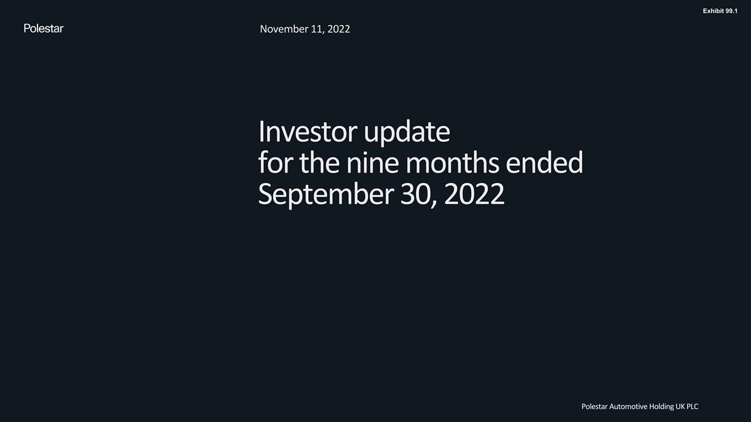

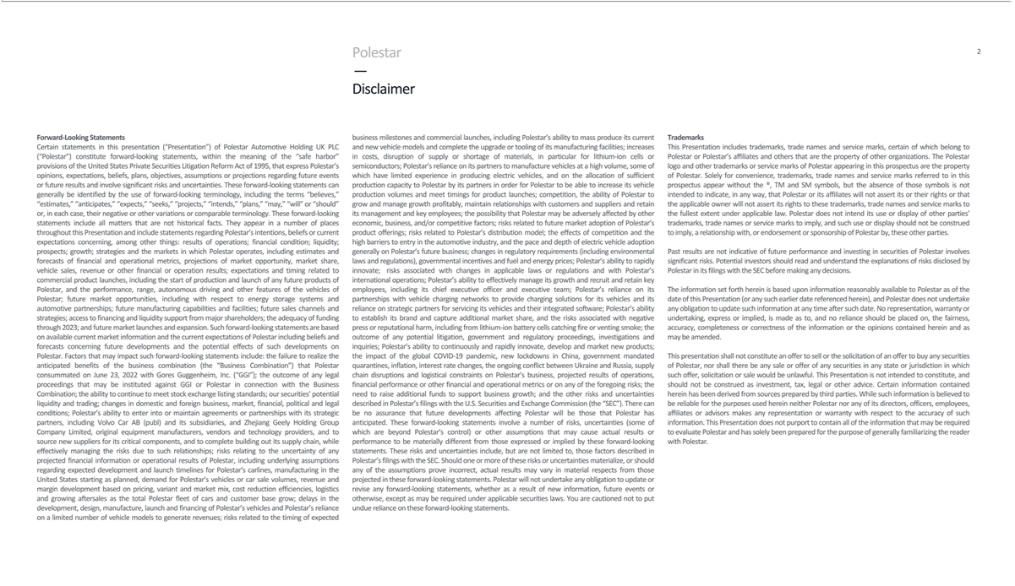

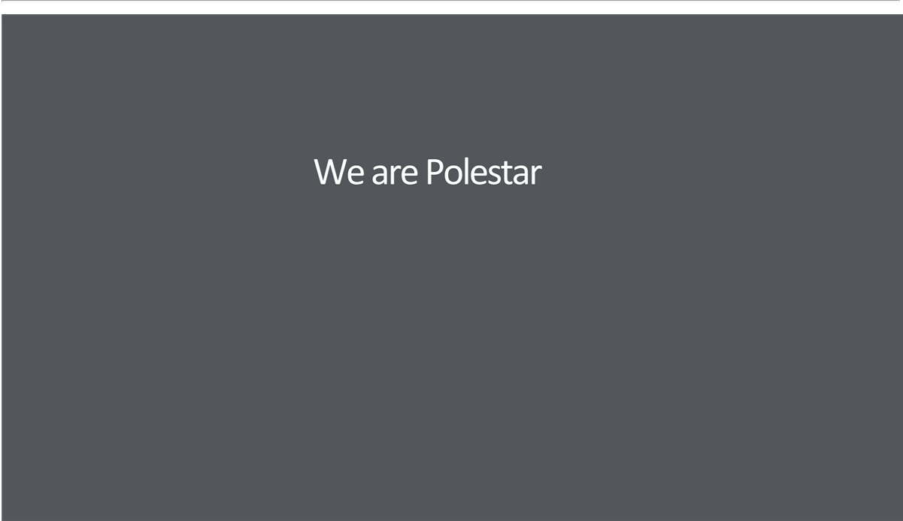

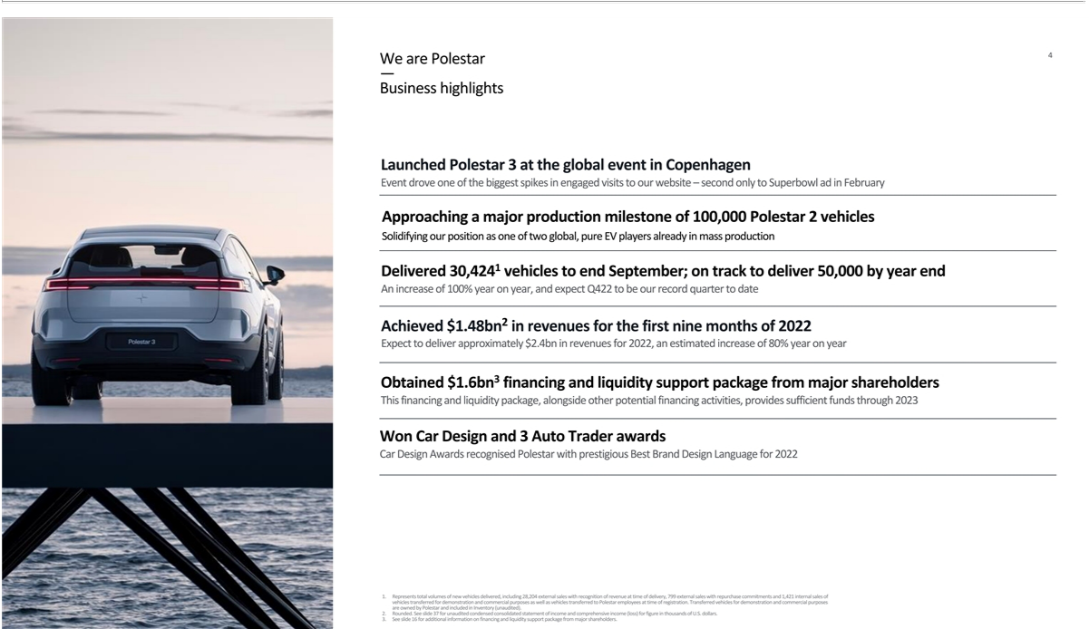

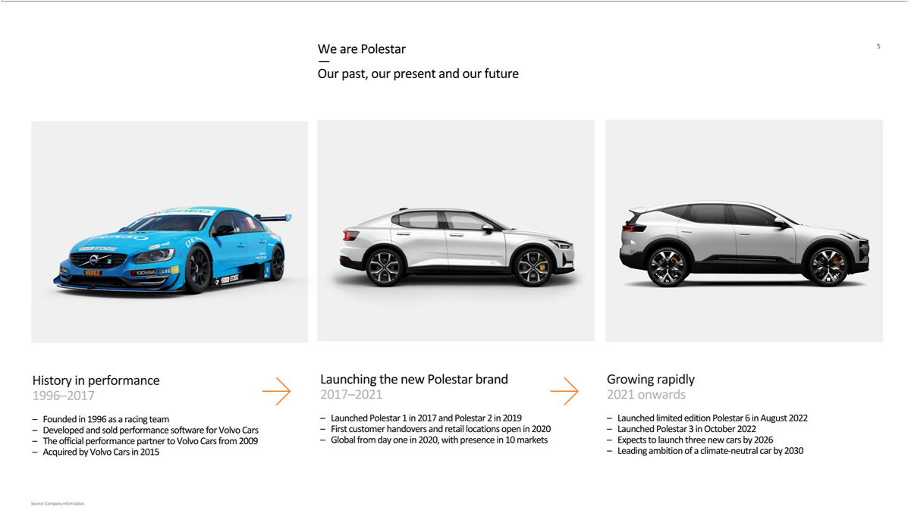

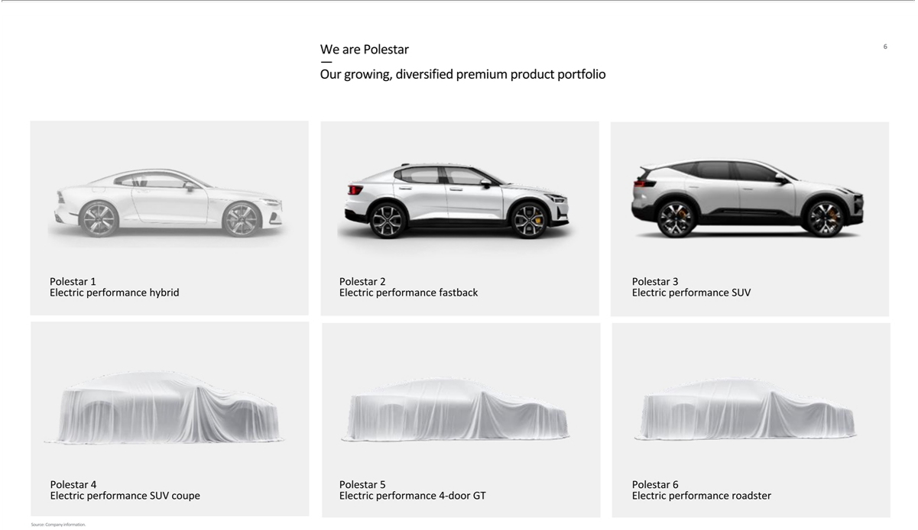

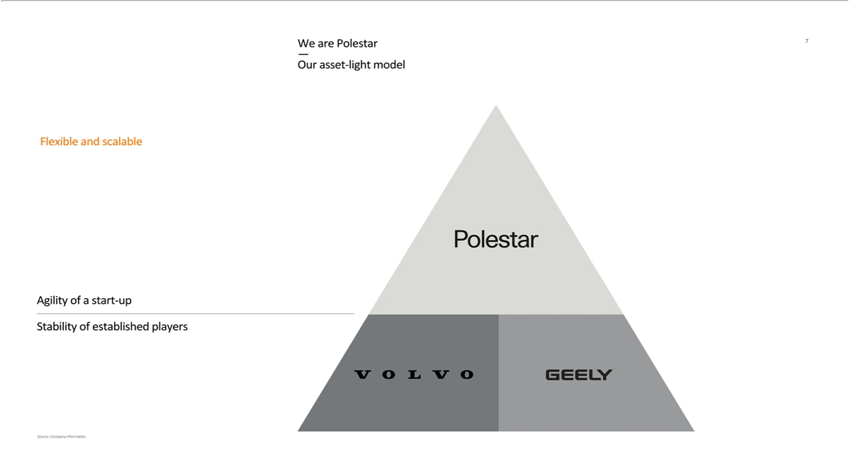

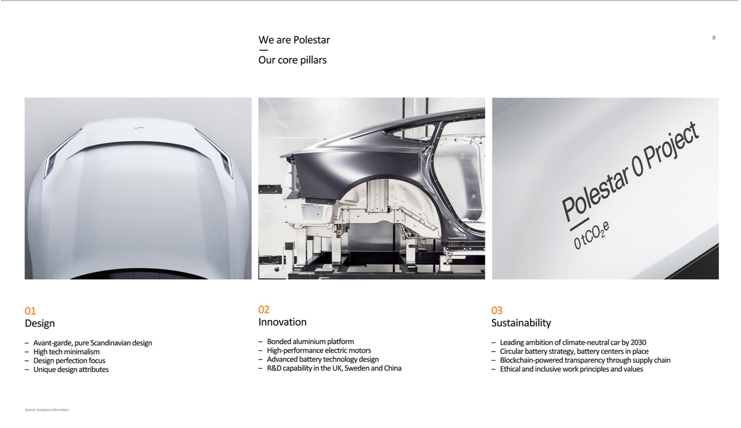

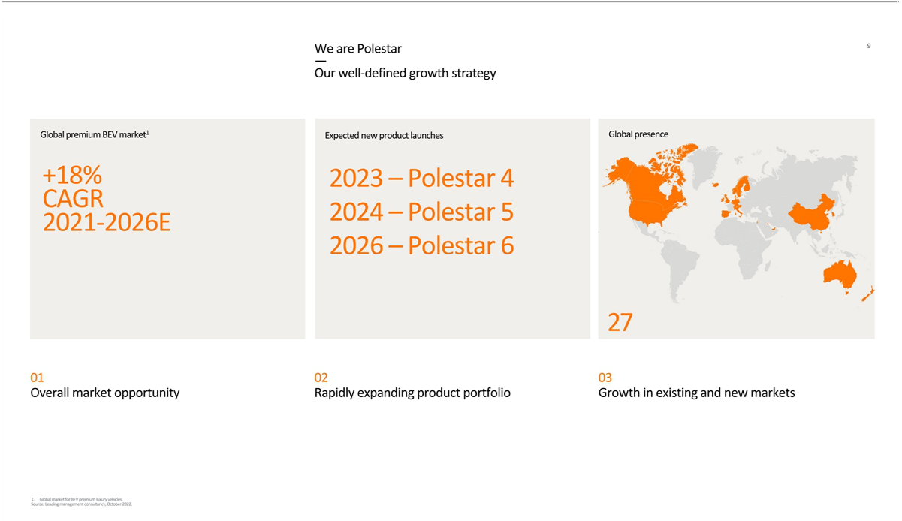

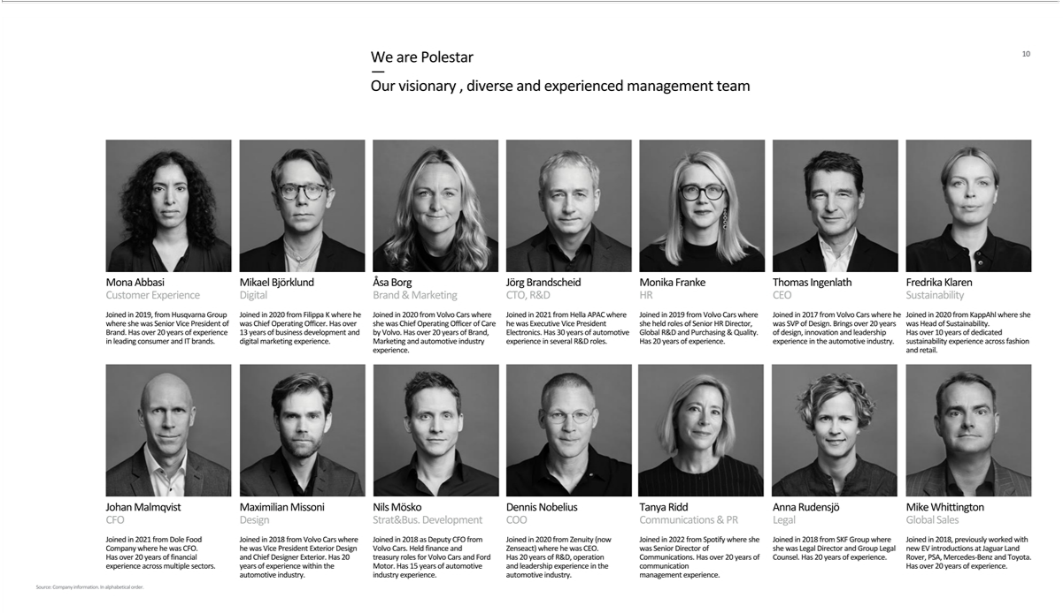

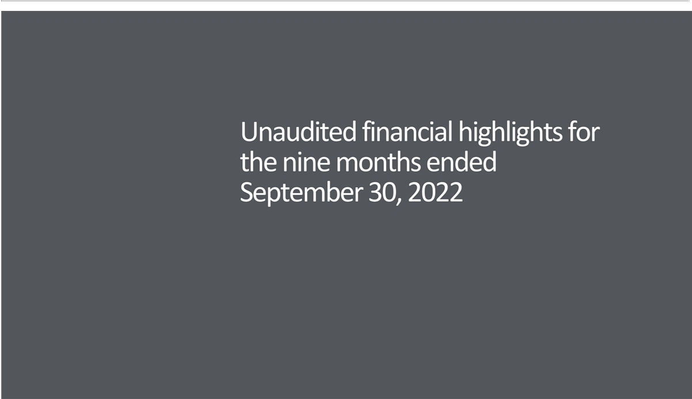

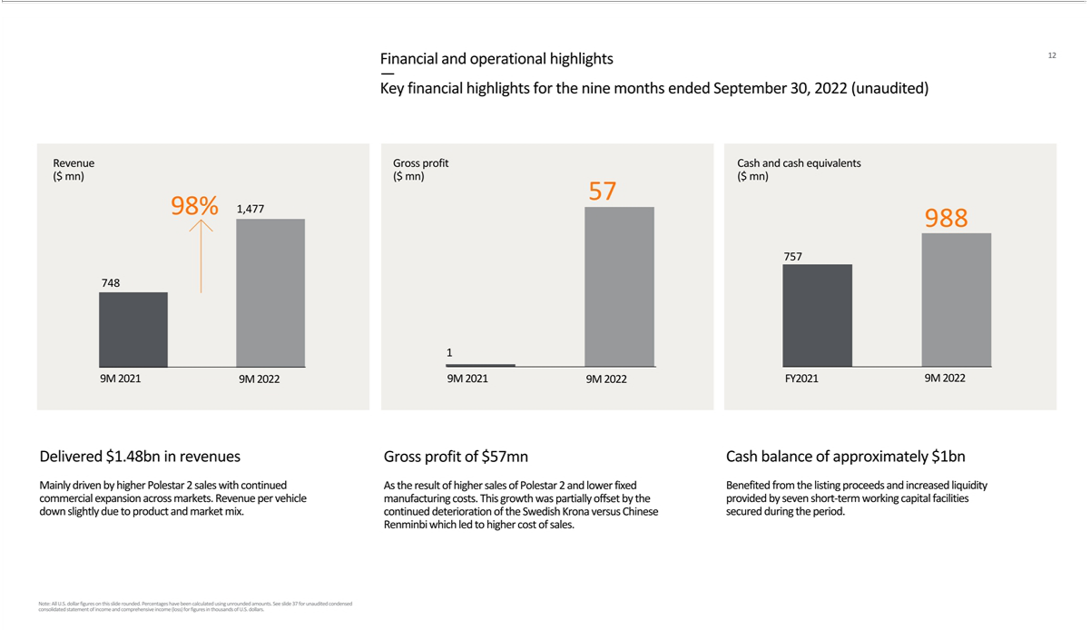

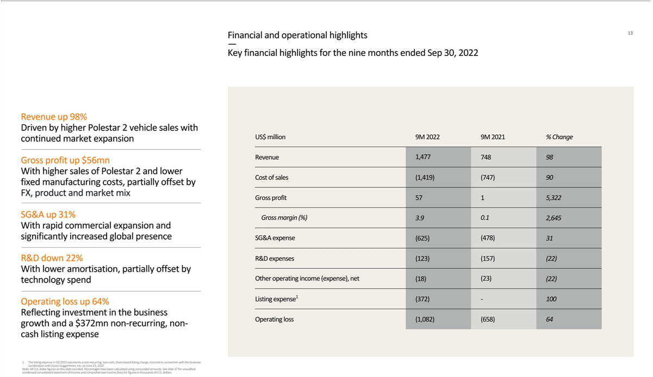

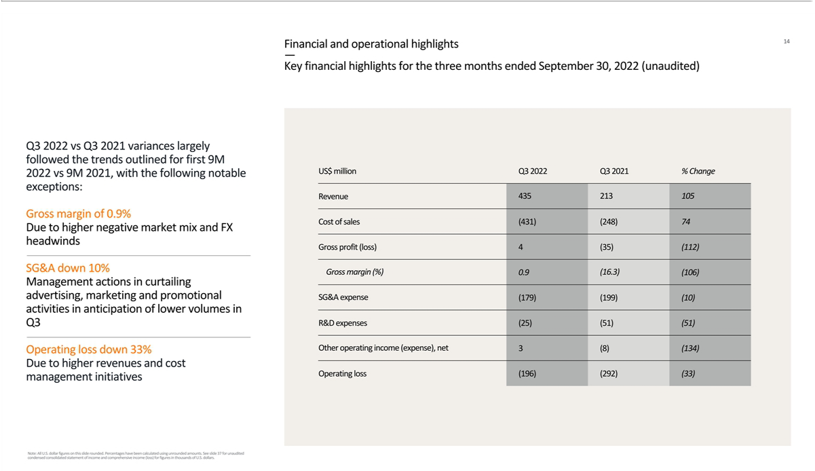

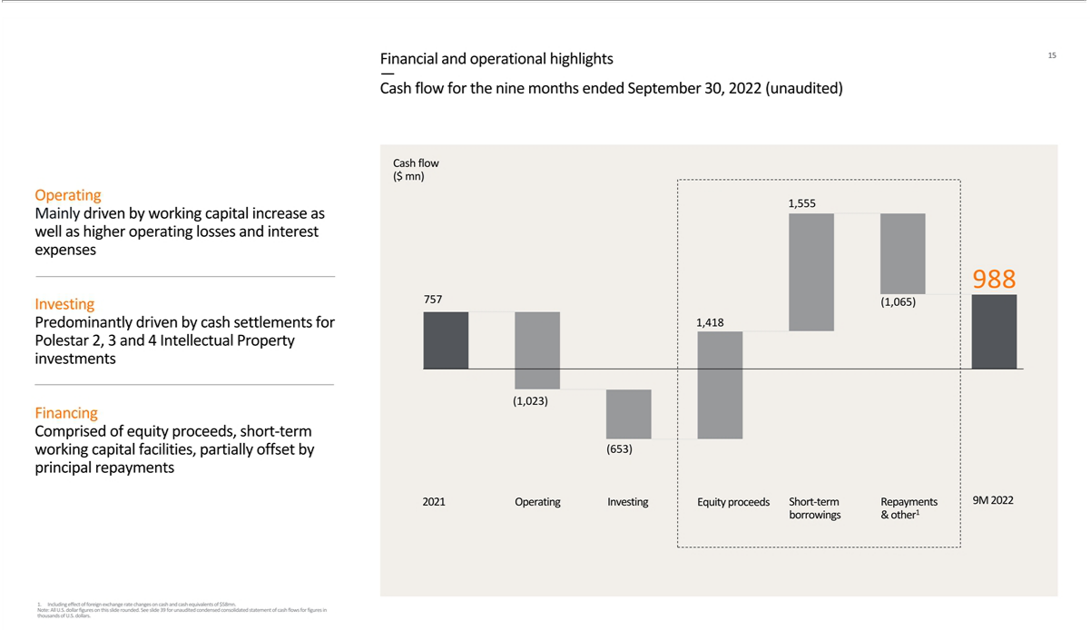

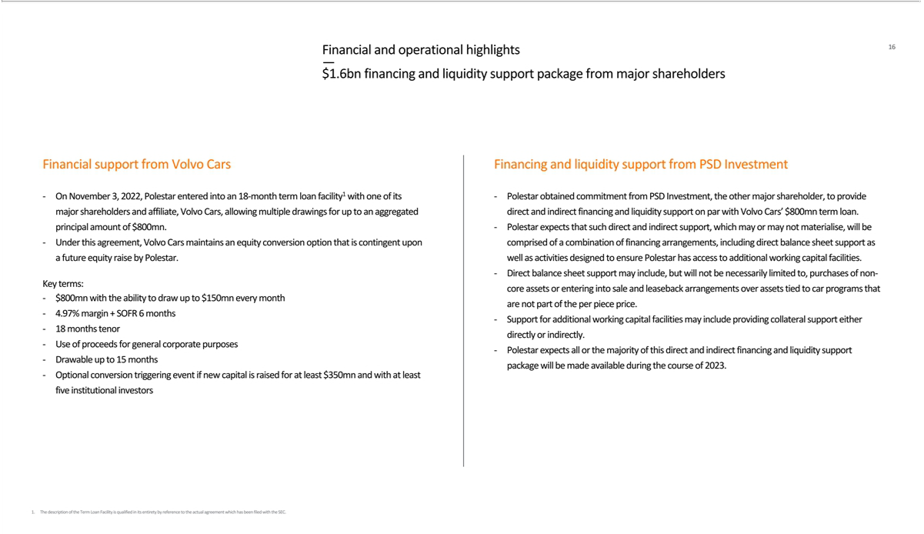

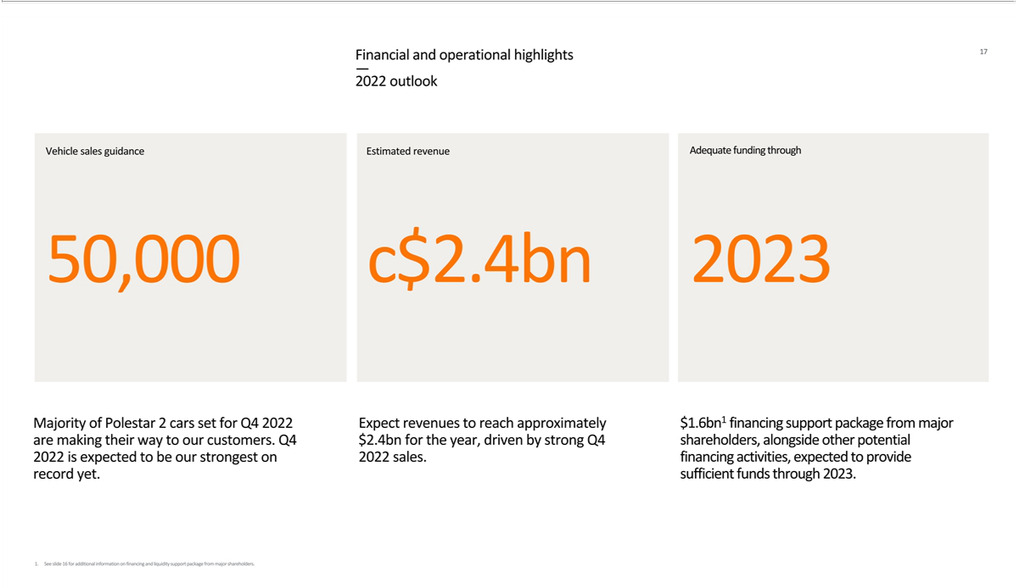

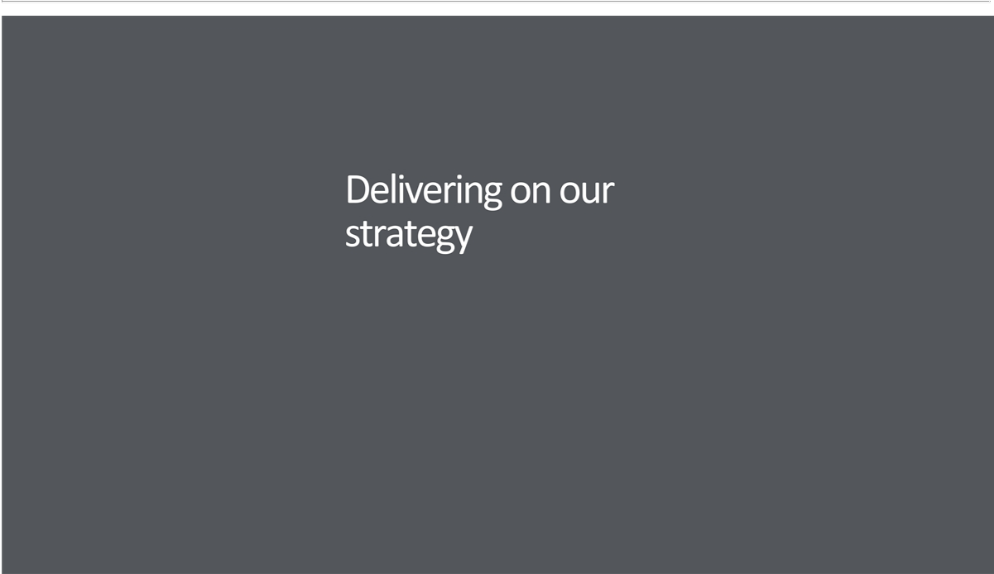

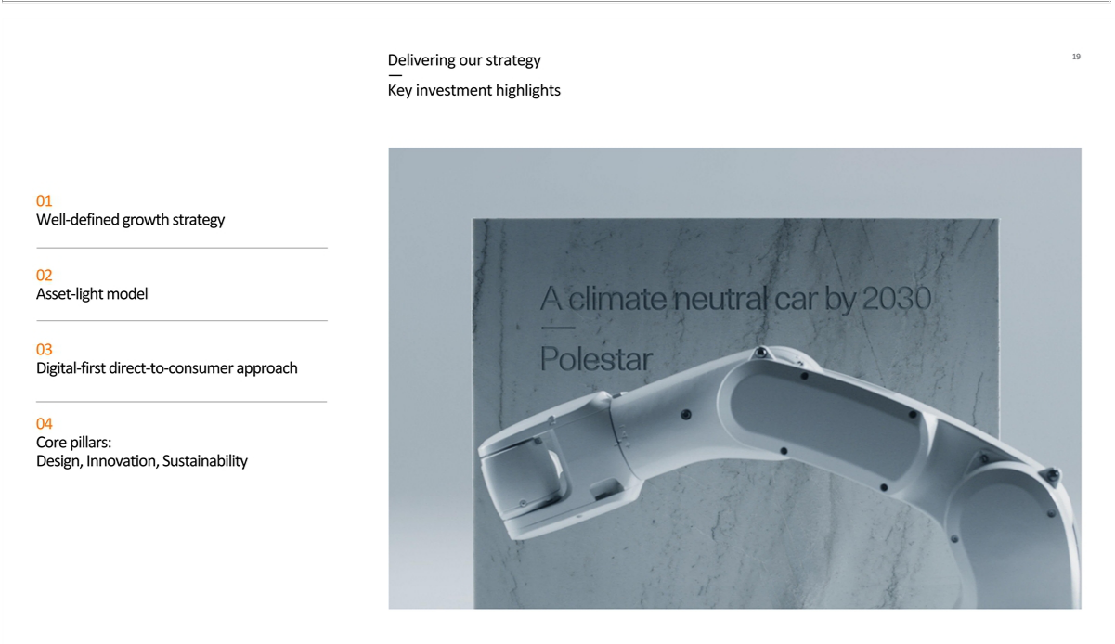

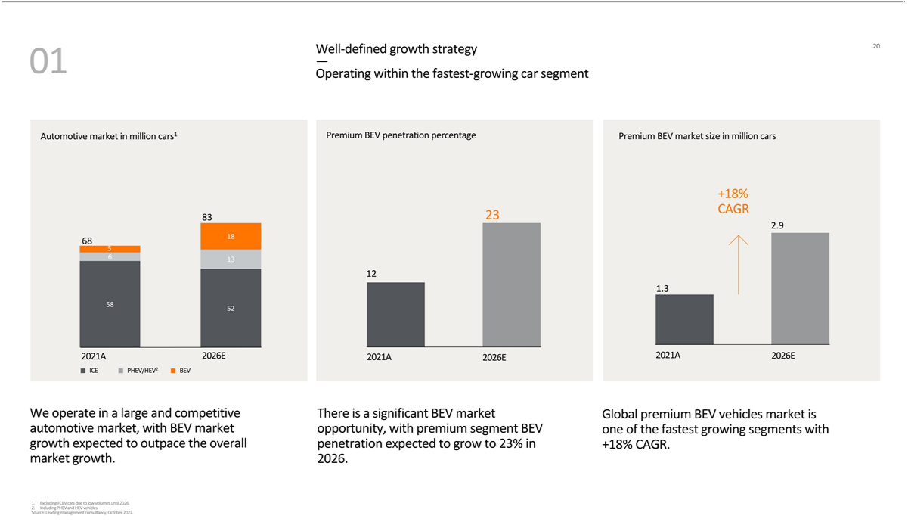

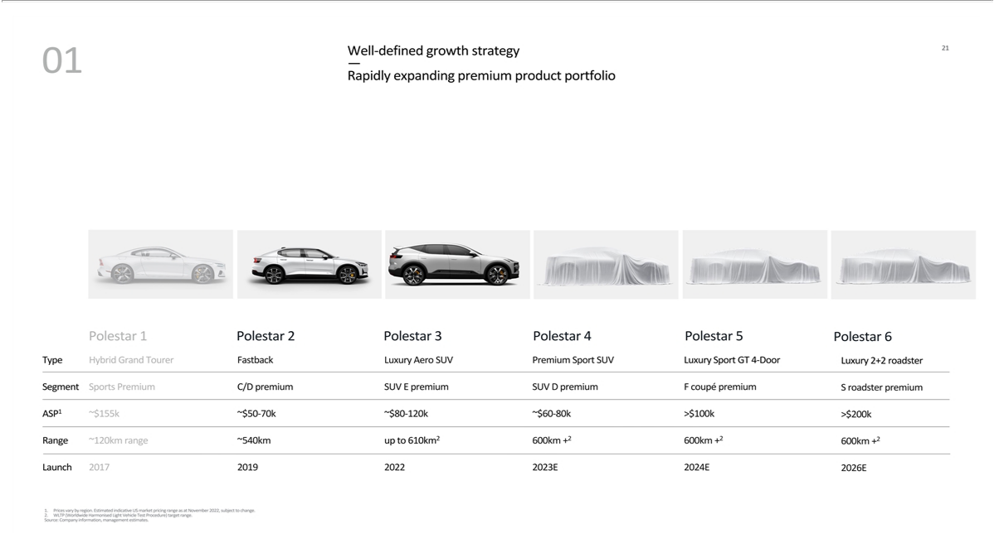

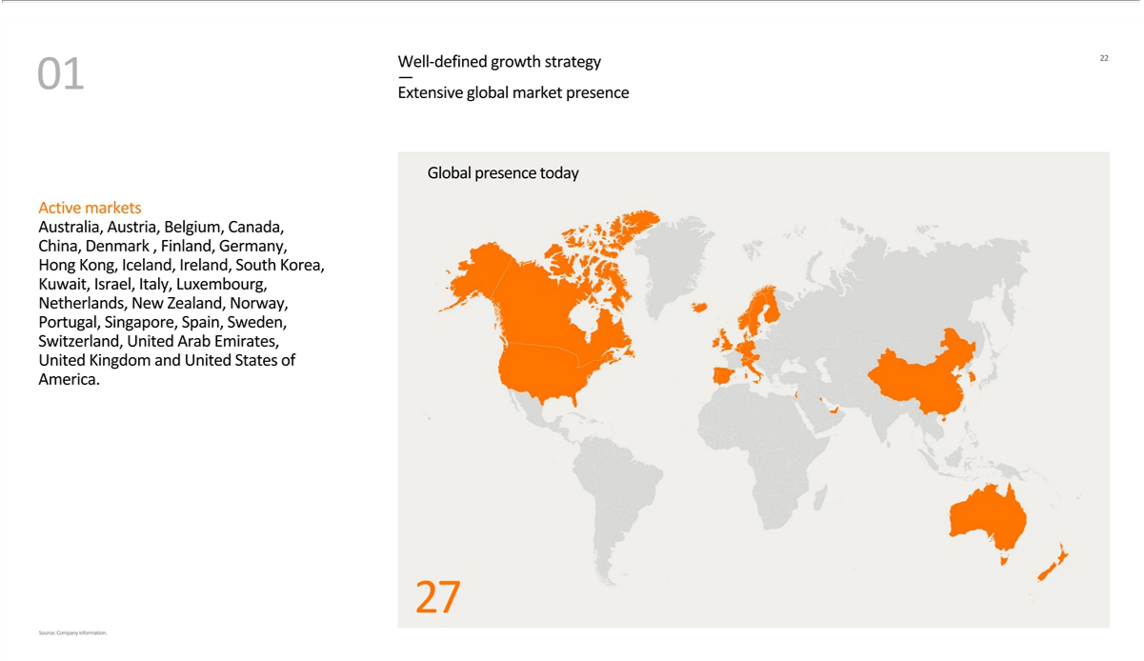

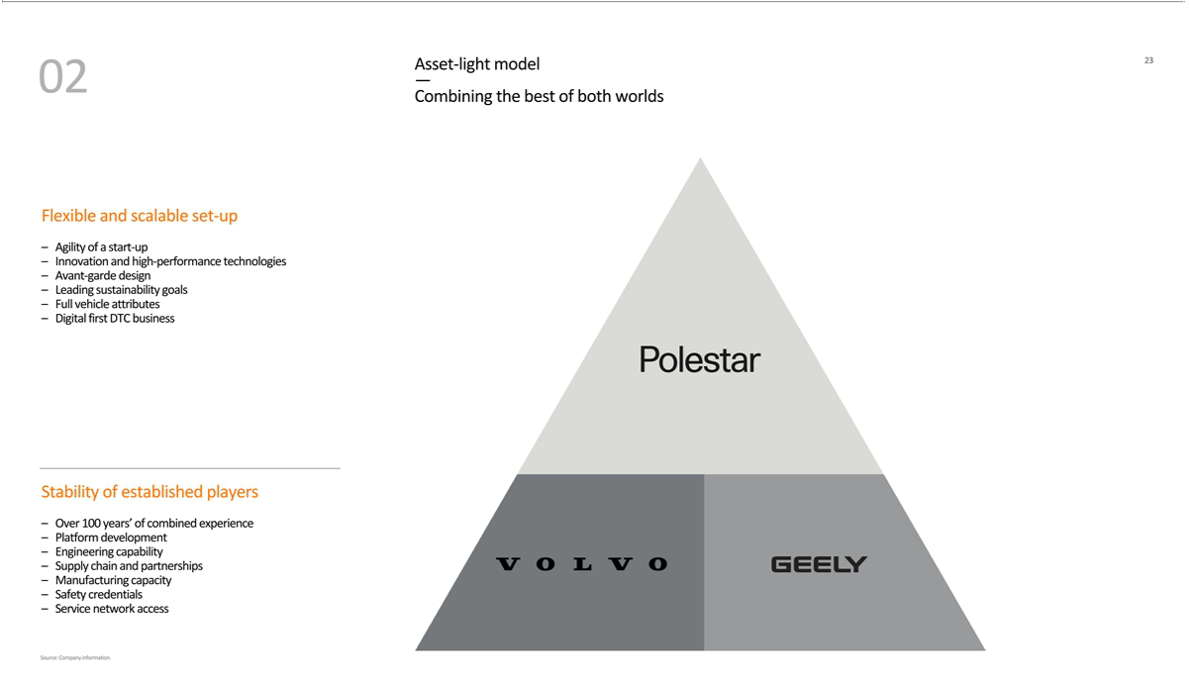

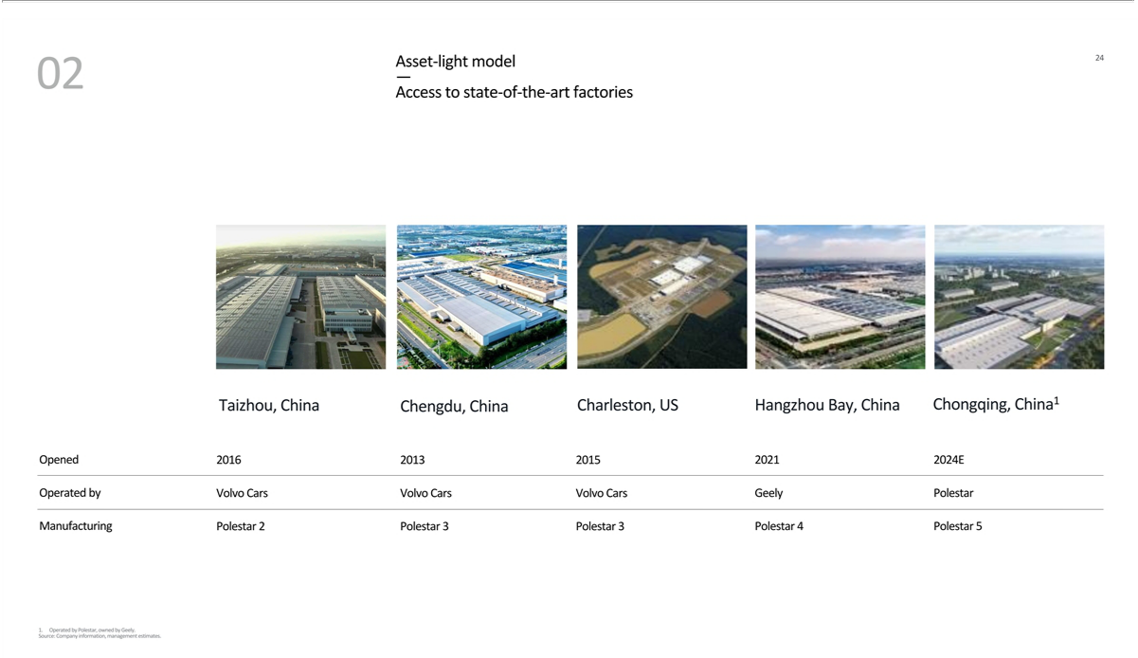

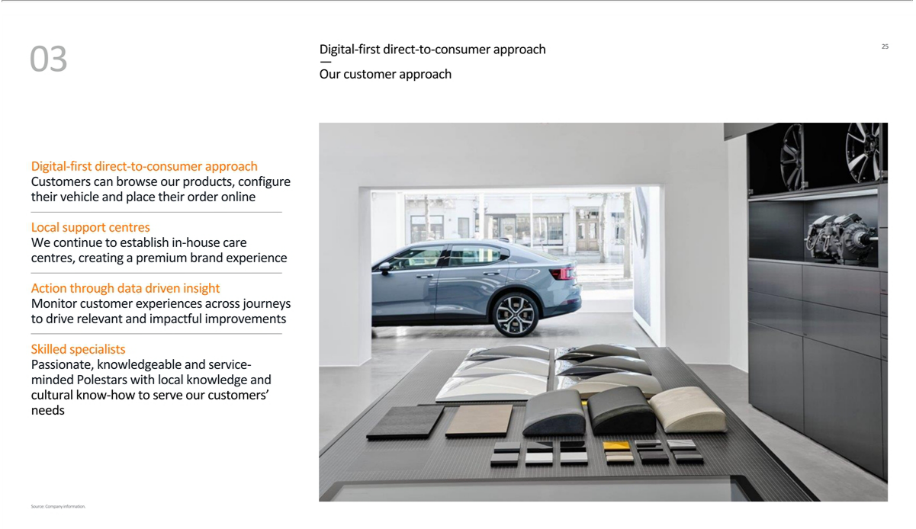

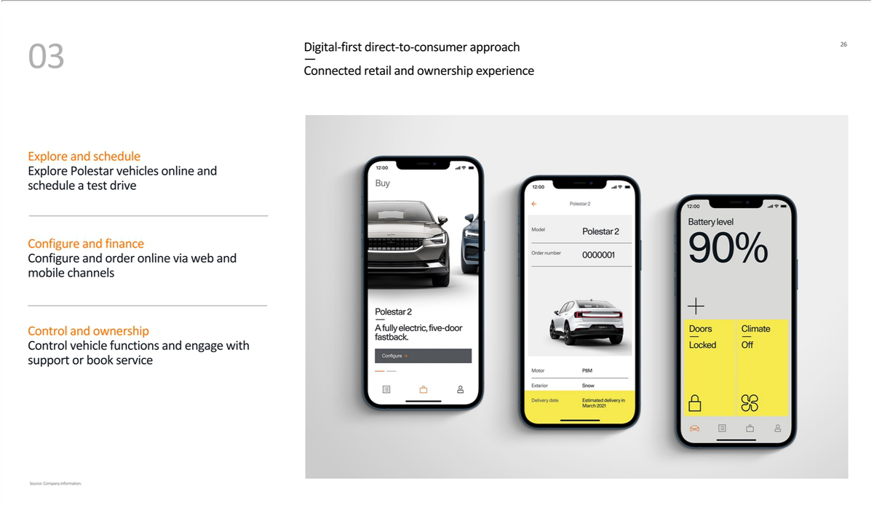

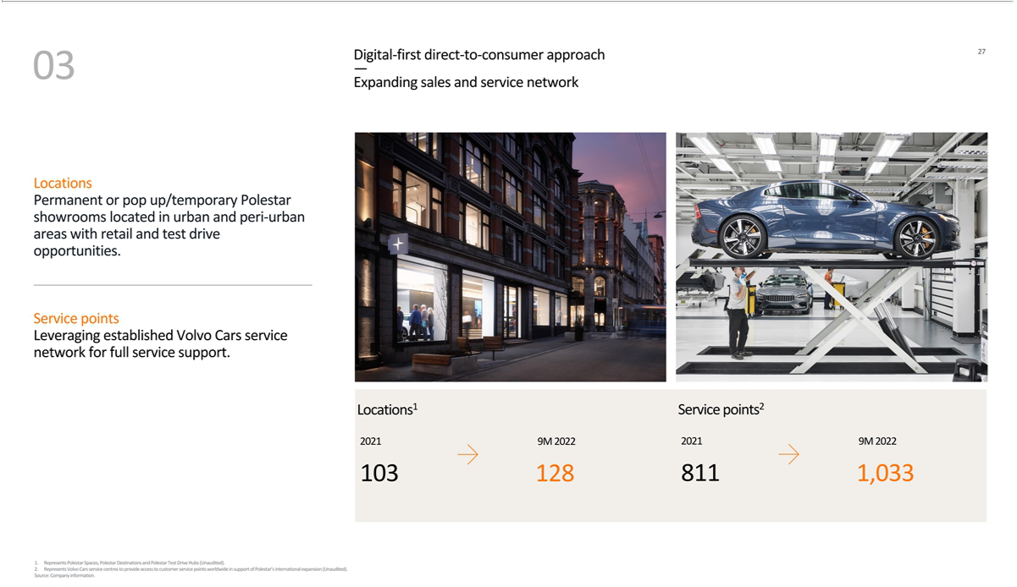

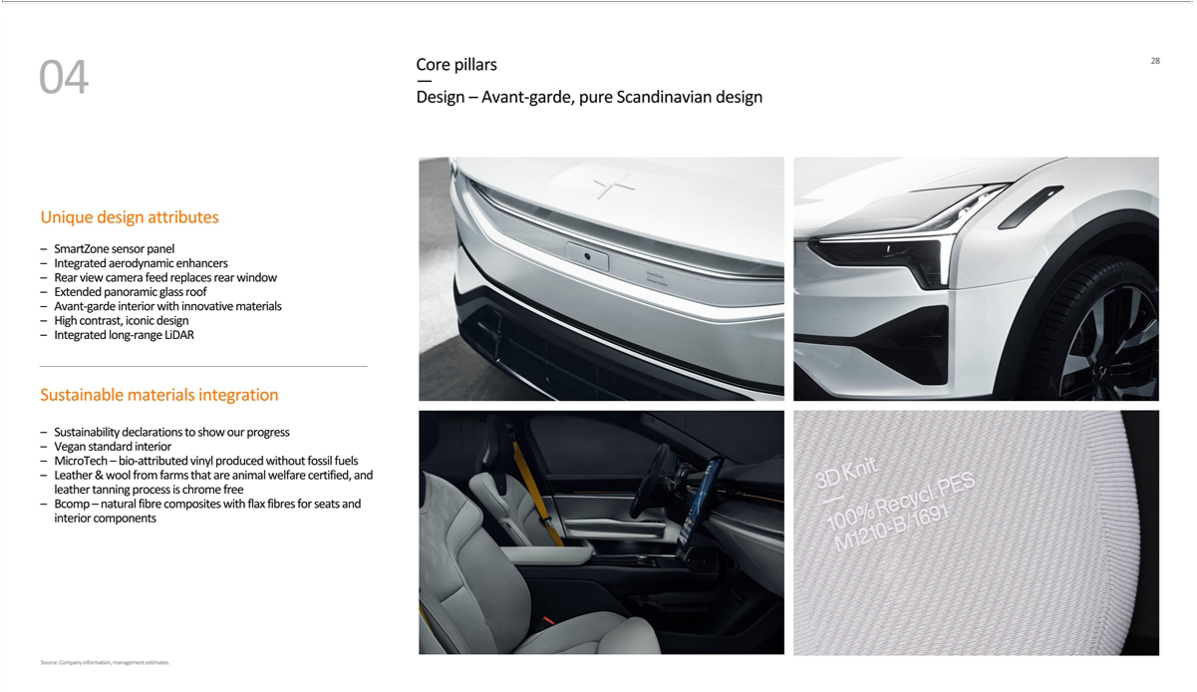

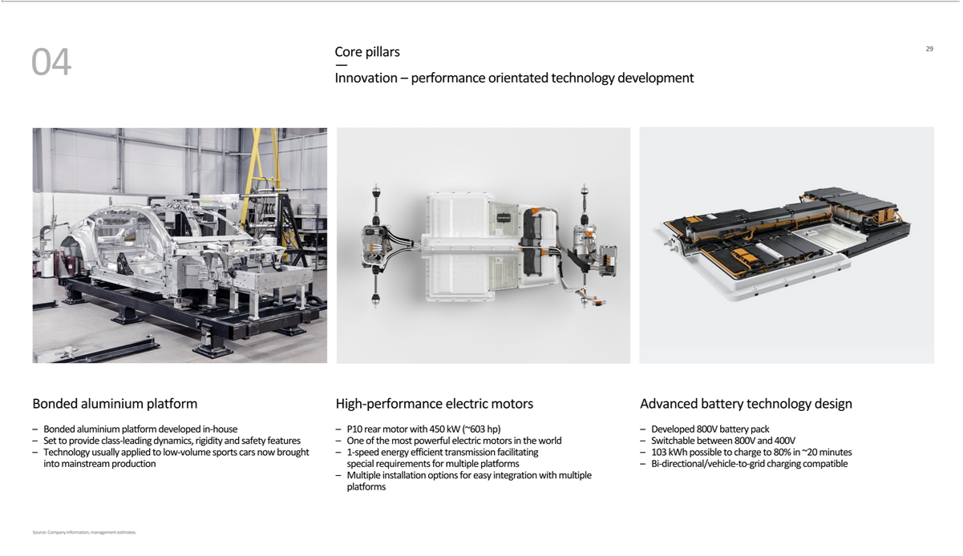

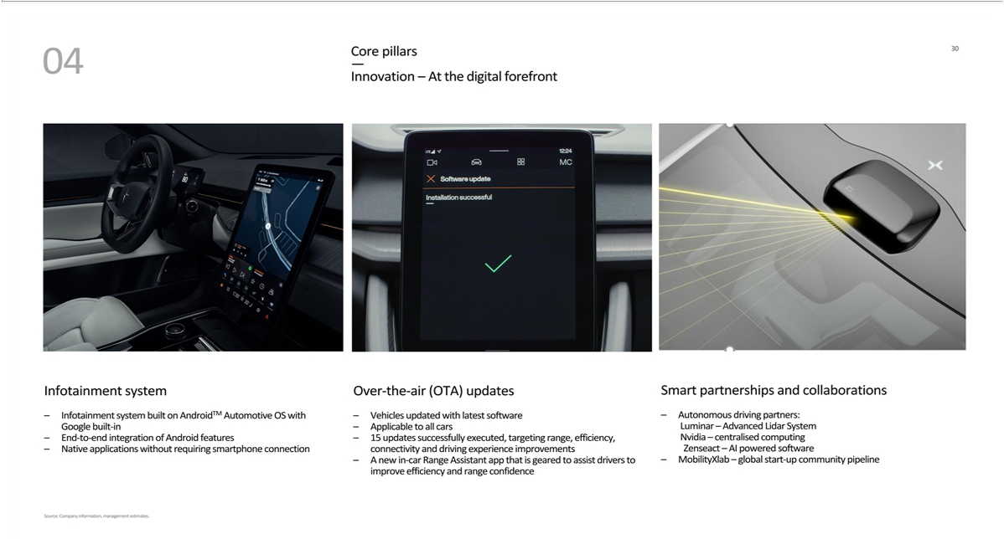

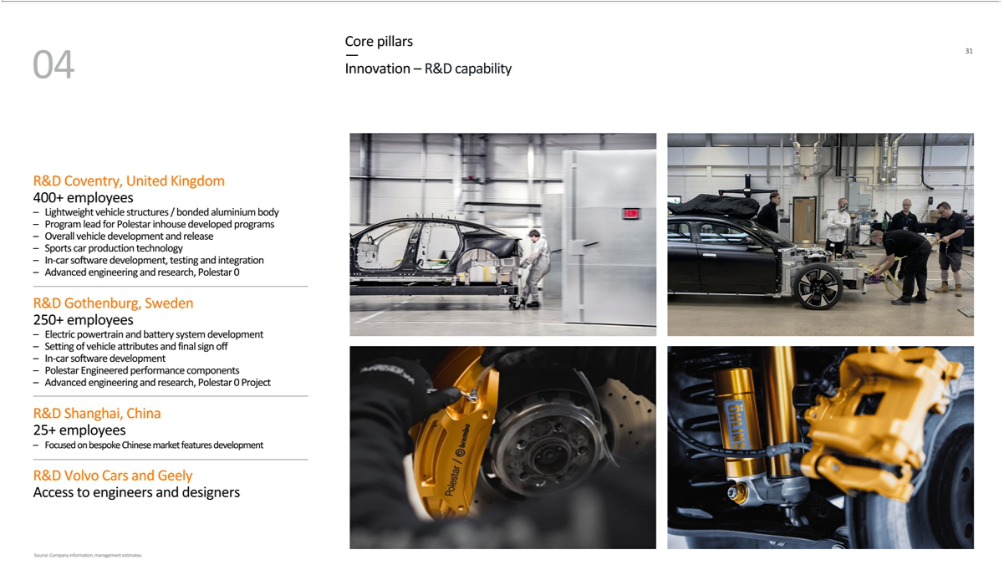

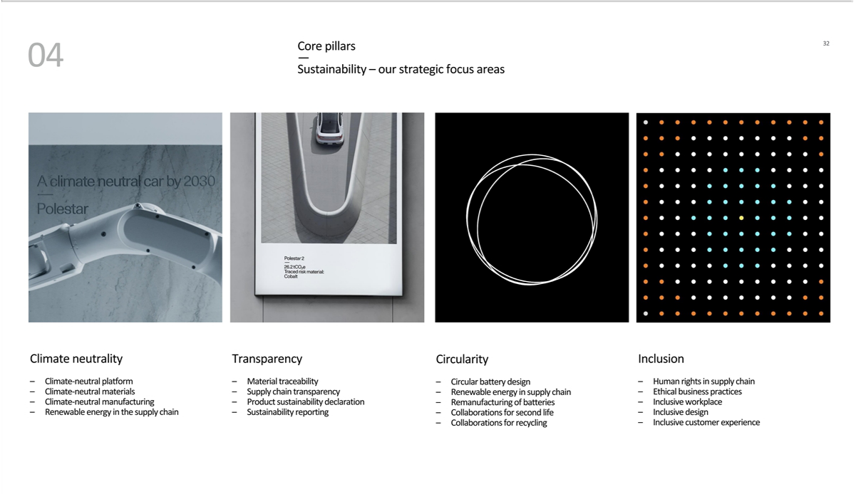

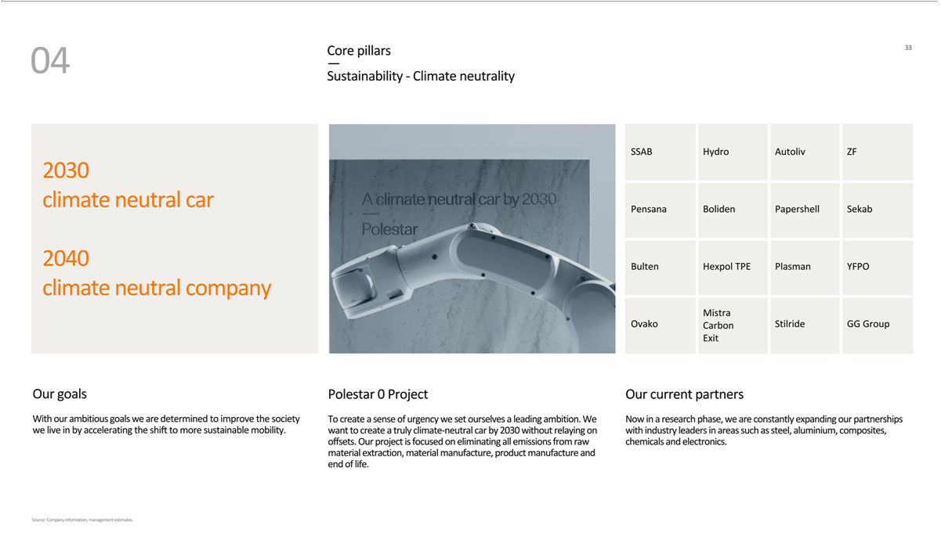

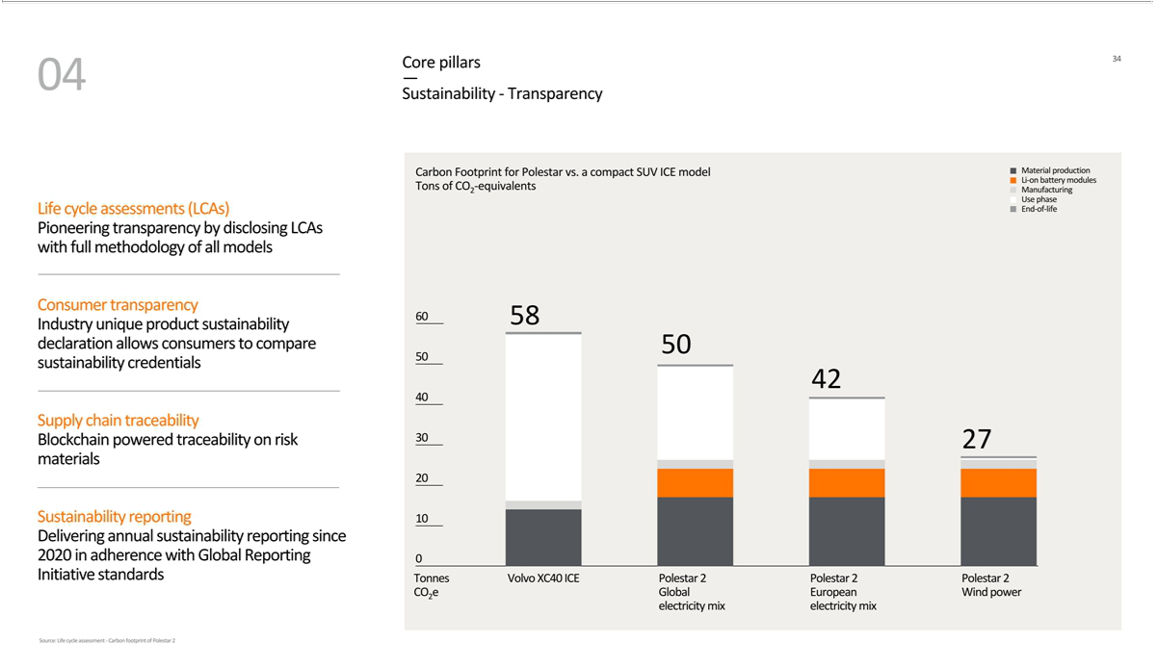

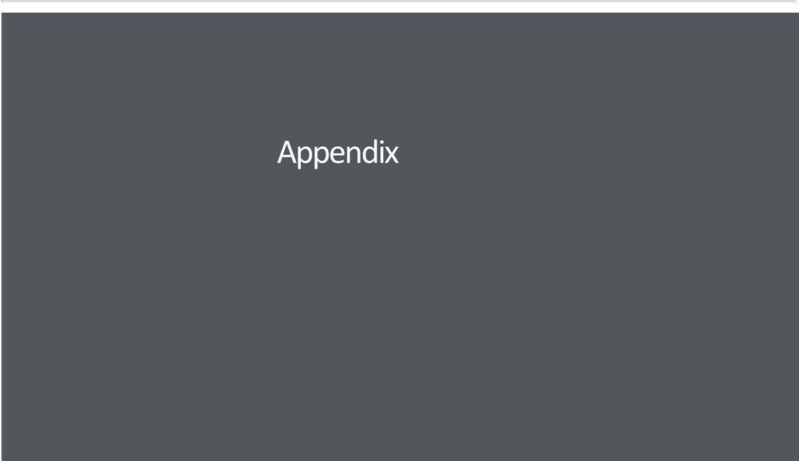

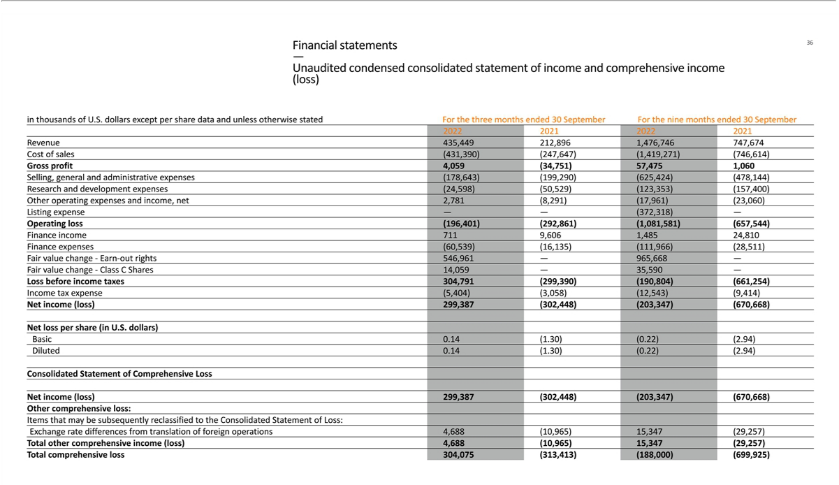

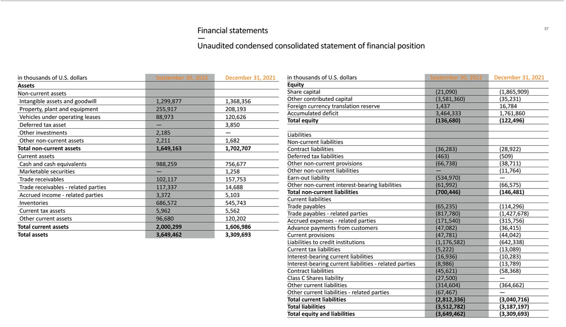

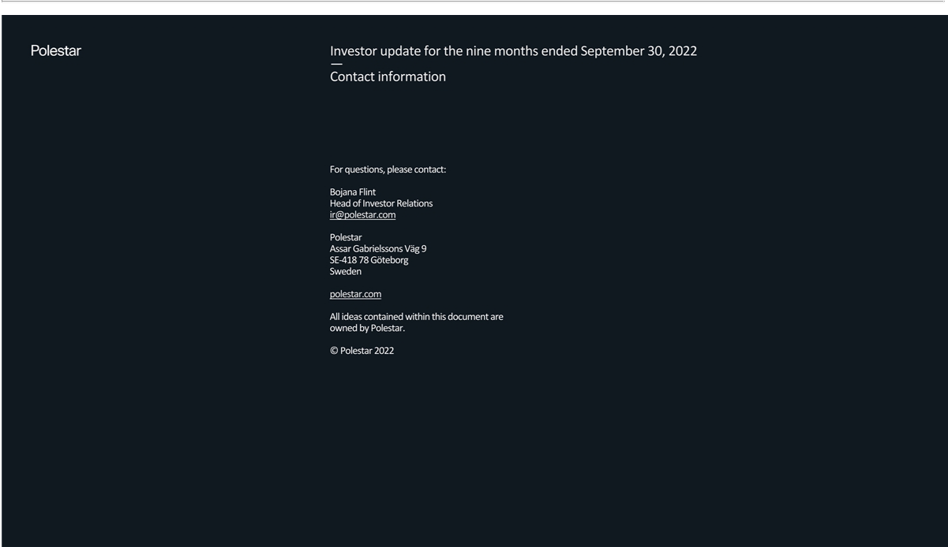

Exhibit 99.2

Management’s Discussion and Analysis of Financial Conditions and Results of Operations

The following discussion includes information that is relevant to understanding Polestar’s financial condition and results of operations and should be read together with the Unaudited Condensed Consolidated Financial Statements as of September 30, 2022 and for the three and nine months ended September 30, 2022, included elsewhere in this report. Refer to the Form 20-F filed with the SEC on June 29, 2022 for information related to the year ended December 31, 2021. All amounts presented in this report are shown in thousands of U.S. dollars, except per share data and unless otherwise stated.

Key figures

 |  |  |  | September 30, |  |  |  |  | December 31,
 |  |  |  |  | 2022 |  |  |  |  |  | 2021
 | Statement of financial position
 | Cash and cash equivalents |  |  |  | 988,259 |  |  |  |  |  | 756,677
 | Total assets | 3,649,461 |  |  |  |  |  | 3,309,693
 | Total equity |  |  |  | (136,680) |  |  |  |  |  | (122,496)
 | Total liabilities | (3,512,782) |  |  |  |  |  | (3,187,197)
 |  |  | For the nine months ended |  |  |  |  |  |  |  |  | For the year
 |  |  |  |  |  |  |  |  |  |  |  | ended
 |  |  | September 30, |  |  |  |  |  |  |  |  | December 31,
 |  |  | 2022 |  | 2021 |  |  |  |  |  |  | 2021
Statement of loss
Revenue |  | 1,476,746 |  |  | 747,674 |  |  |  |  |  | 1,337,181
Cost of sales |  | (1,419,271) |  |  | (746,614) |  |  |  |  |  | (1,336,321)
Gross profit |  |  | 57,475 |  |  | 1,060 |  |  |  |  |  | 860
Operating expenses¹ |  | (1,139,056) |  |  | (658,604) |  |  |  |  |  | (995,699)
Operating loss |  |  | (1,081,581) |  |  | (657,544) |  |  |  |  |  | (994,839)
Finance income and expense, net |  | 890,777 |  |  | (3,710) |  |  |  |  |  | (12,279)
Income tax expense |  |  | (12,543) |  | (9,414) |  |  |  |  |  | (336)
Net loss |  |  | (203,347) |  | (670,668) |  |  |  |  |  | (1,007,454)
Statement of cash flows
Cash used for operating activities |  | (1,023,425) |  |  | (155,078) |  |  |  |  |  | (312,156)
Cash used for investing activities |  | (652,778) |  |  | (72,171) |  |  |  |  |  | (129,672)
Cash provided by financing activities |  | 1,965,753 |  |  | 536,603 |  |  |  |  |  | 909,572
Key metrics
Class A and B shares outstanding at period end |  | 2,109,378,547 |  |  | 232,404,595 |  |  |  |  |  | 232,404,595
Share price at period end² |  | 5.06 |  |  |  |  |  | N/A |  |  |  |  |  | N/A
Net loss per share (basic and diluted) |  | (0.22) |  |  | (2.94) |  |  |  |  |  | (4.39)
 |  | 1

Equity ratio³ | 3.75% | 16.16% | 3.71%
Global volumes⁴ | 30,424 | 15,178 | 28,677
Volume of external vehicles without repurchase obligations | 28,204 | 12,362 | 23,760
Volume of external vehicles with repurchase obligations | 799 | 1,535 | 2,836
Volume of internal vehicles | 1,421 | 1,281 | 2,081
Markets⁵ | 27 | 16 | 19
Locations⁶ | 128 | 101 | 103
Service points⁷ | 1,033 | 738 | 811
- - Included in operating expenses for the nine months ended September 30, 2022 is a non-recurring as well as non-cash USD 372.3 million charge relating to listing expenses incurred upon the merger with Gores Guggenheim, Inc.(“GGI”) on June 23, 2022. See also section “Reverse

recapitalization.”

- - Represents PSNY share price at September 30, 2022. Share prices at the end of prior periods are not disclosed as Polestar was not publicly

traded.

- - Calculated as total equity divided by total assets.

- - Represents total volumes of new vehicles delivered, including external sales with recognition of revenue at time of delivery, external sales with repurchase commitments and internal sales of vehicles transferred for demonstration and commercial purposes as well as vehicles transferred to Polestar employees at time of registration. Transferred vehicles for demonstration and commercial purposes are owned by Polestar and included in

- - Represents the markets in which Polestar operates.

- - Represents Polestar Spaces, Polestar Destinations, and Polestar Test Drive Centers.

- - Represents Volvo Cars service centers to provide access to customer service points worldwide in support of Polestar’s international expansion. The comparison figure for September 30, 2021 is an estimate as the number of service points at period end was not recorded internally.

Key factors affecting performance

Polestar’s continued growth depends on numerous factors and trends. While these factors and trends provide opportunities for Polestar, they also pose risks and challenges as discussed in item 3.D “Risk Factors” in Form 20-F filed with the SEC on June 29, 2022. The following paragraphs explain the key factors that had a notable impact on Polestar during the nine months ended September 30, 2022.

Partnerships with Volvo Cars and Geely

Polestar’s relationship with related parties, Volvo Cars and Geely, has provided it with a unique competitive advantage in its ability to rapidly scale commercialization activities while maintaining an asset light balance sheet. This is achieved primarily through contract manufacturing as well as supply and service agreements with Volvo Cars and Geely. Polestar continues to utilize the established research and development capabilities of Volvo Cars and Geely to accelerate technological advancements in automotive technology. Additionally, selling and administrative expenses have been positively impacted due to service agreements with Volvo Cars that allow Polestar to attain operational efficiencies in the areas of aftermarket services, maintenance, and back-office functions such as information technology, legal, accounting, finance, and human resources.

2

During the nine months ended September 30, 2022, Polestar entered into the following agreements with Volvo Cars and Geely:

- A service agreement with Volvo Cars, effective January 28, 2022, that governs Polestar’s outbound logistics through the utilization of Volvo Cars’ existing vehicle distribution process in the United States.

- Technology license agreements with Geely, effective March 4, 2022, that govern Polestar’s acquisition of certain technology from Geely related to the Polestar 4.

- Service agreements with Volvo Cars, effective June 21, 2022, that govern the import and export of Polestar vehicles into and out of the United States by Volvo Cars.

Refer to Note 8 - Related party transactions in the Unaudited Condensed Consolidated Financial Statements included elsewhere in this report for more information.

Reverse recapitalization

On June 23, 2022, Polestar consummated a capital reorganization via the merger with Gores Guggenheim, Inc. (“GGI”), a special purpose acquisition company. Polestar subsequently began trading on the National Association of Securities Dealers Automated Quotations (“Nasdaq”) on June 24, 2022 under the ticker symbol PSNY. In addition to providing Polestar with access to new funding sources in the United States capital markets, the merger, including all related arrangements, raised net cash proceeds of $1,417,973. Gross proceeds of $638,197 was assumed from GGI, $250,000 was sourced from a private placement in public equity (“PIPE”), and $588,826 was sourced from a preferential share subscription with Volvo Cars. Polestar incurred total transaction costs of $97,953 in connection with the merger, of which $59,050 were attributable to GGI and deducted from the gross proceeds raised.

The merger was accounted for as a reverse recapitalization in accordance with International Financial Reporting Standards (“IFRS”) 2, Share-based Payment, under which Polestar obtained a listing service in exchange for the issuance of 5.1% equity ownership. Accordingly, Polestar recorded a non-recurring as well as non-cash share-based listing expense of $372,318 that was calculated based on the excess of the fair value of equity ownership in Polestar issued to GGI and third-party PIPE investors over the identifiable net assets and cash assumed on June 23, 2022. The fair value of Polestar equity on June 23, 2022 was based on a closing share price of $11.23 per share, a contributing factor to the size of the listing expense. This non-recurring listing expense is included in operating expenses and reflected in operating loss.

As part of the merger, Polestar exchanged rights and obligations to the public and private warrant instruments of GGI, which maintained fair values of

$40,320 and $22,770, respectively, on June 23, 2022. Polestar also issued certain rights to earn-out shares to existing owners with a fair value of

$1,500,638 on June 23, 2022. These earn-out rights were granted to existing owners of Polestar as stipulated by the business combination agreement

with GGI, dated on September 27, 2021. These instruments are accounted for as derivative liabilities under International Accounting Standards (“IAS”)

32, Financial Instruments: Presentation, and IFRS 9, Financial Instruments, that are carried at fair value with subsequent changes in fair value

recognized in the Unaudited Condensed Consolidated Statement of Loss at each reporting date. On June 23, 2022, the day of the merger, these earn out

rights were recorded as a reduction of equity (and a derivative liability) with an amount of $1,500,638.

3

Refer to Note 1 - Significant accounting policies and judgements and Note 9 - Reverse recapitalization in the Unaudited Condensed Consolidated Financial Statements included elsewhere in this report for more information.

Impact of COVID-19, Russo-Ukrainian War, and inflation

In certain instances, Polestar’s suppliers and business partners have experienced delays or disruptions from COVID-19, resulting in negative impacts to Polestar. Specifically, the prolonged government mandated quarantines and lockdowns in eastern China during the nine months ended September 30, 2022 delayed production and delivery of critical components for the Polestar 2. Polestar estimates that it lost approximately eight weeks of production at Volvo Cars’ Luqiao plant during the period.

Further, while Polestar does not directly conduct any business with suppliers in Russia or the Ukraine, there can be no assurance that all parts of the supply chain are devoid of any exposure to disruptions caused by the Russo-Ukrainian War. Refer to Item 3.D “Risk Factors” in Form 20-F filed with the SEC on June 29, 2022 for information on risks posed by COVID-19 and the Russo-Ukrainian War.

The broader impacts of COVID-19 and the Russo-Ukrainian War include rising inflationary pressures on prices of components, materials, labor, and equipment used in the production of Polestar vehicles. Particularly, increases in battery prices due to the increased prices of lithium, cobalt, and nickel are expected to lead to higher costs of goods sold. While price increases for these components have already taken place in the market, Polestar has not yet experienced an increase in costs of goods sold due to certain contract terms between our related party contract manufacturer, Volvo Cars, and their sub-suppliers. Additionally, the natural time lag created by the production, shipping, and selling of vehicles has also contributed to a delay in price increases experienced by Polestar. Higher oil prices have also increased freight and distribution costs across all markets. It is uncertain whether these inflationary pressures will persist in the future. Polestar remains vigilant and will continue to closely monitor the effects of COVID-19, the Russo-Ukrainian War, and inflation.

4

Results of operations

Polestar conducts business under one operating segment with commercial operations in North America, Europe, and Asia. Refer to Note 1 - Significant accounting policies and judgements in the Unaudited Condensed Consolidated Financial Statements included elsewhere in this report for more information on the basis of presentation. Refer to Note 1 - Significant accounting policies and judgements in the Consolidated Financial Statements for Polestar Automotive Holding Limited, as of, and for the year ended, December 31, 2021 that were included the Form 20-F filed with the SEC on June 29, 2022 for more information related to segment reporting.

Comparison of the three and nine months ended September 30, 2022 and 2021

The following table summarizes Polestar’s historical Unaudited Condensed Consolidated Statement of Income and Comprehensive Income (Loss) for the three and nine months ended September 30, 2022 and 2021:

 | For the three months |  |  |  | Variance |  |  |  | For the nine months |  |  |  | Variance
 | ended September 30, |  |  |  |  |  |  |  | ended September 30,
 | 2022 |  | 2021 |  | $ |  | % |  | 2022 |  | 2021 |  | $ |  | %
Revenue | 435,449 |  | 212,896 |  | 222,553 |  | 105 |  | 1,476,746 |  | 747,674 |  | 729,072 |  | 98
Cost of sales | (431,390) |  | (247,647) |  | (183,743) |  | 74 |  | (1,419,271) |  | (746,614) |  | (672,657) |  | 90
Gross profit (loss) | 4,059 |  | (34,751) |  | 38,810 |  | (112) |  | 57,475 |  | 1,060 |  | 56,415 |  | 5,322
Selling, general, and administrative expense | (178,643) |  | (199,290) |  | 20,647 |  | (10) |  | (625,424) |  | (478,144) |  | (147,280) |  | 31
Research and development expense | (24,598) |  | (50,529) |  | 25,931 |  | (51) |  | (123,353) |  | (157,400) |  | 34,047 |  | (22)
Other operating income (expense), net | 2,781 |  | (8,291) |  | 11,072 |  | (134) |  | (17,961) |  | (23,060) |  | 5,099 |  | (22)
Listing expense | — |  | — |  | — |  | — |  | (372,318) |  | — |  | (372,318) |  | N/A
Operating loss | (196,401 | ) | (292,861 | ) | 96,460 |  | (33) |  | (1,081,581 | ) | (657,544 | ) | (424,037 | ) | 64
Finance income | 711 |  | 9,606 |  | (8,895) |  | (93) |  | 1,485 |  | 24,801 |  | (23,316) |  | (94)
Finance expense | (60,539) |  | (16,135) |  | (44,404) |  | 275 |  | (111,966) |  | (28,511) |  | (83,455) |  | 293
Fair value change - Earn-out rights | 546,961 |  | — |  | 546,961 |  | N/A |  | 965,668 |  | — |  | 965,668 |  | N/A
Fair value change - Class C Shares | 14,059 |  | — |  | 14,059 |  | N/A |  | 35,590 |  | — |  | 35,590 |  | N/A
Income (loss) before income taxes | 304,791 |  | (299,390) |  | 604,181 |  | (202) |  | (190,804) |  | (661,254) |  | 470,450 |  | (71)
Income tax expense | (5,404) |  | (3,058) |  | (2,346) |  | 77 |  | (12,543) |  | (9,414) |  | (3,129) |  | 33
Net income (loss) | 299,387 |  | (302,448) |  | 601,835 |  | (199) |  | (203,347) |  | (670,668) |  | 467,321 |  | (70)
 |  |  | 5

Revenues

Polestar’s revenue increased by $222,553 or 105%, from $212,896 for the three months ended September 30, 2021 to $435,449 for the three months ended September 30, 2022. Revenue from related parties decreased by $3,775, or 18%, from $21,232 for the three months ended September 30, 2021 to $17,457 for the three months ended September 30, 2022.

Polestar’s revenue increased by $729,072 or 98%, from $747,674 for the nine months ended September 30, 2021 to $1,476,746 for the nine months ended September 30, 2022. Revenue from related parties increased by $30,059, or 42%, from $70,964 for the nine months ended September 30, 2021 to $101,024 for the nine months ended September 30, 2022.

The following table summarizes the components of revenue and related changes between interim periods:

 | For the three months |  |  |  | Variance |  |  |  | For the nine months |  |  |  | Variance
 | ended September 30, |  |  |  |  |  |  |  | ended September 30,
 | 2022 |  | 2021 |  | $ |  | % |  | 2022 |  | 2021 |  | $ |  | %
Revenues
Sales of vehicles | 425,299 |  | 204,869 |  | 220,430 |  | 108 |  | 1,442,116 |  | 722,152 |  | 719,964 |  | 100
Sales of software and performance engineered kits | 4,451 |  | 5,537 |  | (1,086) |  | (20) |  | 15,313 |  | 19,817 |  | (4,504) |  | (23)
Sales of carbon credits | 162 |  | — |  | 162 |  | — |  | 1,475 |  | — |  | 1,475 |  | —
Vehicle leasing revenue | 4,559 |  | 2,001 |  | 2,558 |  | 128 |  | 12,493 |  | 2,155 |  | 10,338 |  | 480
Other revenue | 978 |  | 489 |  | 489 |  | 100 |  | 5,349 |  | 3,550 |  | 1,799 |  | 51
Total | 435,449 |  | 212,896 |  | 222,553 |  | 105 |  | 1,476,746 |  | 747,674 |  | 729,072 |  | 98

Sales of vehicles increased by $220,430, or 108%, from $204,869 for the three months ended September 30, 2021 to $425,299 for the three months

ended September 30, 2022. Sales of vehicles increased by $719,964, or 100%, from $722,152 for the nine months ended September 30, 2021 to

$1,442,116 for the nine months ended September 30, 2022. The increase was driven by greater volumes of Polestar 2 sales across major geographic

markets such as the United States, the United Kingdom, Germany, Sweden, and South Korea.

6

Revenue per vehicle decreased slightly for the nine months ended September 30, 2022 compared to the nine months ended September 30, 2021 primarily due to Polestar 2 model mix and market mix. During the nine months ended September 30, 2021, the majority of vehicles sold were long-range dual motor variants of the Polestar 2 while the lower priced long-range single motor and

standard-range single motor variants represented a greater share of revenue during the nine months ended September 30, 2022. Continued market expansion outside of Europe, where net revenue per car is generally lower, was a contributing factor in decreased revenue per vehicle during the nine months ended September 30, 2022 as compared to the comparative period.

7

Sales of software and performance engineered kits decreased by $1,086, or 20%, from $5,537 for the three months ended September 30, 2021 to $4,451 for the three months ended September 30, 2022. Sales of software and performance engineered kits decreased by $4,504, or 23%, from $19,817 for the nine months ended September 30, 2021 to $15,313 for the nine months ended September 30, 2022. The decrease across both comparative periods is a result of Polestar’s shifting focus to its own vehicles and a decrease in Volvo Cars’ sales of Polestar’s performance engineered kits.

Vehicle leasing revenue increased by $2,558, or 128%, from $2,001 for the three months ended September 30, 2021 to $4,559 for the three months ended September 30, 2022. Vehicle leasing revenue increased by $10,338, or 480%, from $2,155 for the nine months ended September 30, 2021 to $12,493 for the nine months ended September 30, 2022. Polestar began selling vehicles with repurchase obligations during the first half of 2021 and continued to increase the number of vehicles sold with repurchase obligations in the subsequent periods. This resulted in the increase to vehicle leasing revenue during the three and nine months ended September 30, 2022 as compared to the comparative periods.

Other revenue increased by $489, or 100%, from $489 for the three months ended September 30, 2021 to $978 for the three months ended September 30, 2022. Other revenue increased by $1,799, or 51%, from $3,550 for the nine months ended September 30, 2021 to $5,349 for the nine months ended September 30, 2022. The increase is driven primarily by higher royalties from Volvo Cars’ sales of parts and accessories for Polestar vehicles.

Cost of sales and gross profit

Cost of sales increased by $183,743, or 74%, from $247,647 for the three months ended September 30, 2021 to $431,390 for the three months ended September 30, 2022. Gross profit (loss) increased by $38,810, or 112%, from a loss of $34,751 for the three months ended September 30, 2021 to a profit of $4,059 for the three months ended September 30, 2022.

Cost of sales increased by $672,657, or 90%, from $746,614 for the nine months ended September 30, 2021 to $1,419,271 for the nine months ended September 30, 2022. Gross profit increased by $56,415 from $1,060 for the nine months ended September 30, 2021 to $57,475 for the nine months ended September 30, 2022.

8

In general, the increases in cost of sales and gross profit across comparative periods are the result of expanded production and commercialization of Polestar 2 vehicles. Both cost of sales and gross profit were negatively impacted by higher freight and distribution costs per vehicle across all markets during the three and nine months ended September 30, 2022, partially offset by lower fixed manufacturing costs due to the winding down of Polestar 1 manufacturing in 2021. The decrease in revenue per vehicle from model mix and market mix during the three and nine months ended September 30, 2022 also had a direct impact on gross profit.

Continued deterioration of the SEK/CNY foreign exchange rate has been a contributing factor to higher costs of sales and reduced margin development. The SEK/CNY foreign exchange rate weakened by approximately 8.6% during the nine months ended September 30, 2022 from 0.70 on January 1, 2022 to 0.64 by September 30, 2022. During the comparative period, the SEK/CNY foreign exchange rate weakened by approximately 6.3% from 0.79 on January 1, 2021 to 0.74 by September 30, 2021. In total, the SEK/CNY foreign exchange rate has weakened by approximately 19% since January 1, 2021. This trend impacts Polestar’s gross profit as a transaction effect of contract manufacturing in China when Polestar’s purchasing entity is denominated in a functional currency that is weaker than CNY.

Selling, general, and administrative expense

Selling, general, and administrative expense decreased by $20,647, or 10%, from $199,290 for the three months ended September 30, 2021 to $178,643 for the three months ended September 30, 2022. The decrease is primarily due to lower advertising, marketing, and promotional activities in the three months ended September 30, 2022. Polestar’s began curtailing advertising, marketing and promotional activities during the three months ended September 30, 2022 after experiencing a period of heavier spend in the twelve months prior.

Selling, general, and administrative expense increased by $147,280, or 31%, from $478,144 for the nine months ended September 30, 2021 to $625,424 for the nine months ended September 30, 2022. The increase is primarily due to (1) higher investments in advertising, marketing, and promotional activities during the first half of 2021 as part of Polestar’s commercial expansion across new and existing markets, (2) increased professional service fees related to accounting, finance, and information technology, and (3) higher wages and salaries associated with scaling headcount of Polestar’s sales and administrative personnel to meet the demands of the growing business and becoming a publicly listed company.

Research and development expense

Research and development expense decreased by $25,931, or 51%, from $50,529 for the three months ended September 30, 2021 to $24,598 for the three months ended September 30, 2022. Research and development expense decreased by $34,047, or 22%, from $157,400 for the nine months ended September 30, 2021 to $123,353 for the nine months ended September 30, 2022.

9

The decrease is primarily the result of lower amortization of intangible assets related to the Polestar 1, which was fully amortized during the 2021 period, and positive translation effects on our research and development activities the United Kingdom which are transacted in SEK. The lower amortizations for Polestar 1 and the USD translation impacts are partially offset by increased research and development activities related to future vehicles and battery electric technologies, including the Polestar Precept and the P10 powertrain.

Other operating income (expense), net and Listing expense

Other operating income (expense), net increased by $11,072, or 134%, from an expense of $8,291 for the three months ended September 30, 2021 to an income of $2,781 for the three months ended September 30, 2022. Other operating expense, net decreased by $5,099, or 22%, from $23,060 for the nine months ended September 30, 2021 to $17,961 for the nine months ended September 30, 2022. The changes during the three and nine months ended September 30, 2022 as compared to the respective comparative periods are primarily driven by lower negative foreign exchange effects on payables to Volvo Cars and Geely for the contract manufacturing of the Polestar 2. The listing expense of $372,318 incurred upon the merger with GGI on June 23, 2022 is non-recurring and presented separately below Other operating income (expense), net. Refer to Note 9 - Reverse recapitalization in the Unaudited Condensed Consolidated Financial Statements included elsewhere in this report for more information.

Finance income and Finance expense

Finance income decreased by $8,895, or 93%, from $9,606 for the three months ended September 30, 2021 to $711 for the three months ended September 30, 2022. Finance income decreased by $23,316, or 94%, from $24,801 for the nine months ended September 30, 2021 to $1,485 for the nine months ended September 30, 2022. The decrease is primarily driven by a negative net foreign exchange effect related to financial items for the three and nine months ended September 30, 2022 and 2021.

Finance expense increased by $44,404, or 275%, from $16,135 for the three months ended September 30, 2021 to $60,539 for the three months ended September 30, 2022. Finance expense increased by $83,455 from $28,511 for the nine months ended September 30, 2021 to $111,966 for the nine months ended September 30, 2022. These increases are primarily related to higher interest expense associated with financing arrangements and overdue trade payables to Volvo Cars.

Fair value change - Earn out rights

The earn-out rights were issued in connection with the capital reorganization that was consummated on June 23, 2022. As such, there is no comparison figure for 2021. The gain on the fair value change of the earn out liability for the three and nine months ended September 30, 2022 was $546,961 and $965,668, respectively. These gains are primarily attributable to a decrease in Polestar’s share price from $11.23 on June 23, 2022 (i.e., closing of the merger with GGI and issuance of the earn-out rights) to $5.06 on September 30, 2022 and increased market volatility.

10

Leveraging on a benchmark of peers, the implied asset volatility used in the Monte Carlo simulation increased from of 60% as of June 23, 2022 and 70% as of September 30, 2022.

Fair value change - Class C Shares

As part of the capital reorganization via the merger with GGI on June 23, 2022, Polestar exchanged rights and obligations to the public and private warrant instruments of GGI. The gain on the fair value change of these warrants (Class C Shares in Polestar) for the three and nine months ended September 30, 2022 was $14,059 and $35,590, respectively. These gains are primarily attributable to a decrease in the price of the Class C-1 Shares from $2.52 on June 23, 2022 (i.e., closing of the merger with GGI and exchange of the warrants) to $1.10 on September 30, 2022 and a decrease in the estimated value of the Class C-2 Shares from $2.53 to $1.10 over the same period. Polestar utilizes a binomial lattice model to calculate the value of the Class C-2 Shares which factors several inputs, including the changes in Polestar’s share price from $11.23 to $5.06, implied volatility of Class C-1 Shares from 22.5% to 88%, and risk-free rate from 3.12% to 4.04% over the same period.

11

Liquidity and capital resources

Polestar continues to finance its operations primarily through the issuance of equity instruments, various short-term credit facilities, including working capital facilities, term loans with related parties, sale-leaseback arrangements, and extended trade credit with related parties. The principal uses of liquidity and capital are funding operations, market expansion, and investments in Polestar’s future vehicles and automotive technologies. Substantial doubt about Polestar’s ability to continue as a going concern persists as timely realization of financing endeavors is necessary to cover forecasted operating and investing cash outflow. Refer to Note 1 - Significant accounting policies and judgements, Note 7 - Liabilities to credit institutions, and Note 9 - Reverse recapitalization in the Unaudited Condensed Consolidated Financial Statements included elsewhere in this report for more information.

Comparison of the nine months ended September 30, 2022 and 2021

As of September 30, 2022, Polestar had cash and cash equivalents of $988,259 as compared to $756,677 as of December 31, 2021. The following table summarizes Polestar’s Unaudited Condensed Consolidated Statement of Cash Flows for the nine months ended September 30, 2022 and 2021:

 | For the nine months |  |  |  | Variance
 | ended September 30,
 | 2022 |  | 2021 |  | $
Cash used for operating activities | (1,023,425) |  | (155,078) |  | (868,347)
Cash used for investing activities | (652,778) |  | (72,171) |  | (580,607)
Cash provided by financing activities | 1,965,753 |  | 536,603 |  | 1,429,150

Cash used for operating activities

Cash used for operating activities increased by $868,347, from $155,078 for the nine months ended September 30, 2021 to $1,023,425 for the nine months ended September 30, 2022. The change is primarily attributable to a larger operating loss and negative changes in working capital during the nine months ended September 30, 2022. Cash used for inventories increased by $165,776, from $145,378 for the nine months ended September 30, 2021 to $311,154 for the nine months ended September 30, 2022. This change is primarily attributed to accelerated production of the Polestar 2 following the end of the COVID-19 lockdowns in eastern China that occurred in the first half of 2022, necessary in order to be able to deliver on open customer orders.

Cash provided by changes in trade receivables, prepaid expenses, and other assets decreased by $253,884, from a cash inflow of $210,426 for the nine months ended September 30, 2021 to a cash outflow of $43,458 for the nine months ended September 30, 2022, primarily reflecting the impact of higher outstanding trade receivables with Volvo Cars. Cash provided by changes in trade payables, accrued expenses, and other liabilities decreased by $305,087, from a cash inflow of $244,442 for the nine months ended September 30, 2021 to a cash outflow of $60,645 for the nine months ended September 30, 2022, primarily due to higher repayments of trade payables and accrued expenses with Volvo Cars and Geely during the nine months ended September 30, 2022.

12

Cash used for investing activities

Cash used for investing activities increased by $580,607 from $72,171 for the nine months ended September 30, 2021 to $652,778 for the nine months ended September 30, 2022. The change was primarily the result of significantly more cash settlements with Volvo Cars and Geely for prior period investments in intellectual property related to the Polestar 2, Polestar 3 and Polestar 4. Polestar also made an investment of $2,480 in the fast-charging battery technology innovator, StoreDot, during the nine months ended September 30, 2022.

Cash provided by financing activities

Cash provided by financing activities increased by $1,429,150, from $536,603 for the nine months ended September 30, 2021 to $1,965,753 for the nine months ended September 30, 2022. The change was primarily the result of (1) the merger with GGI that occurred on June 23, 2022 and (2) increased liquidity provided by seven short-term working capital facilities secured by Polestar during the nine months ended September 30, 2022. The merger with GGI and related arrangements provided Polestar with net cash proceeds of $1,417,973. Polestar’s borrowings provided $1,555,201 in gross cash proceeds during the period, of which $815,541 was sourced from six short-term working capital facilities with Chinese banking partners, $642,520 was sourced from a green trade revolving credit facility with a syndicate of European banks, and $97,130 was sourced from multiple low-value floorplan and sale-leaseback facilities, including a small credit facility with Volvo Cars. These gross cash proceeds were partially offset by principal repayments of $957,186 during the period, of which $597,467 was used to settle three short-term working capital facilities with Chinese banking partners, $271,412 was used to settle amounts due on the green trade revolving credit facility, and $88,307 was used to settle amounts due on the low-value floorplan and sale-leaseback facilities, including the credit facility with Volvo Cars.

During the nine months ended September 30, 2021, Polestar sourced $832,701 in financing which was comprised of (1) $547,157 from an equity injection from various investors, including Geely, (2) $250,313 from short-term working capital facilities with Chinese and European banking partners, and (3) $35,231 from a convertible note issuance to various investors, including Geely. These gross cash proceeds were partially offset by principal repayments of $341,863 during the period, all of which was used to settle three short-term working capital facilities and amounts due on low-value floorplan and sale-leaseback facilities.

13

Contractual obligations and commitments

Polestar is party to contractual obligations to make payments to third parties and related parties in the form of short-term credit facilities, sale leaseback arrangements, and various other leasing arrangements. Polestar also has certain capital commitments to purchase property, plant and equipment and intellectual property. The following table summarizes Polestar’s estimated future cash expenditures related to contractual obligations and commitments as of September 30, 2022:

 | Payments due by period
 |  |  | Less than
Contractual obligations and commitments | Total |  | 1 year | After 1 year
Capital commitments | 515,942 | 352,128 |  | 163,814
Credit facilities, including sale-leasebacks | 1,185,568 | 1,185,568 |  |  | —
Lease obligations | 92,274 | 16,936 |  | 75,338
Total | 1,793,784 |  | 1,554,632 |  | 239,152

Critical accounting estimates

The following paragraphs discuss new accounting estimates applied during the nine months ended September 30, 2022 that are critical to the portrayal of our financial condition and results of operations and that require significant, difficult, subjective, or complex judgements.

Fair value measurement – methodologies for measuring the fair value of the financial liabilities related to the Class C-2 Shares and the contingent earn-out rights

The Class C-2 Shares and the contingent earn-out rights are derivative financial instruments that are carried at fair value through profit and loss. Quoted or observable prices for these financial instruments are not available in active markets, requiring Polestar to estimate the fair value of the instruments each period utilizing certain valuation techniques.

The fair value of the financial liability for the Class C-2 Shares is measured using a binomial lattice option pricing model that incorporates a geometric Brownian motion and references the observable price of the Class C-1 Shares. The Class C-1 Shares are almost identical instruments and are publicly traded on the NASDAQ (i.e., an active market). The inputs for this valuation technique include (1) the price of the Class C-1 Shares, (2) the implied volatility of the Class C-2 Shares, determined by reference to the implied volatility of the Class C-1 Shares, (3) the 5-year risk-free rate, and (4) the dividend yield of the Class C-2 Shares. Polestar considers these inputs to be primarily observable by reference to information on the Class C-1 Shares and other information available to the public (e.g., the 5-year risk-free rate is available by reference to published U.S. treasury rates), resulting in a Level 2 measurement methodology.

The fair value of the financial liability for the earn-out rights is measured using a Monte Carlo simulation. The inputs for this valuation technique include (1) the remaining term of the instrument, (2) the five earn-out tranches, (3) the probability of the Polestar’s Class A Shares reaching certain daily volume weighted average prices during the earn out period resulting in the issuance of each tranche of Class A Shares and Class B Shares, as determined by leveraging the implied volatility of the Class A Shares, and (4) the 5-year risk-free rate. The price and implied volatility of the Class A Shares are the most significant inputs to the Monte Carlo Simulation. The implied volatility is unobservable, requiring Polestar to calculate this input by reference to estimations of the asset volatility of common equity of peers. This results in a Level 3 measurement methodology.

14

Exhibit 99.3

The Polestar Group

Unaudited Condensed Consolidated Financial Statements as of September 30, 2022 and for

the Three and Nine Months Ended September 30, 2022 and 2021

1

The Polestar Group

Index to unaudited Condensed Consolidated Financial Statements

(in thousands of U.S. dollars except per share data and unless otherwise stated)

INDEX TO UNAUDITED CONDENSED CONSOLIDATED FINANCIAL STATEMENTS

 | Page(s)
Unaudited Condensed Consolidated Statement of Income (Loss) and Comprehensive Income (Loss) for the Three and Nine Months Ended
September 30, 2022 and 2021 | 3
Unaudited Condensed Consolidated Statement of Financial Position as of September 30, 2022 and December 31, 2021 | 4-5
Unaudited Condensed Consolidated Statement of Cash Flows for the Nine Months Ended September 30, 2022 and 2021 | 6
Unaudited Condensed Consolidated Statement of Changes in Equity for the Nine Months Ended September 30, 2022 | 7
Notes to Unaudited Condensed Consolidated Financial Statements | 8-41
2

The Polestar Group

Unaudited Condensed Consolidated Statement of Income and Comprehensive Income (Loss)

(in thousands of U.S. dollars except per share data and unless otherwise stated)

Consolidated Statement of Income (Loss) |  |  | For the three months ended |  |  |  | For the nine months ended
 | Note |  | September 30, |  |  |  | September 30,
 |  |  | 2022 |  | 2021 |  | 2022 |  | 2021
Revenue | 2 |  | 435,449 |  | 212,896 |  | 1,476,746 |  | 747,674
Cost of sales |  |  | (431,390) |  | (247,647) |  | (1,419,271) |  | (746,614)
Gross profit (loss) |  |  | 4,059 |  | (34,751) |  | 57,475 |  | 1,060
Selling, general, and administrative expense |  |  | (178,643) |  | (199,290) |  | (625,424) |  | (478,144)
Research and development expense |  |  | (24,598) |  | (50,529) |  | (123,353) |  | (157,400)
Other operating income (expense), net |  |  | 2,781 |  | (8,291) |  | (17,961) |  | (23,060)
Listing expense | 9 |  | — |  | — |  | (372,318) |  | —
Operating loss |  |  | (196,401) |  | (292,861) |  | (1,081,581 | ) | (657,544 | )
Finance income |  |  | 711 |  | 9,606 |  | 1,485 |  | 24,801
Finance expense |  |  | (60,539) |  | (16,135) |  | (111,966) |  | (28,511)
Fair value change - Earn-out rights | 9 |  | 546,961 |  | — |  | 965,668 |  | —
Fair value change - Class C Shares | 9 |  | 14,059 |  | — |  | 35,590 |  | —
Income (loss) before income taxes |  |  | 304,791 |  | (299,390) |  | (190,804) |  | (661,254)
Income tax expense |  |  | (5,404) |  | (3,058) |  | (12,543) |  | (9,414)
Net income (loss) |  |  | 299,387 |  | (302,448) |  | (203,347) |  | (670,668)
Net income (loss) per share (in U.S. dollars) | 4
Basic |  |  | 0.14 |  | (1.30) |  | (0.22) |  | (2.94)
Diluted |  |  | 0.14 |  | (1.30) |  | (0.22) |  | (2.94)
Consolidated Statement of Comprehensive Income (Loss)
Net income (loss) |  |  | 299,387 |  | (302,448) |  | (203,347) |  | (670,668)
Other comprehensive income (loss):
Items that may be subsequently reclassified to the Consolidated Statement of Loss:
Exchange rate differences from translation of foreign operations |  |  | 4,688 |  | (10,965) |  | 15,347 |  | (29,257)
Total other comprehensive income (loss) |  |  | 4,688 |  | (10,965) |  | 15,347 |  | (29,257)
Total comprehensive income (loss) |  |  | 304,075 |  | (313,413) |  | (188,000) |  | (699,925)

The accompanying notes are an integral part of these Unaudited Condensed Consolidated Financial Statements.

3

The Polestar Group

Unaudited Condensed Consolidated Statement of Financial Position

(in thousands of U.S. dollars unless otherwise stated)

 | Note |  | September 30, |  |  | December 31,
 |  |  | 2022 |  |  | 2021
Assets
Non-current assets
Intangible assets and goodwill | 5 |  | 1,299,877 |  |  | 1,368,356
Property, plant, and equipment |  |  | 255,917 |  |  | 208,193
Vehicles under operating leases | 3 |  | 88,973 |  |  | 120,626
Deferred tax asset |  |  | — |  |  | 3,850
Other investments | 10 |  | 2,185 |  |  | —
Other non-current assets |  |  | 2,211 |  |  | 1,682
Total non-current assets |  |  | 1,649,163 |  |  | 1,702,707
Current assets
Cash and cash equivalents |  |  | 988,259 |  |  | 756,677
Marketable securities |  |  | — |  |  | 1,258
Trade receivables |  |  | 102,117 |  |  | 157,753
Trade receivables - related parties | 8 |  | 117,337 |  |  | 14,688
Accrued income - related parties | 8 |  | 3,372 |  |  | 5,103
Inventories |  |  | 686,572 |  |  | 545,743
Current tax assets |  |  | 5,962 |  |  | 5,562
Other current assets |  |  | 96,680 |  |  | 120,202
Total current assets |  |  | 2,000,299 |  |  | 1,606,986
Total assets |  |  | 3,649,462 |  |  | 3,309,693

The accompanying notes are an integral part of these Unaudited Condensed Consolidated Financial Statements.

4

The Polestar Group

Unaudited Condensed Consolidated Statement of Financial Position

(in thousands of U.S. dollars unless otherwise stated)

 | Note |  | September 30, |  | December 31,
 |  |  | 2022 |  | 2021
Equity | 6
Share capital |  |  | (21,090) |  | (1,865,909)
Other contributed capital |  |  | (3,581,360) |  | (35,231)
Foreign currency translation reserve |  |  | 1,437 |  | 16,784
Accumulated deficit |  |  | 3,464,333 |  | 1,761,860
Total equity |  |  | (136,680) |  | (122,496)
Liabilities
Non-current liabilities
Contract liabilities | 2 |  | (36,283) |  | (28,922)
Deferred tax liabilities |  |  | (463) |  | (509)
Other non-current provisions |  |  | (66,738) |  | (38,711)
Other non-current liabilities |  |  | — |  | (11,764)
Earn-out liability | 9, 10 |  | (534,970) |  | —
Other non-current interest-bearing liabilities | 3 |  | (61,992) |  | (66,575)
Total non-current liabilities |  |  | (700,446) |  | (146,481)
Current liabilities
Trade payables |  |  | (65,235) |  | (114,296)
Trade payables - related parties | 8 |  | (817,780) |  | (1,427,678)
Accrued expenses - related parties | 8 |  | (171,540) |  | (315,756)
Advance payments from customers |  |  | (47,082) |  | (36,415)
Current provisions |  |  | (47,781) |  | (44,042)
Liabilities to credit institutions | 7 |  | (1,176,582) |  | (642,338)
Current tax liabilities |  |  | (5,222) |  | (13,089)
Interest-bearing current liabilities | 3 |  | (16,936) |  | (10,283)
Interest-bearing current liabilities - related parties | 8 |  | (8,986) |  | (13,789)
Contract liabilities | 2 |  | (45,621) |  | (58,368)
Class C Shares liability | 9, 10 |  | (27,500) |  | —
Other current liabilities |  |  | (314,604) |  | (364,662)
Other current liabilities - related parties | 8 |  | (67,467) |  | —
Total current liabilities |  |  | (2,812,336 | ) | (3,040,716 | )
Total liabilities |  |  | (3,512,782) |  | (3,187,197)
Total equity and liabilities |  |  | (3,649,462 | ) | (3,309,693 | )

The accompanying notes are an integral part of these Unaudited Condensed Consolidated Financial Statements.

5

The Polestar Group

Unaudited Condensed Consolidated Statement of Cash Flows

(in thousands of U.S. dollars unless otherwise stated)

 |  |  | For the nine months ended
 | Note |  | September 30,
 |  |  | 2022 |  |  | 2021
Cash flows from operating activities
Net loss |  |  | (203,347) |  |  | (670,668)
Adjustments to reconcile Net loss to net cash flows
Depreciation and amortization |  |  | 140,063 |  |  | 184,431
Finance income |  |  | (1,485) |  |  | (24,801)
Finance expense |  |  | 111,966 |  |  | 28,511
Fair value change - Earn-out rights |  |  | (965,668) |  |  | —
Fair value change - Class C Shares |  |  | (35,590) |  |  | —
Listing expense | 9 |  | 372,318 |  |  | —
Income tax expense |  |  | 12,543 |  |  | 9,414
Other non-cash expense and income, net |  |  | 12,497 |  |  | 43,243
Change in operating assets and liabilities
Inventories |  |  | (311,154) |  |  | (145,378)
Vehicles under operating leases | 3 |  | 17,722 |  |  | (59,552)
Contract liabilities | 2 |  | (16,390) |  |  | 34,218
Trade receivables, prepaid expenses and other assets |  |  | (43,458) |  |  | 210,426
Trade payables, accrued expenses and other liabilities |  |  | (60,645) |  |  | 244,442
Interest received |  |  | 1,485 |  |  | 1,082
Interest paid |  |  | (37,075) |  |  | (6,367)
Taxes paid |  |  | (17,207) |  |  | (4,079)
Cash used for operating activities |  |  | (1,023,425) |  |  | (155,078)
Cash flows from investing activities
Additions to property, plant and equipment |  |  | (7,452) |  |  | (24,807)
Additions to intangible assets | 5 |  | (642,846) |  |  | (47,364)
Additions to other investments |  |  | (2,480) |  |  | —
Cash used for investing activities |  |  | (652,778) |  |  | (72,171)
Cash flows from financing activities
Change in restricted cash |  |  | — |  |  | 50,225
Proceeds from short-term borrowings | 7 |  | 1,555,201 |  |  | 250,313
Principal repayments of short-term borrowings | 7 |  | (957,186) |  |  | (341,863)
Principal repayments of lease liabilities | 3 |  | (11,332) |  |  | (4,460)
Proceeds from the issuance of share capital and other contributed capital | 1 |  | 1,417,973 |  |  | 585,231
Transaction costs | 1 |  | (38,903) |  |  | (2,843)
Cash provided by financing activities |  |  | 1,965,753 |  |  | 536,603
Effect of foreign exchange rate changes on cash and cash equivalents |  |  | (57,968) |  |  | (18,706)
Net increase in cash and cash equivalents |  |  | 231,582 |  |  | 290,648
Cash and cash equivalents at beginning of period |  |  | 756,677 |  |  | 316,424
Cash and cash equivalents at end of period |  |  | 988,259 |  |  | 607,072

The accompanying notes are an integral part of these Unaudited Condensed Consolidated Financial Statements.

6

The Polestar Group

Unaudited Condensed Consolidated Statement of Changes in Equity

(in thousands of U.S. dollars unless otherwise stated)

 |  |  | Share |  | Other |  | Currency |  | Accumulated
 | Note |  |  |  | contributed |  | translation |  |  |  | Total
 |  |  | capital |  | capital |  | reserve |  | deficit
Balance as of December 31, 2020 |  |  | 1,318,752 |  | — |  | 16,365 |  | (754,406) |  | 580,711
Net loss |  |  | — |  | — |  | — |  | (670,668) |  | (670,668)
Other comprehensive loss |  |  | — |  | — |  | (29,257) |  | — |  | (29,257)
Total comprehensive loss |  |  | — |  | — |  | (29,257) |  | (670,668) |  | (699,925 | )
Shareholders’ contribution |  |  | — |  | 35,231 |  | — |  | — |  | 35,231
Issuance of new shares, net |  |  | 547,157 |  | — |  | — |  | — |  | 547,157
Balance as of September 30, 2021 |  |  | 1,865,909 |  | 35,231 |  | (12,892) |  | (1,425,074) |  | 463,174
Balance as of December 31, 2021 |  |  | 1,865,909 |  | 35,231 |  | (16,784) |  | (1,761,860) |  | 122,496
Net loss |  |  | — |  | — |  | — |  | (203,347) |  | (203,347)
Other comprehensive loss |  |  | — |  | — |  | 15,347 |  | — |  | 15,347
Total comprehensive loss |  |  | — |  | — |  | 15,347 |  | (203,347) |  | (188,000)
Merger with Gores Guggenheim Inc. | 9 |  | 21,090 |  | 1,673,322 |  | — |  | (1,500,638) |  | 193,774
Changes in the consolidated group | 9 |  | (1,865,909) |  | 1,865,909 |  | — |  | 1,512 |  | 1,512
Equity-settled share-based payment | 11 |  | — |  | 6,898 |  | — |  | — |  | 6,898
Balance as of September 30, 2022 |  |  | 21,090 |  | 3,581,360 |  | (1,437) |  | (3,464,333) |  | 136,680

The accompanying notes are an integral part of these Unaudited Condensed Consolidated Financial Statements.

7

Notes to the Unaudited Condensed Consolidated Financial Statements

(in thousands of U.S. dollars unless otherwise stated)

Note 1 - Significant accounting policies and judgements

General information

Polestar Automotive Holding UK PLC (formerly known as Polestar Automotive Holding UK Limited) (the “Parent” or “ListCo”), together with its subsidiaries, hereafter referred to as “Polestar”, “Polestar Group,” and the “Group”, is a limited company incorporated in the United Kingdom. Polestar Group operates principally in the automotive industry, engaging in research and development, manufacturing, branding and marketing, and the commercialization of battery electric vehicles, technologies, and services. Polestar Group operates in 27 markets across Europe, North America, and Asia. Global headquarters is located at Assar Gabrielssons väg 9, 418 78 Göteborg, Sweden.

Merger with Gores Guggenheim, Inc.

Gores Guggenheim, Inc. (“GGI”) was a special purpose acquisition company (“SPAC”) formed for the purpose of effecting a merger, capital stock exchange, asset acquisition, stock purchase, reorganization or a similar business combination. GGI was incorporated in Delaware on December 21, 2021 and completed its initial public offering (“IPO”) on March 25, 2021.

On September 27, 2021, GGI entered into a Business Combination Agreement (“BCA”) with Polestar Automotive Holding Limited, a Hong Kong incorporated company (“Former Parent”), Polestar Automotive (Singapore) Pte. Ltd., a private company limited by shares in Singapore, Polestar Holding AB, a private limited liability company incorporated under the laws of Sweden, Polestar Automotive Holding UK Limited, a limited company incorporated under the laws of England and Wales and a direct wholly owned subsidiary of the Former Parent, and PAH UK Merger Sub Inc., a Delaware corporate and a direct wholly owned subsidiary of ListCo (“US Merger Sub”).

On June 23, 2022 (“Closing”), the Former Parent consummated a reverse recapitalization pursuant to the terms and conditions of the BCA. At the Closing, Polestar Holding AB and its subsidiaries became wholly owned subsidiaries of ListCo. US Merger Sub merged with GGI, pursuant to which the separate corporate existence of US Merger Sub ceased and GGI became a wholly owned subsidiary of ListCo. Simultaneously, the following events occurred:

- the Convertible Notes of the Former Parent outstanding immediately prior to the Closing were automatically converted into 4,306,466 Class A Shares in ListCo;

- the Former Parent was separated from Polestar Group and issued 294,877,349 Class A Shares in ListCo, 1,642,233,575 Class B Shares in ListCo, and the right to receive an earn out of a variable number of additional Class A Shares and Class B Shares, depending on the daily volume weighted average price of Class A Shares in the future;

- all GGI units outstanding immediately prior to the Closing held by GGI stockholders were automatically separated and the holder was deemed to hold one share of GGI Class A Common Stock and one-fifth of a GGI Public Warrant;

- all GGI Class A Common Stock issued and outstanding, other than those held in treasury, were exchanged for 65,389,140 Class A Shares in ListCo;

8

Notes to the Unaudited Condensed Consolidated Financial Statements

(in thousands of U.S. dollars unless otherwise stated)

- all GGI Class F Common Stock issued and outstanding, other than those held in treasury, were exchanged for 18,459,165 Class A Shares in ListCo;

- all GGI Common Stock held in treasury were canceled and extinguished without consideration;

- all GGI Public Warrants issued and outstanding immediately prior to the Closing were exchanged for 15,999,965 Class C-1 Shares in ListCo with effectively the same terms as the GGI Public Warrants and are exercisable for Class A Shares in ListCo;

- all GGI Private Warrants issued and outstanding immediately prior to the Closing were exchanged for 9,000,000 Class C-2 Shares in ListCo with effectively the same terms as the GGI Private Warrants and are exercisable for Class A Shares in ListCo;

- pursuant to the PIPE Subscription Agreements, third-party investors purchased 25,423,445 Class A Shares in ListCo and Volvo Cars purchased 1,117,390 Class A Shares in ListCo, for a total of 26,540,835 Class A Shares in ListCo for an aggregate total of $250,000; and

- pursuant to the Volvo Cars Preference Subscription Agreement, Volvo Cars purchased 58,882,610 Preference Shares in ListCo for an aggregate total of $588,826 which automatically converted to Class A Shares in ListCo thereafter.

The merger with GGI, including all related arrangements, raised net cash proceeds of $1,417,973. Gross proceeds of $638,197 was assumed from GGI, $250,000 was sourced from the PIPE Subscription Agreements, and $588,826 was sourced from the Volvo Cars Preference Subscription Agreement. Polestar incurred total transaction costs of $97,953 in connection with the merger, of which $59,050 were attributable to GGI and deducted from the gross proceeds raised. The merger was accounted for as a reverse recapitalization, in accordance with the relevant International Financial Reporting Standards (“IFRS”). Refer to Note 9 - Reverse recapitalization for additional information on the reverse recapitalization.

Immediately following the closing of the transaction, ListCo changed its name to Polestar Automotive Holding UK PLC and began trading on the National Association of Securities Dealers Automated Quotations (“Nasdaq”) under the ticker symbol PSNY.

As of September 30, 2022, the Former Parent (including also direct ownership by Volvo Cars owns 94.7% of the Group. The remaining 5.3% is owned by external investors.

Basis of preparation

The Unaudited Condensed Consolidated Financial Statements in this interim report of Polestar Group are prepared in accordance with International Accounting Standards (“IAS”) 34, Interim Financial Reporting (“IAS 34”), as adopted by the International Accounting Standards Board (“IASB”). For financial reporting purposes, Polestar Group companies apply the same accounting principles, irrespective of national legislation, as defined in the Group accounting directives. Such accounting principals have been applied consistently for all periods, unless otherwise stated.

9

Notes to the Unaudited Condensed Consolidated Financial Statements

(in thousands of U.S. dollars unless otherwise stated)

This interim report is prepared in the presentation currency, U.S. Dollar (“USD”). All amounts are stated in thousands of USD (“TUSD”), unless otherwise stated.

Going concern

Polestar Group’s Unaudited Condensed Consolidated Financial Statements have been prepared on a basis that assumes Polestar Group will continue as a going concern and the ordinary course of business will continue in alignment with management’s 2022-2025 business plan.

10

Notes to the Unaudited Condensed Consolidated Financial Statements

(in thousands of U.S. dollars unless otherwise stated)

Management assessed Polestar Group’s ability to continue as a going concern and evaluated whether there are certain events or conditions, considered in the aggregate, that may cast substantial doubt about Polestar Group’s ability to continue as a going concern. All information available to management pertaining to the twelve-month period after the issuance date of these Unaudited Condensed Consolidated Financial Statements was used in performing this assessment.

Historically, Polestar Group has financed its operations primarily through short-term working capital loan arrangements with credit institutions (i.e., 12 months or less), contributions from shareholders, and extended trade credit from related parties. Since inception, Polestar Group has primarily generated recurring operating losses and negative operating and investing cash flows. Operating losses for the three months ended September 30, 2022 and 2021 amounted to $196,401 and $292,861, respectively. Operating losses for the nine months ended September 30, 2022 and 2021 amounted to $1,081,581 and $657,544, respectively.

Negative operating and investing cash flows for the nine months ended September 30, 2022 and 2021 amounted to $1,676,203 and $227,249, respectively. Management forecasts that Polestar Group will continue to generate negative operating and investing cash flows in the near-future, until sustainable commercial operations are achieved. Securing financing to support operating and development activities represents an ongoing challenge for Polestar Group.

Management’s 2022-2025 business plan indicates that Polestar Group depends on additional financing that is expected to be funded via a combination of new short-term working capital loan arrangements, shareholder loans, long-term loan arrangements, and new share issuances. The timely realization of these financing endeavors is crucial for Polestar Group’s ability to continue as a going concern. If these financing endeavors are not successful or sufficient enough to cover forecasted operating and investing cash flow needs, Polestar Group will need to seek additional funding through other means. Management has no certainty that Polestar Group will be successful in securing the funds necessary to continue operating and development activities as planned.

Based on these circumstances, management has determined there is substantial doubt about Polestar Group’s ability to continue as a going concern. There are ongoing efforts in place to mitigate the uncertainty. The Unaudited Condensed Consolidated Financial Statements do not include any adjustments to factor for the going concern uncertainty.

11

Notes to the Unaudited Condensed Consolidated Financial Statements

(in thousands of U.S. dollars unless otherwise stated)

Adoption of new and revised standards

Management concluded the adoption of new and revised accounting pronouncements has not and will not have a material impact on the Group’s Unaudited Condensed Consolidated Financial Statements. The adoptions of accounting pronouncements issued, but not effective, for the nine months ended September 30, 2022 will not have a material impact to the Group’s Unaudited Condensed Consolidated Financial Statements. For a detailed assessment of the Group’s adoption of new and revised standards, refer to Note 1 - Significant accounting policies and judgements of the Consolidated Financial Statements for Polestar Automotive Holding Limited, as of, and for the year ended, December 31, 2021 that were included in the Form 20-F filed with the United States Securities and Exchange Commission (“SEC”) on June 29, 2022.

12

Notes to the Unaudited Condensed Consolidated Financial Statements

(in thousands of U.S. dollars unless otherwise stated)

Presentation, basis of consolidation, segment reporting, and foreign currency

For a detailed description of the Group’s presentation, basis of consolidation, segment reporting, and foreign currency, including currency risk, refer to Note 1 - Significant accounting policies and judgements and Note 2 - Financial risk management of the Consolidated Financial Statements for Polestar Automotive Holding Limited, as of, and for the year ended, December 31, 2021 that were included in the Form 20-F filed with the SEC on June 29, 2022. There are no changes for the periods presented in these Unaudited Condensed Consolidated Financial Statements.

The following tables show the breakdown of the Group’s revenue from external customers and non-current assets (i.e., property, plant, and equipment (“PPE”), intangibles, goodwill, vehicles under operating leases and other investments) by geographical location:

 | For the three months ended |  |  |  | For the nine months ended
Revenue | September 30, |  |  |  | September 30,
 | 2022 |  | 2021 |  | 2022 |  | 2021
USA | 103,020 |  | 49,258 |  | 317,251 |  | 80,844
Sweden | 67,681 |  | 16,453 |  | 222,838 |  | 110,024
United Kingdom | 49,992 |  | 36,742 |  | 187,209 |  | 127,427
Germany | 52,182 |  | 22,843 |  | 154,391 |  | 81,683
Norway | 25,599 |  | 30,379 |  | 142,121 |  | 167,340
Korea | 48,775 |  | — |  | 92,516 |  | —
Netherlands | 11,583 |  | 17,089 |  | 67,520 |  | 64,045
Belgium | 8,825 |  | 9,015 |  | 51,533 |  | 35,231
Canada | 24,002 |  | 3,455 |  | 48,171 |  | 10,735
Denmark | 6,613 |  | 14,967 |  | 45,544 |  | 16,724
China | 2,889 |  | 4,131 |  | 34,532 |  | 20,350
Other regions¹ | 34,288 |  | 8,564 |  | 113,120 |  | 33,271
Total | 435,449 |  | 212,896 |  | 1,476,746 |  | 747,674

1 - Revenue: Other regions primarily consist of Austria, Switzerland, Finland, and Australia in 2022. Other regions primarily consist of Switzerland in

2021.

13

Notes to the Unaudited Condensed Consolidated Financial Statements

(in thousands of U.S. dollars unless otherwise stated)

 | As of |  |  | As of
 | September 30, |  |  | December 31,
 | 2022 |  |  | 2021
Non-current assets²
Sweden | 1,052,930 |  |  | 954,842
China | 500,520 |  |  | 637,900
USA | 49,394 |  |  | 64,072
Germany | 22,590 |  |  | 24,009
Belgium | 3,234 |  |  | 1,571
Canada | 3,055 |  |  | 3,139
Netherlands | 2,333 |  |  | 2,541
United Kingdom | 2,190 |  |  | 2,484
Norway | 2,047 |  |  | 1,660
Other regions³ | 8,659 |  |  | 4,958
Total | 1,646,952 |  |  | 1,697,176

2 - Non-current assets; excluded Other non-current assets.

3 - Non-current assets: Other regions primarily consist of Switzerland, Austria and Denmark in 2022 and Switzerland and Austria in 2021.

Accounting policies

Polestar Group continues to apply the same accounting policies, methods, estimates and judgements as described in Note 1 - Significant accounting policies and judgements of the Consolidated Financial Statements for Polestar Automotive Holding Limited, as of, and for the year ended, December 31, 2021 that were included in the Form 20-F filed with the SEC on June 29, 2022. Additions to these accounting policies and methods due to new events that occurred during the nine months ended September 30, 2022 are described below.

Earnings per share

Basic earnings per share is calculated by dividing the net income or loss for the period by the weighted average number of Class A Shares and Class B Shares in ListCo outstanding during the period. Diluted earnings per share is calculated by adjusting the net income for the period and the weighted average number of Class A Shares and Class B Shares outstanding for the effect of dilutive potential ordinary shares (“POSs”) outstanding during the period (i.e., Class A Shares and/or Class B Shares that the Group is obligated to issue, or might issue under certain circumstances, in accordance with various contractual arrangements). The Group’s POSs are classified based on the nature of their instrument or arrangement and then the earnings per incremental share (“EPIS”) is calculated for each class of POS to determine if they are dilutive or anti-dilutive. Anti-dilutive POSs are excluded from the calculation of dilutive earnings per share.

14

Notes to the Unaudited Condensed Consolidated Financial Statements

(in thousands of U.S. dollars unless otherwise stated)

EPIS is calculated as (1) the consequential effect on profit or loss from the assumed conversion of the class of POS (i.e., the numerator adjustment) divided by (2) the weighted average number of outstanding POSs for the class (i.e., the denominator adjustment). The EPIS denominator adjustment depends on the class of POS. The Group’s classes of POSs and their related EPIS denominator adjustment methods are as follows:

POS Class | EPIS Denominator Adjustment Method
Unvested equity-settled share-based payments | Treasury share¹
Class C Shares | Treasury share
Earn-out Rights and PSUs | The number of shares issuable if the reporting date were the end of the
 | contingency period
Convertible Notes | The number of shares issued assuming conversion occurred at the
 | beginning of the reporting period

- - The treasury share method prescribed by IAS 33, Earnings Per Share (“IAS 33”), includes only the bonus element as the EPIS denominator adjustment. The bonus element is the difference between the number of ordinary shares that would be issued at the exercise of the options and the number of ordinary shares deemed to be repurchased at the average market price.

Share-based payments

Share-based payments qualify as either cash-settled or equity-settled transactions, depending on the nature of their settlement terms. When the participant has the option for cash or equity settlement, the awards are classified as a compound financial instrument consisting of an equity and a financial liability component. When the Group has the option for cash or equity settlement, the awards are classified as equity-settled unless the Group has the obligation to settle in cash (i.e., the award provides the participant with a put option to the Group).

Cash settled share-based payment awards are recognized as a financial liability at their fair value on the date of grant and remeasured at each reporting date until the date of settlement, with changes in fair value recognized in profit and loss. Equity-settled share-based payment awards are recognized in equity using the fair value as of the date of grant and not remeasured thereafter. The expense associated with share-based payments is recognized over the period in which services are provided by the participant, immediately if services are deemed to have already been provided by the participant, or a combination thereof if services were already provided and the participant will continue to provide services over a future period. Share-based payment expenses are recorded in the functional cost category of the Unaudited Condensed Consolidated Statement of Income and Comprehensive Income (Loss) that corresponds with the nature of the services provided.

During the nine months ended September 30, 2022, the Group granted equity settled share-based payments to employees in the form of free shares, restricted stock units (“RSU”), and performance stock units (“PSU”) through the 2022 Omnibus Incentive Plan. The Group also granted equity settled share-based payments in exchange for certain marketing services through November 1, 2023 and the service of a public listing of the Group on the Nasdaq through the merger with GGI. Refer to Note 9 - Reverse recapitalization for detail on the merger with GGI. Refer to Note 11 - Share-based payments for more detail on the 2022 Omnibus Incentive Plan and marketing service agreement.

15

Notes to the Unaudited Condensed Consolidated Financial Statements

(in thousands of U.S. dollars unless otherwise stated)

Use of estimates and judgements

The preparation of these Unaudited Condensed Consolidated Financial Statements, in accordance with IAS 34, requires management to make judgements, estimates, and assumptions that affect the application of the Group’s accounting policies, the reported amount of assets, liabilities, revenues, expenses, and other related financial items. Management reviews its estimates and assumptions on a continuous basis; changes in accounting estimates are recognized in the period in which the estimates are revised, and prospectively thereafter. Details of new critical estimates and judgements which the Group considers to have a significant impact on these Unaudited Condensed Consolidated Financial Statements are set out below and the corresponding impacts can be seen in the following notes:

- Valuation of the financial liability for the Class C-1 Shares and Class C-2 Shares (collectively, “Class C Shares”) - refer to Note 9 - Reverse recapitalization.

- Valuation of the financial liability for the Former Parent’s contingent earn out right - refer to Note 9 - Reverse recapitalization.

Actual results could differ materially from those estimates using different assumptions or under different conditions.

Fair value measurement

Valuation methodology for the fair value of the financial liability related to the Class C-2 Shares

The Class C-2 Shares represents a derivative financial instrument that is carried at fair value through profit and loss (“FVTPL”) by reference to Level 2 measurement inputs because an observable price for the Class C-1 Shares, which are almost identical instruments, is available in the active market. Class C Shares are presented in current liabilities within the Unaudited Condensed Consolidated Statement of Financial Position as they can be exercised by the holder at any time. The related liability is measured at fair value, with any changes in fair value recognized in earnings. The fair value of the Class C-2 Shares is determined using a binomial lattice option pricing model in a risk-neutral framework whereby the future prices of the Class A Shares are calculated assuming a geometric Brownian motion (“GBM”). For each future price, the Class C-2 payoff amount is calculated based on the contractual terms of the Class C-2 Shares, including assumptions for optimal early exercise and redemption, and then discounted at the term-matched risk-free rate. The final fair value of the Class C-2 Shares is calculated as the probability-weighted present value over all modeled future payoff amounts. As of September 30, 2022, the fair value of the Class C-2 Shares was determined to equal approximately $9,900 by leveraging the closing price of the Class C-1 Shares on the Nasdaq of $1.10 per share, an implied volatility of 88.8%, a risk-free rate of 4.04%, a dividend yield of nil, and a 1,000 time-steps for the binomial lattice option pricing model. Refer to Note 9 - Reverse recapitalization for more detail on the Class C-2 Shares.

16

Notes to the Unaudited Condensed Consolidated Financial Statements

(in thousands of U.S. dollars unless otherwise stated)

Valuation methodology for the fair value of the financial liability related to the Former Parent’s contingent earn-out rights

The Former Parent’s contingent earn out right represents a derivative financial instrument that is carried at FVTPL by reference to Level 3 measurement inputs because a quoted or observable price for the instrument or an identical instrument is not available in active markets. The earn-out liability is presented in non-current liabilities within the Unaudited Condensed Consolidated Statement of Financial Position to align with the expected timing of the underlying earn-out payments. The fair value of the earn out is determined using a Monte Carlo simulation that incorporates a term of 5.23 years, the five earn-out tranches, and the probability of the Class A Shares in ListCo reaching certain daily volume weighted average prices during the earn-out period resulting in the issuance of each tranche of Class A Shares and Class B Shares in ListCo to the Former Parent. As of September 30, 2022, the fair value of the earn-out was determined to equal approximately $534,970 by leveraging an implied volatility of 70% and a risk-free rate of 4.01%. The implied volatility represents the most significant unobservable input utilized in this Level 3 valuation technique. The calculated fair value would increase (decrease) if the implied volatility were higher (lower). Refer to Note 9 - Reverse recapitalization for more detail on the Former Parent’s earn-out rights.

Valuation methodology for the fair value of RSUs and PSUs granted to employees under the 2022 Omnibus Incentive Plan

The fair value of the RSUs granted was determined by reference to the Group’s share price of $6.72 on the grant date (i.e., $6.72 per RSU). The fair value of PSUs granted was determined by calculating the weighted-average fair value of the 214,705 units linked to market-based vesting conditions and the 644,116 units linked to non-market-based vesting conditions. The units linked to non-market-based vesting conditions were fair valued by reference to the Group’s share price of $6.72 on the grant date (i.e., $6.72 per unit). The units linked to market-based vesting conditions were fair valued using a Monte Carlo simulation in a risk-neutral option pricing framework whereby the future share prices of Polestar’s Class A Shares and shares of the peer group over the performance period were calculated assuming a GBM. For each simulation path, the payoff amount of the awards was calculated as the simulated price of the Class A Shares multiplied by the simulated total shareholder return vesting (i.e., the number of awards simulated to vest based on the probability of achievement of certain performance conditions) and then discounted to the grant date at the term-matched risk-free rate. The fair value per unit of the units linked to non-market-based vesting conditions was determined to be $7.93 by leveraging an implied volatility of 70%, a peer group historical average volatility of 81.9%, a risk-free rate of 3.5%, a simulation term of 2.3 years, a dividend yield of nil, and a 100,000 simulation iterations. As such, the weighted-average fair value per PSU was calculated to be $7.02. Refer to Note 11 - Share-based payments for more detail on the 2022 Omnibus Incentive Plan.

Note 2 - Revenue

Polestar Group disaggregates revenue by major category based on the primary economic factors that may impact the nature, amount, timing, and uncertainty of revenue and cash flows from these customer contracts as seen in the table below:

17

Notes to the Unaudited Condensed Consolidated Financial Statements

(in thousands of U.S. dollars unless otherwise stated)

 | For the three months ended |  |  |  | For the nine months ended
 | September 30, |  |  |  | September 30,
 | 2022 | 2021 |  |  | 2022 | 2021
Sales of vehicles and related services¹ | 425,299 |  | 204,869 |  | 1,442,116 |  | 722,152
Sales of software and performance engineered kits | 4,451 | 5,537 |  | 15,313 |  | 19,817
Sales of carbon credits | 162 |  | — | 1,475 |  |  | —
Vehicle leasing revenue | 4,559 | 2,001 |  | 12,493 |  | 2,155
Other revenue | 978 | 489 |  | 5,349 |  | 3,550
Total | 435,449 |  | 212,896 |  | 1,476,746 |  | 747,674

1 - Revenue related to sale of vehicles are inclusive of extended and connected services recognized over time.

For the three and nine months ended September 30, 2022 and 2021, other revenue primarily consisted of license revenue generated from sales-based royalties received from Volvo Cars on sales of parts and accessories for Polestar vehicles.

For the three and nine months ended September 30, 2022, no sole customer, that are not related parties, exceeded 10% of total revenue. The Group’s two largest customers that are not related parties accounted for $95,148 (12.73%) and $82,867 (11.08%) of revenue, respectively, for the three and nine months ended September 2021. Refer to Note 8 - Related party transactions for further details on revenues from related parties.

Contract liabilities

 |  |  | Deferred |  | Deferred |  | Deferred
 | Sales |  |  |  |  |  | revenue -
 |  |  | revenue - |  | revenue - |  | operating
 | generated |  | extended |  | connected |  | leases & |  | Total
 | obligation |  | service |  | services |  | other
Balance as of January 1, 2022 | 24,702 |  | 23,680 |  | 18,593 |  | 20,315 |  | 87,290
Provided for during the period | 49,410 |  | 19,408 |  | 10,215 |  | 6,964 |  | 85,997
Settled during the period | (54,478) |  | — |  | — |  | — |  | (54,478)
Released during the period | — |  | (8,818) |  | (2,535) |  | (16,226) |  | (27,579)
Translation differences and other | (1,220) |  | (3,957) |  | (2,874) |  | (1,275) |  | (9,326)
Balance as of September 30, 2022 | 18,414 |  | 30,313 |  | 23,399 |  | 9,778 |  | 81,904
of which current | 18,414 |  | 14,999 |  | 3,412 |  | 8,796 |  | 45,621
of which non-current | — |  | 15,314 |  | 19,987 |  | 982 |  | 36,283

As of September 30, 2022, contract liabilities amounted to $81,904, of which $18,414 was related to variable consideration payable to fleet customers in the form of volume related bonuses and $63,490 was related to remaining performance obligations associated with sales of vehicles and vehicle leasing revenue.

18

Notes to the Unaudited Condensed Consolidated Financial Statements

(in thousands of U.S. dollars unless otherwise stated)

Note 3 - Leases

The following table depicts the changes in the Group’s right-of-use assets, which are included within Property, plant, and equipment:

 |  | Buildings |  | Machinery
 |  |  |  |  | and |  | Total
 |  | and land |  |  | equipment
Acquisition cost
Balance as of January 1, 2022 | 45,113 |  |  | 50,099 |  |  | 95,212
Additions | 31,957 |  |  |  | — |  | 31,957
Reclassification |  | — |  | (847) |  |  | (847)
Effect of foreign currency exchange rate differences | (9,366) |  |  | (5,312) |  |  | (14,678)
Balance as of September 30, 2022 |  | 67,704 |  |  | 43,940 |  | 111,644
Accumulated depreciation
Balance as of January 1, 2022 | (10,159) |  |  | (15,447) |  |  | (25,606)
Depreciation expense | (8,755) |  |  | (6,054) |  |  | (14,809)
Reclassification |  | — |  | 847 |  |  | 847
Effect of foreign currency exchange rate differences | 1,840 |  |  | 2,052 |  |  | 3,892
Balance as of September 30, 2022 |  | (17,074 | ) |  | (18,602) |  | (35,676 | )
Carrying amount as of September 30, 2022 | 50,630 |  |  | 25,338 |  |  | 75,968
 | 19

Notes to the Unaudited Condensed Consolidated Financial Statements

(in thousands of U.S. dollars unless otherwise stated)

Amounts related to leases recognized in the Unaudited Condensed Consolidated Statement of Income and Comprehensive Income (Loss) are as follows:

 |  |  | For the three months ended |  |  |  |  |  | For the nine months ended
 |  |  | September 30, |  |  |  |  |  |  | September 30,
 |  |  | 2022 |  | 2021 |  |  |  | 2022 |  |  |  | 2021
 | Expense relating to short-term leases |  | 487 |  |  | 79 |  |  | 1,322 |  |  |  | 208
 | Expense relating to leases of low value assets |  | 1,031 |  | 1,103 |  |  |  | 2,942 |  |  |  | 3,139
 | Interest expense on leases |  | 698 |  | 540 |  |  |  | 2,398 |  |  |  | 1,689
 | Income from sub-lease right of use assets |  | 274 |  | 234 |  |  |  | 889 |  |  |  | 234
The current and non-current portion of the Group’s lease liabilities are as follows:
 |  |  |  |  |  | As of |  |  |  | As of
 |  |  |  |  | September 30, |  |  |  |  | December 31,
 |  |  |  |  | 2022 |  |  |  | 2021
 |  | Current lease liability |  |  | 16,936 |  |  |  |  | 10,250
 |  | Non-current lease liability |  |  | 61,992 |  |  |  |  | 66,575
 |  | Total |  |  | 78,928 |  |  |  |  | 76,825
Expected future lease payments to be made to satisfy the Group’s lease liabilities are as follows:
 |  |  |  |  |  | As of |  |  |  | As of
 |  |  |  |  | September 30, |  |  |  |  | December 31,
 |  |  |  |  | 2022 |  |  |  | 2021
 |  | Within 1 year |  |  | 16,936 |  |  |  |  | 10,250
 |  | Between 1 and 2 years |  |  | 18,396 |  |  |  | 11,715
 |  | Between 2 and 3 years |  |  | 17,237 |  |  |  | 10,375
 |  | Between 3 and 4 years |  |  | 8,594 |  |  |  | 8,596
 |  | Between 4 and 5 years |  |  | 7,822 |  |  |  | 42,032
 |  | Later than 5 years |  |  | 23,289 |  |  |  |  | 6,361
 |  | Total |  |  | 92,274 |  |  |  |  | 89,329

For the nine months ended September 30, 2022 and 2021, total cash outflows for leases amounted to $11,332 and $4,460, respectively.

As a lessor, revenue recognized from operating leases are as follows:

 |  | For the three months ended |  |  |  |  | For the nine months ended
 |  | September 30, |  |  | 2021 |  | September 30, |  |  | 2021
 | 2022 |  |  |  |  |  | 2022
Vehicle leasing revenue |  | 4,559 |  |  | 2,001 |  | 12,493 |  |  | 2,155
 | 20

Notes to the Unaudited Condensed Consolidated Financial Statements

(in thousands of U.S. dollars unless otherwise stated)

For the majority of the Group’s operating lease contracts as a lessor, vehicles are paid for upfront by the customer at contract inception and repurchased by Polestar at the end of the lease term. In a few cases such vehicles are not paid upfront. As of September 30, 2022, expected future undiscounted lease payments to be received in those cases amounts to $297. All of which will be earned within 12 months. The following table depicts the changes in the Group’s vehicles under operating leases:

 | Vehicles under
 | operating
 | leases
Acquisition cost
Balance as of January 1, 2022 | 124,764
Additions | 22,749
Reclassification to inventory | (43,007)
Effect of foreign currency exchange rate differences | (6,298)
Balance as of September 30, 2022 | 98,208
Accumulated depreciation
Balance as of January 1, 2022 | (4,138)
Depreciation expense | (7,865)
Reclassification to inventory | 2,536
Effect of foreign currency exchange rate differences | 232
Balance as of September 30, 2022 | (9,235)
Carrying amount as of September 30, 2022 | 88,973

Note 4 - Net income (loss) per share

The following table presents the computation of basic and diluted net income (loss) per share for the three and nine months ended September 30, 2022 and 2021:

 |  | For the three months ended |  |  |  | For the nine months ended
 |  | September 30, |  |  |  | September 30,
 |  | 2022 |  | 2021 |  | 2022 |  | 2021
 |  | Class A and B |  | Class A and B |  | Class A and B |  | Class A and B
 |  | Common |  | Common |  | Common |  | Common
Numerator:
Net income (loss) attributable to common shareholders | 299,387 |  |  | (302,448) |  | (203,347) |  | (670,668)
Denominator:
Weighted-average number of common shares outstanding
Basic | 2,109,199,199 |  |  | 232,404,595 |  | 913,056,665 |  | 228,309,237
Diluted | 2,109,587,244 |  |  | 232,404,595 |  | 913,056,665 |  | 228,309,237
Net income (loss) per share (in ones):
Basic | 0.14 |  |  | (1.30) |  | (0.22) |  | (2.94)
Diluted | 0.14 |  |  | (1.30) |  | (0.22) |  | (2.94)
 | 21

Notes to the Unaudited Condensed Consolidated Financial Statements

(in thousands of U.S. dollars unless otherwise stated)

The following table presents shares that were not included in the calculation of diluted earnings per share as of three and nine months ended,

September 30, 2022 and 2021, as the shares would be antidilutive:

 | For the three months ended |  |  |  | For the nine months ended
 | September 30, |  |  |  | September 30,
 | 2022 |  | 2021 |  | 2022 |  | 2021
Earn-out Shares | 158,177,609 |  | — |  | 158,177,609 |  | —
Class C-1 Shares | 15,999,965 |  | — | 15,999,965 |  |  | —
Class C-2 Shares | 9,000,000 |  | — | 9,000,000 |  |  | —
PSUs | 858,821 |  | — | 858,821 |  |  | —
RSUs | — |  | — | 629,303 |  |  | —
Free share plan | 334,990 |  | — | 334,990 |  |  | —
Marketing services agreement | — |  | — | 156,250 |  |  | —
Convertible Notes | — |  | 4,306,466 |  | — |  | 4,306,466
Total antidilutive shares | 184,371,385 |  | 4,306,466 | 185,156,938 |  |  | 4,306,466

Refer to Note 6 - Equity for more details on the rights of Class A and B common shareholders.

22

Notes to the Unaudited Condensed Consolidated Financial Statements

(in thousands of U.S. dollars unless otherwise stated)

Note 5 - Intangible assets and goodwill

The following table depicts the split between Polestar Group’s intangible assets, goodwill and trademarks:

Intangible assets,
goodwill and
trademarks
 |  | Intangible assets |  |  |  |  |  | 1,254,210
 |  | Goodwill and trademarks |  |  |  |  |  | 45,667
 |  | Balance as of September 30, 2022 |  |  |  |  |  | 1,299,877
Intangible assets were as follows:
 |  |  | Internally |  | Software |  |  |  | Acquired IP |  |  | Total
 |  |  | developed IP
 | Acquisition cost
 | Balance as of January 1, 2022 |  | 151,884 |  | 1,267 |  |  | 1,541,855 |  |  |  | 1,695,006
 | Additions¹ |  | 73,688 |  | — |  |  | 201,699 |  |  |  | 275,387
 | Replacement cost development project |  | (9,565) |  | — |  |  |  | — |  |  | (9,565)
 | Effect of foreign currency exchange rate differences |  | (35,450) |  | (211) |  |  | (274,703) |  |  |  | (310,364)
 | Balance as of September 30, 2022 |  | 180,557 |  | 1,056 |  |  |  | 1,468,851 |  |  | 1,650,464
 | Accumulated amortization and impairment
 | Balance as of January 1, 2022 |  | (15,659) |  | (283) |  |  | (366,637) |  |  |  | (382,579)
 | Amortization expense |  | (1,372) |  | (111) |  |  | (83,768) |  |  |  | (85,251)
 | Effect of foreign currency exchange rate differences |  | 2,987 |  | 59 |  |  | 68,530 |  |  |  | 71,576
 | Balance as of September 30, 2022 |  | (14,044) |  | (335) |  |  | (381,875) |  |  |  | (396,254)
 | Carrying amount as of September 30, 2022 |  | 166,513 |  | 721 |  |  |  | 1,086,976 |  |  | 1,254,210

- – Of $275,387 in additions for the nine months ended September 30, 2022, $198,994 has been settled in cash. These $198,994 are included in the $642,846 in the cash-flow statement in cash from investing activities related to additions to intangible assets, while $443,852 is settled in cash in 2022 but added as investments through Trade payables - related parties in prior years.

Additions to internally developed IP are primarily related to the Polestar Precept concept car and various other internal programs, such as model year changes, for the nine months ended September 30, 2022. Additions of acquired IP during the nine months ended September 30, 2022 were related to acquisitions of the Polestar 2 (“PS2”) and Polestar 3 (“PS3”) IP from Volvo Cars. Polestar also acquired IP related to the Polestar 4 (“PS4”) from Geely. Refer to Note 8 - Related party transactions for further details.

Changes to the carrying amount of goodwill and trademarks during the period were as follows:

23

Notes to the Unaudited Condensed Consolidated Financial Statements

(in thousands of U.S. dollars unless otherwise stated)

 | Goodwill |  |  | Trademarks |  |  | Total
Balance as of January 1, 2022 |  | 53,282 |  |  | 2,647 |  | 55,929
Effect of foreign currency exchange rate differences |  | (9,776) |  | (486) |  |  | (10,262)
Balance as of September 30, 2022 |  | 43,506 |  |  | 2,161 |  | 45,667

Note 6 - Equity

Between January 1, 2022, and prior to the Closing of the merger with GGI, there were no events impacting the Group’s equity other than the issuance of 50,000 British Pound Sterling (“GBP”) Redeemable Preferred Shares in ListCo with a par value of GBP 1.00, equivalent to $65, to the Former Parent. This issuance was part of ListCo’s incorporation in the United Kingdom as a subsidiary of the Former Parent in preparation for the Closing of the merger with GGI. The issuance was included in Other contributed capital within the Unaudited Condensed Consolidated Statement of Financial Position. Refer to Note 1 - Significant accounting policies and judgements for the list of events impacting equity upon the Closing of the merger with GGI. The following instruments of ListCo were issued and outstanding as of September 30, 2022:

- 467,144,972 Class A Shares with a par value of $0.01, of which 241,264,235 were owned by related parties;

- 1,642,233,575 Class B Shares with a par value of $0.01, of which all were owned by related parties;

- 15,999,965 Class C-1 Shares with a par value of $0.10;

- 9,000,000 Class C-2 Shares with a par value of $0.10; and

- 50,000 Redeemable Preferred Shares with a par value of GBP 1.00.

Holders of Class A Shares in ListCo are entitled to one vote per share and holders of Class B Shares in ListCo are entitled to ten votes per share. Holders of Class C Shares in ListCo are entitled to one vote per share for certain matters, but have no voting rights with respect to general matters voted on by holders of Class A Shares and Class B Shares in ListCo. Additionally, holders of GBP Redeemable Preferred Shares in ListCo have no voting rights. Any dividends or other distributions paid by ListCo shall be issued to holders of outstanding Class A Shares and Class B Shares in ListCo. Holders of Class C Shares and GBP Redeemable Preferred Shares in ListCo are not entitled to participate in any dividends or other distributions. Refer to Note 9 - Reverse recapitalization for additional information on the Class C Shares.

Changes to the number of Class A Shares and Class B Shares in ListCo issued and outstanding during the period were as follows:

 |  | Class A |  | Class B
Balance as of January 1, 2022 |  | 197,026,729 |  | 35,377,866
Issuance during the period |  | — |  | —
Conversion from Class A to Class B |  | — |  | —
Balance as of June 23, 2022 |  | 197,026,729 |  | 35,377,866
Issuance during the period | 172,267,623 |  |  | —
 | 24

Notes to the Unaudited Condensed Consolidated Financial Statements

(in thousands of U.S. dollars unless otherwise stated)

Removal of Polestar Automotive Holding Limited from the Group
Conversion from Class A to Class B | (197,026,729) |  | 1,642,233,575
Conversion from Class B to Class A | 294,877,349 |  | (35,377,866)
Balance as of September 30, 2022 | 467,144,972 |  | 1,642,233,575

As of September 30, 2022, there were an additional 4,532,855,028 Class A Shares and 135,133,164 Class B Shares with par values of $0.01 authorized for issuance. No additional Class C Shares or Redeemable Preferred Shares were authorized for issuance.

Note 7 - Liabilities to credit institutions

The carrying amount of Polestar Group’s liabilities to credit institutions as of September 30, 2022 and December 31, 2021 are as follows:

Liabilities to credit institutions |  | As of September 30, |  |  | As of December 31,
 |  | 2022 |  |  | 2021
Working capital loans from banks |  | 1,143,011 |  |  | 609,209
Floorplan facilities |  | 18,759 |  |  | 18,664
Sale-leaseback facilities |  | 14,812 |  |  | 14,465
Balance as of September 30, 2022 |  | 1,176,582 |  |  | 642,338

The Group has the following working capital loans outstanding as of September 30, 2022:

 |  |  |  |  |  |  |  | Nominal amount in
Currency |  | Term |  | Security |  | Interest |  | respective currency |  | TUSD
 |  |  |  |  |  |  |  | (thousands)
EUR |  | February 2022 - February 2023 |  | Secured⁴ |  | 3-month EURIBOR⁵ plus 2.1% and an arrangement fee of 0.15% |  | 344,894 |  | 337,065
CNY |  | June 2022 - June 2023 |  | Unsecured |  | 12-month LPR¹ plus 1.25%, settled monthly |  | 500,000 |  | 70,290
CNY |  | August 2022 - August 2023 |  | Unsecured |  | 12-month LPR plus 0.05%, settled quarterly |  | 716,000 |  | 100,656
USD |  | August 2022 - August 2023 |  | Unsecured |  | 3-month LPR plus 2.3%, settled quarterly |  | 147,000 |  | 147,000
USD |  | September 2022 - September 2023 |  | Unsecured |  | 3-month LPR plus 2.3%, settled quarterly |  | 255,000 |  | 255,000
USD |  | September 2022 - September 2023 |  | Secured² |  | 4.48% per annum |  | 133,000 |  | 133,000
USD |  | September 2022 - September 2023 |  | Unsecured |  | 3-month SOFR³ plus 2.4%, settled quarterly |  | 100,000 |  | 100,000
Total |  |  |  |  |  |  |  |  |  | 1,143,011

1 - People’s Bank of China (“PBOC”) Loan Prime Rate (“LPR”).

- - Secured by a related party, including a subsidiary guarantee from Polestar Shanghai as well as letters of keep well from the two major shareholders.

3 - Secured Overnight Financing Rate (“SOFR”).

4 - New vehicle inventory purchased via this facility is pledged as security until repaid. This facility has a repayment period of 90 days and includes a covenant tied to the Group’s financial performance.

25

Notes to the Unaudited Condensed Consolidated Financial Statements

(in thousands of U.S. dollars unless otherwise stated)

5 - Euro Interbank Offered Rate (“EURIBOR”).

Floorplan and related party facilities

In the ordinary course of business, Polestar, on a market-by-market basis, enters into multiple low-value credit facilities with various financial service providers to fund operations related to vehicle sales. These facilities provide access to credit with the option to renew as mutually determined by Polestar Group and the financial service provider. The facilities are partially secured by the underlying assets on a market-by-market basis. As of September 30, 2022 and December 31, 2021, the aggregate amount outstanding under these arrangements to external credit institutions was $18,759 and $18,664, respectively. The aggregated amount outstanding as of September 30, 2022 and December 31, 2021 to related parties amounted to $8,986 and $13,789, respectively. The Group maintains a working capital loan with the related party Volvo Cars that is presented separately in Interest-bearing current liabilities - related parties within the Unaudited Condensed Consolidated Statement of Financial Position. Refer to Note 8 - Related party transactions for further details.

Sale-leaseback facilities

Polestar has also entered into contracts to sell vehicles and then lease such vehicles back for a period of up to twelve months. At the end of the lease-back period, Polestar is obligated to re-purchase the vehicles. Accordingly, the consideration received for these transactions was recorded as a financing transaction. As of September 30, 2022 and December 31, 2021, $14,812 and $14,465 of this financing obligation was outstanding, respectively, and had accrued interest of $376 and $1,679, respectively.

Since the contracts identified above are short-term with a duration of twelve months or less, the carrying amount of the contracts is deemed to be a reasonable approximation of their fair value. The Group’s risk management policies related to debt instruments are further detailed in Note 2 - Financial risk management of the Consolidated Financial Statements, as of, and for the year ended, December 31, 2021 that were included in the Form 20-F filed with the SEC on June 29, 2022. There are no changes in terms of risk management policies for the periods presented in these Unaudited Condensed Consolidated Financial Statements.

Note 8 - Related party transactions

For a detailed description of the Group’s related parties, refer to Note 23 - Related party transactions of the Consolidated Financial Statements, as of, and for the year ended, December 31, 2021 that were included in the Form 20-F filed with the SEC on June 29, 2022. There are no changes to the Group’s related parties for the periods presented in these Unaudited Condensed Consolidated Financial Statements.

As of September 30, 2022, the Group has related party agreements in the following functions:

26

Notes to the Unaudited Condensed Consolidated Financial Statements

(in thousands of U.S. dollars unless otherwise stated)

Product development

The agreements in place to support the Group’s product development includes license and intellectual property, patents, R&D services, design, and technology agreements with Volvo Cars and Geely. The Group owns its developed Polestar Unique technology, which was created using purchased R&D, design services, and licenses to critical common technology from Volvo Cars.

Procurement

The Group has entered into Service Agreements with Volvo Cars regarding the procurement of direct (production related) materials, whereas the joint sourcing of direct material for the Group and Volvo Cars has allowed both companies to leverage economies of scale.

Manufacturing

The Group purchases contract manufacturing services, manufacturing and logistics engineering services, and entered into tool sharing agreements with related parties.

In December 2021, Polestar Group entered into agreements with Geely to acquire technology and related services leveraged in the development of the PS4. Under these agreements, Geely will perform development services in pursuit of achieving project milestones through 2025 for which the Group will make certain milestone payments to Geely. The agreements also obligate Polestar to make certain royalty payments per vehicle sold once the PS4 reaches commercialization.

Polestar also entered into a unique vendor tooling agreement and a unique in-house tooling and equipment agreement for the PS4. These agreements were entered into as part of Polestar’s and Geely’s intent to enter into a more detailed agreement related to manufacturing original equipment manufacturer (“OEM”) services for the PS4 prior to the commencement of production.

In 2021, production of the PS2 was commenced at the Geely owned Luqiao plant through contract manufacturing agreements. In the second half of 2021, ownership transferred to Volvo Cars and the plant was renamed to Taizhou.

Manufacturing engineering includes activities related to the development of the production process (i.e., deciding which manufacturing equipment should be utilized and where equipment should be situated to ensure an efficient production process). The Group outsourced the manufacturing engineering for the production process of the PS1, PS2 and PS3 to Volvo Cars.

Activities related to logistics engineering (i.e., activities related to the determination of how different components are delivered to the production sites) were outsourced to Volvo Cars for the PS1, PS2, and PS3.

Tool sharing occurs when the Group purchases production tools, together with Volvo Cars, to obtain synergies from utilizing the same tools.

27

Notes to the Unaudited Condensed Consolidated Financial Statements

(in thousands of U.S. dollars unless otherwise stated)

Polestar enters into machinery and equipment lease arrangements with Geely and certain building lease agreements with Volvo Cars. Refer to Note 3 - Leases for more information on Polestar’s leasing arrangements.

Sales and distribution

Prior to entering the commercial space in the third quarter of 2020, the Group’s principal operations was related to the sale of R&D services to Volvo Cars and Geely, and the sale of software and performance engineering kits to Volvo Cars. In addition to these sales agreements, in 2020, the Group had agreements in place to begin selling commercial vehicles, prototype engines and carbon credits to Geely and Volvo Cars, respectively. Refer to Note 2 - Revenue for further discussion on revenue recognized in accordance with IFRS 15, Revenue from contracts with customers (“IFRS 15”). The Group leverages Volvo Cars sales and services network for go-to-market strategies and dealer support to assist with tasks, which include agreements related to distribution and outbound logistics, delivery of vehicles and other products and global customer service.

Information technology

While the Group has its own information technology (“IT”) department, Polestar operate in a shared IT environment with Volvo Cars and has service and software license agreements related to the support, maintenance and operation of IT processes associated with the Group. These IT services include resource planning systems, operations, infrastructure, networking, communications, collaboration, integration and application hosting.

28

Notes to the Unaudited Condensed Consolidated Financial Statements

(in thousands of U.S. dollars unless otherwise stated)

Other support

The Group has various other related party agreements in place with Volvo Cars. These are primarily service agreements that relate to support for corporate or back-office functions, including legal entity accounting. Additionally, the Group has service agreements in place with Volvo Cars over the inbound and outbound logistics, as well as customs handling.

Financing

In May 2021, the Group entered into a working capital credit facility with Volvo Cars and subsequently borrowed $13,789 of the line, which has a maturity of one year. As of September 30, 2022, $8,986 of this financing arrangement remained outstanding, which is included in Interest-bearing current liabilities - related parties on the Unaudited Condensed Consolidated Statement of Financial Position. Refer to Note 7 - Liabilities to credit institutions for further details.

Convertible notes

Of the $35,231 in convertible notes issued on July 28, 2021, $9,531 was related to Geely. Upon the Closing of the merger with GGI, the Notes held by Geely were automatically converted to 1,165,041 shares of Class A Shares in ListCo. Refer to Note 1 - Significant accounting policies and judgements and Note 6 - Equity for further details.

Sale of goods, services and other

Revenue from related parties relates to the product development and sales and distribution agreements discussed above. These transactions are comprised of sales of products and related goods and services, sales of software and performance engineered kits, sales of carbon credits and sales of prototype engines. The total revenue recognized for each related party is shown in the table below:

 | For the three months ended |  |  |  |  | For the nine months ended
 | September 30, |  |  |  |  | September 30,
 | 2022 |  |  | 2021 |  | 2022 |  | 2021
Volvo Cars | 10,365 |  |  | 12,626 |  | 54,817 |  | 40,977
Volvofinans Bank AB | 7,092 |  |  | 8,047 |  | 46,207 |  | 29,287
Geely | — |  |  | 559 |  | — |  | 700
Total | 17,457 |  |  | 21,232 |  | 101,024 |  | 70,964

For the three months ended September 30, 2022 and 2021, revenue from related parties amounted to $17,457 (4.01%) and $21,232 (9.97%) of total revenue, respectively. For the nine months ended September 30, 2022 and 2021, revenue from related parties was $101,024 (6.84%) and $70,964 (9.49%) of total revenue, respectively.

Purchases of goods, services and other

Purchases from related parties include agreements related to product development, procurement, manufacturing, IT and other support (specifically, inbound and outbound logistics) agreements discussed above. These agreements include work in progress and finished goods. Inventory cost of the Group is comprised of all costs of purchase, production charges and other expenditures incurred in bringing the inventory to its present location and condition.

29

Notes to the Unaudited Condensed Consolidated Financial Statements

(in thousands of U.S. dollars unless otherwise stated)

Additionally, purchases from related parties include administrative costs associated with service agreements with Volvo Cars that relate to corporate or back-office functions. IT service and software related agreements are also included in administrative costs.

The total purchases of goods, services and other for each related party is shown in the table below:

 | For the three months ended |  |  |  | For the nine months ended
 | September 30, |  |  |  | September 30,
 | 2022 |  | 2021 |  | 2022 |  | 2021
Volvo Cars | 732,708 |  | 22,663 |  | 1,485,201 |  | 271,647
Volvofinans Bank AB | 109 |  | 363 |  | 443 |  | 369
Geely | 86,620 |  | 423,215 |  | 193,482 |  | 739,960
Total | 819,437 |  | 446,241 |  | 1,679,126 |  | 1,011,976

Cost of R&D and intellectual property

Polestar Group entered into agreements with Volvo Cars and Geely regarding the development of technology. The Group is in control of the developed product either through a license or through ownership of the IP and the recognized asset reflects the relevant proportion of Polestar Group’s interest. The recognized asset associated with these agreements as of September 30, 2022 was $1,086,976, of which acquisitions attributable to 2022 were $201,699. As of December 31, 2021, the recognized asset associated with these agreements was $1,175,218 and acquisitions attributable to 2021 were $349,876.

Amounts due to related parties

Amounts due to related parties include transactions from agreements associated with purchases of intangible assets, sales and distribution, procurement, manufacturing and other support with Volvo Cars and Geely.

Trade payables - related parties, accrued expenses, and other current liabilities to | As of |  | As of
 | September 30, |  | December 31,
related parties | 2022 |  | 2021
Volvo Cars | 1,018,148 |  | 1,507,308
Geely | 38,639 |  | 235,622
Volvofinans Bank AB | — |  | 504
Total | 1,056,787 |  | 1,743,434

Amounts due from related parties

Amounts due from related parties include transactions related to product development and sales and distribution agreements discussed above.

30

Notes to the Unaudited Condensed Consolidated Financial Statements

(in thousands of U.S. dollars unless otherwise stated)

 |  |  |  |  |  | As of |  |  |  | As of
 |  | Trade receivables - related parties and accrued income - related parties |  |  | September 30, |  |  |  |  | December 31,
 |  |  |  |  | 2022 |  |  |  | 2021
 |  | Volvo Cars |  |  | 117,036 |  |  |  |  | 15,457
 |  | Geely |  |  | 1,614 |  |  |  | 4,025
 |  | Volvofinans Bank AB |  |  | 2,059 |  |  |  | 309
 |  | Total |  |  | 120,709 |  |  |  |  | 19,791
The Group’s interest expense on related party trade payables for amounts past due is as follows:
 |  |  | For the three months ended |  |  |  |  |  | For the nine months ended
 |  |  | September 30, |  |  |  |  |  |  | September 30,
 |  |  | 2022 |  | 2021 |  |  |  | 2022 |  |  | 2021
 | Interest expense on related party trade payables |  | 3,994 |  |  | 15,277 |  |  | 28,269 |  |  |  | 18,129

Note 9 - Reverse recapitalization

As previously outlined in Note 1 - Significant accounting policies and judgements, Polestar underwent a reverse recapitalization through the merger with GGI and related arrangements. Under this type of transaction structure, Polestar Group is the accounting acquirer and accounting predecessor while GGI is treated as the acquired entity for financial reporting purposes. The Group was deemed to be the accounting acquirer based on an evaluation of the following facts and circumstances:

- Shareholders of the Former Parent retained the largest voting interest in the Group with over 99% of the voting interests;

- the Board of Directors of the Group comprises four members nominated by the Former Parent, as compared to one member nominated by certain investors in GGI;

- the Former Parent has the ability to appoint the remaining members of the Board as deemed necessary;

- the Former Parent’s senior management is the senior management of the Group;

- the Former Parent’s operations comprise substantially all of the ongoing operations of the Group following the merger with GGI; and

- the Group was the larger entity by substantive operations and employee base while GGI lacked operating activities and maintained net assets principally comprised of cash.

Therefore, GGI did not meet the definition of a business in accordance with IFRS 3, Business Combinations (“IFRS 3”), and the merger with GGI was instead accounted for within the scope of IFRS 2, Share-based payment (“IFRS 2”), as a share-based payment transaction in exchange for a public listing service. Under IFRS 2, the Group recorded a one-time share-based expense of $372,318 at the Closing of the BCA that was calculated based on the excess of the fair value of the Group issued to public investors via Class A Shares in ListCo utilizing the publicly traded share price at the Closing of $11.23 over the fair value of the identifiable net assets of GGI that were acquired. The amount of GGI’s identifiable net assets of acquired at Closing, were as follows:

31

Notes to the Unaudited Condensed Consolidated Financial Statements

(in thousands of U.S. dollars unless otherwise stated)

Cash and cash equivalents | 579,146
Prepaid assets | 6,050
Public warrant liability | (40,320)
Private warrant liability |  | (22,770)
Total GGI identifiable net assets at fair value |  | 522,106
 | 32

Notes to the Unaudited Condensed Consolidated Financial Statements

(in thousands of U.S. dollars unless otherwise stated)

The net assets of GGI are stated at fair value, with no goodwill or other intangible assets recorded. The IFRS 2 listing expense was calculated as follows:

Fair value of Polestar* | 22,183,823
Equity interest in Polestar issued to GGI shareholders | 5.1%
Equity interest in Polestar issued to Former Parent shareholders | 94.9%
Deemed cost of shares issued by Polestar* | 1,131,375
GGI identifiable net assets at fair value | 522,106
Sponsor and third-party PIPE Cash | 236,951
IFRS 2 Listing Expense | 372,318

- The deemed cost of the shares issued by Polestar was estimated based on the fair value of Polestar at Closing, less an adjustment in respect to the fair value of the earn out rights (discussed below).

Class C Shares

On the Closing of the BCA, Public Warrants and Private Warrants in GGI that were issued and are outstanding immediately prior to the Closing were exchanged for Class C-1 Shares and Class C-2 Shares in ListCo. Class C-1 Shares have the following terms:

- Each whole Class C-1 Share entitles the holder to purchase one Class A Share in ListCo at an exercise price of $11.50, subject to adjustments for split-ups and dividends. The Class C-1 Shares may also be exercised on a cashless basis by the holder

- Each whole Class C-1 Share is exercisable 30 days after the Closing of the BCA and expires on the earlier of:

  - June 23, 2027,

  - the date the Class C-1 Shares are redeemed by the Group, or

  - the liquidation of the Group.

- The Group may (1) redeem the outstanding whole Class C-1 Shares at a price of $0.01 per Class C-1 Share or (2) convert the outstanding whole Class C-1 Shares in Class A Shares in ListCo on a cashless basis any time while the warrants are exercisable upon a minimum of 30 days prior written notice of redemption if, and only if, the last sales price of the Class A Shares in ListCo equals or exceeds $18 per share (as adjusted for split-ups, dividends, and the like) on each of 20 trading days within any 30 trading day period ending on the third business day prior to the date on which redemption notice is given.

- The Group may require the conversion of all of the outstanding Class C-1 Shares into Class A Shares in ListCo on a cashless basis beginning on October 24, 2022, provided:

  - that the last reported price of the Class A Shares in ListCo was at least $10.00 per share (as adjusted for split-ups, dividends, and the like) on the trading day prior to the date on which redemption notice is given,

  - the Class C-2 Shares are converted on the same basis as the outstanding Class C-1 Shares, and

  - there is an effective registration statement covering the Class A Shares in ListCo arising upon conversion of the Class C Shares is available for 30 days prior to the date the Class C-1 Shares are redeemed by the Group.

33

Notes to the Unaudited Condensed Consolidated Financial Statements

(in thousands of U.S. dollars unless otherwise stated)

- The Class C-1 Shares may be exercised, on a cash or cashless basis at any time after a notice of redemption shall have been given by the Group and prior to the date the Class C-1 Shares are redeemed by the Group.

34

Notes to the Unaudited Condensed Consolidated Financial Statements

(in thousands of U.S. dollars unless otherwise stated)

The Class C-2 Shares are identical to the Class C-1 Shares, except that the Class C-2 Shares:

- are not redeemable by the Group as long as they are held by certain GGI investors and their permitted transferees;

- automatically convert to Class C-1 Shares if they are transferred to individuals other than certain GGI investors and their permitted transferees;

- may be converted to Class C-1 Shares at any time by the holder upon notification to the Group; and

- are exercisable on a cashless basis by the holder.

The Group applied the provisions of IAS 32, Financial Instruments: Presentation (“IAS 32”), and IFRS 9, Financial Instruments (“IFRS 9”), in

accounting for the Class C Shares. Under IAS 32 and IFRS 9, the Class C Shares failed to meet the definition of equity because they could result in the

issuance of a variable number of Class A Shares in ListCo in the case of a cashless basis exercise. Additionally, in the case of a redemption or

conversion, the Group would be required to either pay cash or issue a variable number of shares to the holders of the Class C Shares. Instead, the

Class C Shares meet the definition of derivative liabilities that are carried at fair value with subsequent changes in fair value recognized in the Unaudited

Condensed Consolidated Statement of Loss and Comprehensive Loss at each reporting date.

 | As of
 | September 30,
 | 2022
Class C-1 Shares | 17,600
Class C-2 Shares | 9,900
Total Class C Shares | 27,500

The Class C-1 Shares are publicly traded on the Nasdaq (i.e., Level 1 input) and the closing share price of the GGI Public Warrants on June 23, 2022 was used to measure their fair value upon initial recognition, at which time the Class C-1 Shares had a fair value of $40,320. On September 30, 2022, the fair value of the Class C-1 Shares was remeasured at $17,600, for a total gain related to the change in fair value of $22,720.

 | Class C-1
 | Shares
As of January 1, 2022 | —
Class C-1 Shares issued | 40,320
Change in fair value measurement | (22,720)
As of September 30, 2022 | 17,600

The Class C-2 Shares had a fair value as of June 23, 2022, of $22,770. On September 30, 2022, the fair value of the Class C-2 Shares was remeasured at $9,900, for a total gain related to the change in fair value of $12,870. The Class C-2 Shares are not publicly traded and require a valuation approach leveraging Level 2 inputs. Refer to Note 1 - Significant accounting policies and judgements for further details on the valuation methodology utilized to determine the fair value of the Class C-2 Shares.

35

Notes to the Unaudited Condensed Consolidated Financial Statements

(in thousands of U.S. dollars unless otherwise stated)

 |  |  |  |  |  |  |  | Class C-2
 |  |  |  |  |  |  |  | Shares
 |  | As of January 1, 2022 |  |  |  |  |  |  | —
 |  | Class C-2 Shares issued |  |  |  |  |  | 22,770
 |  | Change in fair value measurement |  |  |  |  |  | (12,870)
 |  | As of September 30, 2022 |  |  |  |  |  | 9,900
The fair value change for Class C Shares are as follows:
 |  |  | For the three months ended |  |  |  |  |  | For the nine months ended
 |  |  | September 30, |  |  | 2021 |  |  |  | September 30, |  |  | 2021
 |  |  | 2022 |  |  |  |  | 2022
 | Fair value change - Class C-1 Shares |  | 8,960 |  |  | — |  |  | 22,720 |  |  |  | —
 | Fair value change - Class C-2 Shares |  | 5,099 |  |  | — |  |  | 12,870 |  |  |  | —
 | Fair value change - Class C Shares |  | 14,059 |  |  | — |  |  | 35,590 |  |  |  | —

Earn-out rights

On the Closing of the BCA, the Former Parent (or the shareholders of the Former Parent if the Former Parent is dissolved or liquidated) was issued a contingent right to receive earn outs of up to 24,078,638 Class A Shares and 134,098,971 Class B Shares in ListCo, issuable in five tranches that each comprise 4,815,728 Class A Shares and 26,819,794 Class B Shares in ListCo. Each tranche is issuable once the daily volume weighted average price of Class A Shares in ListCo meets specific price hurdles for 20 trading days out of any 30 day trading period beginning after December 23, 2022 and ending on December 23, 2028. The daily volume weighted average price of Class A Shares in ListCo that is required to trigger each tranche is as follows:

- Tranche 1 — $13 per share

- Tranche 2 — $15.50 per share

- Tranche 3 — $18 per share

- Tranche 4 — $20.50 per share

- Tranche 5 — $23 per share

If the daily volume weighted average price of Class A Shares in ListCo triggers a higher price tranche prior to triggering a lower price tranche, all tranches below the tranche triggered are also triggered for (e.g., if tranche 5 is triggered, tranches 1 through 4 are also triggered). Additionally, in the event there is a change of control of the Group, i.e., greater than 50%, all five tranches are automatically triggered for issuance. The Former Parent’s contingent right to the earn out tranches that are not triggered for issuance by December 23, 2028 will expire immediately.

The Group applied the provisions of IAS 32 and IFRS 9 in accounting for the contingent earn out rights of the Former Parent. Under IAS 32 and IFRS 9, the contingent earn out right failed to meet the definition of equity because it could result in the issuance of a variable number of Class A Shares and Class B Shares in ListCo and the triggering events are subject to price hurdles (i.e., a market condition) that are outside of the control of the Group. Instead, it meets definition of a derivative liability that is carried at fair value with subsequent changes in fair value recognized in the Unaudited Condensed Consolidated Statement of Income and Comprehensive Income (Loss) at each reporting date. However, since it provides value to owners of the Former Parent effectively in the form of a pro rata dividend, the fair value at the Closing of the BCA was charged to Accumulated deficit.

36

Notes to the Unaudited Condensed Consolidated Financial Statements

(in thousands of U.S. dollars unless otherwise stated)

At the Closing of the BCA, the fair value of the contingent earn out rights was approximately $1,500,638. The financial liability was remeasured on September 30, 2022 at $534,970, resulting in a total gain related to the change in fair value of $965,668. Refer to Note 1 - Significant accounting policies and judgements for further details on the valuation methodology utilized to determine the fair value of the earn out.

 |  |  |  |  |  |  |  | Earn out
 |  |  |  |  |  |  |  | rights
 |  | As of January 1, 2022 |  |  |  |  |  |  | —
 |  | Earn-out rights issued |  |  |  |  | 1,500,638
 |  | Change in fair value measurement |  |  |  |  | (965,668)
 |  | As of September 30, 2022 |  |  |  |  | 534,970
The fair value change of earn-out rights are as follows:
 |  |  | For the three months ended |  |  |  |  |  | For the nine months ended
 |  |  | September 30, |  |  | 2021 |  |  |  | September 30, |  |  | 2021
 |  |  | 2022 |  |  |  | 2022
 | Fair value change - Earn-out rights |  | 546,961 |  |  | — |  |  | 965,668 |  |  |  | —

Volvo Cars Preference Subscription Shares

At the Closing of the BCA and pursuant to the Volvo Cars Preference Subscription Agreement, Volvo Cars agreed to subscribe for Preference Shares in ListCo in exchange for a cash payment of $588,826. The cash proceeds were used to pay down outstanding payables owed to VCC. Each Preference Share in ListCo automatically converts into Class A Shares in ListCo at a conversion price of $10 per share thereafter. The Group applied the provisions of IAS 32 and IFRS 9 in accounting for the Volvo Cars Preference Subscription Shares. Under IAS 32, the preference shares did not meet the definition of a financial liability but instead represent a fixed residual interest in ListCo (i.e., Class A shares). As such, the initial carrying value of the Volvo Cars Preference Subscription Shares was equity classified and accounted for as capital contribution from Volvo Cars.

37

Notes to the Unaudited Condensed Consolidated Financial Statements

(in thousands of U.S. dollars unless otherwise stated)

Note 10 - Financial instruments

The following table shows the carrying amounts of financial assets and liabilities measured at fair value through profit and loss on a recurring basis:

 | Level 1 |  | September 30, 2022 |  |  |  | Total |  | Level 1 |  | December 31, 2021 |  |  |  |  | Total
 |  |  | Level 2 |  | Level 3 |  |  |  |  |  |  | Level 2 |  | Level 3
Assets measured at FVTPL
Marketable securities |  |  | — |  | — |  | — |  | 1,258 |  |  | — |  | — |  | 1,258
Other investments | — |  | — | 2,185 |  |  | 2,185 |  | — |  |  | — |  | — |  | —
Total assets | — |  | — |  | 2,185 |  | 2,185 |  | 1,258 |  |  | — |  | — |  | 1,258
Liabilities measured at FVTPL
Earn out rights | — |  | — | 534,970 |  |  | 534,970 |  | — |  |  | — |  | — |  | —
Class C-1 Shares | 17,600 |  | — |  | — |  | 17,600 |  | — |  |  | — |  | — |  | —
Class C-2 Shares | — |  | 9,900 |  | — |  | 9,900 |  | — |  |  | — |  | — |  | —
Total liabilities | 17,600 |  | 9,900 |  | 534,970 |  | 562,470 |  | — |  |  | — |  | — |  | —

During the nine months ended September 30, 2022, Polestar made a $2,480 investment in the fast charging innovator, StoreDot. This investment is presented in Other investments in the Unaudited Condensed Consolidated Statement of Financial Position and is valued at $2,185 as of September 30, 2022. Refer to Note 1 - Significant accounting policies and judgements and Note 9 - Reverse recapitalization for more detail on the financial liabilities related to the Class C-2 Shares and the Former Parent’s earn-out rights.

Note 11 - Share-based payments

As noted in Note 1 - Significant accounting policies and judgements, Polestar granted shares to employees under the Omnibus Plans as part of the Group’s employee compensation. Under the Omnibus Plan, there are three kinds of programs: At-listing Plan, Post-listing Plan, and the Free Share Plan

The following table illustrates share activity as of September 30, 2022:

 | Number of PSUs |  | Number of RSUs |  | Number of free |  | Total
 |  |  |  |  | shares
Outstanding as of January 1, 2022 | — |  | — |  | — |  | —
Granted | 858,821 |  | 629,303 |  | 334,990 | 1,823,114
Vested | — |  | — |  | — |  | —
Cancelled | — |  | — |  | — |  | —
Outstanding as of September 30, 2022 | 858,821 |  | 629,303 |  | 334,990 | 1,823,114
 | 38

Notes to the Unaudited Condensed Consolidated Financial Statements

(in thousands of U.S. dollars unless otherwise stated)

At-listing plan

All executives and other key management members are eligible to receive RSUs under this plan. RSUs were granted on September 9, 2022 with the vestment commencement date of June 24, 2022; 33% of the RSUs vested on October 3, 2022 and the remaining RSU’s will vest in two installments, with 33% of the awards vesting on June 24, 2023, and the remaining 34% of awards vesting on June 24, 2024. In order for the RSUs to vest, the employee must remain employed with Polestar at each vesting date.

The total number of RSUs granted was 517,220, with a fair value of $3,476 as of the grant date. There were no changes to the number of shares granted during the period due to leavers or any vesting/non-vesting conditions.

Post-listing plan

Under this plan, the Chief Executive Officer (“CEO”), Chief Financial Officer (“CFO”), and Chief Operating Officer (“COO”), collectively referred to as the Executive Management Team is eligible to receive PSUs and other key management members are eligible to receive RSUs and PSUs. Awards were granted on September 9, 2022. The Post-listing plan has a three-year cliff vesting period, where the first vesting date is October 3, 2022 with a final vesting date of June 24, 2025. The vesting commencement date for the Post-listing plan is June 24, 2022. In order for the participants to receive the awards, they must remain employees at Polestar throughout the three year vesting period, and achieve certain market and non-market performance-based targets:

Market condition

- 25% Value Creation – The target is equal to positive relative market value development compared to a specified peer group. This is measured by Relative Total Shareholder Return (“rTSR”) which captures share price change (of a single share) and dividend reinvestment. Relative rTSR is a metric that will be externally measured.

Non-market conditions

- 25% Cash flow – The target is equal to unleveraged free cash flow forecast accumulated from 2022 – 2024.

- 20% ESG – The target is equal to Polestar’s total yearly greenhouse gas emissions divided by the number of cars sold for the applicable year. The greenhouse gas emissions are calculated every year according to Greenhouse gas protocol reporting standards. Polestar includes Scope 1, 2 and 3 emissions. The results and methodology are reported in the annual sustainability report.

- 30% Operational milestones – The target is the fulfillment of operational milestones driving growth and stand-alone capabilities.

The total number of RSUs granted was 112,083, with a fair value of $753 as of the grant date. The total number of PSUs granted was 858,821, with a fair value of $6,031 as of the grant date. There were no changes to the number of shares granted during the period due to leavers or any vesting/non-vesting conditions.

39

Notes to the Unaudited Condensed Consolidated Financial Statements

(in thousands of U.S. dollars unless otherwise stated)

Free share plan

All permanent employees hired no later than December 31, 2021 who remained employed were granted free shares on September 30, 2022. The awards vested on October 3, 2022 and are subject to a one-year holding period. The total number of Free Shares granted was 334,990, with a fair value of $1,715 as of the grant date. The fair value was determined using the market value of the shares listed on the NASDAQ.

Marketing consulting services agreement

On March 24, 2022, Polestar granted an equity settled share-based payment in exchange for marketing services through November 1, 2023. Per the terms of the agreement, 250,000 shares vested on the date the Registration Statement became effective. The remaining 250,000 shares vest in eight, equal, quarterly installments with a final vesting date of November 1, 2023. For the period ended September 30, 2022, 343,750 Class A Shares with a fair value of $4,693 vested under the marketing consulting services agreement.

Total share-based compensation expense for three and nine months ended September 30, 2022 and 2021 is as follows:

 | For the three months ended |  |  |  |  |  | For the nine months ended
 | September 30, |  |  | 2021 |  |  | September 30, |  |  | 2021
 | 2022 |  |  |  |  |  | 2022
Selling, general and administrative expense | 2,434 |  |  |  | 0 |  | 6,776 |  |  | 0
Research and development expense | 122 |  |  |  | 0 |  | 122 |  |  | 0
Total | 2,556 |  |  | — |  |  | 6,898 |  |  | —

Note 12 - Commitments and contingencies

Commitments

As of September 30, 2022, commitments to acquire PPE and intangible assets were $192,238 and $323,704, respectively. As of December 31, 2021, commitments to acquire PPE and intangible assets were $235,573 and $501,207, respectively. These commitments are contractual obligations to invest in PPE and intangible assets for the production of upcoming vehicle models PS3 and PS4. For the production of PS5, agreements are yet to be signed that define the upcoming investment commitments in Geely’s Chongqing plant.

Contingencies

In the normal course of business, the Group is subject to contingencies related to legal proceedings and claims and assessments that cover a wide range of matters. Liabilities for such contingencies are recorded to the extent that it is probable the liability is incurred, and the amount is reasonably estimable. Associated legal costs related to such contingencies are expensed as incurred.

40

Notes to the Unaudited Condensed Consolidated Financial Statements

(in thousands of U.S. dollars unless otherwise stated)

Note 13 - Subsequent events

Management has evaluated events subsequent to September 30, 2022 and through November 11, 2022, the date these Unaudited Condensed Consolidated Financial Statements were authorized for issuance by the Board of Directors. The following events which occurred subsequent to September 30, 2022 merited disclosure in these Unaudited Condensed Consolidated Financial Statements. Management determined that no adjustments were required to the figures presented as a result of these events.

On October 12, 2022, Polestar officially revealed its first SUV, Polestar 3, at a launch even in Copenhagen, Denmark. Interested customers in all initial launch markets, North America, Europe and China, were able to place online orders from October 12, 2022. Production of the vehicle is expected to begin from mid-2023, with first deliveries expected in the fourth quarter of 2023. Production is planned to begin in Volvo Cars’ facility in Chengdu, China. Additional manufacturing at Volvo Cars’ Charlston facility, South Carolina, United States, is expected to follow towards the middle of 2024. The contract manufacturing agreements for the Polestar 3 are yet to be signed with Volvo Cars.

On November 3, 2022, Polestar entered into an 18-month credit facility with one of its major shareholders, Volvo Cars, allowing multiple drawings for up to an aggregated principal amount of $800,000. Under this agreement, Volvo Cars maintains an equity conversion option that is contingent upon a future equity raise by Polestar.

41

