Filed by Polestar Automotive Holding UK PLC

Pursuant to Rule 425 under the Securities Act of 1933

and deemed filed pursuant to 14a-12 under the

Securities Exchange Act of 1934

Subject Companies:

Polestar Automotive Holding UK PLC

Gores Guggenheim, Inc.

(Commission File No. 001-40265)

On June 15, 2022, the following communication was made available by Polestar on Twitter:

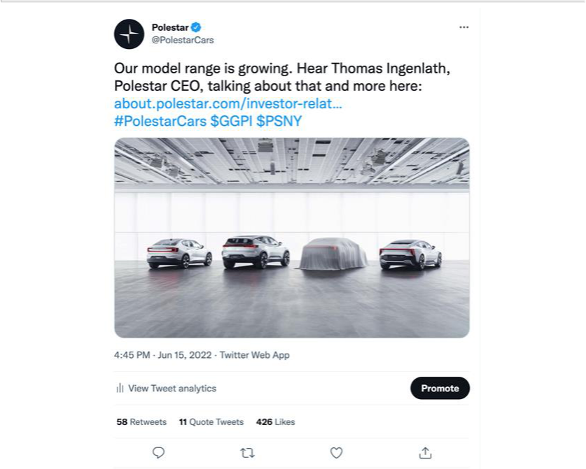

Forward-Looking Statements

Certain statements in this communication (“Communication”) may be considered “forward-looking statements” as defined in the Private Securities Litigation Reform Act of 1995. Forward-looking statements generally relate to future events or the future financial or operating performance of Gores Guggenheim, Inc. (“Gores Guggenheim”), Polestar Performance AB and/or its affiliates (the “Company”) and Polestar Automotive Holding UK PLC (“ListCo”). For example, projections of future Adjusted EBITDA or revenue and other metrics are forward-looking statements. In some cases, you can identify forward-looking statements by terminology such as “may”, “should”, “expect”, “intend”, “will”, “estimate”, “anticipate”, “believe”, “predict”, “potential”, “forecast”, “plan”, “seek”, “future”, “propose” or “continue”, or the negatives of these terms or variations of them or similar terminology. Such forward-looking statements are subject to risks, uncertainties, and other factors which could cause actual results to differ materially from those expressed or implied by such forward looking statements.

These forward-looking statements are based upon estimates and assumptions that, while considered reasonable by Gores Guggenheim and its management, and the Company and its management, as the case may be, are inherently uncertain. Factors that may cause actual results to differ materially from current expectations include, but are not limited to: (1) the occurrence of any event, change or other circumstances that could give rise to the termination of definitive agreements with respect to the proposed business combination between the Company and Gores Guggenheim (the “Business Combination”); (2) the outcome of any legal proceedings that may be instituted against Gores Guggenheim, the combined company or others following the announcement of the Business Combination and any definitive agreements with respect thereto; (3) the inability to complete the Business Combination due to the failure to obtain approval of the stockholders of Gores Guggenheim, to obtain financing to complete the Business Combination or to satisfy other conditions to closing; (4) changes to the proposed structure of the Business Combination that may be required or appropriate as a result of applicable laws or regulations or as a condition to obtaining regulatory approval of the Business Combination; (5) the ability to meet stock exchange listing standards following the consummation of the Business Combination; (6) the risk that the Business Combination disrupts current plans and operations of the Company as a result of the announcement and consummation of the Business Combination; (7) the ability to recognize the anticipated benefits of the Business Combination, which may be affected by, among other things, competition, the ability of the combined company to grow and manage growth profitably, maintain relationships with customers and suppliers and retain its management and key employees; (8) costs related to the Business Combination; (9) risks associated with changes in applicable laws or regulations and the Company’s international operations; (10) the possibility that the Company or the combined company may be adversely affected by other economic, business, and/or competitive factors; (11) the Company’s estimates of expenses and profitability; (12) the Company’s ability to maintain agreements or partnerships with its strategic partners Volvo Cars and Geely and to develop new agreements or partnerships; (13) the Company’s ability to maintain relationships with its existing suppliers and strategic partners, and source new suppliers for its critical components, and to complete building out its supply chain, while effectively managing the risks due to such relationships; (14) the Company’s reliance on its partnerships with vehicle charging networks to provide charging solutions for its vehicles and its strategic partners for servicing its vehicles and their integrated software; (15) the Company’s ability to establish its brand and capture additional market share, and the risks associated with negative press or reputational harm, including from lithium-ion battery cells catching fire or venting smoke; (16) delays in the design, manufacture, launch and financing of the Company’s vehicles and the Company’s reliance on a limited number of vehicle models to generate revenues; (17) the Company’s ability to continuously and rapidly innovate, develop and market new products; (18) risks related to future market adoption of the Company’s offerings; (19) increases in costs, disruption of supply or shortage of materials, in particular

for lithium-ion cells or semiconductors; (20) the Company’s reliance on its partners to manufacture vehicles at a high volume, some of which have limited experience in producing electric vehicles, and on the allocation of sufficient production capacity to the Company by its partners in order for the Company to be able to increase its vehicle production capacities; (21) risks related to the Company’s distribution model; (22) the effects of competition and the high barriers to entry in the automotive industry, and the pace and depth of electric vehicle adoption generally on the Company’s future business;

- changes in regulatory requirements, governmental incentives and fuel and energy prices; (24) the impact of the global COVID-19 pandemic, inflation, interest rate changes, the ongoing conflict between Ukraine and Russia, supply chain disruptions and logistical constraints on Gores Guggenheim, the Company, the Company’s post business combination’s projected results of operations, financial performance or other financial metrics, or on any of the foregoing risks; and (25) other risks and uncertainties set forth in the section entitled “Risk Factors” and “Cautionary Note Regarding Forward-Looking Statements” in Gores Guggenheim’s final prospectus relating to its initial public offering (File No. 333-253338) declared effective by the SEC on March 22, 2021, and other documents filed, or to be filed, with the SEC by Gores Guggenheim or ListCo, including the Definitive Proxy Statement. There may be additional risks that neither Gores Guggenheim, the Company nor ListCo presently know or that Gores Guggenheim, the Company or ListCo currently believe are immaterial that could also cause actual results to differ from those contained in the forward-looking statements.

Nothing in this Communication should be regarded as a representation by any person that the forward-looking statements set forth herein will be achieved or that any of the contemplated results of such forward-looking statements will be achieved. You should not place undue reliance on forward-looking statements, which speak only as of the date they are made. Neither Gores Guggenheim, the Company nor ListCo undertakes any duty to update these forward-looking statements.

Additional Information

In connection with the Business Combination, (a) ListCo has filed with the SEC a registration statement on Form F-4 containing a proxy statement of the Gores Guggenheim and a prospectus, which the SEC declared effective on May 25, 2022 and (b) Gores Guggenheim has filed a definitive proxy statement relating to the Business Combination (the “Definitive Proxy Statement”) and has mailed the Definitive Proxy Statement and other relevant materials to its stockholders and warrant holders, each as of May 18, 2022, the record date established for voting on the Business Combination and the other matters to be voted upon at the Special Meeting and Warrant Holder Meeting. The Definitive Proxy Statement contains important information about the Business Combination and the other matters to be voted upon at the meetings of Gores Guggenheim’s stockholders and warrant holders. This communication does not contain all the information that should be considered concerning the Business Combination and is not intended to form the basis of any investment decision or any other decision in respect of the Business Combination. Before making any voting or other investment decisions, securityholders of Gores Guggenheim and other interested persons are advised to read the Definitive Proxy Statement and other documents filed or to be filed in connection with the Business Combination, as these materials will contain important information about Gores Guggenheim, Polestar, ListCo and the Business Combination. Stockholders will also be able to obtain copies of the Definitive Proxy Statement and other documents filed with the SEC, without charge, once available, at the SEC’s website at www.sec.gov, or by directing a request to: Gores Guggenheim, Inc., 6260 Lookout Rd., Boulder, CO 80301, attention: Jennifer Kwon Chou.

INVESTMENT IN ANY SECURITIES DESCRIBED HEREIN HAS NOT BEEN APPROVED OR DISAPPROVED BY THE SEC OR ANY OTHER REGULATORY AUTHORITY NOR HAS ANY AUTHORITY PASSED UPON OR ENDORSED THE MERITS OF THE OFFERING OR THE ACCURACY OR ADEQUACY OF THE INFORMATION CONTAINED HEREIN. ANY REPRESENTATION TO THE CONTRARY IS A CRIMINAL OFFENSE.

Participants in the Solicitation

Gores Guggenheim and certain of its directors and executive officers may be deemed participants in the solicitation of proxies from Gores Guggenheim’s stockholders with respect to the Business Combination. A list of the names of those directors and executive officers and a description of their interests in Gores Guggenheim is set forth in Gores Guggenheim’s filings with the SEC (including Gores Guggenheim’s final prospectus related to its initial public offering (File No. 333-253338) declared effective by the SEC on March 22, 2021), and are available free of charge at the SEC’s website at www.sec.gov, or by directing a request to Gores Guggenheim, Inc., 6260 Lookout Rd., Boulder, CO 80301, attention: Jennifer Kwon Chou. Additional information regarding the interests of such participants is contained in the Definitive Proxy Statement.

The Company and ListCo, and certain of their directors and executive officers may also be deemed to be participants in the solicitation of proxies from the stockholders of Gores Guggenheim in connection with the Business Combination. A list of the names of such directors and executive officers and information regarding their interests in the Business Combination is included in the Definitive Proxy Statement.

No Offer and Non-Solicitation

This Communication is not a proxy statement or solicitation of a proxy, consent or authorization with respect to any securities or in respect of the potential transaction and shall not constitute an offer to sell or a solicitation of an offer to buy the securities of Gores Guggenheim, the Company or ListCo, nor shall there be any sale of any such securities in any state or jurisdiction in which such offer, solicitation, or sale would be unlawful prior to registration or qualification under the securities laws of such state or jurisdiction. No offer of securities shall be made except by means of a prospectus meeting the requirements of the Securities Act of 1933, as amended.

