SEC Form 3
FORM 3 | UNITED STATES SECURITIES AND EXCHANGE COMMISSION
 | Washington, D.C. 20549
 | Washington, D.C. 20549 |  | OMB APPROVAL
 | INITIAL STATEMENT OF BENEFICIAL OWNERSHIP OF SECURITIES
 | INITIAL STATEMENT OF BENEFICIAL OWNERSHIP OF SECURITIES |  | OMB Number: | 3235-0104
 |  |  | Estimated average burden
 | Filed pursuant to Section 16(a) of the Securities Exchange Act of 1934 |  | hours per response: | 0.5
or Section 30(h) of the Investment Company Act of 1940
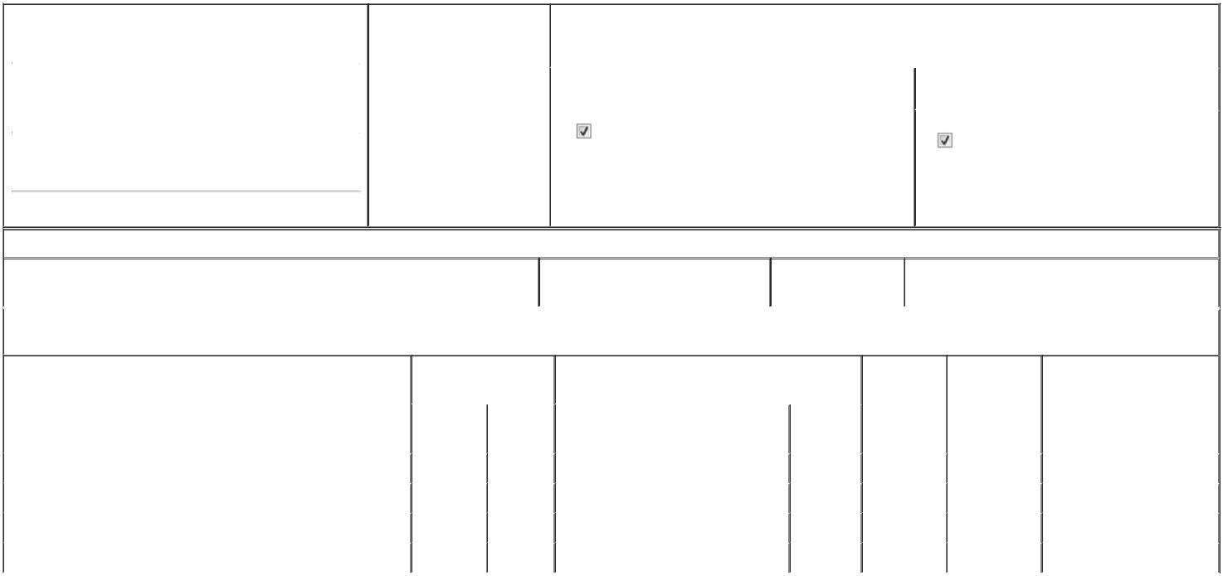

1. Name and Address of Reporting Person* |  |  |  |  |  | 2. Date of Event Requiring
 |  | Dicken Scott Fraser |  |  |  | Statement (Month/Day/Year)
 |  |  |  |  | 03/18/2026
 |  | (Last) | (First) |  | (Middle)
 |  | ASSAR GABRIELSSONS VAG 9
(Street)
 |  | GOTHENBURG | V7 |  | SE-405 31

3. |  | Issuer Name and Ticker or Trading Symbol
Polestar Automotive Holding UK PLC [ PSNY ]
4. |  | Relationship of Reporting Person(s) to Issuer |  |  | 5. | If Amendment, Date of Original Filed (Month/Day/Year)
(Check all applicable)
 |  | Director | 10% Owner
 |  | Director |  |  | 6. | Individual or Joint/Group Filing (Check Applicable Line)
 |  | Officer (give title | Other (specify below) |  | 6. | Individual or Joint/Group Filing (Check Applicable Line)
 |  | below) |  |  |  | Form filed by One Reporting Person
 |  | Chief Commercial Officer |  |  |  | Form filed by More than One Reporting Person

(City) (State) (Zip)

Table I - Non-Derivative Securities Beneficially Owned

 | 1. Title of Security (Instr. 4) | 2. Amount of Securities Beneficially | 3. Ownership Form: | 4. Nature of Indirect Beneficial Ownership (Instr. 5)
 |  | Owned (Instr. 4) | Direct (D) or Indirect
 |  |  | (I) (Instr. 5)

Table II - Derivative Securities Beneficially Owned

(e.g., puts, calls, warrants, options, convertible securities)

 | 1. Title of Derivative Security (Instr. 4) | 2. Date Exercisable and |  | 3. Title and Amount of Securities Underlying |  |  | 4. | 5. Ownership |  | 6. Nature of Indirect Beneficial
 |  | Expiration Date |  | Derivative Security (Instr. 4) |  |  | Conversion | Form: Direct |  | Ownership (Instr. 5)
 |  | (Month/Day/Year) |  |  |  |  | or Exercise | (D) or Indirect
 |  |  |  |  |  |  | Price of | (I) (Instr. 5)
 |  |  |  |  |  | Amount or | Price of
 |  |  |  |  |  | Amount or | Derivative
 |  | Date | Expiration | Title |  | Number of | Security
 |  | Exercisable | Date |  |  | Shares
 | Restricted Stock Units | (1) | (1) | Class A American Depositary Shares |  | 1,224 | (1) |  | D
 | Restricted Stock Units | (2) | (2) | Class A American Depositary Shares |  | 176 | (2) |  | D
 | Restricted Stock Units | (3) | (3) | Class A American Depositary Shares |  | 436 | (3) |  | D
 | Restricted Stock Units | (4) | (4) | Class A American Depositary Shares |  | 1,588 | (4) |  | D
 | Explanation of Responses:
 | 1. Each restricted stock unit ("RSU") represents a contingent right to receive one Class A American Despositary Share. The RSUs will vest on January 20, 2028.
 | 2. Each restricted stock unit ("RSU") represents a contingent right to receive one Class A American Despositary Share. The RSUs will vest on April 3, 2026.
 | 3. Each restricted stock unit ("RSU") represents a contingent right to receive one Class A American Despositary Share. The RSUs will vest on June 1, 2027.
 | 4. Each restricted stock unit ("RSU") represents a contingent right to receive one Class A American Despositary Share. The RSUs will vest on April 1, 2026.
 | Remarks:
 | Exhibit 24 - Power of Attorney
 |  |  |  |  | Chris Bailey-Gates, Attorney-in-fact |  |  |  | 03/18/2026
 |  |  |  |  | ** Signature of Reporting Person |  |  | Date
 | Reminder: Report on a separate line for each class of securities beneficially owned directly or indirectly.
 | * If the form is filed by more than one reporting person, see Instruction 5 (b)(v).
 | ** Intentional misstatements or omissions of facts constitute Federal Criminal Violations See 18 U.S.C. 1001 and 15 U.S.C. 78ff(a).
 | Note: File three copies of this Form, one of which must be manually signed. If space is insufficient, see Instruction 6 for procedure.
 | Persons who respond to the collection of information contained in this form are not required to respond unless the form displays a currently valid OMB Number.



