UNITED STATES
SECURITIES AND EXCHANGE COMMISSION
WASHINGTON, D.C. 20549

FORM 6-K

REPORT OF FOREIGN PRIVATE ISSUER
PURSUANT TO RULE 13a-16 OR 15d-16
UNDER THE SECURITIES EXCHANGE ACT OF 1934
For the month of May 2023
Commission File Number: 001-41431

Polestar Automotive Holding UK PLC

Assar Gabrielssons Väg 9
405 31 Göteborg, Sweden
(Address of principal executive office)

Indicate by check mark whether the registrant files or will file annual reports under cover of Form 20-F or Form 40-F.
Form 20-F ☒ Form 40-F ☐
Indicate by check mark if the registrant is submitting the Form 6-K in paper as permitted by Regulation S-T Rule 101(b)(1): ☐
Indicate by check mark if the registrant is submitting the Form 6-K in paper as permitted by Regulation S-T Rule 101(b)(7): ☐

INFORMATION CONTAINED IN THIS REPORT ON FORM 6-K
On May 11, 2023, Polestar Automotive Holding UK PLC (Polestar) announced its financial results for the first quarter ended March 31, 2023 in a press release that is attached hereto as Exhibit 99.1. A copy of the investor update presentation that was posted on the investor relations website of Polestar in connection with the announcement is attached hereto as Exhibit 99.2.
Also attached as exhibits to this Report on Form 6-K are (i) Polestars Managements Discussion and Analysis of Financial Conditions and Results of Operations for the Three Months Ended March 31, 2023 and 2022, which is attached as Exhibit 99.3; and (ii) Polestars Unaudited Condensed Consolidated Financial Statements as of March 31, 2023 and for the Three Months Ended March 31, 2023 and 2022, which are attached as Exhibit 99.4
The information contained in Exhibit 99.3 and Exhibit 99.4 shall be deemed to be incorporated by reference into Polestars registration statement on Form S-8 (File No: 333-267146) and to be a part thereof from the date on which this report is submitted, to the extent not superseded by documents or reports subsequently filed or furnished. Exhibits 99.1 and 99.2 to this Report on Form 6-K shall not be deemed filed for purposes of Section 18 of the Securities Exchange Act of 1934 (the Exchange Act) or otherwise subject to the liabilities of that section, nor shall they be deemed incorporated by reference in any filing under the Securities Act of 1933 or the Exchange Act.

2

EXHIBIT INDEX

Exhibit No. |  | Description of Exhibit
99.1 |  | Press Release of Polestar Automotive Holding UK PLC, dated May 11, 2023, titled Polestar reports results for first quarter of 2023 and intensifies cost management.
99.2 |  | Investor Update, dated May 11, 2023.
99.3 |  | Managements Discussion and Analysis of Financial Conditions and Results of Operations for the Three Months Ended March 31, 2023 and 2022.
99.4 |  | Unaudited Condensed Consolidated Financial Statements as of March 31, 2023 and for the Three Months Ended March 31, 2023 and 2022.

3

SIGNATURES
Pursuant to the requirements of the Securities Exchange Act of 1934, the registrant has duly caused this report to be signed on its behalf by the undersigned, thereunto duly authorized.

 |  | POLESTAR AUTOMOTIVE HOLDING UK PLC
Date: May 11, 2023 |  | By: |  | /s/ Thomas Ingenlath
 |  | Name: |  | Thomas Ingenlath
 |  | Title: |  | Chief Executive Officer
 |  | By: |  | /s/ Johan Malmqvist
 |  | Name: |  | Johan Malmqvist
 |  | Title: |  | Chief Financial Officer

4
Exhibit 99.1

Polestar reports results for first quarter of 2023 and intensifies cost management
GOTHENBURG, SWEDEN  11 May 2023. Polestar Automotive Holding UK PLC (Polestar or the Company, Nasdaq: PSNY), the Swedish electric performance car brand, reports its results for the three months ended March 31, 2023.
Polestar achieved record first quarter deliveries of 12,076 cars, up 26% year on year and enters the second quarter with good commercial momentum. The Company has experienced strong growth over the past five years establishing a global footprint with over 100,000 cars on the road across 27 markets. It recently launched two new cars  Polestar 3 and Polestar 4  to address the popular SUV segment.
Polestar was recently informed that additional time for final software development of the new all-electric platform shared by Volvo Cars is needed and that the start of production of Polestar 3 is now expected in the first quarter of 2024. In light of this and the economic environment affecting the automotive industry, Polestar now expects 2023 global volumes of 60,000  70,000 vehicles, representing annual growth of 16% - 36%, following record deliveries of 51,491 last year. There is no change to the start of production of Polestar 4, which is expected for China in the fourth quarter of 2023, and for other markets in early 2024.
Polestar is intensifying its focus on cost management, including a global hiring freeze and 10% headcount reduction, driving greater efficiencies across the business.
Thomas Ingenlath, Polestar CEO, comments: We are taking necessary steps to strengthen Polestar in the near-term. While production of Polestar 3 will now start in the first quarter of 2024, the successful launch of Polestar 4 last month means that we add two strong offers in the attractive electric SUV market in 2024. I am confident that we will deliver on our growth ambitions and path towards profitability.
The investor update presentation, Managements Discussion and Analysis of Financial Conditions and Results of Operations and Unaudited Condensed Consolidated Financial Statements, are available on the Polestar investor relations website and will be filed with the SEC.
Polestar management will hold a live audio webcast today, 11 May 2023 at 08:00 EDT (14:00 CEST) to discuss the Companys results and outlook. The live webcast will be available at https://edge.media-server.com/mmc/p/kjynmjj5.
Following the completion of the call, a replay will be available shortly at https://investors.polestar.com/.
Ends.

Contacts
Bojana Flint
Head of Investor Relations
bojana.flint@polestar.com
Tanya Ridd
Global Head of Communications & PR
tanya.ridd@polestar.com
About Polestar
Polestar (Nasdaq: PSNY) is the Swedish electric performance car brand determined to improve society by using design and technology to accelerate the shift to sustainable mobility. Headquartered in Gothenburg, Sweden, its cars are available online in 27 markets globally across North America, Europe and Asia Pacific. The company plans to create a truly climate-neutral production car, without offsetting, by 2030.
Polestar 2 launched in 2019 as the electric performance fastback with avant-garde Scandinavian design and up to 350 kW. Polestar 3 launched in late 2022 as the SUV for the electric age  a large high-performance SUV that delivers sports car dynamics with a low stance and spacious interior. Polestar 4 launched in April 2023 and transforms the aerodynamic of a coupé and the space of an SUV into a new breed of SUV coupé. Polestar plans to release two more electric performance vehicles through to 2026.
Forward-Looking Statements
Certain statements in this press release (Press Release) may be considered forward-looking statements as defined in the Private Securities Litigation Reform Act of 1995. Forward-looking statements generally relate to future events or the future financial or operating performance of Polestar. For example, projections of revenue, volumes and other financial or operating metrics are forward-looking statements. In some cases, you can identify forward-looking statements by terminology such as may, should, expect, intend, will, estimate, anticipate, believe, predict, potential, forecast, plan, seek, future, propose or continue, or the negatives of these terms or variations of them or similar terminology. Such forward-looking statements are subject to risks, uncertainties, and other factors which could cause actual results to differ materially from those expressed or implied by such forward looking statements.
These forward-looking statements are based upon estimates and assumptions that, while considered reasonable by Polestar and its management, as the case may be, are inherently uncertain. Factors that may cause actual results to differ materially from current expectations include, but are not limited to: (1) Polestars ability to maintain agreements or partnerships with its strategic partners, Volvo Cars and Geely, and to develop new agreements or partnerships; (2) Polestars ability to maintain relationships with its existing suppliers, and source new suppliers for its critical components, and to complete building out its supply chain, while effectively managing the risks due to such relationships; (3) Polestars reliance on its partnerships with vehicle charging networks to provide charging solutions for its vehicles and its reliance on strategic partners for servicing its vehicles and their integrated software; (4) Polestars reliance on its partners to manufacture vehicles at a high volume, some of which have limited experience in producing electric vehicles, and on the allocation of sufficient production capacity to Polestar by its partners in order for Polestar to be able to increase its vehicle production capacities; (5) competition, the ability of Polestar to grow and manage growth profitably, maintain relationships with customers and suppliers and retain its management and key employees; (6) Polestars estimates of expenses and profitability; (7) increases in costs, disruption of supply or shortage of materials, in particular for lithium-ion cells or semiconductors, and Polestars ability to implement cost management strategies, including hiring freezes, headcount reductions and improvement of efficiencies across its business; (8) the possibility that Polestar may be adversely affected by other economic, business, and/or competitive factors; (9) the effects of competition and the high barriers to entry in the automotive industry, and the pace and depth of electric vehicle adoption generally on Polestars future business; (10) changes in regulatory requirements, governmental incentives and fuel and energy prices; (11) the outcome of any legal proceedings that may be instituted against Polestar or others; (12) the ability to meet stock exchange

listing standards; (13) risks associated with changes in applicable laws or regulations and with Polestars international operations; (14) Polestars ability to establish its brand and capture additional market share, and the risks associated with negative press or reputational harm, including from lithium-ion battery cells catching fire or venting smoke; (15) delays in the design, manufacture, launch and financing of Polestars vehicles and Polestars reliance on a limited number of vehicle models to generate revenues; (16) Polestars ability to continuously and rapidly innovate, develop and market new products; (17) risks related to future market adoption of Polestars offerings; (18) risks related to Polestars distribution model; (19) the impact of the global COVID-19 pandemic, inflation, interest rate changes, the ongoing conflict between Ukraine and Russia, supply chain disruptions and logistical constraints on Polestar, Polestars projected results of operations, financial performance or other financial and operational metrics, or on any of the foregoing risks; and (20) other risks and uncertainties set forth in the sections entitled Risk Factors and Cautionary Note Regarding Forward-Looking Statements in Polestars Form 20-F, and other documents filed, or to be filed, with the SEC by Polestar. There may be additional risks that Polestar presently does not know or that Polestar currently believes are immaterial that could also cause actual results to differ from those contained in the forward-looking statements.
Nothing in this Press Release should be regarded as a representation by any person that the forward-looking statements set forth herein will be achieved or that any of the contemplated results of such forward-looking statements will be achieved. You should not place undue reliance on forward-looking statements, which speak only as of the date they are made. Polestar assumes no obligation to update these forward-looking statements, even if new information becomes available in the future.
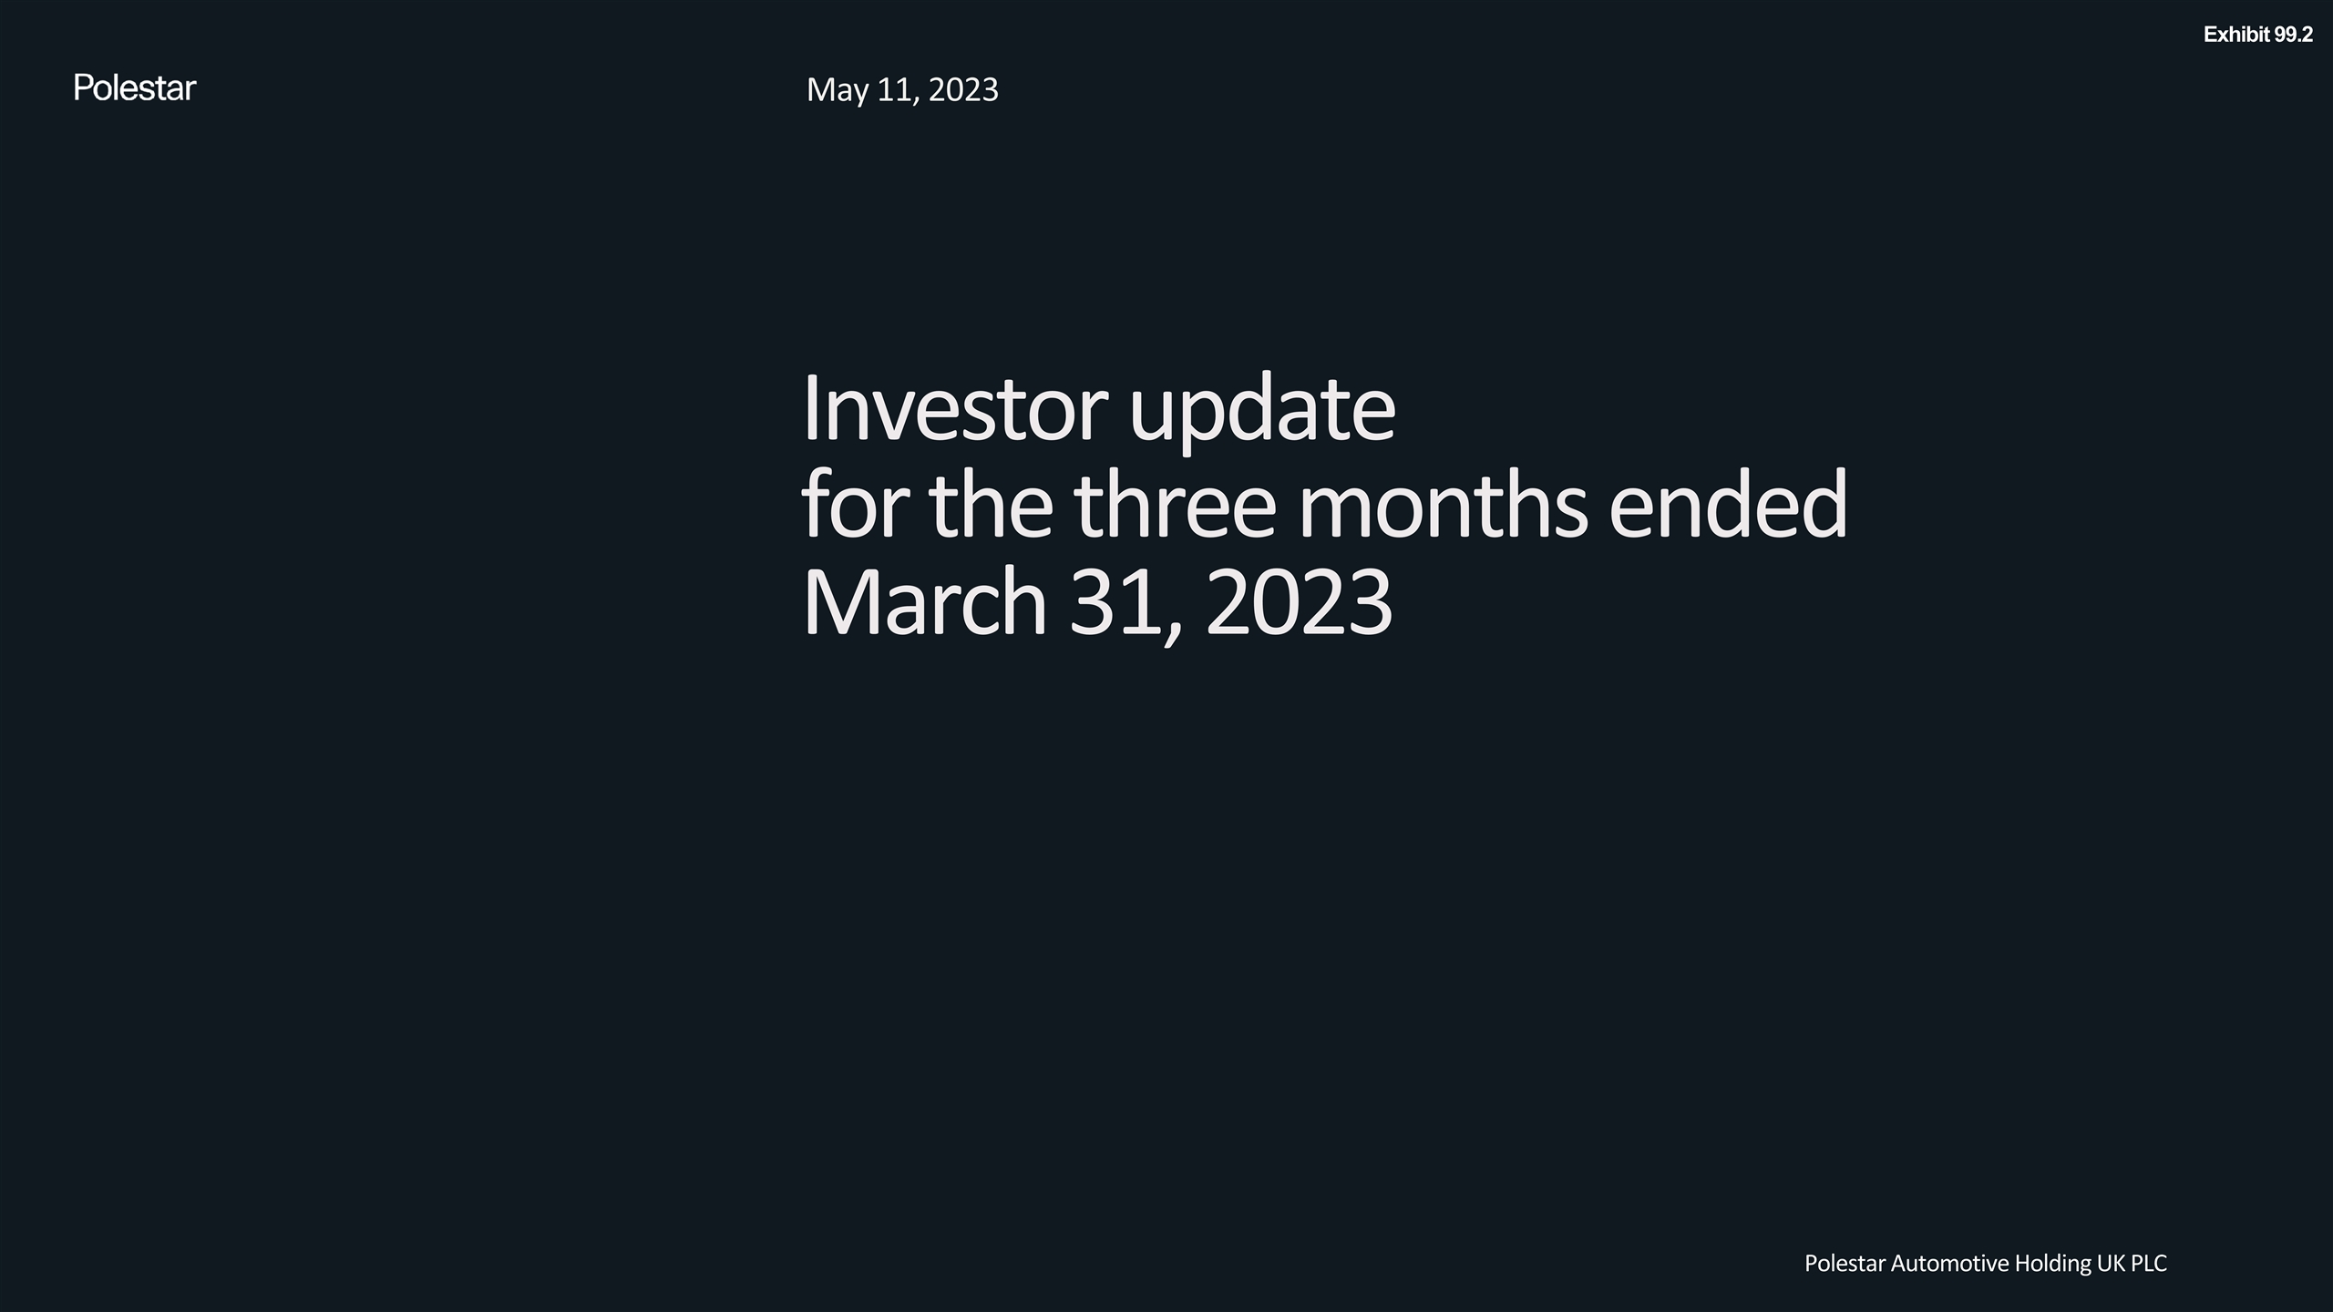
Investor update for the three months ended March 31, 2023 May 11, 2023 Polestar Automotive Holding UK PLC Exhibit 99.2

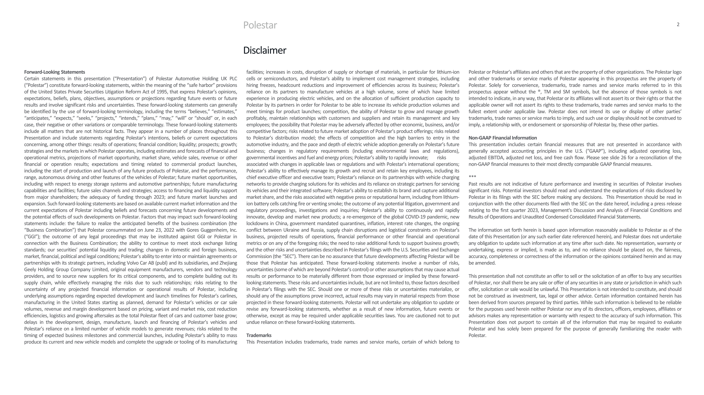
Polestar Disclaimer Forward-Looking Statements Certain statements in this presentation (“Presentation”) of Polestar Automotive Holding UK PLC (“Polestar”) constitute forward-looking statements, within the meaning of the “safe harbor” provisions of the United States Private Securities Litigation Reform Act of 1995, that express Polestar’s opinions, expectations, beliefs, plans, objectives, assumptions or projections regarding future events or future results and involve significant risks and uncertainties. These forward-looking statements can generally be identified by the use of forward-looking terminology, including the terms “believes,” “estimates,” “anticipates,” “expects,” “seeks,” “projects,” “intends,” “plans,” “may,” “will” or “should” or, in each case, their negative or other variations or comparable terminology. These forward-looking statements include all matters that are not historical facts. They appear in a number of places throughout this Presentation and include statements regarding Polestar’s intentions, beliefs or current expectations concerning, among other things: results of operations; financial condition; liquidity; prospects; growth; strategies and the markets in which Polestar operates, including estimates and forecasts of financial and operational metrics, projections of market opportunity, market share, vehicle sales, revenue or other financial or operation results; expectations and timing related to commercial product launches, including the start of production and launch of any future products of Polestar, and the performance, range, autonomous driving and other features of the vehicles of Polestar; future market opportunities, including with respect to energy storage systems and automotive partnerships; future manufacturing capabilities and facilities; future sales channels and strategies; access to financing and liquidity support from major shareholders; the adequacy of funding through 2023; and future market launches and expansion. Such forward-looking statements are based on available current market information and the current expectations of Polestar including beliefs and forecasts concerning future developments and the potential effects of such developments on Polestar. Factors that may impact such forward-looking statements include: the failure to realize the anticipated benefits of the business combination (the “Business Combination”) that Polestar consummated on June 23, 2022 with Gores Guggenheim, Inc. (“GGI”); the outcome of any legal proceedings that may be instituted against GGI or Polestar in connection with the Business Combination; the ability to continue to meet stock exchange listing standards; our securities’ potential liquidity and trading; changes in domestic and foreign business, market, financial, political and legal conditions; Polestar’s ability to enter into or maintain agreements or partnerships with its strategic partners, including Volvo Car AB (publ) and its subsidiaries, and Zhejiang Geely Holding Group Company Limited, original equipment manufacturers, vendors and technology providers, and to source new suppliers for its critical components, and to complete building out its supply chain, while effectively managing the risks due to such relationships; risks relating to the uncertainty of any projected financial information or operational results of Polestar, including underlying assumptions regarding expected development and launch timelines for Polestar’s carlines, manufacturing in the United States starting as planned, demand for Polestar’s vehicles or car sale volumes, revenue and margin development based on pricing, variant and market mix, cost reduction efficiencies, logistics and growing aftersales as the total Polestar fleet of cars and customer base grow; delays in the development, design, manufacture, launch and financing of Polestar’s vehicles and Polestar’s reliance on a limited number of vehicle models to generate revenues; risks related to the timing of expected business milestones and commercial launches, including Polestar’s ability to mass produce its current and new vehicle models and complete the upgrade or tooling of its manufacturing facilities; increases in costs, disruption of supply or shortage of materials, in particular for lithium-ion cells or semiconductors, and Polestar's ability to implement cost management strategies, including hiring freezes, headcount reductions and improvement of efficiencies across its business; Polestar’s reliance on its partners to manufacture vehicles at a high volume, some of which have limited experience in producing electric vehicles, and on the allocation of sufficient production capacity to Polestar by its partners in order for Polestar to be able to increase its vehicle production volumes and meet timings for product launches; competition, the ability of Polestar to grow and manage growth profitably, maintain relationships with customers and suppliers and retain its management and key employees; the possibility that Polestar may be adversely affected by other economic, business, and/or competitive factors; risks related to future market adoption of Polestar’s product offerings; risks related to Polestar’s distribution model; the effects of competition and the high barriers to entry in the automotive industry, and the pace and depth of electric vehicle adoption generally on Polestar’s future business; changes in regulatory requirements (including environmental laws and regulations), governmental incentives and fuel and energy prices; Polestar’s ability to rapidly innovate;risks associated with changes in applicable laws or regulations and with Polestar’s international operations; Polestar’s ability to effectively manage its growth and recruit and retain key employees, including its chief executive officer and executive team; Polestar’s reliance on its partnerships with vehicle charging networks to provide charging solutions for its vehicles and its reliance on strategic partners for servicing its vehicles and their integrated software; Polestar’s ability to establish its brand and capture additional market share, and the risks associated with negative press or reputational harm, including from lithium-ion battery cells catching fire or venting smoke; the outcome of any potential litigation, government and regulatory proceedings, investigations and inquiries; Polestar’s ability to continuously and rapidly innovate, develop and market new products; a re-emergence of the global COVID-19 pandemic, new lockdowns in China, government mandated quarantines, inflation, interest rate changes, the ongoing conflict between Ukraine and Russia, supply chain disruptions and logistical constraints on Polestar’s business, projected results of operations, financial performance or other financial and operational metrics or on any of the foregoing risks; the need to raise additional funds to support business growth; and the other risks and uncertainties described in Polestar’s filings with the U.S. Securities and Exchange Commission (the “SEC”). There can be no assurance that future developments affecting Polestar will be those that Polestar has anticipated. These forward-looking statements involve a number of risks, uncertainties (some of which are beyond Polestar’s control) or other assumptions that may cause actual results or performance to be materially different from those expressed or implied by these forward-looking statements. These risks and uncertainties include, but are not limited to, those factors described in Polestar’s filings with the SEC. Should one or more of these risks or uncertainties materialize, or should any of the assumptions prove incorrect, actual results may vary in material respects from those projected in these forward-looking statements. Polestar will not undertake any obligation to update or revise any forward-looking statements, whether as a result of new information, future events or otherwise, except as may be required under applicable securities laws. You are cautioned not to put undue reliance on these forward-looking statements. Trademarks This Presentation includes trademarks, trade names and service marks, certain of which belong to Polestar or Polestar’s affiliates and others that are the property of other organizations. The Polestar logo and other trademarks or service marks of Polestar appearing in this prospectus are the property of Polestar. Solely for convenience, trademarks, trade names and service marks referred to in this prospectus appear without the ®, TM and SM symbols, but the absence of those symbols is not intended to indicate, in any way, that Polestar or its affiliates will not assert its or their rights or that the applicable owner will not assert its rights to these trademarks, trade names and service marks to the fullest extent under applicable law. Polestar does not intend its use or display of other parties’ trademarks, trade names or service marks to imply, and such use or display should not be construed to imply, a relationship with, or endorsement or sponsorship of Polestar by, these other parties. Non-GAAP Financial Information This presentation includes certain financial measures that are not presented in accordance with generally accepted accounting principles in the U.S. (“GAAP”), including adjusted operating loss, adjusted EBITDA, adjusted net loss, and free cash flow. Please see slide 26 for a reconciliation of the non-GAAP financial measures to their most directly comparable GAAP financial measures. *** Past results are not indicative of future performance and investing in securities of Polestar involves significant risks. Potential investors should read and understand the explanations of risks disclosed by Polestar in its filings with the SEC before making any decisions. This Presentation should be read in conjunction with the other documents filed with the SEC on the date hereof, including a press release relating to the first quarter 2023, Management's Discussion and Analysis of Financial Conditions and Results of Operations and Unaudited Condensed Consolidated Financial Statements. The information set forth herein is based upon information reasonably available to Polestar as of the date of this Presentation (or any such earlier date referenced herein), and Polestar does not undertake any obligation to update such information at any time after such date. No representation, warranty or undertaking, express or implied, is made as to, and no reliance should be placed on, the fairness, accuracy, completeness or correctness of the information or the opinions contained herein and as may be amended. This presentation shall not constitute an offer to sell or the solicitation of an offer to buy any securities of Polestar, nor shall there be any sale or offer of any securities in any state or jurisdiction in which such offer, solicitation or sale would be unlawful. This Presentation is not intended to constitute, and should not be construed as investment, tax, legal or other advice. Certain information contained herein has been derived from sources prepared by third parties. While such information is believed to be reliable for the purposes used herein neither Polestar nor any of its directors, officers, employees, affiliates or advisors makes any representation or warranty with respect to the accuracy of such information. This Presentation does not purport to contain all of the information that may be required to evaluate Polestar and has solely been prepared for the purpose of generally familiarizing the reader with Polestar.


Polestar

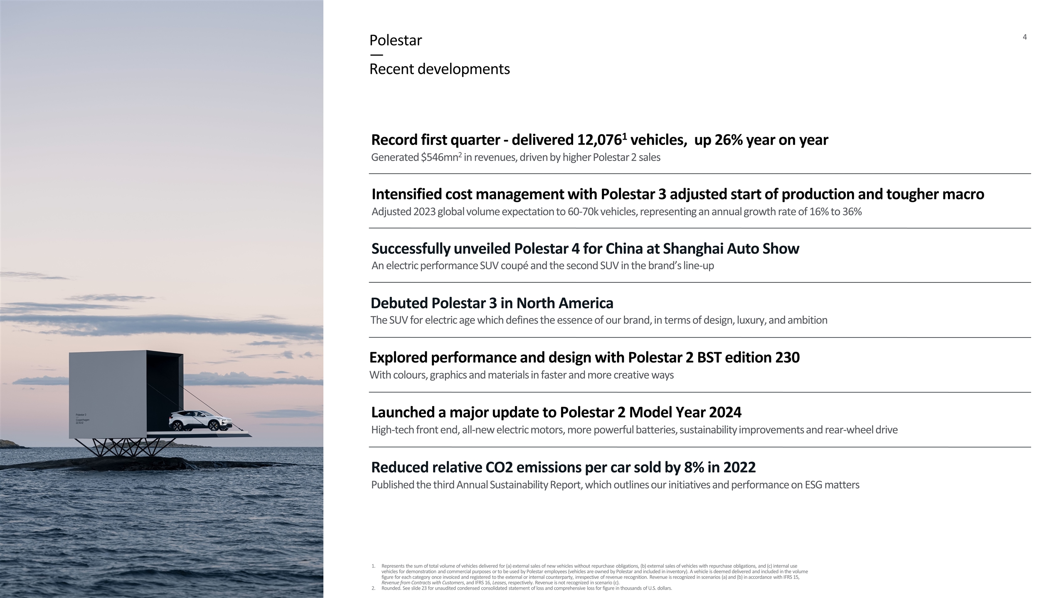
Debuted Polestar 3 in North America The SUV for electric age which defines the essence of our brand, in terms of design, luxury, and ambition Polestar — Recent developments Reduced relative CO2 emissions per car sold by 8% in 2022 Published the third Annual Sustainability Report, which outlines our initiatives and performance on ESG matters Record first quarter - delivered 12,0761 vehicles, up 26% year on year Generated $546mn2 in revenues, driven by higher Polestar 2 sales Represents the sum of total volume of vehicles delivered for (a) external sales of new vehicles without repurchase obligations, (b) external sales of vehicles with repurchase obligations, and (c) internal use vehicles for demonstration and commercial purposes or to be used by Polestar employees (vehicles are owned by Polestar and included in inventory). A vehicle is deemed delivered and included in the volume figure for each category once invoiced and registered to the external or internal counterparty, irrespective of revenue recognition. Revenue is recognized in scenarios (a) and (b) in accordance with IFRS 15, Revenue from Contracts with Customers, and IFRS 16, Leases, respectively. Revenue is not recognized in scenario (c). Rounded. See slide 23 for unaudited condensed consolidated statement of loss and comprehensive loss for figure in thousands of U.S. dollars. Explored performance and design with Polestar 2 BST edition 230 With colours, graphics and materials in faster and more creative ways Successfully unveiled Polestar 4 for China at Shanghai Auto Show An electric performance SUV coupé and the second SUV in the brand’s line-up Launched a major update to Polestar 2 Model Year 2024 High-tech front end, all-new electric motors, more powerful batteries, sustainability improvements and rear-wheel drive Intensified cost management with Polestar 3 adjusted start of production and tougher macro Adjusted 2023 global volume expectation to 60-70k vehicles, representing an annual growth rate of 16% to 36%

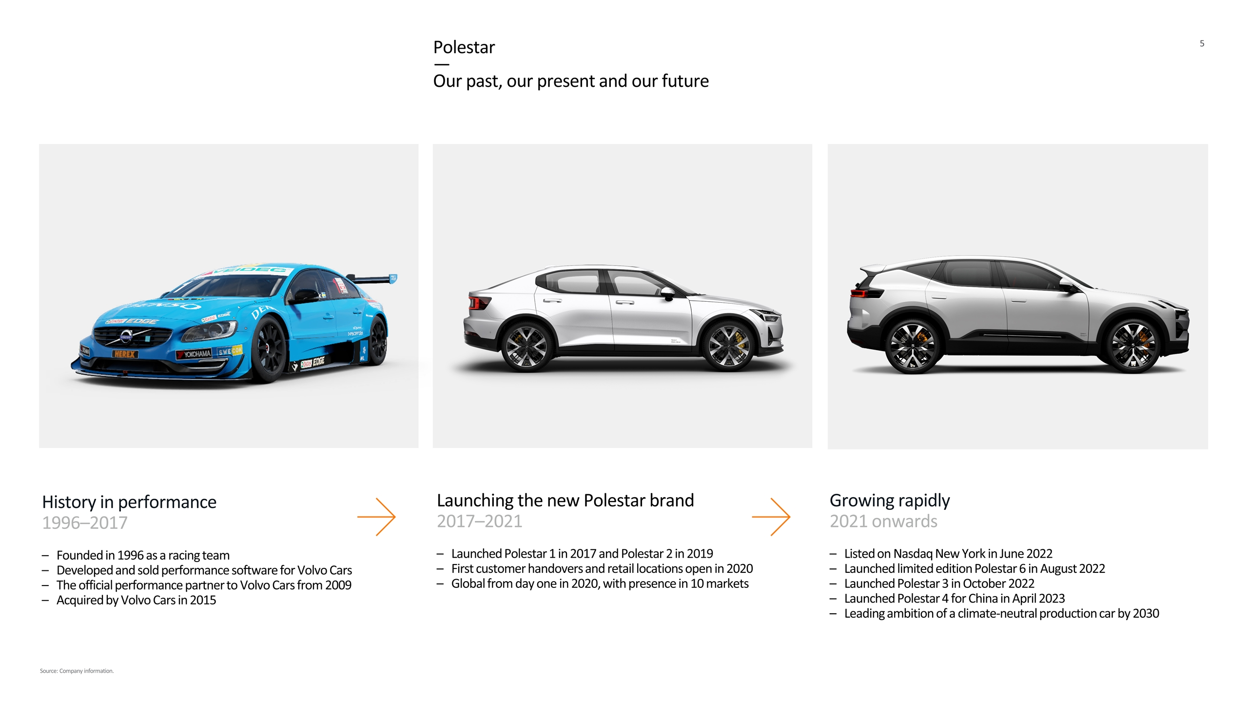
Polestar — Our past, our present and our future History in performance 1996–2017 Founded in 1996 as a racing team Developed and sold performance software for Volvo Cars The official performance partner to Volvo Cars from 2009 Acquired by Volvo Cars in 2015 Launching the new Polestar brand 2017–2021 Launched Polestar 1 in 2017 and Polestar 2 in 2019 First customer handovers and retail locations open in 2020 Global from day one in 2020, with presence in 10 markets Growing rapidly 2021 onwards Listed on Nasdaq New York in June 2022 Launched limited edition Polestar 6 in August 2022 Launched Polestar 3 in October 2022 Launched Polestar 4 for China in April 2023 Leading ambition of a climate-neutral production car by 2030 Source: Company information.

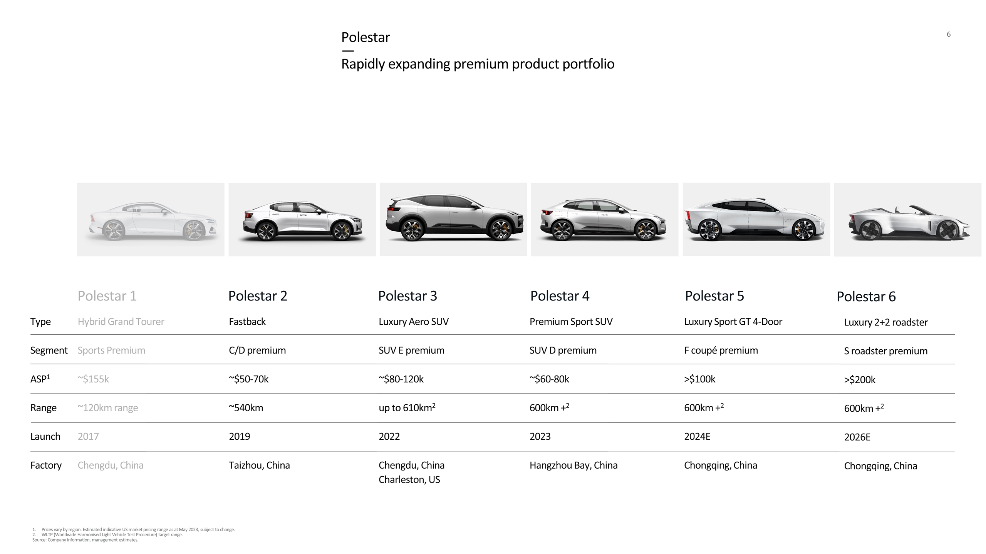
Polestar 1 Polestar 2 Polestar 3 Polestar 4 Polestar 5 Type Segment ASP1 Range Launch Factory Hybrid Grand Tourer Sports Premium ~$155k ~120km range 2017 Chengdu, China Fastback C/D premium ~$50-70k ~540km 2019 Taizhou, China Luxury Aero SUV SUV E premium ~$80-120k up to 610km2 2022 Chengdu, China Charleston, US Premium Sport SUV SUV D premium ~$60-80k 600km +2 2023 Hangzhou Bay, China Luxury Sport GT 4-Door F coupé premium >$100k 600km +2 2024E Chongqing, China Polestar — Rapidly expanding premium product portfolio Polestar 6 Luxury 2+2 roadster S roadster premium >$200k 600km +2 2026E Chongqing, China Prices vary by region. Estimated indicative US market pricing range as at May 2023, subject to change. WLTP (Worldwide Harmonised Light Vehicle Test Procedure) target range. Source: Company information, management estimates.

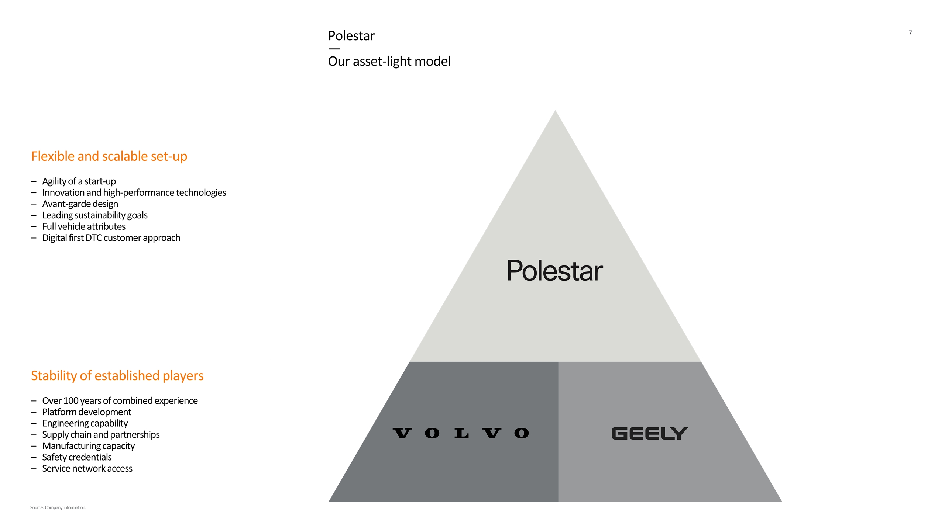
Flexible and scalable set-up Agility of a start-up Innovation and high-performance technologies Avant-garde design Leading sustainability goals Full vehicle attributes Digital first DTC customer approach Stability of established players Over 100 years of combined experience Platform development Engineering capability Supply chain and partnerships Manufacturing capacity Safety credentials Service network access Source: Company information. Polestar — Our asset-light model

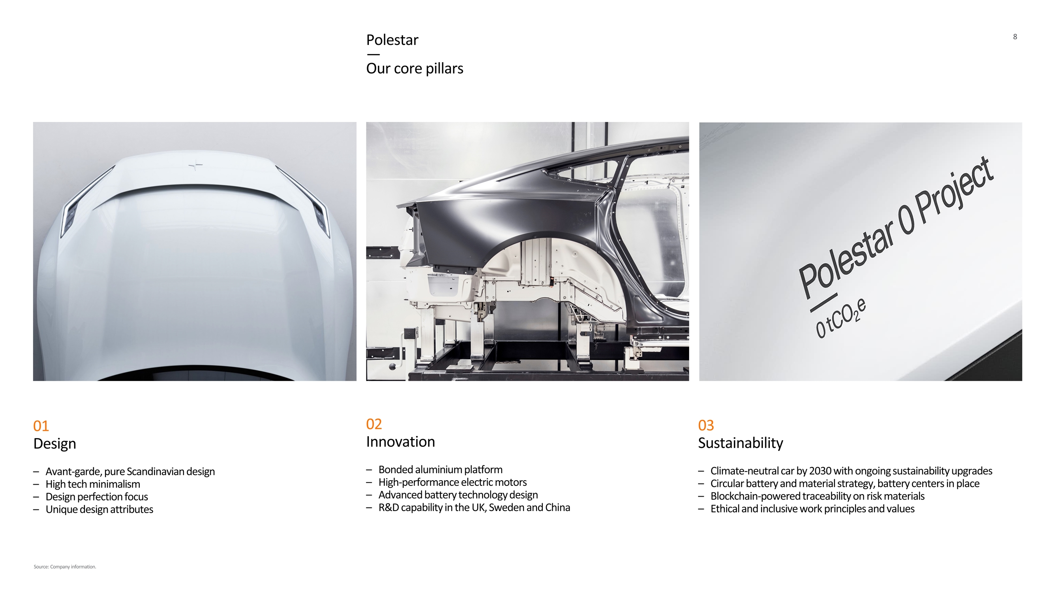
01 Design Avant-garde, pure Scandinavian design High tech minimalism Design perfection focus Unique design attributes 03 Sustainability Climate-neutral car by 2030 with ongoing sustainability upgrades Circular battery and material strategy, battery centers in place Blockchain-powered traceability on risk materials Ethical and inclusive work principles and values 02 Innovation Bonded aluminium platform High-performance electric motors Advanced battery technology design R&D capability in the UK, Sweden and China Polestar — Our core pillars Source: Company information.

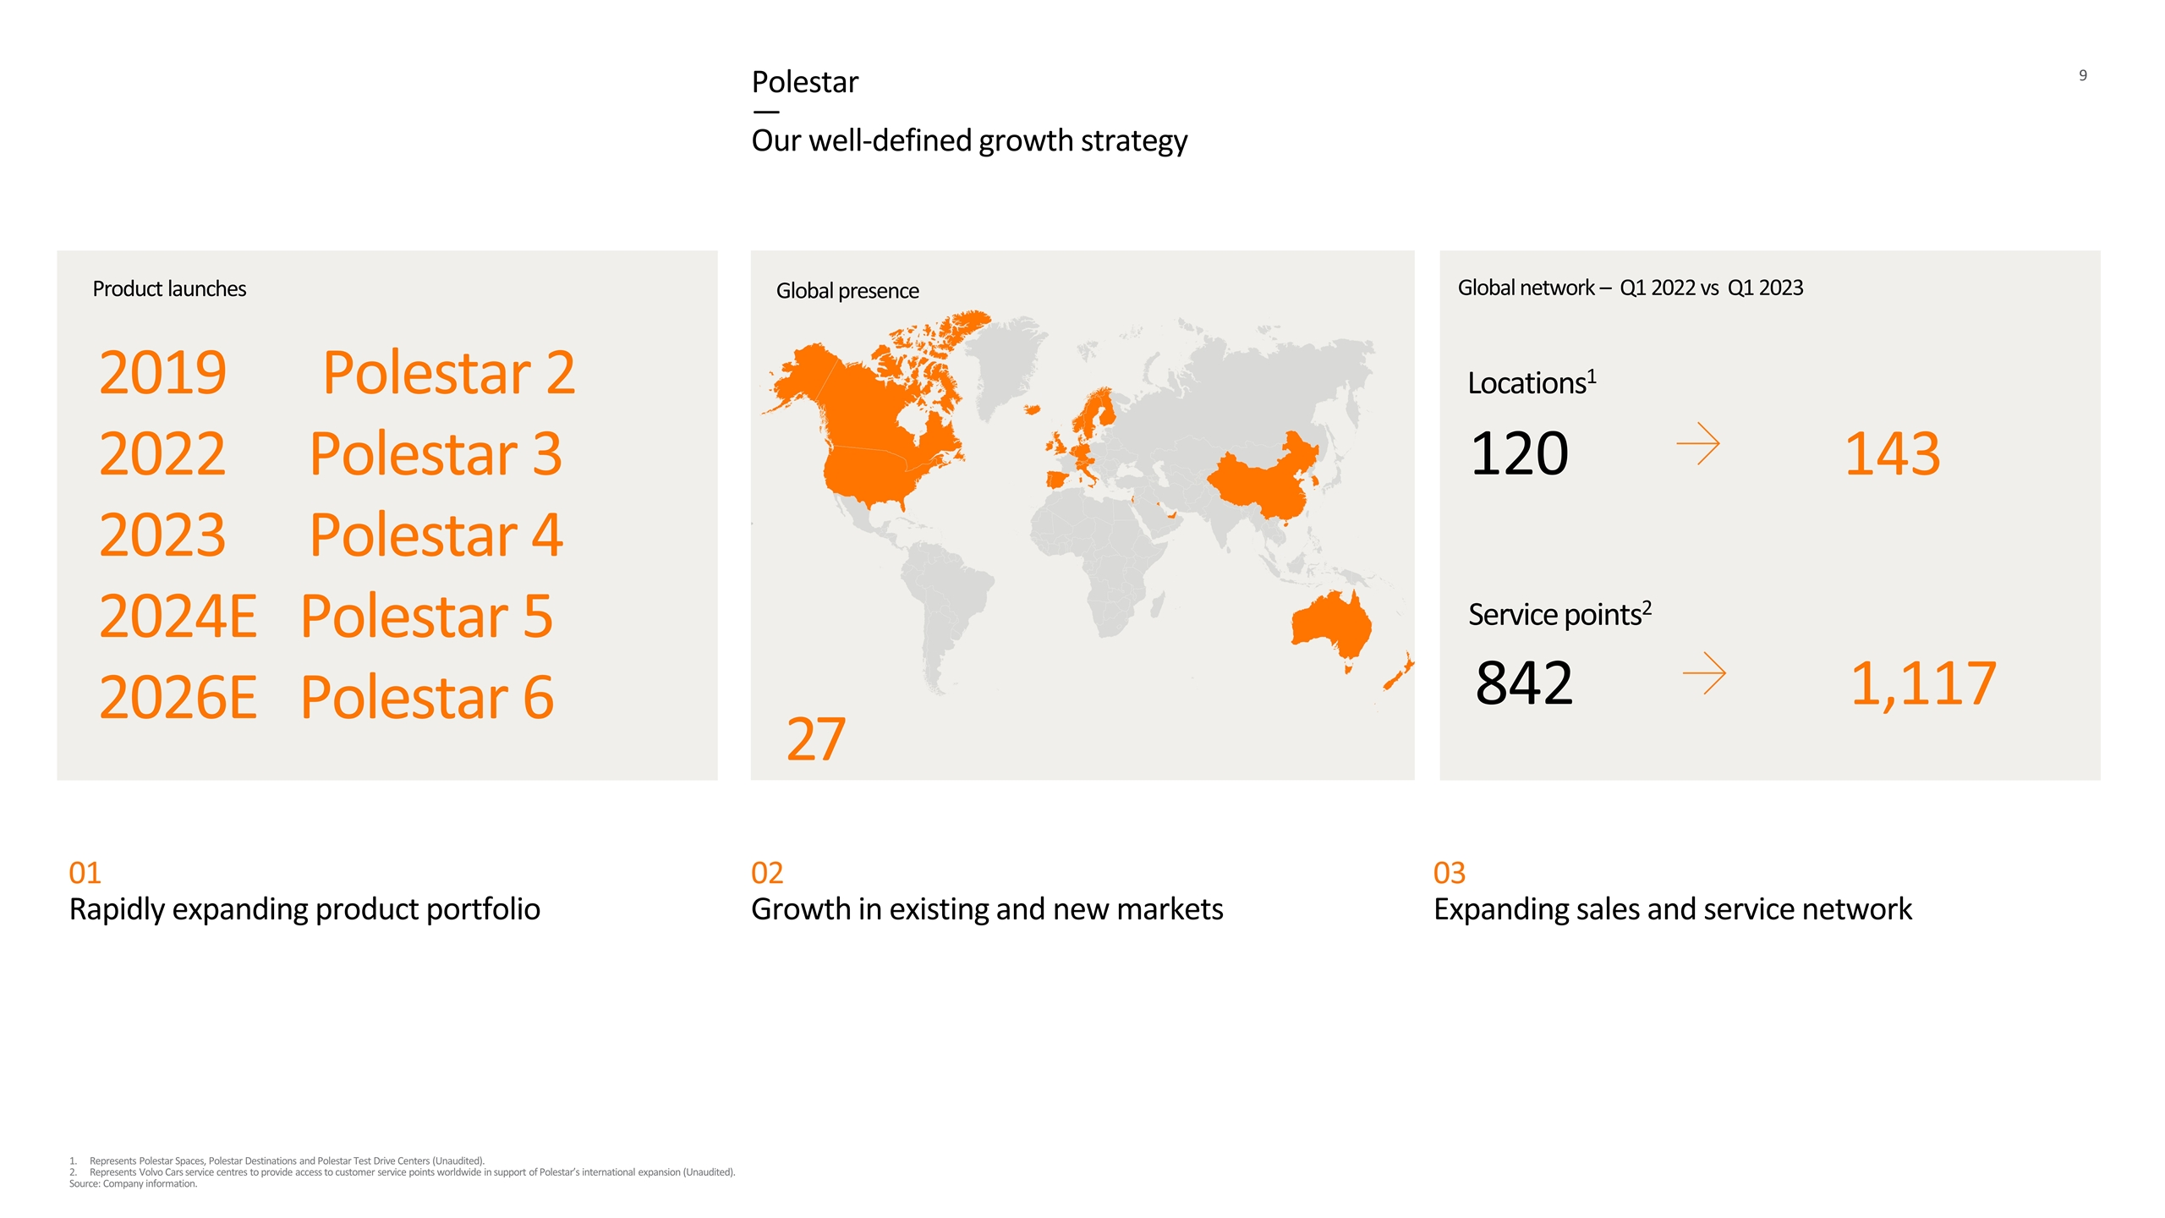
01 Rapidly expanding product portfolio 02 Growth in existing and new markets 03 Expanding sales and service network Polestar — Our well-defined growth strategy 2019 Polestar 2 2022 Polestar 3 2023 Polestar 4 2024E Polestar 5 2026E Polestar 6 Product launches Global network – Q1 2022 vs Q1 2023 Global presence 27 Represents Polestar Spaces, Polestar Destinations and Polestar Test Drive Centers (Unaudited). Represents Volvo Cars service centres to provide access to customer service points worldwide in support of Polestar’s international expansion (Unaudited). Source: Company information. Locations1 143 120 Service points2 1,117 842

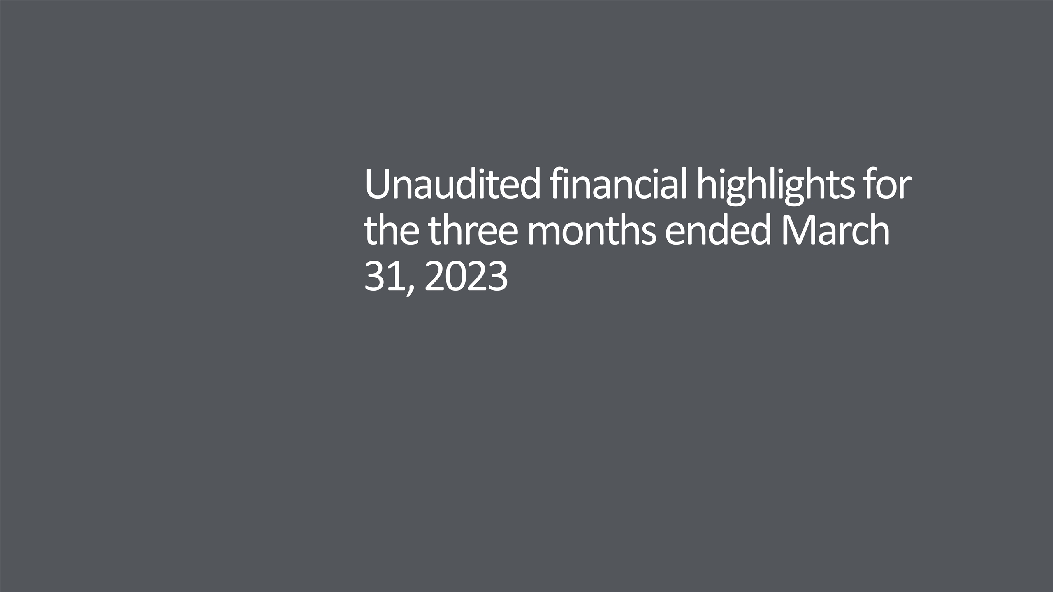
Unaudited financial highlights for the three months ended March 31, 2023

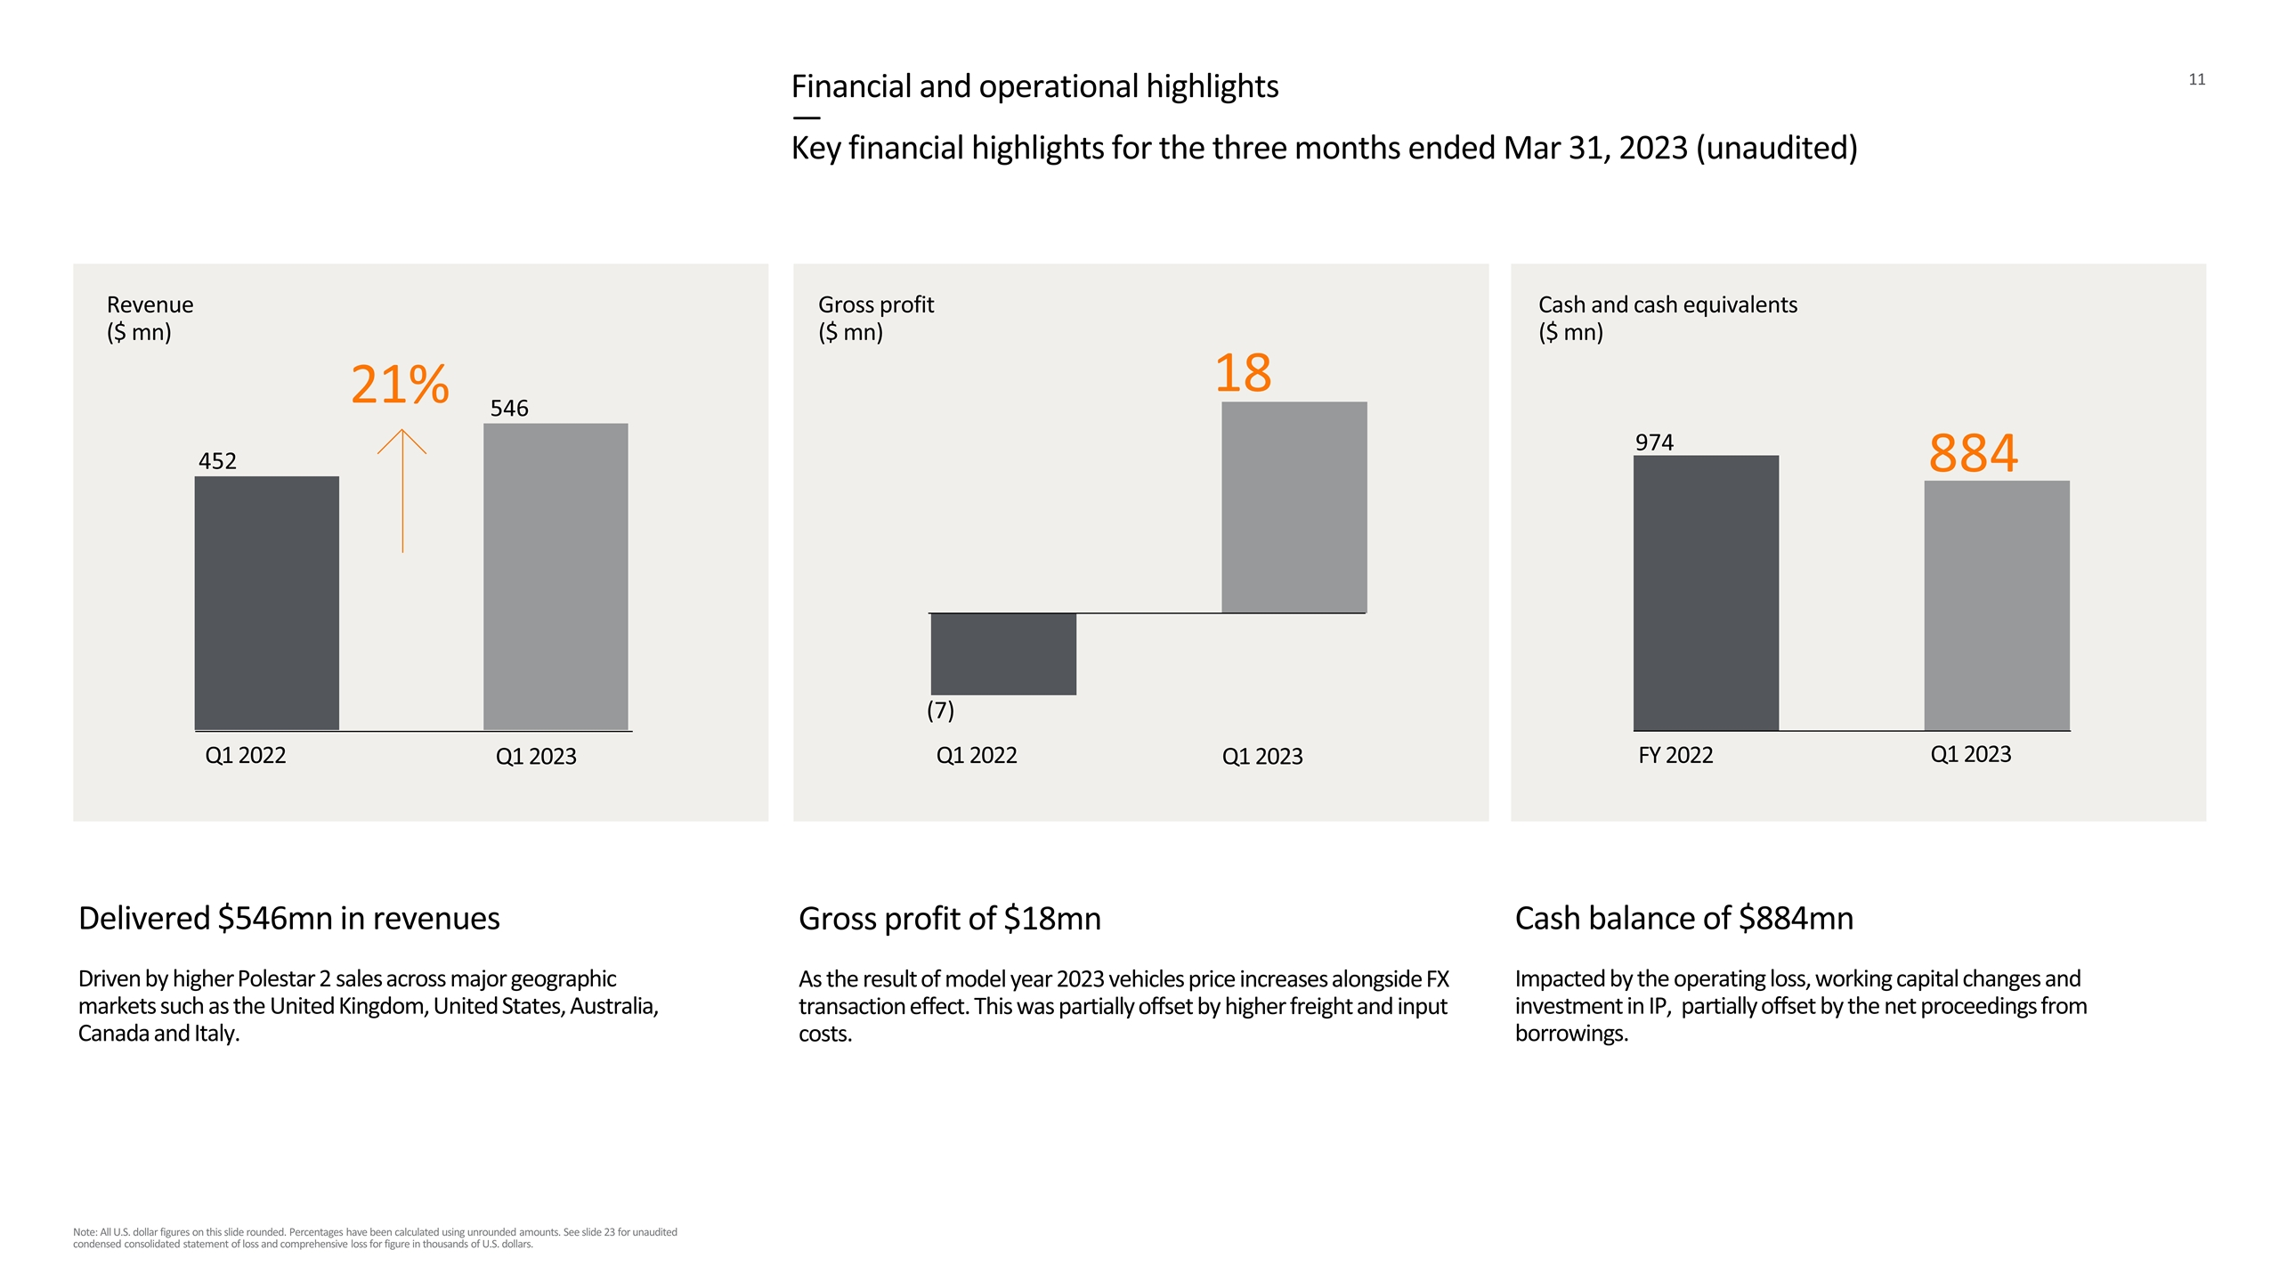
Financial and operational highlights — Key financial highlights for the three months ended Mar 31, 2023 (unaudited) Revenue ($ mn) Gross profit ($ mn) Q1 2022 Q1 2023 546 452 Q1 2022 Q1 2023 (7) 21% Gross profit of $18mn As the result of model year 2023 vehicles price increases alongside FX transaction effect. This was partially offset by higher freight and input costs. Delivered $546mn in revenues Driven by higher Polestar 2 sales across major geographic markets such as the United Kingdom, United States, Australia, Canada and Italy. Cash and cash equivalents ($ mn) FY 2022 884 974 Cash balance of $884mn Impacted by the operating loss, working capital changes and investment in IP, partially offset by the net proceedings from borrowings. Q1 2023 18 Note: All U.S. dollar figures on this slide rounded. Percentages have been calculated using unrounded amounts. See slide 23 for unaudited condensed consolidated statement of loss and comprehensive loss for figure in thousands of U.S. dollars.

Financial and operational highlights — Key financial highlights for the three months ended Mar 31, 2023 (unaudited) US$ million Q1 2023 Q1 2022 % Change Revenue 546 452 21 Cost of sales (528) (459) 15 Gross profit (loss) 18 (7) n/m Gross margin (%) 3.4 (1.6) n/m SG&A expense (189) (213) (11) R&D expenses (36) (32) 11 Other operating income (expense), net 7 (6) n/m Operating loss (199) (258) (23) Note: All U.S. dollar figures on this slide rounded. Percentages have been calculated using unrounded amounts. See slide 23 for unaudited condensed consolidated statement of loss and comprehensive loss for figure in thousands of U.S. dollars. Revenue up 21% Driven by higher Polestar 2 sales across major geographic markets Gross profit up $25mn With vehicle price increases alongside FX transaction effects, partially offset by higher freight and input costs SG&A down 11% With active cost management R&D up $4mn With continued product development for future vehicles and technologies Operating loss reduced by c.$60mn Benefiting from higher gross profit and active cost management

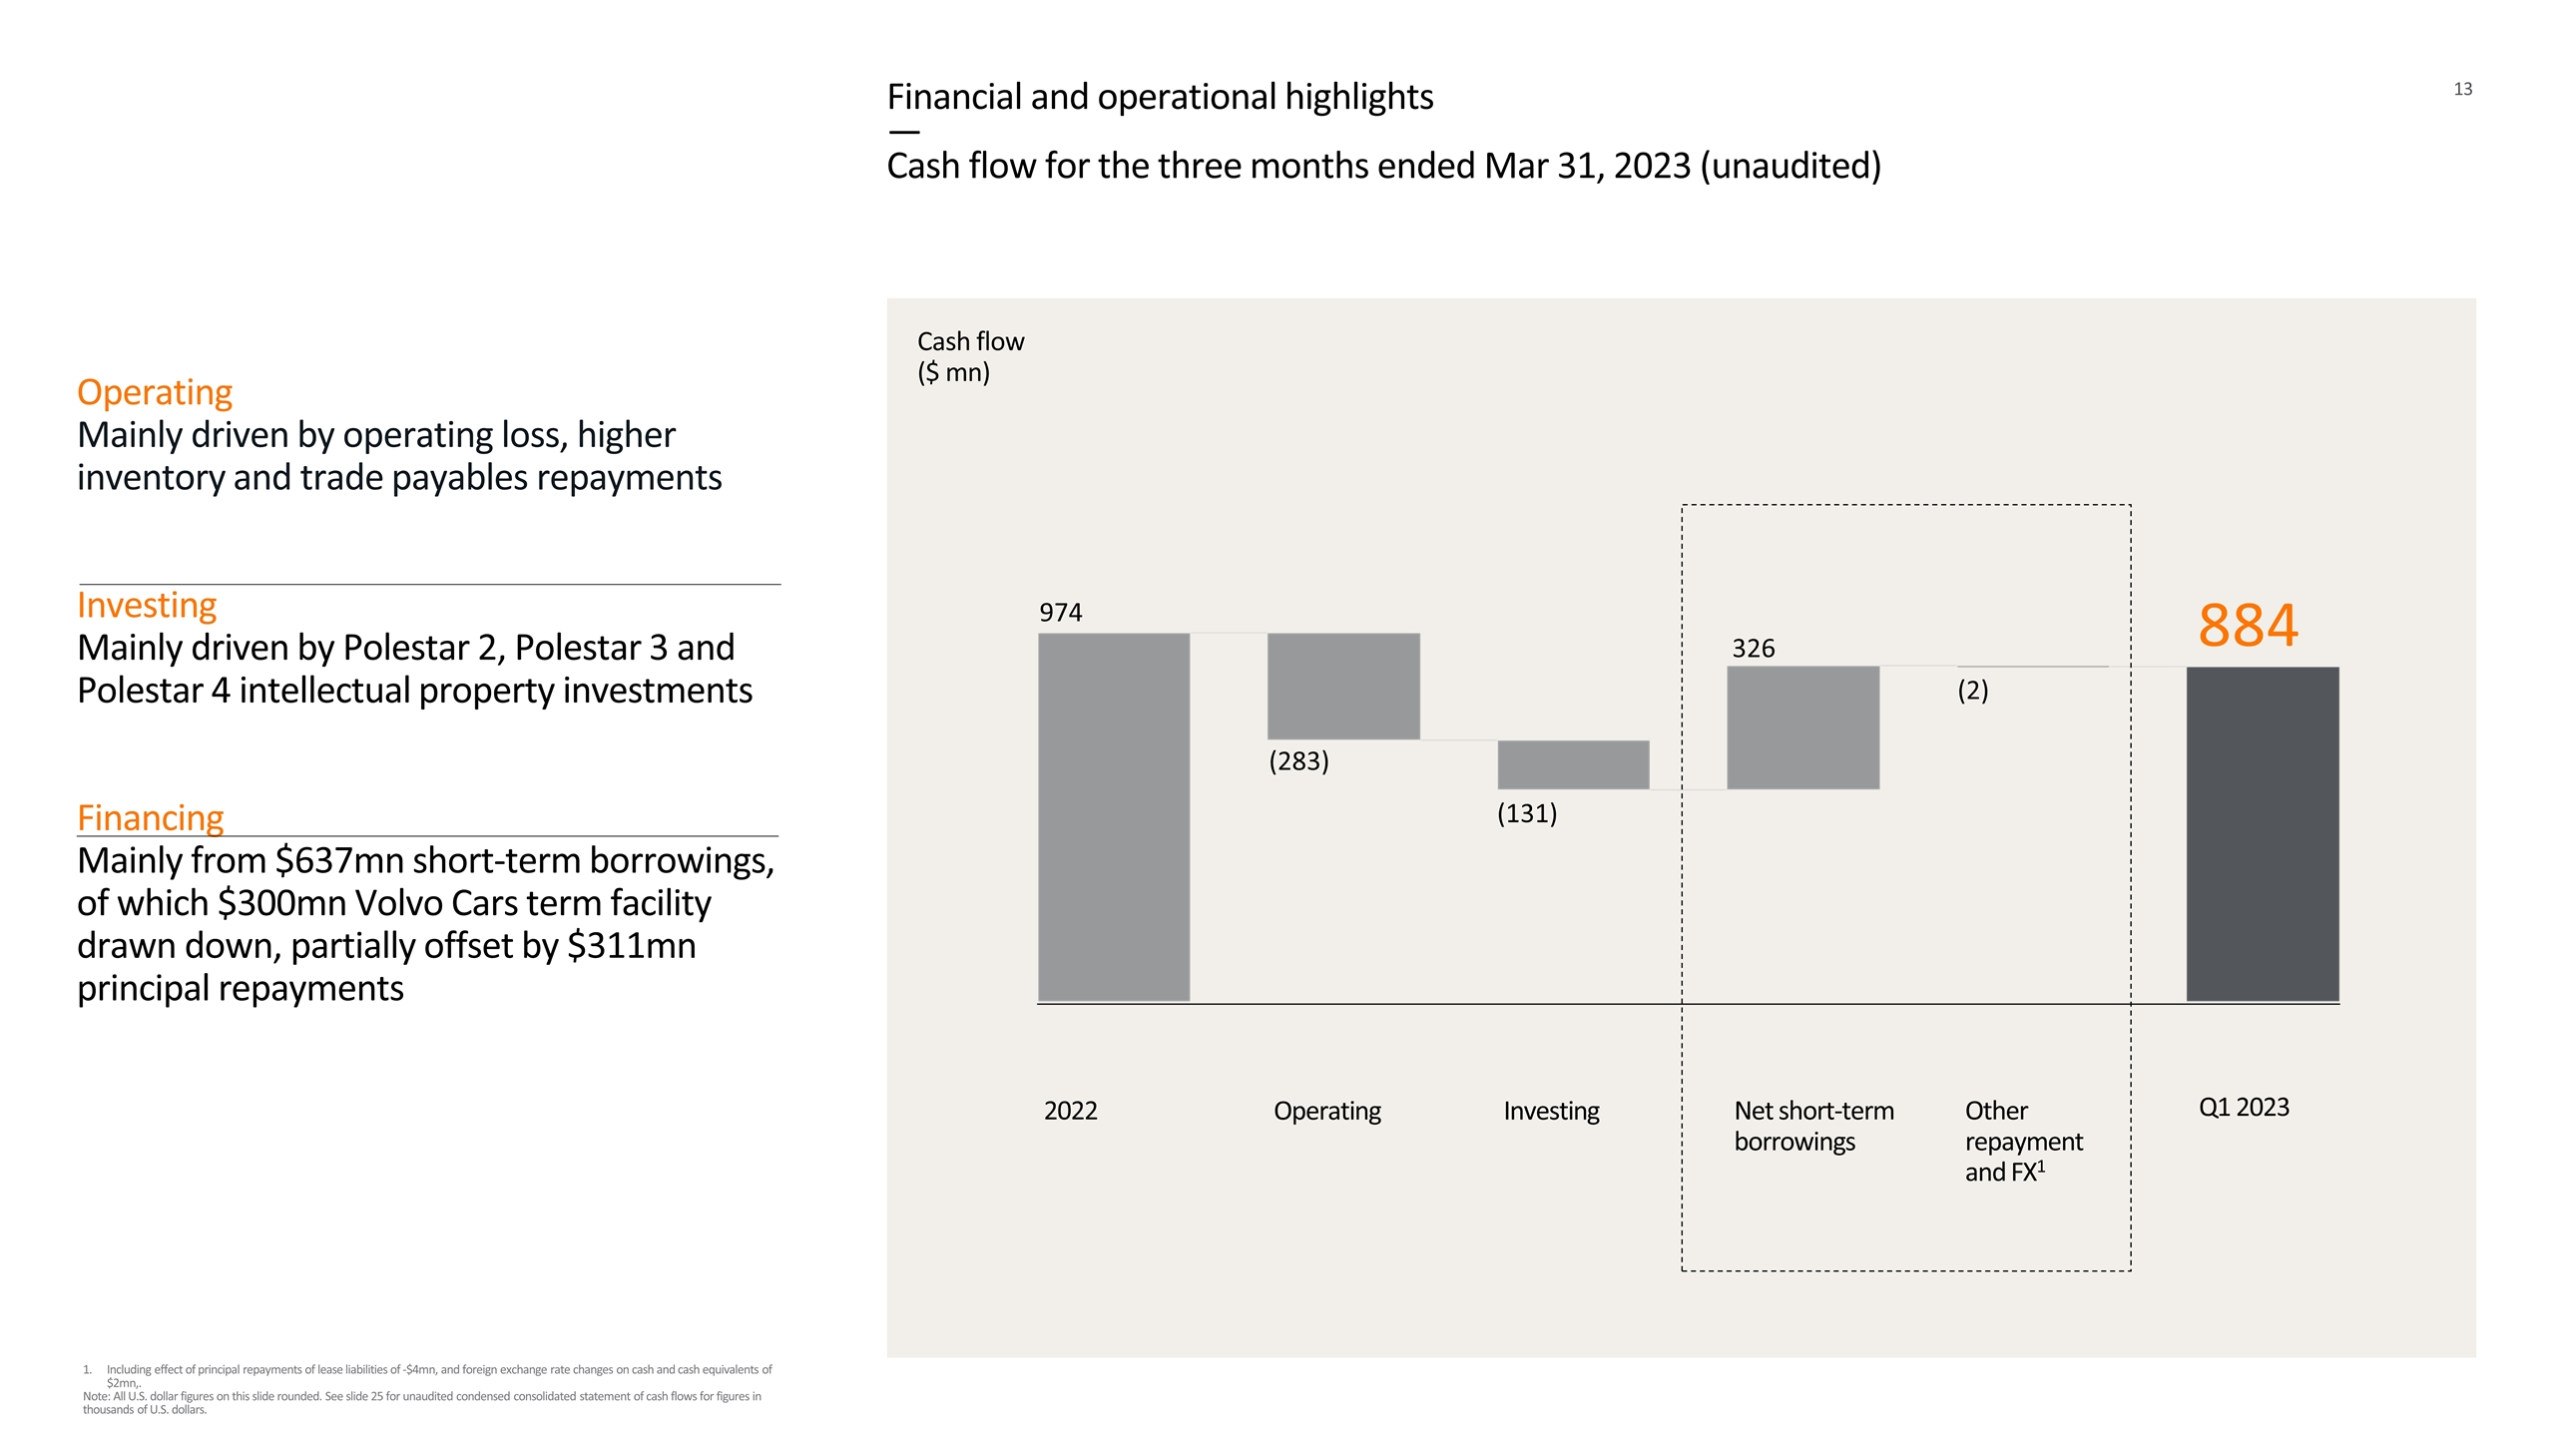
Financial and operational highlights — Cash flow for the three months ended Mar 31, 2023 (unaudited) Cash flow ($ mn) 2022 Operating Investing Other repayment and FX1 Q1 2023 Operating Mainly driven by operating loss, higher inventory and trade payables repayments Investing Mainly driven by Polestar 2, Polestar 3 and Polestar 4 intellectual property investments Financing Mainly from $637mn short-term borrowings, of which $300mn Volvo Cars term facility drawn down, partially offset by $311mn principal repayments Net short-term borrowings Including effect of principal repayments of lease liabilities of -$4mn, and foreign exchange rate changes on cash and cash equivalents of $2mn,. Note: All U.S. dollar figures on this slide rounded. See slide 25 for unaudited condensed consolidated statement of cash flows for figures in thousands of U.S. dollars. 326 (2) 884 (131) (283) 974

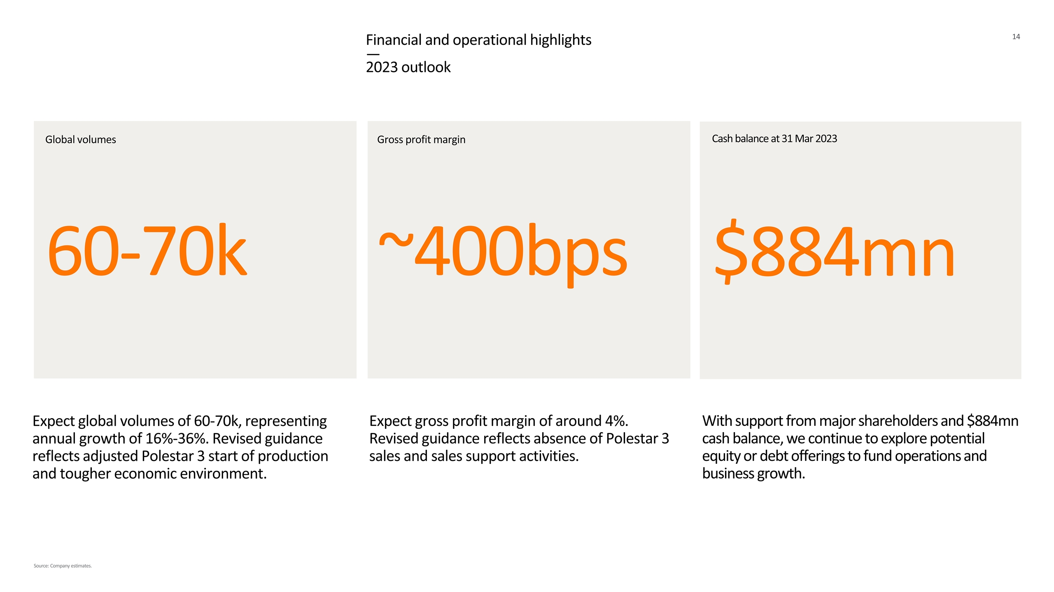
Financial and operational highlights — 2023 outlook Cash balance at 31 Mar 2023 Global volumes Gross profit margin 60-70k With support from major shareholders and $884mn cash balance, we continue to explore potential equity or debt offerings to fund operations and business growth. Expect global volumes of 60-70k, representing annual growth of 16%-36%. Revised guidance reflects adjusted Polestar 3 start of production and tougher economic environment. Expect gross profit margin of around 4%. Revised guidance reflects absence of Polestar 3 sales and sales support activities. $884mn Source: Company estimates. ~400bps


Imagery

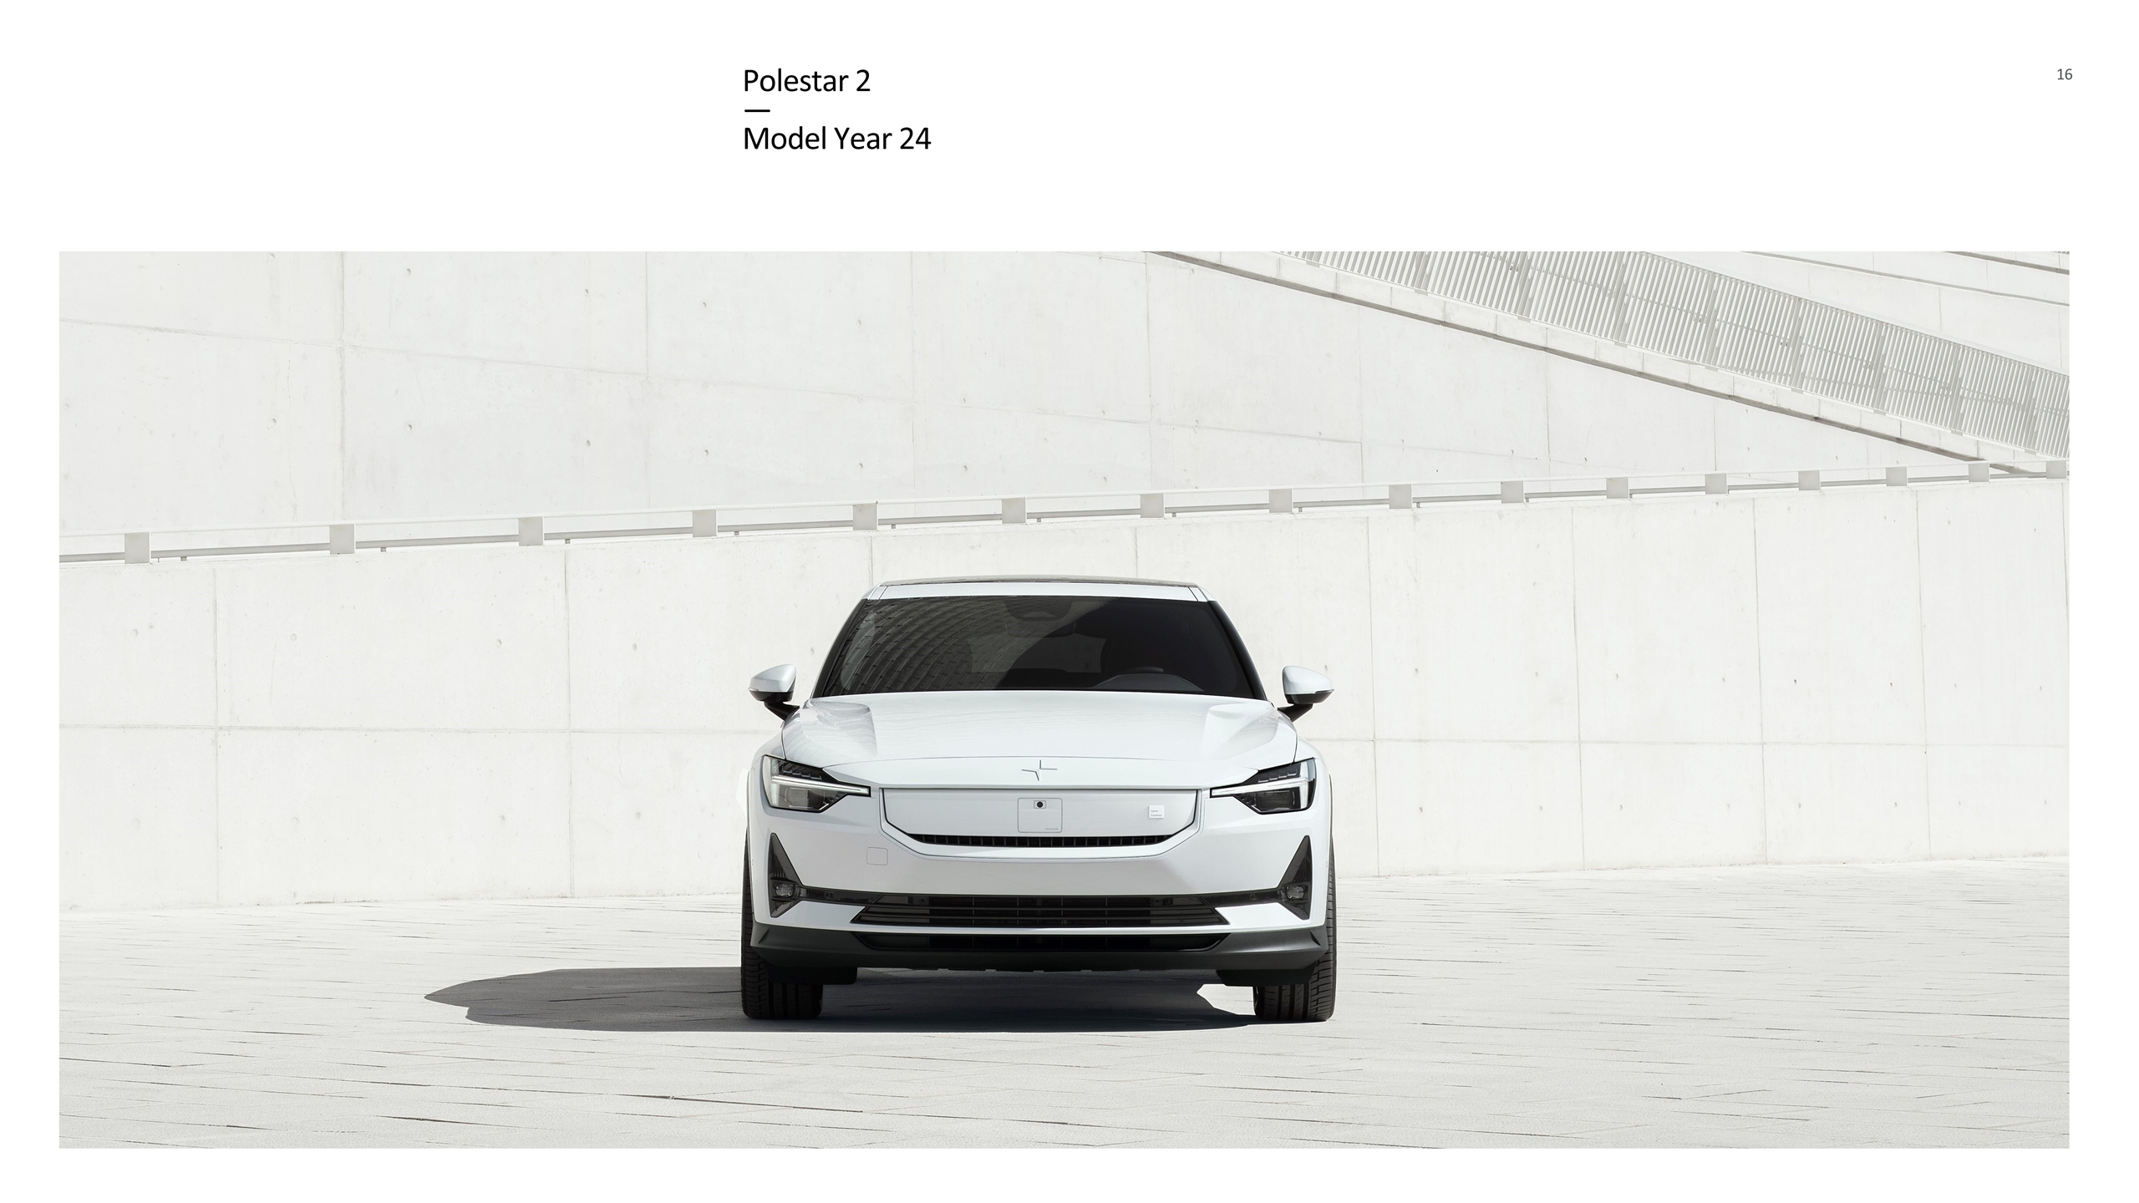
Polestar 2 — Model Year 24

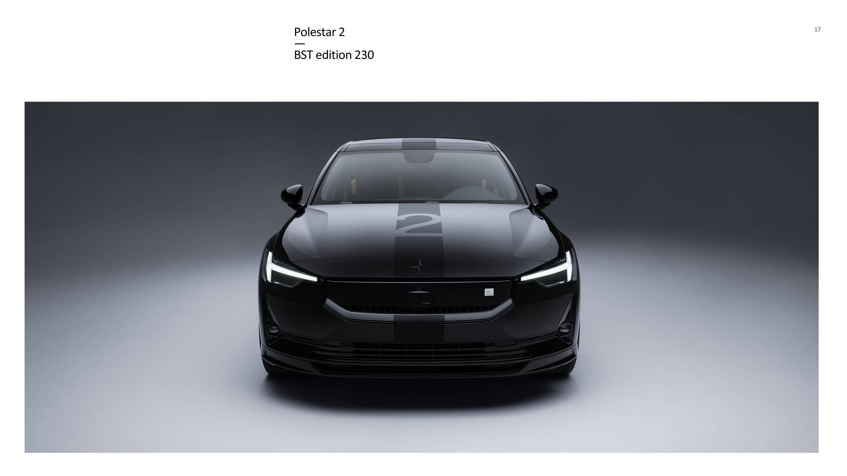
Polestar 2 — BST edition 230

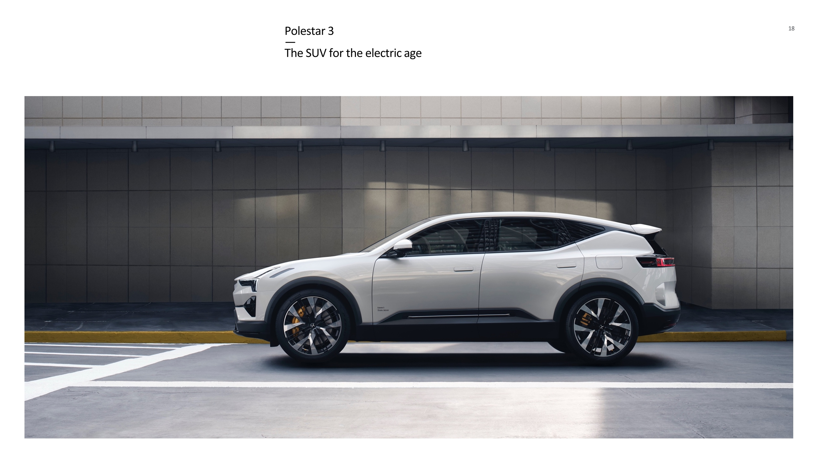
Polestar 3 — The SUV for the electric age

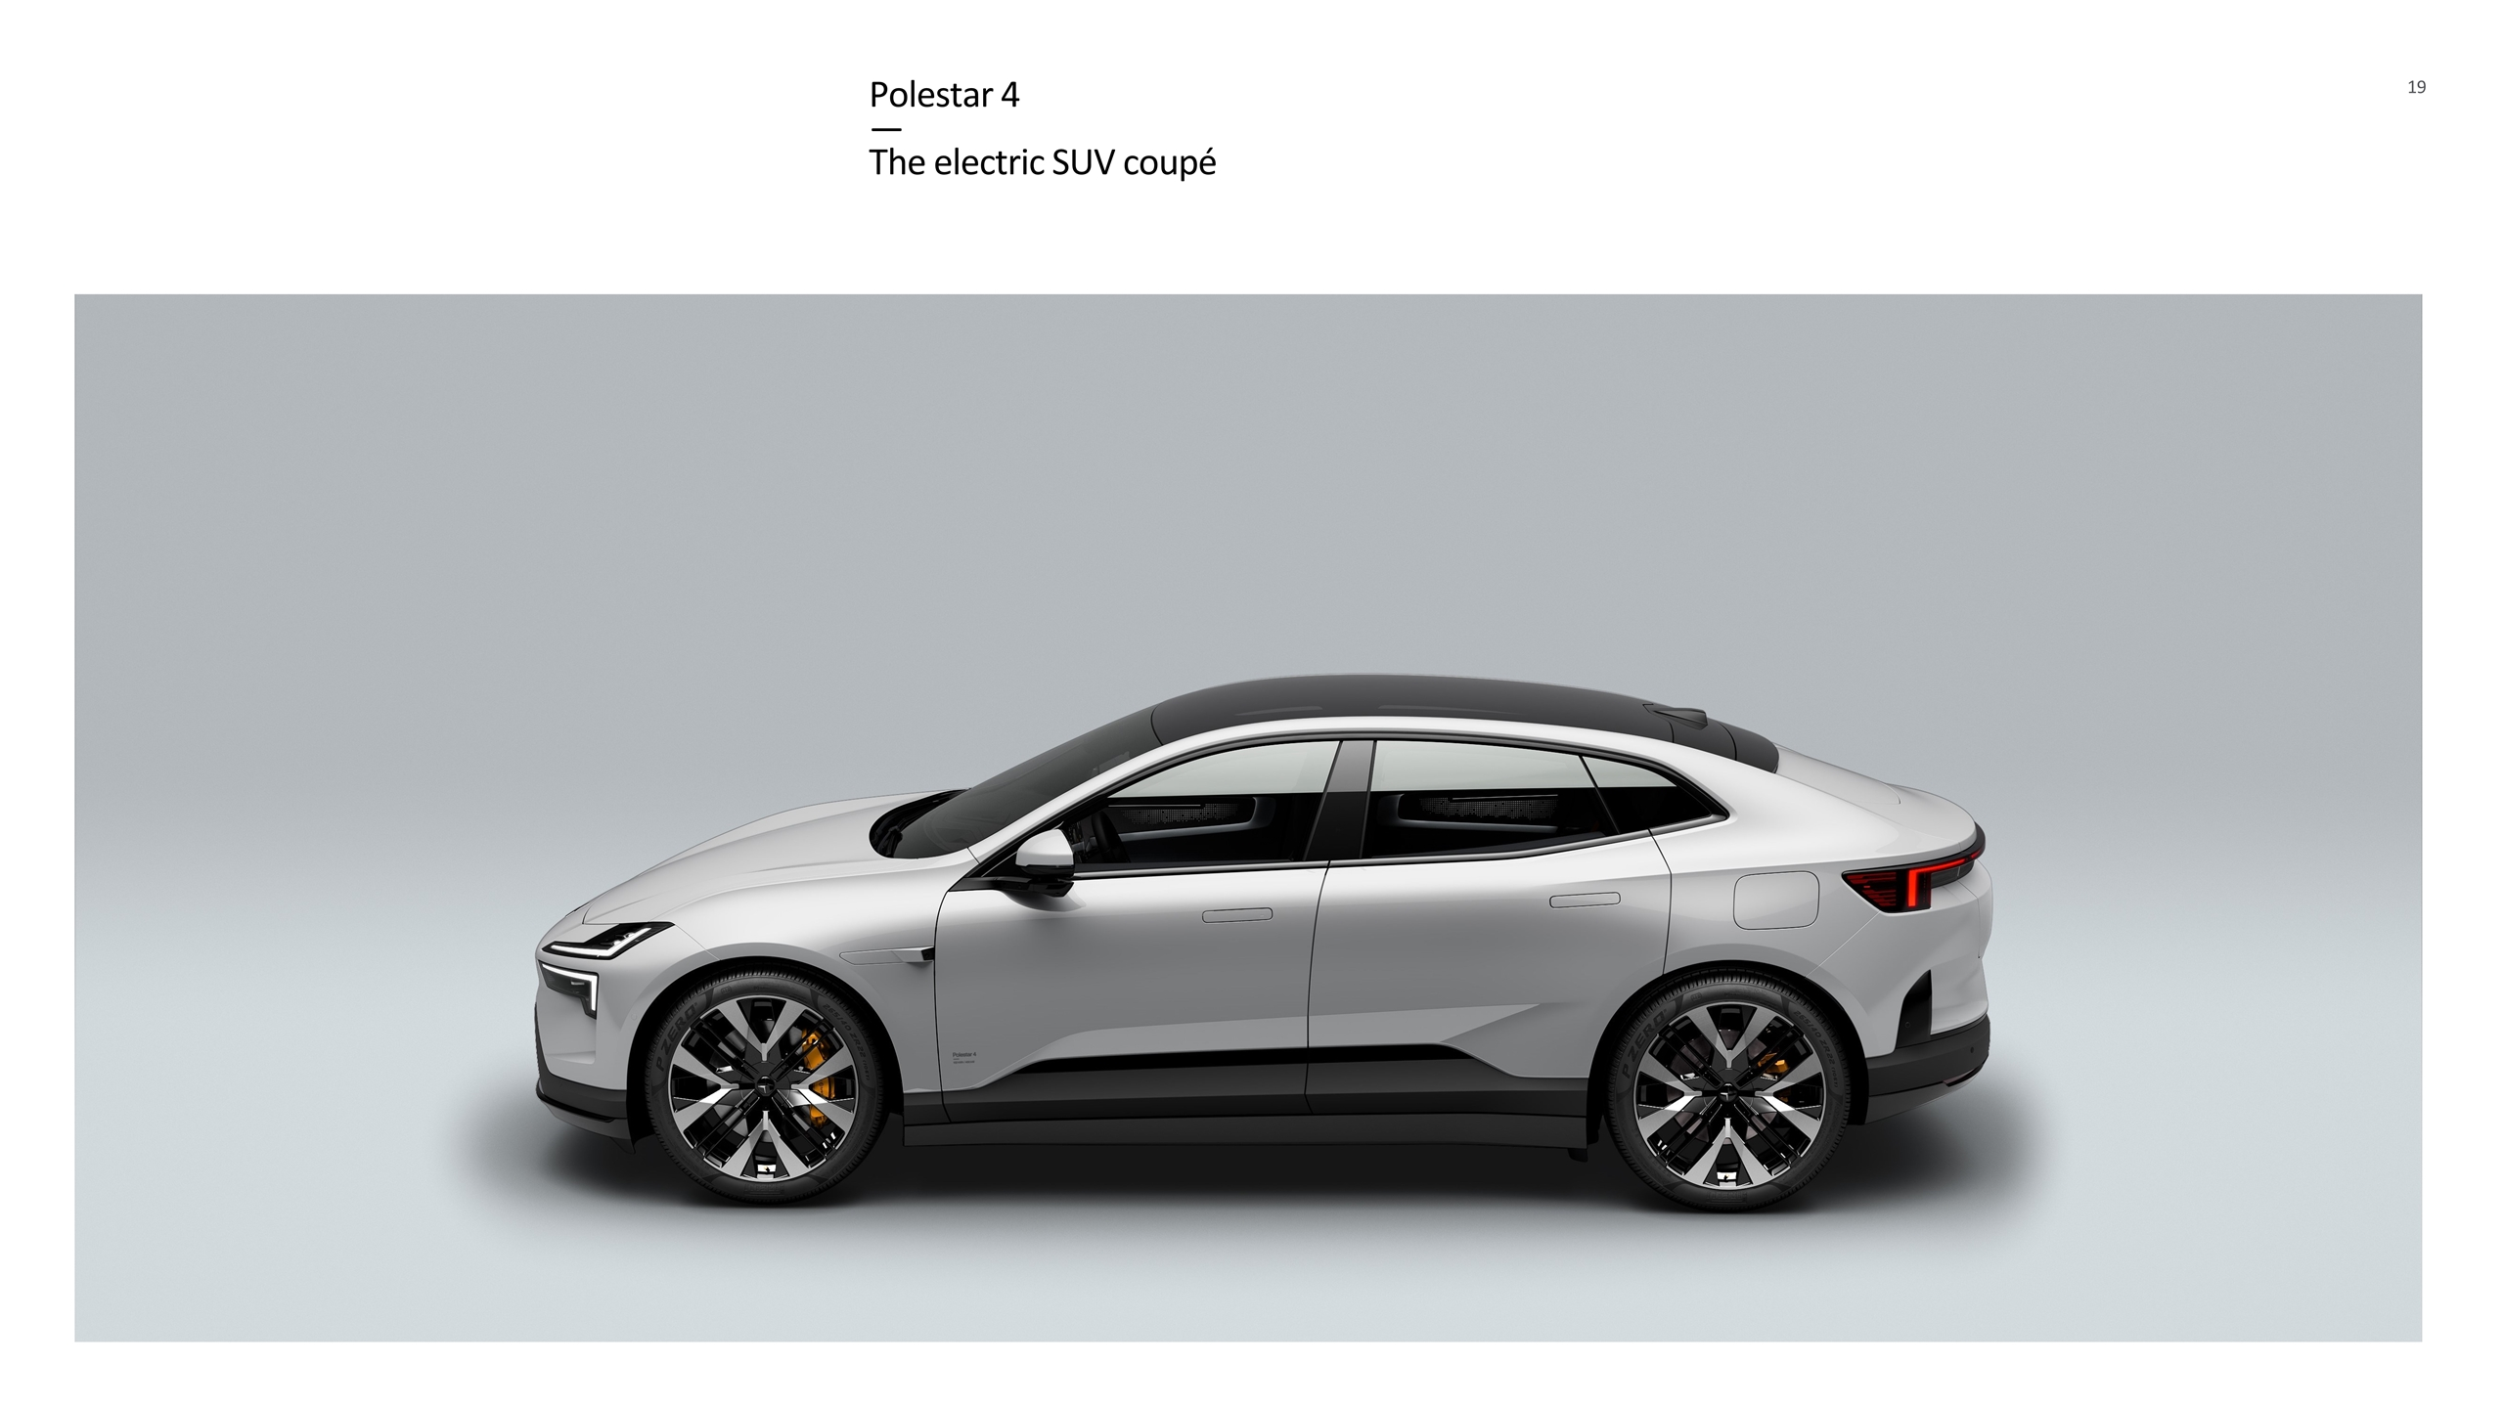
Polestar 4 — The electric SUV coupé

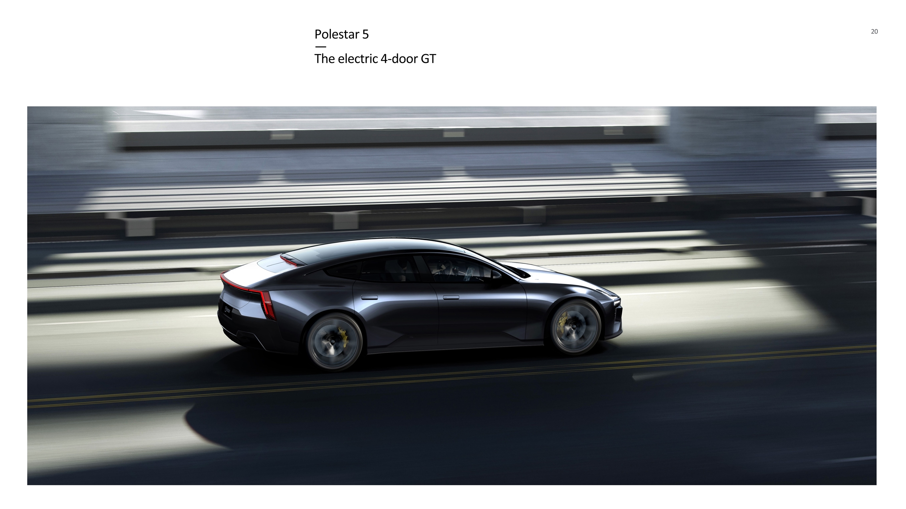
Polestar 5 — The electric 4-door GT

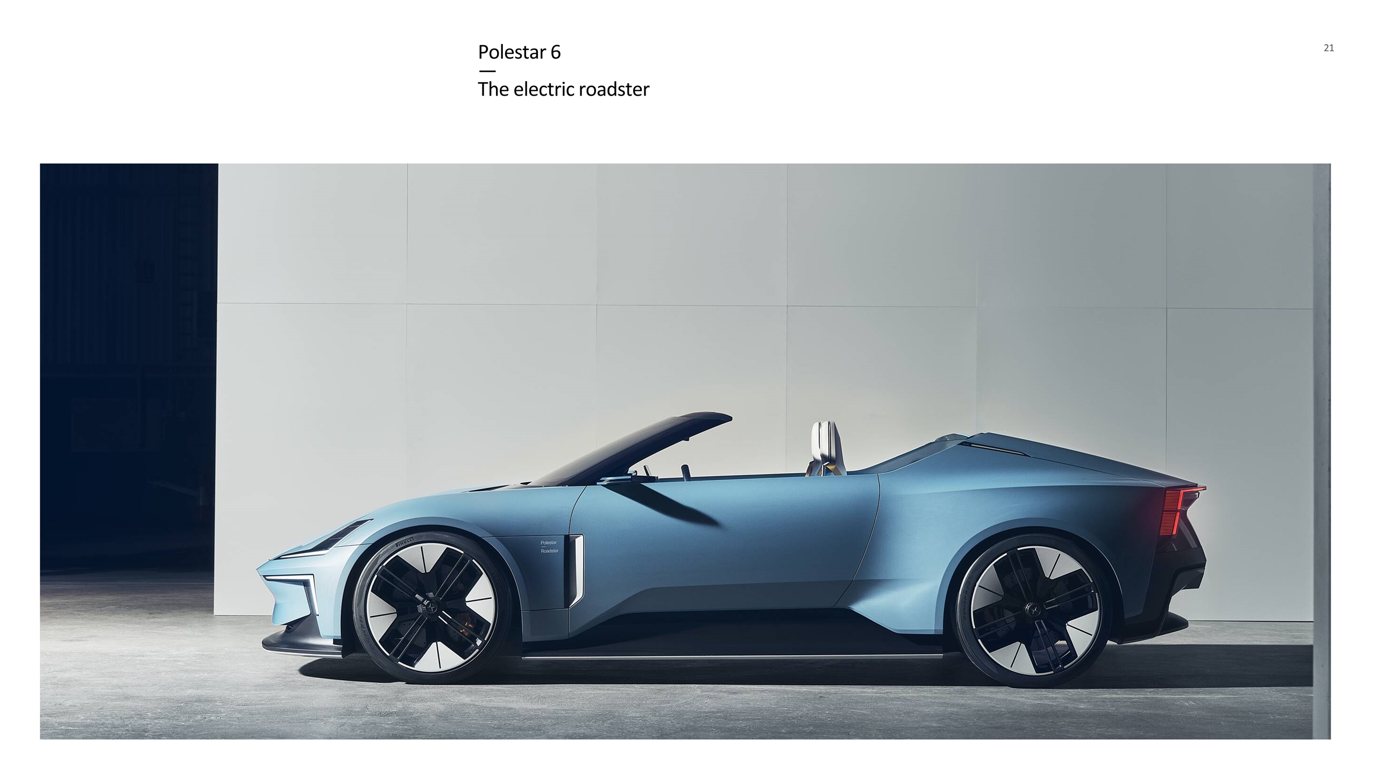
Polestar 6 — The electric roadster


Appendix

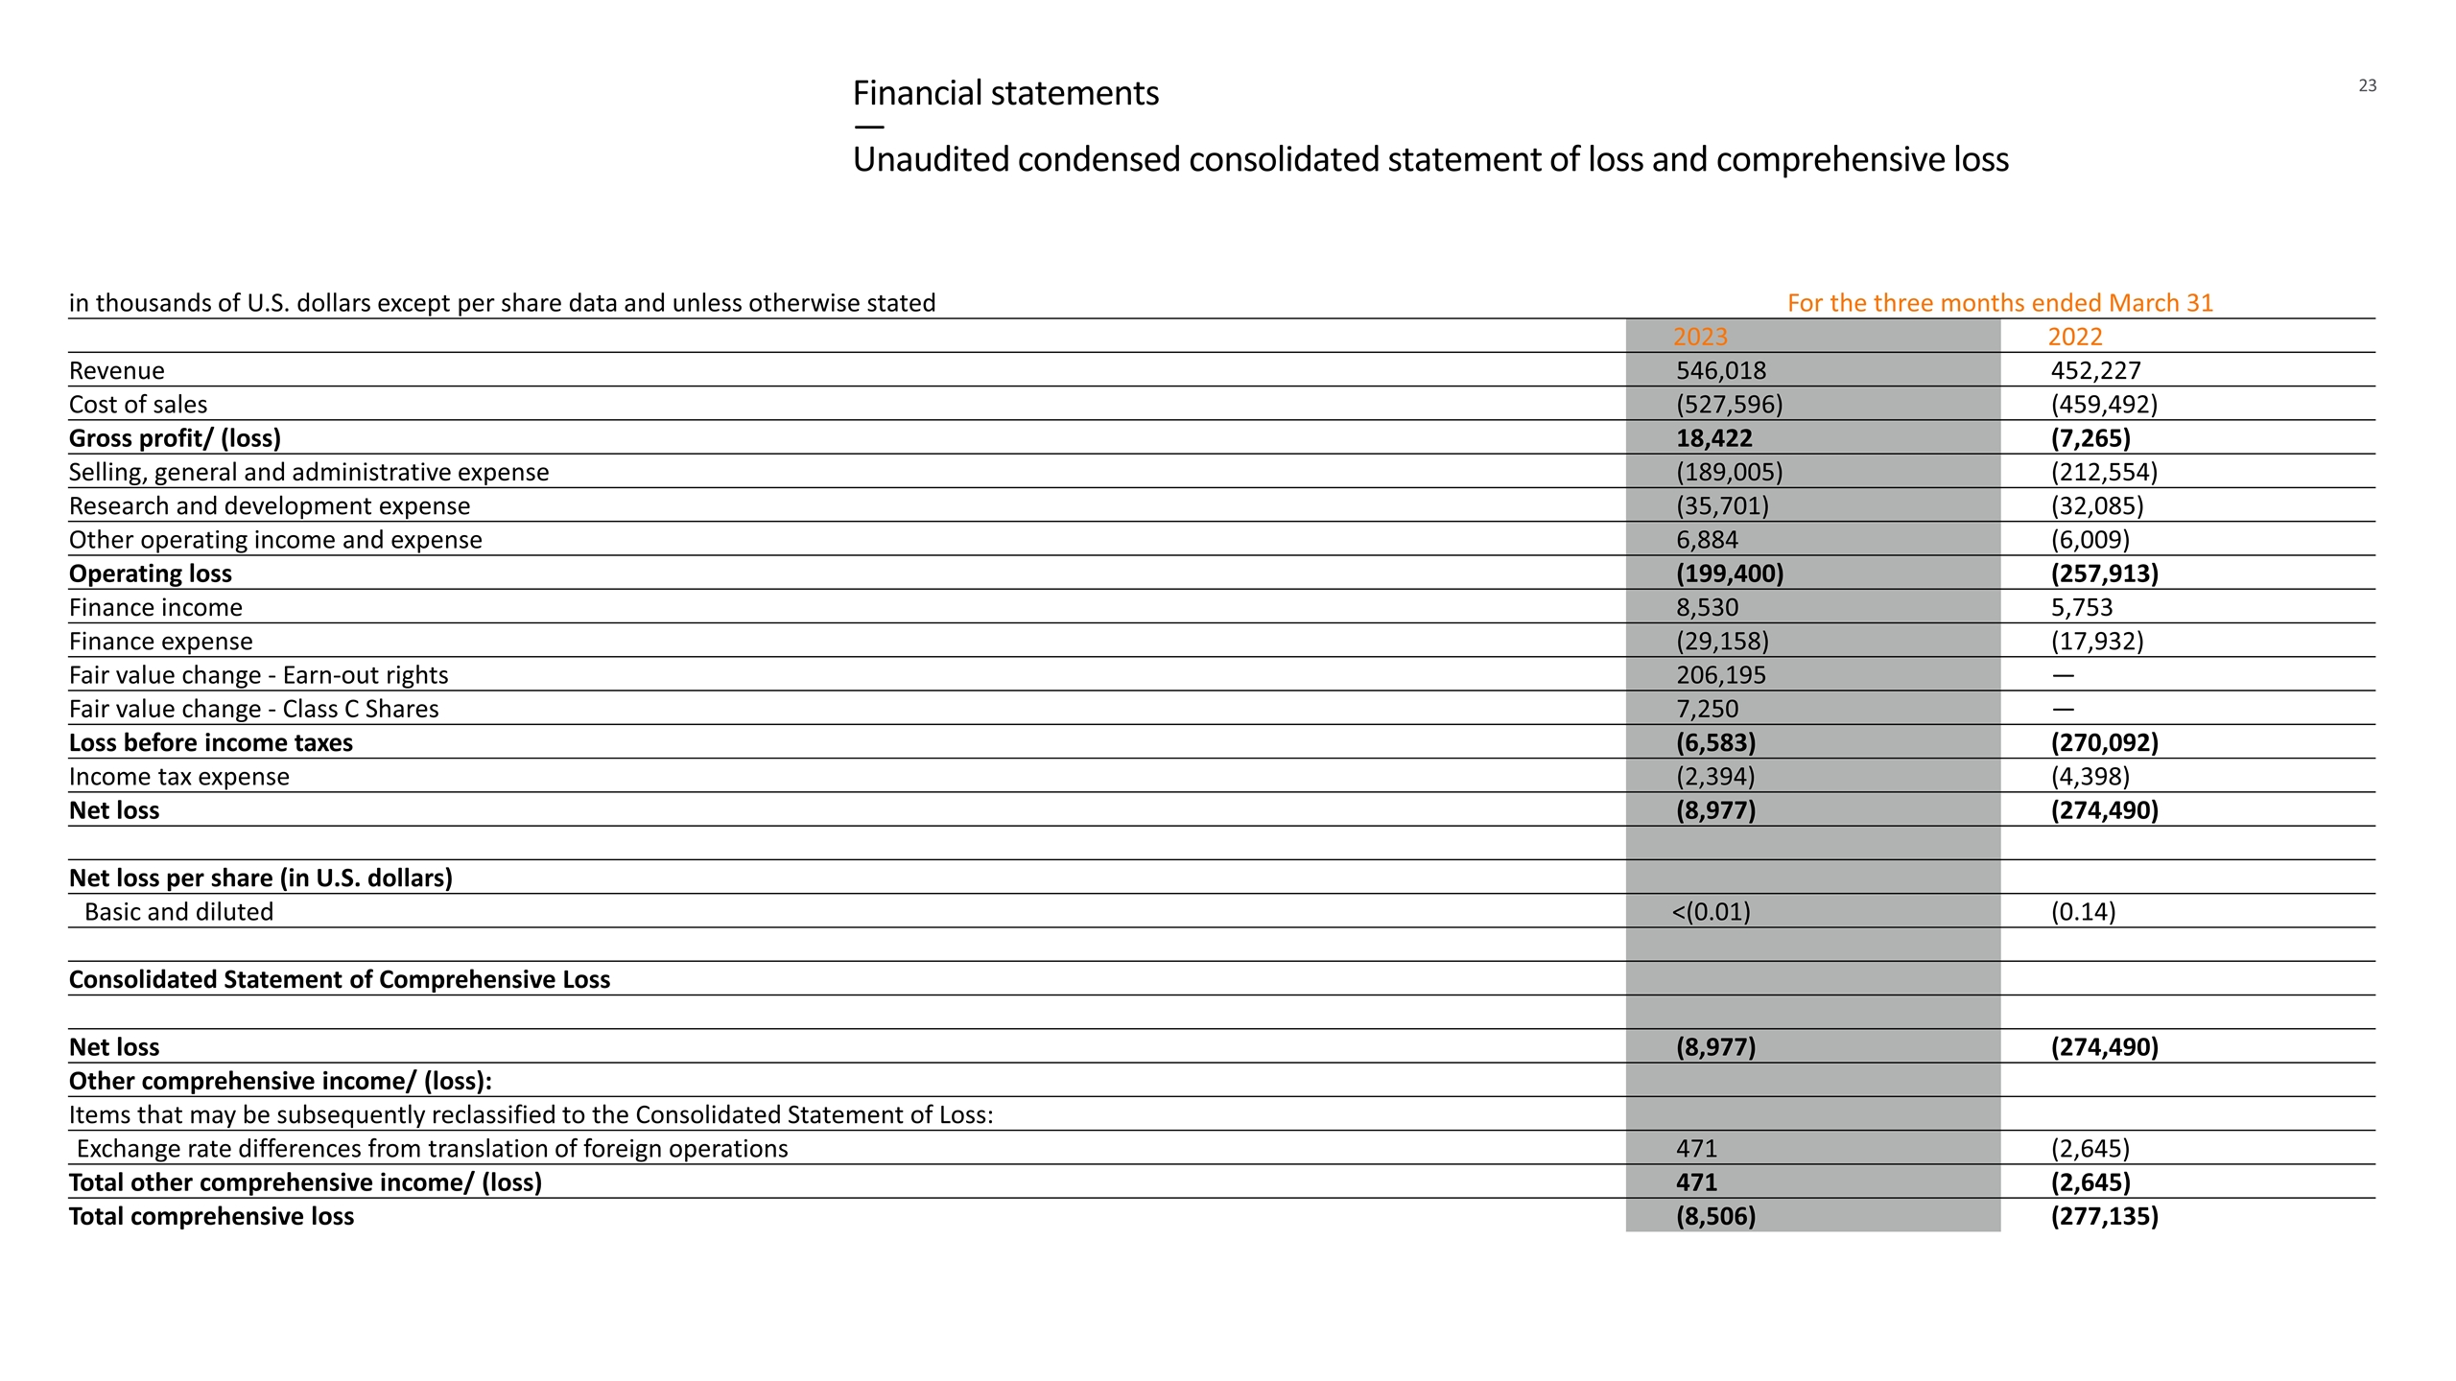
Financial statements — Unaudited condensed consolidated statement of loss and comprehensive loss in thousands of U.S. dollars except per share data and unless otherwise stated For the three months ended March 31 2023 2022 Revenue 546,018 452,227 Cost of sales (527,596) (459,492) Gross profit/ (loss) 18,422 (7,265) Selling, general and administrative expense (189,005) (212,554) Research and development expense (35,701) (32,085) Other operating income and expense 6,884 (6,009) Operating loss (199,400) (257,913) Finance income 8,530 5,753 Finance expense (29,158) (17,932) Fair value change - Earn-out rights 206,195 — Fair value change - Class C Shares 7,250 — Loss before income taxes (6,583) (270,092) Income tax expense (2,394) (4,398) Net loss (8,977) (274,490) Net loss per share (in U.S. dollars) Basic and diluted <(0.01) (0.14) Consolidated Statement of Comprehensive Loss Net loss (8,977) (274,490) Other comprehensive income/ (loss): Items that may be subsequently reclassified to the Consolidated Statement of Loss: Exchange rate differences from translation of foreign operations 471 (2,645) Total other comprehensive income/ (loss) 471 (2,645) Total comprehensive loss (8,506) (277,135)

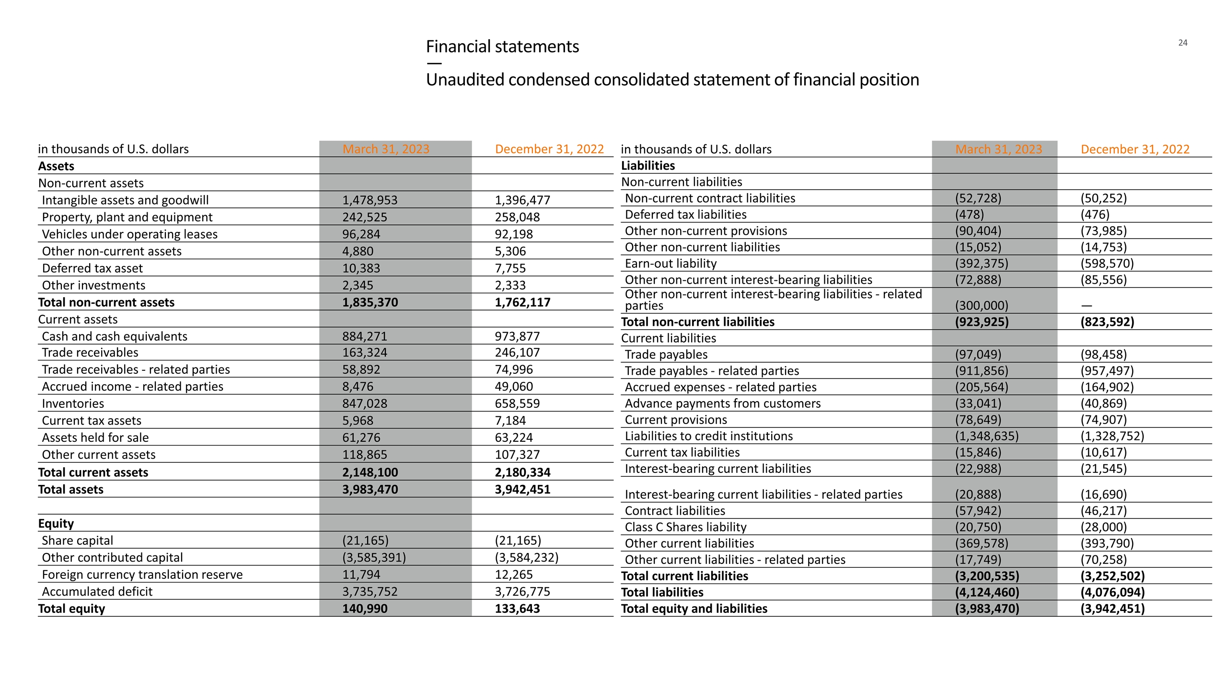
Financial statements — Unaudited condensed consolidated statement of financial position in thousands of U.S. dollars March 31, 2023 December 31, 2022 Assets Non-current assets Intangible assets and goodwill 1,478,953 1,396,477 Property, plant and equipment 242,525 258,048 Vehicles under operating leases 96,284 92,198 Other non-current assets 4,880 5,306 Deferred tax asset 10,383 7,755 Other investments 2,345 2,333 Total non-current assets 1,835,370 1,762,117 Current assets Cash and cash equivalents 884,271 973,877 Trade receivables 163,324 246,107 Trade receivables - related parties 58,892 74,996 Accrued income - related parties 8,476 49,060 Inventories 847,028 658,559 Current tax assets 5,968 7,184 Assets held for sale 61,276 63,224 Other current assets 118,865 107,327 Total current assets 2,148,100 2,180,334 Total assets 3,983,470 3,942,451 Equity Share capital (21,165) (21,165) Other contributed capital (3,585,391) (3,584,232) Foreign currency translation reserve 11,794 12,265 Accumulated deficit 3,735,752 3,726,775 Total equity 140,990 133,643 in thousands of U.S. dollars March 31, 2023 December 31, 2022 Liabilities Non-current liabilities Non-current contract liabilities (52,728) (50,252) Deferred tax liabilities (478) (476) Other non-current provisions (90,404) (73,985) Other non-current liabilities (15,052) (14,753) Earn-out liability (392,375) (598,570) Other non-current interest-bearing liabilities (72,888) (85,556) Other non-current interest-bearing liabilities - related parties (300,000) — Total non-current liabilities (923,925) (823,592) Current liabilities Trade payables (97,049) (98,458) Trade payables - related parties (911,856) (957,497) Accrued expenses - related parties (205,564) (164,902) Advance payments from customers (33,041) (40,869) Current provisions (78,649) (74,907) Liabilities to credit institutions (1,348,635) (1,328,752) Current tax liabilities (15,846) (10,617) Interest-bearing current liabilities (22,988) (21,545) Interest-bearing current liabilities - related parties (20,888) (16,690) Contract liabilities (57,942) (46,217) Class C Shares liability (20,750) (28,000) Other current liabilities (369,578) (393,790) Other current liabilities - related parties (17,749) (70,258) Total current liabilities (3,200,535) (3,252,502) Total liabilities (4,124,460) (4,076,094) Total equity and liabilities (3,983,470) (3,942,451)

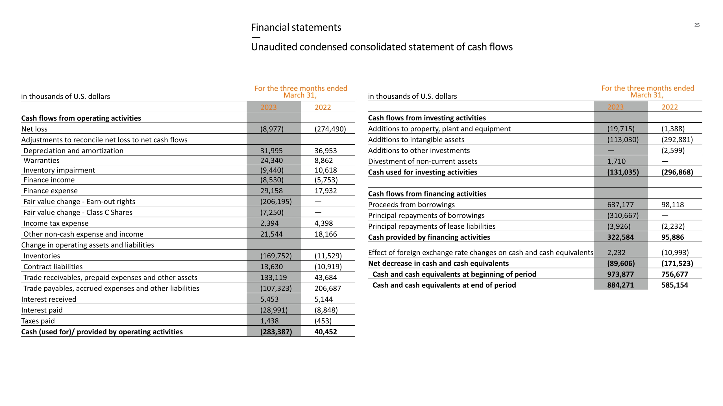
Financial statements — Unaudited condensed consolidated statement of cash flows in thousands of U.S. dollars For the three months ended March 31, 2023 2022 Cash flows from operating activities Net loss (8,977) (274,490) Adjustments to reconcile net loss to net cash flows Depreciation and amortization 31,995 36,953 Warranties 24,340 8,862 Inventory impairment (9,440) 10,618 Finance income (8,530) (5,753) Finance expense 29,158 17,932 Fair value change - Earn-out rights (206,195) — Fair value change - Class C Shares (7,250) — Income tax expense 2,394 4,398 Other non-cash expense and income 21,544 18,166 Change in operating assets and liabilities Inventories (169,752) (11,529) Contract liabilities 13,630 (10,919) Trade receivables, prepaid expenses and other assets 133,119 43,684 Trade payables, accrued expenses and other liabilities (107,323) 206,687 Interest received 5,453 5,144 Interest paid (28,991) (8,848) Taxes paid 1,438 (453) Cash (used for)/ provided by operating activities (283,387) 40,452 in thousands of U.S. dollars For the three months ended March 31, 2023 2022 Cash flows from investing activities Additions to property, plant and equipment (19,715) (1,388) Additions to intangible assets (113,030) (292,881) Additions to other investments — (2,599) Divestment of non-current assets 1,710 — Cash used for investing activities (131,035) (296,868) Cash flows from financing activities Proceeds from borrowings 637,177 98,118 Principal repayments of borrowings (310,667) — Principal repayments of lease liabilities (3,926) (2,232) Cash provided by financing activities 322,584 95,886 Effect of foreign exchange rate changes on cash and cash equivalents 2,232 (10,993) Net decrease in cash and cash equivalents (89,606) (171,523) Cash and cash equivalents at beginning of period 973,877 756,677 Cash and cash equivalents at end of period 884,271 585,154

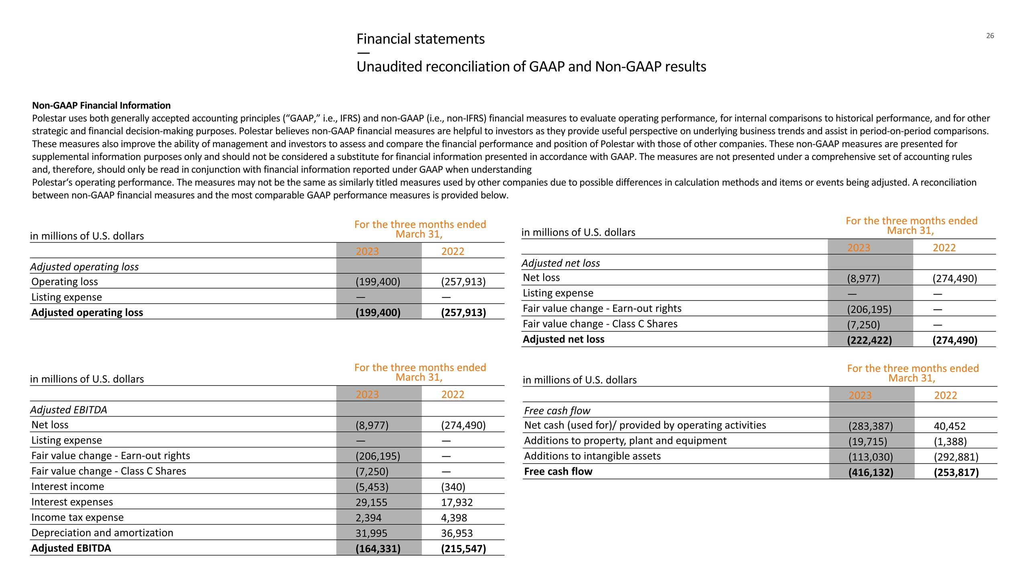
Financial statements — Unaudited reconciliation of GAAP and Non-GAAP results in millions of U.S. dollars For the three months ended March 31, 2023 2022 Adjusted EBITDA Net loss (8,977) (274,490) Listing expense — — Fair value change - Earn-out rights (206,195) — Fair value change - Class C Shares (7,250) — Interest income (5,453) (340) Interest expenses 29,155 17,932 Income tax expense 2,394 4,398 Depreciation and amortization 31,995 36,953 Adjusted EBITDA (164,331) (215,547) in millions of U.S. dollars For the three months ended March 31, 2023 2022 Adjusted net loss Net loss (8,977) (274,490) Listing expense — — Fair value change - Earn-out rights (206,195) — Fair value change - Class C Shares (7,250) — Adjusted net loss (222,422) (274,490) in millions of U.S. dollars For the three months ended March 31, 2023 2022 Adjusted operating loss Operating loss (199,400) (257,913) Listing expense — — Adjusted operating loss (199,400) (257,913) in millions of U.S. dollars For the three months ended March 31, 2023 2022 Free cash flow Net cash (used for)/ provided by operating activities (283,387) 40,452 Additions to property, plant and equipment (19,715) (1,388) Additions to intangible assets (113,030) (292,881) Free cash flow (416,132) (253,817) Non-GAAP Financial Information Polestar uses both generally accepted accounting principles (“GAAP,” i.e., IFRS) and non-GAAP (i.e., non-IFRS) financial measures to evaluate operating performance, for internal comparisons to historical performance, and for other strategic and financial decision-making purposes. Polestar believes non-GAAP financial measures are helpful to investors as they provide useful perspective on underlying business trends and assist in period-on-period comparisons. These measures also improve the ability of management and investors to assess and compare the financial performance and position of Polestar with those of other companies. These non-GAAP measures are presented for supplemental information purposes only and should not be considered a substitute for financial information presented in accordance with GAAP. The measures are not presented under a comprehensive set of accounting rules and, therefore, should only be read in conjunction with financial information reported under GAAP when understanding Polestar‘s operating performance. The measures may not be the same as similarly titled measures used by other companies due to possible differences in calculation methods and items or events being adjusted. A reconciliation between non-GAAP financial measures and the most comparable GAAP performance measures is provided below.

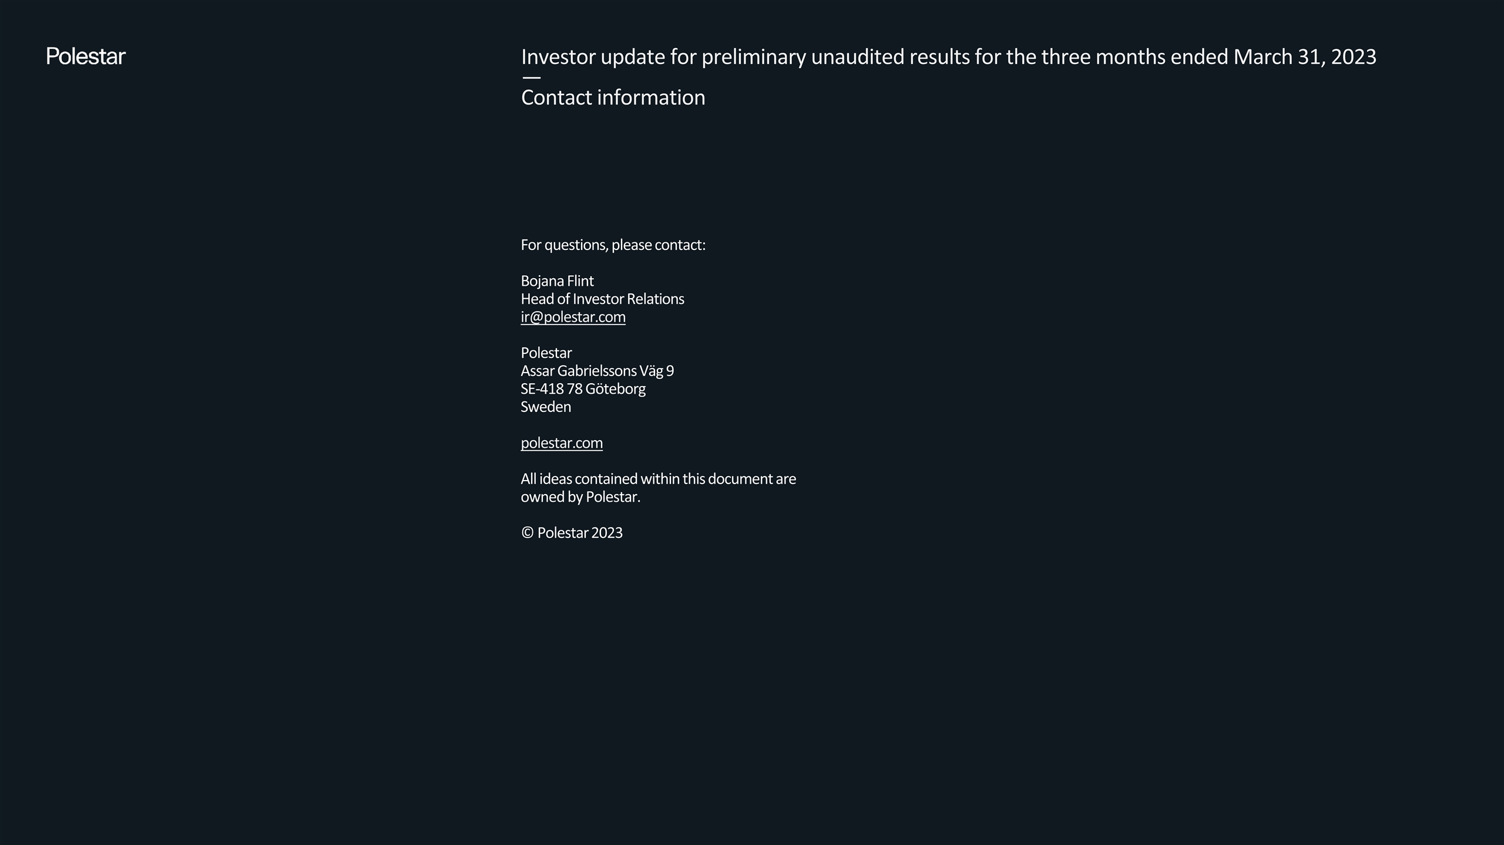
For questions, please contact: Bojana Flint Head of Investor Relations ir@polestar.com Polestar Assar Gabrielssons Väg 9 SE-418 78 Göteborg Sweden polestar.com All ideas contained within this document are owned by Polestar. © Polestar 2023 Investor update for preliminary unaudited results for the three months ended March 31, 2023 — Contact information
Exhibit 99.3
Managements Discussion and Analysis of Financial Conditions and Results of Operations
The following discussion includes information that is relevant to understanding Polestars financial condition and results of operations and should be read together with the Unaudited Condensed Consolidated Financial Statements as of March 31, 2023 and for the three months ended March 31, 2023 and 2022, included elsewhere in this report. Refer to the Form 20-F filed with the SEC on April 14, 2023 for information related to the year ended December 31, 2022. All amounts presented in this report are shown in thousands of U.S. dollars, except per share data and unless otherwise stated.
Key figures

 |  | March 31,  2023 |  |  |  | December 31,  2022
Statement of financial position
Cash and cash equivalents |  |  | 884,271 |  |  |  | 973,877
Total assets |  |  | 3,983,470 |  |  |  | 3,942,451
Total equity |  |  | 140,990 |  |  |  | 133,643
Total liabilities |  |  | (4,124,460 | ) |  |  | (4,076,094 | )

 |  | For the three months ended  March 31, |  |  |  |  |  |  |  | For the year ended  December 31,
 |  | 2023 |  |  |  | 2022 |  |  |  | 2022
Statement of loss
Revenue |  |  | 546,018 |  |  |  | 452,227 |  |  |  | 2,461,896
Cost of sales |  |  | (527,596 | ) |  |  | (459,492 | ) |  |  | (2,342,453 | )
Gross profit/(loss) |  |  | 18,422 |  |  |  | (7,265 | ) |  |  | 119,443
Operating expenses |  |  | (217,822 | ) |  |  | (250,648 | ) |  |  | (1,405,723 | )
Operating loss |  |  | (199,400 | ) |  |  | (257,913 | ) |  |  | (1,286,280 | )
Finance income and expense, net |  |  | 192,817 |  |  |  | (12,179 | ) |  |  | 837,275
Income tax expense |  |  | (2,394 | ) |  |  | (4,398 | ) |  |  | (16,784 | )
Net loss |  |  | (8,977 | ) |  |  | (274,490 | ) |  |  | (465,789 | )
Statement of cash flows
Cash (used for)/provided by operating activities |  |  | (283,387 | ) |  |  | 40,452 |  |  |  | (1,083,423 | )
Cash used for investing activities |  |  | (131,035 | ) |  |  | (296,868 | ) |  |  | (715,973 | )
Cash provided by financing activities |  |  | 322,584 |  |  |  | 95,886 |  |  |  | 2,083,029
Key metrics
Class A shares outstanding at period end |  |  | 467,708,923 |  |  |  | 197,026,729 |  |  |  | 467,677,673
Class B shares outstanding at period end |  |  | 1,642,233,575 |  |  |  | 35,377,866 |  |  |  | 1,642,233,575
Share price at period end1 |  |  | 3.79 |  |  |  | N/A |  |  |  | 5.31
Net loss per share (basic and diluted) |  |  | < (0.01 | ) |  |  | (0.14 | ) |  |  | (0.23 | )
Equity ratio2 |  |  | (3.54 | )% |  |  | 4.88 | % |  |  | (3.39 | )%
Global volumes3 |  |  | 12,076 |  |  |  | 9,576 |  |  |  | 51,491
Volume of external vehicles without repurchase obligations |  |  | 11,423 |  |  |  | 8,507 |  |  |  | 48,531
Volume of external vehicles with repurchase obligations |  |  | 355 |  |  |  | 440 |  |  |  | 1,296
Volume of internal vehicles |  |  | 298 |  |  |  | 629 |  |  |  | 1,664
Markets4 |  |  | 27 |  |  |  | 21 |  |  |  | 27
Locations5 |  |  | 143 |  |  |  | 120 |  |  |  | 158
Service points6 |  |  | 1,117 |  |  |  | 842 |  |  |  | 1,116
1 - Represents PSNY share price at period end while publicly traded. The share price at March 31, 2022 is not disclosed as Polestar was not publicly traded.
2 - Calculated as total equity divided by total assets.

1

3 - Represents the sum of total volume of vehicles delivered for (a) external sales of new vehicles without repurchase obligations, (b) external sales of vehicles with repurchase obligations, and (c) internal use vehicles for demonstration and commercial purposes or to be used by Polestar employees (vehicles are owned by Polestar and included in inventory). A vehicle is deemed delivered and included in the volume figure for each category once invoiced and registered to the external or internal counterparty, irrespective of revenue recognition. Revenue is recognized in scenarios (a) and (b) in accordance with IFRS 15, Revenue from Contracts with Customers, and IFRS 16, Leases, respectively. Revenue is not recognized in scenario (c).
4 - Represents the markets in which Polestar operates.
5 - Represents Polestar Spaces, Polestar Destinations, and Polestar Test Drive Centers.
6 - Represents Volvo Cars service centers to provide access to customer service points worldwide in support of Polestars international expansion. The number of service points at March 31, 2022 is an estimate as information was not recorded internally.
Key factors affecting performance
Polestars continued growth depends on numerous factors and trends. While these factors and trends provide opportunities for Polestar, they also pose risks and challenges as discussed in item 3.D Risk Factors in Form 20-F filed with the SEC on April 14, 2023. The following paragraphs explain the key factors that had a notable impact on Polestar during the three months ended March 31, 2023.
Partnerships with Volvo Cars and Geely
Polestars relationship with Volvo Cars and Geely has provided it with a unique competitive advantage in its ability to rapidly scale and finance commercialization activities while maintaining an asset light balance sheet. This is achieved primarily through contract manufacturing, supply, and financing agreements with Volvo Cars and Geely. Polestar has utilized Volvo Cars and Geelys established research and development capabilities to accelerate technological advancements in automotive technology. Additionally, selling and administrative expenses have been positively impacted due to service agreements with Volvo Cars that allow it to attain operational efficiencies in the areas of aftermarket services and maintenance and back-office functions such as information technology, legal, accounting, finance, and human resources.
Utilizing Volvo Cars Luqiao facility in China has allowed Polestar to ramp production of its Polestar 2 with over 100,000 units produced by December 31, 2022, while simultaneously producing limited edition variants utilizing Polestars Chengdu facility. Going forward, Polestar 3 is planned to be produced both in China at Volvo Cars Chengdu facility and in the United States at Volvo Cars facility in Charleston, South Carolina. The Polestar 4 and Polestar 5 are expected to be manufactured at Geelys Hangzhou Bay and Chongquing (currently under construction) facilities in China, respectively. Having access to the global manufacturing footprint of Volvo Cars and Geely has and will continue to provide Polestar flexibility to adjust and optimize its manufacturing plans in response factors such as particular market demand, relative production cost, changing shipping and logistic expenses and the availability of market-specific tax credit schemes.
During the three months ended March 31, 2023, Polestar did not enter into any new agreements with Volvo Cars or Geely. However, Polestar began to leverage the 18-month $800,000 credit facility with Volvo Cars that was entered into on November 3, 2022 during the period. Polestar drew down $150,000 on February 23, 2023 and March 29. 2023; leaving $500,000 of principal available to draw upon under the facility as of March 31, 2023. Refer to Note 11 - Related party transactions in the Unaudited Condensed Consolidated Financial Statements included elsewhere in this report for more information.
Premium electric vehicle portfolio
Polestar is developing a premium all-electric vehicle portfolio to address the tastes and preferences of premium vehicle customers, one of the fastest growing segments of the global electric car market. The planned portfolio currently consists of the following models:

 |  |  | Polestar 2 - a performance fastback;

 |  |  | Polestar 3 - a performance sport utility vehicle;

 |  |  | Polestar 4 - a performance sport utility coupe;

 |  |  | Polestar 5 - a high performance 4-door grand tourer; and

 |  |  | Polestar 6 - a high performance roadster.
The Polestar 2 has received numerous accolades and positive reviews since its launch in 2019. The limited edition higher specification Polestar 2 variants, the BST 270 and BST 230, which sell at higher price points have also received favorable reviews from customers and the automotive community. Polestar plans to continue offering higher specification variants, sometimes in limited production runs, for its future models, which it expects will further establish its brand within the premium electric segment and allow for pricing variability within certain markets. As a premium electric vehicle company, Polestar does not intend to offer models priced below the Polestar 2.
Innovative automotive technologies and design
Polestar develops electric vehicles and technologies through cutting edge design and sustainable choices. Polestar has a high-performance, innovation-driven research and development team with safety heritage rooted from Volvo Cars and in-house competencies at its dedicated research and development facility in Coventry, UK. Internal development programs such as the Polestar Precept and P10 electric powertrain have advanced Polestars organic intellectual property. Further, Polestar continues to display ambition to create

2

industry-leading technologies through partnerships with Volvo Cars, Geely, Nvidia, Luminar, and Zenseact, among others. This combination of research and development resources allows Polestar flexibility in determining which technologies to develop in-house versus which to outsource to partners. Polestar believes that continued investments such as these are critical to establishing market share, attracting new customers, and becoming a profitable global electric vehicle company. During the three months ended March 31, 2023, Polestar invested $96,394 in new intellectual property. Refer to Note 6 - Intangible assets and goodwill in the Unaudited Condensed Consolidated Financial Statements included elsewhere in this report for more information.
Direct-to-consumer business model
Polestar operates a direct-to-consumer business model for sales of vehicles, which allows it to create a tailored experience for customers based on their individual preferences. Polestar cultivates this experience through Polestar Spaces where potential customers can experience Polestar vehicles, engage with Polestar specialists, and in certain cases, test drive Polestar vehicles. This serves as important brand awareness and as a sales driver for commercial expansion in key markets. Through these locations, Polestar is able to introduce customers to vehicles and enhance the Polestar experience, from brand introduction and education to vehicle delivery. Additionally, Polestar is able to run a lean sales model via the Polestar App and website, offer a wide service network for aftermarket services and maintenance, and offer competitive pricing and financing for customers. This business model approach has allowed Polestar to achieve rapid expansion in, and capitalization of, the luxury electric vehicle market in Europe with lower overall selling, general, and administrative expenses as compared to a traditional OEM dealer model.
Direct-to-business model
In the U.S. and Canada, Polestar operates a direct-to-business model through which vehicles are sold directly to a network of independent authorized dealers. In these markets, vehicles are displayed and subsequently sold to end retail consumers at Polestar Spaces, which are designed, built, and equipped by dealers in accordance with Polestars standards. Dealers also diagnose and repair Polestar vehicles at associated service facilities. Vehicles are sold to dealers at wholesale prices and Polestar provides a suggested retail price.
Fleet sales
In addition to Polestar and its subsidiaries direct-to-consumer and direct-to-business models, vehicles are also sold to various fleet customers (e.g., rental car companies and corporate fleet managers). As an incentive for high-volume purchases, sales to fleet customers often include certain upfront discounts and annual rebates based on the number of vehicles ordered during the year.
Importer markets
Polestar also sells vehicles to various importers in smaller markets around the globe where it does not have sales units (e.g., Hong Kong, New Zealand, Israel, UAE (United Arab Emirates), among others). Polestars relationships with importers allow it to create a more diversified global footprint and tap potential opportunities which may lead to increased sales.
Earn-out rights and Class C Shares from the reverse recapitalization
On June 23, 2022, Polestar consummated a capital reorganization via the merger with Gores Guggenheim, Inc. (GGI), a special purpose acquisition company. Polestar subsequently began trading on the National Association of Securities Dealers Automated Quotations (Nasdaq) on June 24, 2022 under the ticker symbol PSNY. As part of the merger, Polestar exchanged rights and obligations to the public and private warrant instruments of GGI, resulting in the issuance of similar instruments in the form of Class C-1 Shares and Class C-2 Shares, respectively. Polestar also issued certain rights to earn-out shares to its existing owners. These instruments are accounted for as derivative liabilities under International Accounting Standards (IAS) 32, Financial Instruments: Presentation, and IFRS 9, Financial Instruments, that are carried at fair value with subsequent changes in fair value recognized in the Unaudited Condensed Consolidated Statement of Loss and Comprehensive Loss at each reporting date.
As of December 31, 2022 and March 31, 2023, the Class C Shares were valued at $28,000 and $20,750, respectively, resulting in an unrealized gain from the fair-value change of $7,250 during the three months ended March 31, 2023. As of December 31, 2022 and March 31, 2023, the earn-out rights were valued at $598,570 and $392,375, respectively, resulting in an unrealized gain from the fair value change of $206,195 during the three months ended March 31, 2023. The fair values of these derivative financial instruments are volatile and influenced by changes Polestars share price, resulting in impacts to Polestars net income or loss that are not directly related to ongoing operations. Nevertheless, these derivative financial instruments have a notable impact on our overall financial performance each period. Refer to Note 1 - Significant accounting policies and judgements and Note 8 - Reverse recapitalization in the Unaudited Condensed Consolidated Financial Statements included elsewhere in this report for more information.
Impact of COVID-19, Russo-Ukrainian War, and inflation
In certain instances, Polestars suppliers and business partners have experienced delays or disruptions from COVID-19, resulting in negative impacts to Polestar. Further, while Polestar does not directly conduct any business with suppliers in Russia or the Ukraine, there can be no assurance that all parts of the supply chain are devoid of any exposure to disruptions caused by the Russo-Ukrainian War. Refer to Item 3.D Risk Factors in Form 20-F filed with the SEC on April 14, 2023 for information on risks posed by COVID-19 and the Russo-Ukrainian War.

3

Global economic conditions have caused rising inflationary pressures on prices of components, materials, labor, and equipment used in the production of Polestar vehicles. Particularly, increases in battery prices due to the increased prices of lithium, cobalt, and nickel has contributed to increased cost of goods sold and is expected to lead to higher costs of goods sold in the future. Additionally, the natural time lag created by the production, shipping, and selling of vehicles has also contributed to a delay in price increases experienced by Polestar. Higher oil prices have also increased freight and distribution costs across all markets. It is uncertain whether these inflationary pressures will persist in the future. Polestar remains vigilant and will continue to closely monitor the effects of COVID-19, the Russo- Ukrainian War, and inflation.
A. Results of operations
Polestar conducts business under one operating segment with commercial operations in North America, Europe, Asia, and various importer markets. Refer to Note 1 - Significant accounting policies and judgements in the Unaudited Condensed Consolidated Financial Statements included elsewhere in this report for more information on the basis of presentation. Refer to Note 1 - Significant accounting policies and judgements in the Consolidated Financial Statements for Polestar Automotive Holding Limited, as of December 31, 2022 and 2021, and for the three years ended December 31, 2022, that were included the Form 20-F filed with the SEC on April 14, 2023 for more information related to segment reporting.
Comparison of the three months ended March 31, 2023, and 2022
The following table summarizes Polestars historical Unaudited Condensed Consolidated Statement of Loss and Comprehensive Loss for three months ended March 31, 2023, and 2022:

 |  | For the three months  ended March 31, |  |  |  |  |  |  |  | Variance
 |  | 2023 |  |  |  | 2022 |  |  |  | $ |  |  |  | %
Revenue |  |  | 546,018 |  |  |  | 452,227 |  |  |  | 93,791 |  |  |  | 21
Cost of sales |  |  | (527,596 | ) |  |  | (459,492 | ) |  |  | (68,104 | ) |  |  | 15
Gross profit/(loss) |  |  | 18,422 |  |  |  | (7,265 | ) |  |  | 25,687 |  |  |  | (354 | )
Selling, general and administrative expense |  |  | (189,005 | ) |  |  | (212,554 | ) |  |  | 23,549 |  |  |  | (11 | )
Research and development expense |  |  | (35,701 | ) |  |  | (32,085 | ) |  |  | (3,616 | ) |  |  | 11
Other operating income and expense |  |  | 6,884 |  |  |  | (6,009 | ) |  |  | 12,893 |  |  |  | (215 | )
Operating loss |  |  | (199,400 | ) |  |  | (257,913 | ) |  |  | 58,513 |  |  |  | (23 | )
Finance income |  |  | 8,530 |  |  |  | 5,753 |  |  |  | 2,777 |  |  |  | 48
Finance expense |  |  | (29,158 | ) |  |  | (17,932 | ) |  |  | (11,226 | ) |  |  | 63
Fair value change - Earn-out rights |  |  | 206,195 |  |  |  |  |  |  |  | 206,195 |  |  |  | N/A
Fair value change - Class C Shares |  |  | 7,250 |  |  |  |  |  |  |  | 7,250 |  |  |  | N/A
Loss before income taxes |  |  | (6,583 | ) |  |  | (270,092 | ) |  |  | 263,590 |  |  |  | (98 | )
Income tax expense |  |  | (2,394 | ) |  |  | (4,398 | ) |  |  | 2,004 |  |  |  | (46 | )
Net loss |  |  | (8,977 | ) |  |  | (274,490 | ) |  |  | 265,513 |  |  |  | (97 | )
Revenues
Polestars revenue increased by $93,791 or 21%, from $452,227 for the three months ended March 31, 2022 to $546,018 for the three months ended March 31, 2023. Revenue from related parties decreased by $21,201, or 48%, from $44,009 for the three months ended March 31, 2023 to $22,808 for the three months ended March 31, 2023.
The following table summarizes the components of revenue and related changes between interim periods:

 |  | For the three months  ended March 31, |  |  |  |  |  |  |  | Variance
 |  | 2023 |  |  |  | 2022 |  |  |  | $ |  |  |  | %
Revenues
Sales of vehicles |  |  | 529,732 |  |  |  | 438,419 |  |  |  | 91,313 |  |  |  | 21
Sales of software and performance engineered kits |  |  | 6,754 |  |  |  | 4,529 |  |  |  | 2,225 |  |  |  | 49
Sales of carbon credits |  |  |  |  |  |  | 1,168 |  |  |  | (1,168 | ) |  |  | N/A
Vehicle leasing revenue |  |  | 4,206 |  |  |  | 4,874 |  |  |  | (668 | ) |  |  | (14 | )
Other revenue |  |  | 5,326 |  |  |  | 3,237 |  |  |  | 2,089 |  |  |  | 65
Total |  |  | 546,018 |  |  |  | 452,227 |  |  |  | 93,791 |  |  |  | 21

4

Sales of vehicles increased by $91,313, or 21%, from $438,419 for the three months ended March 31, 2022 to $529,732 for the three months ended March 31, 2023. The increase was driven primarily by price increases established in second half of 2022 and greater volumes of Polestar 2 sales across certain geographic markets such as the United Kingdom, United States, Italy, Australia, and Canada. These positive impacts on revenue were partially offset by negative impacts from foreign currency translation effects, sales channel mix, and powertrain mix. Revenue per vehicle decreased slightly as fleet sales and sales of long-range single motor powertrains of the Polestar 2 represented a greater proportion of revenue during the three months ended March 31, 2023 as compared to the three months ended March 31, 2022.
Sales of software and performance engineered kits increased by $2,225, or 49%, from $4,529 for the three months ended March 31, 2022 to $6,754 for the three months ended March 31, 2023. The increase is primarily the result of performance software upgrades for the Polestar 2 which were introduced to customers in the United States and Canada in December 2022.
Sales of carbon credits decreased by $1,168, from $1,168 for the three months ended March 31, 2022 to $0 for three months ended March 31, 2023. Polestar did not sell carbon credits during the three months ended March 31, 2023.
Vehicle leasing revenue decreased by $668, or 14%, from $4,874 for the three months ended March 31, 2022 to $4,206 for the three months ended March 31, 2023. This activity is primarily due to a decrease in revenue from repurchased vehicles leased to related parties for the three months ended March 31, 2022.
Other revenue increased by $2,089, or 65%, from $3,237 for the three months ended March 31, 2022 to $5,326 for the three months ended March 31, 2023. The increase is driven primarily by sales-based royalties received from Volvo Cars on sales of parts and accessories for the Polestar 2. In general, higher sales-based royalties on parts and accessories is correlated to higher sales volumes of the Polestar 2.
Cost of sales and gross profit/(loss)
Cost of sales increased by $68,104, or 15%, from $459,492 for the three months ended March 31, 2022 to $527,596 for the three months ended March 31, 2023. This increase was driven primarily by expanded production and commercialization of Polestar 2 vehicles leading to higher contract manufacturing, warranty, freight costs, offset by positive impacts from powertrain mix and foreign currency translation effects.
Gross profit/(loss) changed by $25,687, or 354%, from a gross loss of $7,265 for the three months ended March 31, 2022 to a gross profit of $18,422 for the three months ended March 31, 2023. Gross profit for the three months ended March 31, 2023 was positively impacted by $41,857 from price increases established in second half of 2022 and $10,637 from foreign currency transaction effects on contract manufacturing costs. These positive impacts were offset primarily by higher contract manufacturing, warranty, and freight costs of $30,617 during the three months ended March 31, 2023. The EUR and USD strengthened against the SEK and CNY during the three months ended March 31, 2023 as compared to three months ended March 31, 2022, resulting in an overall positive impact on gross profit/(loss) from foreign currency effects.
Selling, general, and administrative expense
Selling, general, and administrative expense decreased by $23,549, or 11%, from $212,554 for the three months ended March 31, 2022 to $189,005 for the three months ended March 31, 2023. This activity is primarily due to a decrease in advertising, selling, and promotional activities of $37,185 and a reversal of impairment on internal vehicles of $11,154 during the three months ended March 31, 2023. The decrease of advertising, selling, and promotional activities was offset by an increase in administrative expenses of $24,761 related to higher wages and salaries associated with scaling headcount across global operations to meet demands of the growing business.
Research and development expense
Research and development expense increased by $3,616, or 11%, from $32,085 for the three months ended March 31, 2022 to $35,701 for the three months ended March 31, 2023. This activity is primarily the result of increased R&D personnel costs due to continuing product development for future vehicles and technologies.
Other operating income (expenses), net
Other operating income (expense), net increased by $12,893, or 215%, from an expense of $6,009 for the three months ended March 31, 2022 to an income of $6,884 for the three months ended March 31, 2023. This increase is primarily driven by lower negative foreign exchange effects on working capital, comprised of realized and unrealized gains on foreign currency transactions.

5

Finance income
Finance income increased by $2,777, or 48%, from $5,753 for the three months ended March 31, 2022 to $8,530 for the three months ended March 31, 2023. This increase was the result of higher interest income on bank accounts of $5,113, offset by lower net foreign currency exchange gains of $2,147 during the three months ended March 31, 2023.
Finance expenses
Finance expense increased by $11,226, or 63%, from $17,932 for the three months ended March 31, 2022 to $29,158 for the three months ended March 31, 2023. This increase was primarily the result of higher interest expense associated with liabilities to credit institutions of $14,694, offset by lower interest expense on related party liabilities of $3,834.
Fair value change - Earn-out rights
The earn-out rights were issued in connection with the capital reorganization that was consummated on June 23, 2022. As such, there is no comparison figure for the three months ended March 31, 2023. The gain on the fair value change of the earn out liability for three months ended March 31, 2023 was $206,195. These gains are primarily attributable to a decrease in Polestars share price from $5.31 on December 31, 2022 to $3.79 on March 31, 2023 and increased market volatility. Leveraging on a benchmark of peers, the implied asset volatility used in the Monte Carlo simulation increased from of 75% as of December 31, 2022 to 80% as of March 31, 2023.
Fair value change - Class C Shares
As part of the capital reorganization via the merger with GGI on June 23, 2022, Polestar exchanged rights and obligations to the public and private warrant instruments of GGI. The gain on the fair value change of these warrants (Class C Shares in Polestar) for the three months ended March 31, 2023 was $7,250. These gains are primarily attributable to a decrease in the price of the Class C-1 Shares from $1.12 on December 31, 2022 to $0.83 on March 31, 2023 and a decrease in the estimated value of the Class C-2 Shares from $1.12 to $0.83 over the same period. Polestar utilizes a binomial lattice model to calculate the value of the Class C-2 Shares which factors several inputs, including the changes in Polestars share price from $5.31 to $3.79, implied volatility of Class C-1 Shares from 89% to 123%, and risk-free rate from 4.01% to 3.65% over the same period.
B. Liquidity and capital resources
Polestar continues to finance its operations primarily through the issuance of equity instruments, various short-term credit facilities, including working capital facilities, term loans with related parties, sale-leaseback arrangements, and extended trade credit with related parties. The principal uses of liquidity and capital are funding operations, market expansion, and investments in Polestars future vehicles and automotive technologies.
Polestar continues to generate negative operating and investing cash flows as a result of scaling up commercialization efforts globally and capital expenditures for the Polestar 2, Polestar 3, Polestar 4, and Polestar 5 and does not expect to achieve positive cash flow from operations for several years. Managing the companys liquidity profile and funding needs remains one of Managements key priorities. Substantial doubt about Polestars ability to continue as a going concern persists as timely realization of financing endeavors is necessary to cover forecasted operating and investing cash outflow. Refer to Note 1 - Significant accounting policies and judgements in the Unaudited Condensed Consolidated Financial Statements included elsewhere in this report for more information.
If Polestars cash resources are insufficient to finance its future cash requirements, Polestar will need to finance future cash needs through a combination of public or private equity offerings, debt financings, or other means. To the extent Polestar raises additional capital through the sale of equity or convertible debt securities, the ownership interest of its shareholders may be diluted, and the terms of such securities may include liquidation or other preferences that adversely affect the rights of its existing shareholders. Debt financing, if available, may involve agreements that include covenants limiting or restricting Polestars ability to take specific actions, such as incurring additional debt, making capital expenditures or declaring dividends. If Polestar is unable to raise additional funds through equity, debt financings, or other means when needed, it may be required to delay, limit, reduce, or, in the worst case, to terminate research and development and commercialization efforts and may not be able to fund continuing operations.
Managements intention is to continue to develop Polestars short-term working capital financing relationships with European and Chinese banking partners, including upsizing current facilities where applicable, while also continuing to explore potential equity or debt offerings.
Comparison of the three months ended March 31, 2023 and 2022
As of March 31, 2023, Polestar had cash and cash equivalents of $884,271 as compared to $973,877 as of December 31, 2022. Cash and cash equivalents consist of cash in banks with an original term of three months or less. Polestar did not have any restricted cash as of March 31, 2023 and December 31, 2022. The following table summarizes Polestars Unaudited Condensed Consolidated Statement of Cash Flows for the three months ended March 31, 2023 and 2022:

 |  | For the three months  ended March 31, |  |  |  |  |  |  |  | Variance
 |  | 2023 |  |  |  | 2022 |  |  |  | $
Cash (used for)/provided by operating activities |  |  | (283,387 | ) |  |  | 40,452 |  |  |  | (323,839 | )
Cash used for investing activities |  |  | (131,035 | ) |  |  | (296,868 | ) |  |  | 165,833
Cash provided by financing activities |  |  | 322,584 |  |  |  | 95,886 |  |  |  | 226,698

6

Cash (used for)/provided by operating activities
Cash used for operating activities increased by $323,839, from a cash inflow of $40,452 for the three months ended March 31, 2022 to a cash outflow of $283,387 for the three months ended March 31, 2023. The change is primarily attributable to negative changes in working capital during the three months ended March 31, 2023. Cash used for inventories increased by $158,223, from $11,529 for the three months ended March 31, 2022 to $169,752 for the three months ended March 31, 2023. This change is primarily due to the build-up in model year 2023 Polestar 2 inventory following a general ramp up in business and a readiness to deliver on orders throughout 2023.
Cash provided by changes in trade receivables, prepaid expenses, and other assets increased by $89,435 from $43,684 for the three months ended March 31, 2022 to $133,119 for the three months ended March 31, 2023. This change is primarily due a $101,029 decrease in accounts receivable reflecting higher collections of receivables in the three months ended March 31, 2023 as compared to the three months ended March 31, 2022.
Cash used for trade payables, accrued expenses, and other liabilities increased by $314,010 from an inflow of $206,687 for the three months ended March 31, 2022 to an outflow of $107,323 for the three months ended March 31, 2023. This change is primarily due to payments of $89,905 on trade payables and other current liabilities to Volvo Cars and Geely and $14,727 for warranty costs and other provisions during three months ended March 31, 2023. During the three months ended March 31, 2022, Polestar made less repayments to Volvo Cars and Geely while continuing to invest in intellectual property and purchase vehicles on trade payables.
Cash used for investing activities
Cash used for investing activities decreased by $165,833 from $296,868 for the three months ended March 31, 2022 to $131,035 for the three months ended March 31, 2023. The change is primarily related to a decrease in cash used for intangible assets of $179,851 from $292,881 for the three months ended March 31, 2022 to $113,030 for the three months ended March 31, 2023 due to Polestar settling larger amounts of trade payables with Volvo Cars and Geely for intellectual property related to the Polestar 2, Polestar 3 and Polestar 4. Polestar also made $18,327 more in cash payments for property, plant, and equipment during the three months ended March 31, 2023 as compared to the three months ended March 31, 2022.
Cash provided by financing activities
Cash provided by financing activities increased by $226,698, from $95,886 for the three months ended March 31, 2022 to $322,584 for the three months ended March 31, 2023. The change was primarily the result of increased liquidity provided by draw-downs on Polestars Term Facility Agreement with Volvo Cars and short-term working capital facilities with Chinese and European banking partners during the three months ended March 31, 2023. Polestars borrowings provided $637,177 in gross cash proceeds during the period, of which $300,000 was sourced from draw downs on Polestars Term Facility Agreement with Volvo Cars, $137,481 was sourced from short-term working capital facilities with Chinese banking partners, $157,196 was sourced from a green trade revolving credit facility with a syndicate of European banks, and $42,500 was sourced from multiple low-value floorplan and sale-leaseback facilities, including a small credit facility with Volvo Cars. These gross cash proceeds were partially offset by principal repayments of $310,667 during the period, of which $283,159 was used to settle amounts due on the green trade revolving credit facility, and $27,508 was used to settle amounts due on the low-value floorplan and sale-leaseback facilities, including the small credit facility with Volvo Cars.
Contractual obligations and commitments
Polestar is party to contractual obligations to make payments to third parties and related parties in the form of short-term credit facilities, sale leaseback arrangements, and various other leasing arrangements. Polestar also has certain capital commitments to purchase property, plant and equipment and intellectual property. The following table summarizes Polestars estimated future cash expenditures related to contractual obligations and commitments as of March 31, 2023:

Payments due by period
Less than
Contractual obligations and commitments |  | Total |  |  |  | 1 year |  |  |  | After 1 year |  |  |  | After 5 year
Capital commitments |  |  | 433,219 |  |  |  | 356,598 |  |  |  | 76,621 |  |  |  | 
Credit facilities, including sale-leasebacks |  |  | 1,669,523 |  |  |  | 1,369,523 |  |  |  | 300,000 |  |  |  | 
Lease obligations |  |  | 115,114 |  |  |  | 27,252 |  |  |  | 73,486 |  |  |  | 14,376
Total |  |  | 2,217,856 |  |  |  | 1,753,373 |  |  |  | 450,107 |  |  |  | 14,376
Critical accounting estimates
Polestar did not have any new accounting estimates applied during the three months ended March 31, 2023 that are critical to the portrayal of our financial condition and results of operations and that require significant, difficult, subjective, or complex judgements. See Form 20-F filed with the SEC on April 14, 2023, for critical accounting estimates for the year ended, December 31, 2022.

7

C. Non-GAAP Financial Measures
Polestar uses both generally accepted accounting principles (GAAP, i.e., IFRS) and non-GAAP (i.e., non-IFRS) financial measures to evaluate operating performance, for internal comparisons to historical performance, and for other strategic and financial decision-making purposes. Polestar believes non-GAAP financial measures are helpful to investors as they provide useful perspective on underlying business trends and assist in period-on-period comparisons. These measures also improve the ability of management and investors to assess and compare the financial performance and position of Polestar with those of other companies.
These non-GAAP measures are presented for supplemental information purposes only and should not be considered a substitute for financial information presented in accordance with GAAP. The measures are not presented under a comprehensive set of accounting rules and, therefore, should only be read in conjunction with financial information reported under GAAP when understanding Polestars operating performance.
The measures may not be the same as similarly titled measures used by other companies due to possible differences in calculation methods and items or events being adjusted. A reconciliation between non-GAAP financial measures and the most comparable GAAP performance measures is provided below.
Non-GAAP financial measures include adjusted operating loss, adjusted EBITDA, adjusted net loss, and free cash flow.
Adjusted Operating Loss
Polestar defines adjusted operating loss as Operating loss, adjusted to exclude listing expense. This measure is reviewed by management and provides a relevant measure for understanding the ongoing operating performance of the business prior to the impact of the non-recurring adjusting item. The listing expense relating to the merger with GGI was incurred on June 23, 2022 and does not impact the periods presented in this report.
Adjusted EBITDA
Adjusted EBITDA is calculated as Net loss, adjusted for listing expense, fair value change of earn-out rights, fair value change of Class C Shares, interest income, interest expense, income tax expense, depreciation, and amortization. Adjusted EBITDA is defined as EBITDA, adjusted for certain income and expenses which are significant in nature and that management considers not reflective of ongoing operational activities. This measure is reviewed by management and is a relevant measure for understanding the underlying operating results and trends of the business prior to the impact of any adjusting items.
Adjusted Net Loss
Adjusted net loss is calculated as Net loss, adjusted to exclude listing expense, fair value change of earn-out rights, and fair value change of Class C Shares. This measure represents net loss, adjusted for certain income and expenses which are significant in nature and that management considers not reflective of ongoing operational activities. This measure is reviewed by management and is a relevant measure for understanding the underlying performance of Polestars core business operations. The listing expense relating to the merger with GGI was incurred on June 23, 2022 and does not impact the periods presented in this report.
Free Cash Flow
Free cash flow is calculated as cash used for operating activities, adjusted for cash flows used for tangible assets and intangible assets. This measure is reviewed by management and is a relevant measure for understanding cash sourced from operating activities that is available to repay debts, fund capital expenditures, and spend on other strategic initiatives.
Unaudited Reconciliation of GAAP and Non-GAAP Results
Adjusted Operating Loss

For the three months
ended March 31,
 |  | 2023 |  |  |  | 2022
Operating loss |  |  | (199,400 | ) |  |  | (257,913 | )
Listing expense |  |  |  |  |  |  | 
Adjusted operating loss |  |  | (199,400 | ) |  |  | (257,913 | )

8

Adjusted EBITDA

For the three months
ended March 31,
 |  | 2023 |  |  |  | 2022
Net loss |  |  | (8,977 | ) |  |  | (274,490 | )
Listing expense |  |  |  |  |  |  | 
Fair value change - Earn-out rights |  |  | (206,195 | ) |  |  | 
Fair value change - Class C Shares |  |  | (7,250 | ) |  |  | 
Interest income |  |  | (5,453 | ) |  |  | (340 | )
Interest expenses |  |  | 29,155 |  |  |  | 17,932
Income tax expense |  |  | 2,394 |  |  |  | 4,398
Depreciation and amortization |  |  | 31,995 |  |  |  | 36,953
Adjusted EBITDA |  |  | (164,331 | ) |  |  | (215,547 | )
Adjusted Net Loss

For the three months
ended March 31,
 |  | 2023 |  |  |  | 2022
Net loss |  |  | (8,977 | ) |  |  | (274,490 | )
Listing expense |  |  |  |  |  |  | 
Fair value change - Earn-out rights |  |  | (206,195 | ) |  |  | 
Fair value change - Class C Shares |  |  | (7,250 | ) |  |  | 
Adjusted net loss |  |  | (222,422 | ) |  |  | (274,490 | )
Free Cash Flow

For the three months
ended March 31,
 |  | 2023 |  |  |  | 2022
Net cash (used for)/provided by operating activities |  |  | (283,387 | ) |  |  | 40,452
Additions to property, plant and equipment |  |  | (19,715 | ) |  |  | (1,388 | )
Additions to intangible assets |  |  | (113,030 | ) |  |  | (292,881 | )
Free cash flow |  |  | (416,132 | ) |  |  | (253,817 | )

9
Exhibit 99.4
The Polestar Group
Unaudited Condensed Consolidated Financial Statements as of March 31, 2023 and for
the three months ended March 31, 2023 and 2022

1

INDEX TO UNAUDITED CONDENSED CONSOLIDATED FINANCIAL STATEMENTS

 |  | Page(s)
Unaudited Condensed Consolidated Statement of Loss and Comprehensive Loss for the Three months ended March 31, 2023 and 2022 |  |  | 3
Unaudited Condensed Consolidated Statement of Financial Position as of March 31, 2023 and December 31, 2022 |  |  | 4
Unaudited Condensed Consolidated Statement of Cash Flows for the Three months ended March 31, 2023 and 2022 |  |  | 5
Unaudited Condensed Consolidated Statement of Changes in Equity for the Three months ended March 31, 2023 and 2022 |  |  | 6
Notes to Unaudited Condensed Consolidated Financial Statements |  |  | 7 - 20

2

Polestar Automotive Holding UK PLC
Unaudited Condensed Consolidated Statement of Loss and Comprehensive Loss
(in thousands of U.S. dollars except per share data and unless otherwise stated)

Consolidated Statement of Loss |  |  |  |  |  | For the three months  ended March 31,
 |  | Note |  |  |  | 2023 |  |  |  | 2022
Revenue |  |  | 2 |  |  |  | 546,018 |  |  |  | 452,227
Cost of sales |  |  |  |  |  |  | (527,596 | ) |  |  | (459,492 | )
Gross profit/(loss) |  |  |  |  |  |  | 18,422 |  |  |  | (7,265 | )
Selling, general and administrative expense |  |  | 3 |  |  |  | (189,005 | ) |  |  | (212,554 | )
Research and development expense |  |  | 3 |  |  |  | (35,701 | ) |  |  | (32,085 | )
Other operating income and expense |  |  |  |  |  |  | 6,884 |  |  |  | (6,009 | )
Operating loss |  |  |  |  |  |  | (199,400 | ) |  |  | (257,913 | )
Finance income |  |  |  |  |  |  | 8,530 |  |  |  | 5,753
Finance expense |  |  |  |  |  |  | (29,158 | ) |  |  | (17,932 | )
Fair value change - Earn-out rights |  |  | 8 |  |  |  | 206,195 |  |  |  | 
Fair value change - Class C Shares |  |  | 8 |  |  |  | 7,250 |  |  |  | 
Loss before income taxes |  |  |  |  |  |  | (6,583 | ) |  |  | (270,092 | )
Income tax expense |  |  |  |  |  |  | (2,394 | ) |  |  | (4,398 | )
Net loss |  |  |  |  |  |  | (8,977 | ) |  |  | (274,490 | )
Net loss per share (in U.S. dollars) |  |  | 5
Basic and diluted |  |  |  |  |  |  | < (0.01 | ) |  |  | (0.14 | )
Consolidated Statement of Comprehensive Loss
Net loss |  |  |  |  |  |  | (8,977 | ) |  |  | (274,490 | )
Other comprehensive Income/(loss):
Items that may be subsequently reclassified to the Consolidated Statement of Loss:
Exchange rate differences from translation of foreign operations |  |  |  |  |  |  | 471 |  |  |  | (2,645 | )
Total other comprehensive income/(loss) |  |  |  |  |  |  | 471 |  |  |  | (2,645 | )
Total Comprehensive Loss |  |  |  |  |  |  | (8,506 | ) |  |  | (277,135 | )
The accompanying notes are an integral part of these Unaudited Condensed Consolidated Financial Statements.

3

Unaudited Condensed Consolidated Statement of Financial Position
(in thousands of U.S. dollars unless otherwise stated)

 |  | Note |  |  |  | March 31,  2023 |  |  |  | December 31,  2022
Assets
Non-current assets
Intangible assets and goodwill |  |  | 6 |  |  |  | 1,478,953 |  |  |  | 1,396,477
Property, plant, and equipment |  |  |  |  |  |  | 242,525 |  |  |  | 258,048
Vehicles under operating leases |  |  | 4 |  |  |  | 96,284 |  |  |  | 92,198
Other non-current assets |  |  |  |  |  |  | 4,880 |  |  |  | 5,306
Deferred tax asset |  |  |  |  |  |  | 10,383 |  |  |  | 7,755
Other investments |  |  | 7 |  |  |  | 2,345 |  |  |  | 2,333
Total non-current assets |  |  |  |  |  |  | 1,835,370 |  |  |  | 1,762,117
Current assets
Cash and cash equivalents |  |  |  |  |  |  | 884,271 |  |  |  | 973,877
Trade receivables |  |  |  |  |  |  | 163,324 |  |  |  | 246,107
Trade receivables - related parties |  |  | 11 |  |  |  | 58,892 |  |  |  | 74,996
Accrued income - related parties |  |  | 11 |  |  |  | 8,476 |  |  |  | 49,060
Inventories |  |  |  |  |  |  | 847,028 |  |  |  | 658,559
Current tax assets |  |  |  |  |  |  | 5,968 |  |  |  | 7,184
Assets held for sale |  |  |  |  |  |  | 61,276 |  |  |  | 63,224
Other current assets |  |  |  |  |  |  | 118,865 |  |  |  | 107,327
Total current assets |  |  |  |  |  |  | 2,148,100 |  |  |  | 2,180,334
Total assets |  |  |  |  |  |  | 3,983,470 |  |  |  | 3,942,451
Equity
Share capital |  |  |  |  |  |  | (21,165 | ) |  |  | (21,165 | )
Other contributed capital |  |  |  |  |  |  | (3,585,391 | ) |  |  | (3,584,232 | )
Foreign currency translation reserve |  |  |  |  |  |  | 11,794 |  |  |  | 12,265
Accumulated deficit |  |  |  |  |  |  | 3,735,752 |  |  |  | 3,726,775
Total equity |  |  | 9 |  |  |  | 140,990 |  |  |  | 133,643
Liabilities
Non-current liabilities
Non-current contract liabilities |  |  | 2 |  |  |  | (52,728 | ) |  |  | (50,252 | )
Deferred tax liabilities |  |  |  |  |  |  | (478 | ) |  |  | (476 | )
Other non-current provisions |  |  |  |  |  |  | (90,404 | ) |  |  | (73,985 | )
Other non-current liabilities |  |  |  |  |  |  | (15,052 | ) |  |  | (14,753 | )
Earn-out liability |  |  | 7, 8 |  |  |  | (392,375 | ) |  |  | (598,570 | )
Other non-current interest-bearing liabilities |  |  | 4 |  |  |  | (72,888 | ) |  |  | (85,556 | )
Other non-current interest-bearing liabilities - related parties |  |  | 11 |  |  |  | (300,000 | ) |  |  | 
Total non-current liabilities |  |  |  |  |  |  | (923,925 | ) |  |  | (823,592 | )
Current liabilities
Trade payables |  |  |  |  |  |  | (97,049 | ) |  |  | (98,458 | )
Trade payables - related parties |  |  | 11 |  |  |  | (911,856 | ) |  |  | (957,497 | )
Accrued expenses - related parties |  |  | 11 |  |  |  | (205,564 | ) |  |  | (164,902 | )
Advance payments from customers |  |  |  |  |  |  | (33,041 | ) |  |  | (40,869 | )
Current provisions |  |  |  |  |  |  | (78,649 | ) |  |  | (74,907 | )
Liabilities to credit institutions |  |  | 10 |  |  |  | (1,348,635 | ) |  |  | (1,328,752 | )
Current tax liabilities |  |  |  |  |  |  | (15,846 | ) |  |  | (10,617 | )
Interest-bearing current liabilities |  |  | 4 |  |  |  | (22,988 | ) |  |  | (21,545 | )
Interest-bearing current liabilities - related parties |  |  | 11 |  |  |  | (20,888 | ) |  |  | (16,690 | )
Current contract liabilities |  |  | 2 |  |  |  | (57,942 | ) |  |  | (46,217 | )
Class C Shares liability |  |  | 7, 8 |  |  |  | (20,750 | ) |  |  | (28,000 | )
Other current liabilities |  |  |  |  |  |  | (369,578 | ) |  |  | (393,790 | )
Other current liabilities - related parties |  |  | 11 |  |  |  | (17,749 | ) |  |  | (70,258 | )
Total current liabilities |  |  |  |  |  |  | (3,200,535 | ) |  |  | (3,252,502 | )
Total liabilities |  |  |  |  |  |  | (4,124,460 | ) |  |  | (4,076,094 | )
Total equity and liabilities |  |  |  |  |  |  | (3,983,470 | ) |  |  | (3,942,451 | )
The accompanying notes are an integral part of these Unaudited Condensed Consolidated Financial Statements.

4

Polestar Automotive Holding UK PLC
Unaudited Condensed Consolidated Statement of Cash Flows
(in thousands of U.S. dollars unless otherwise stated)

For the three months
ended March 31,
 |  | Note |  |  |  | 2023 |  |  |  | 2022
Cash flows from operating activities
Net loss |  |  |  |  |  |  | (8,977 | ) |  |  | (274,490 | )
Adjustments to reconcile net loss to net cash flows
Depreciation and amortization |  |  |  |  |  |  | 31,995 |  |  |  | 36,953
Warranties |  |  |  |  |  |  | 24,340 |  |  |  | 8,862
Inventory impairment |  |  |  |  |  |  | (9,440 | ) |  |  | 10,618
Finance income |  |  |  |  |  |  | (8,530 | ) |  |  | (5,753 | )
Finance expense |  |  |  |  |  |  | 29,158 |  |  |  | 17,932
Fair value change - Earn-out rights |  |  |  |  |  |  | (206,195 | ) |  |  | 
Fair value change - Class C Shares |  |  |  |  |  |  | (7,250 | ) |  |  | 
Income tax expense |  |  |  |  |  |  | 2,394 |  |  |  | 4,398
Other non-cash expense and income |  |  |  |  |  |  | 21,544 |  |  |  | 18,166
Change in operating assets and liabilities:
Inventories |  |  |  |  |  |  | (169,752 | ) |  |  | (11,529 | )
Contract liabilities |  |  |  |  |  |  | 13,630 |  |  |  | (10,919 | )
Trade receivables, prepaid expenses and other assets |  |  |  |  |  |  | 133,119 |  |  |  | 43,684
Trade payables, accrued expenses and other liabilities |  |  |  |  |  |  | (107,323 | ) |  |  | 206,687
Interest received |  |  |  |  |  |  | 5,453 |  |  |  | 5,144
Interest paid |  |  |  |  |  |  | (28,991 | ) |  |  | (8,848 | )
Taxes paid |  |  |  |  |  |  | 1,438 |  |  |  | (453 | )
Cash (used for)/provided by operating activities |  |  |  |  |  |  | (283,387 | ) |  |  | 40,452
Cash flows from investing activities
Additions to property, plant and equipment |  |  |  |  |  |  | (19,715 | ) |  |  | (1,388 | )
Additions to intangible assets |  |  | 6 |  |  |  | (113,030 | ) |  |  | (292,881 | )
Additions to other investments |  |  |  |  |  |  |  |  |  |  | (2,599 | )
Divestment of non-current assets |  |  |  |  |  |  | 1,710 |  |  |  | 
Cash used for investing activities |  |  |  |  |  |  | (131,035 | ) |  |  | (296,868 | )
Cash flows from financing activities
Proceeds from borrowings |  |  |  |  |  |  | 637,177 |  |  |  | 98,118
Principal repayments of borrowings |  |  |  |  |  |  | (310,667 | ) |  |  | 
Principal repayments of lease liabilities |  |  |  |  |  |  | (3,926 | ) |  |  | (2,232 | )
Cash provided by financing activities |  |  |  |  |  |  | 322,584 |  |  |  | 95,886
Effect of foreign exchange rate changes on cash and cash equivalents |  |  |  |  |  |  | 2,232 |  |  |  | (10,993 | )
Net decrease in cash and cash equivalents |  |  |  |  |  |  | (89,606 | ) |  |  | (171,523 | )
Cash and cash equivalents at beginning of period |  |  |  |  |  |  | 973,877 |  |  |  | 756,677
Cash and cash equivalents at end of period |  |  |  |  |  |  | 884,271 |  |  |  | 585,154
The accompanying notes are an integral part of these Unaudited Condensed Consolidated Financial Statements.

5

Polestar Automotive Holding UK PLC
Unaudited Condensed Consolidated Statement of Changes in Equity
(in thousands of U.S. dollars unless otherwise stated)

 |  | Note |  |  |  | Share  capital |  |  |  | Other  contributed  capital |  |  |  | Currency  translation  reserve |  |  |  | Accumulated  deficit |  |  |  | Total
Balance as of January 1, 2022 |  |  |  |  |  |  | (1,865,909 | ) |  |  | (35,231 | ) |  |  | 16,784 |  |  |  | 1,761,860 |  |  |  | (122,496 | )
Net loss |  |  |  |  |  |  |  |  |  |  |  |  |  |  |  |  |  |  | 274,490 |  |  |  | 274,490
Other comprehensive loss |  |  |  |  |  |  |  |  |  |  |  |  |  |  | 2,645 |  |  |  |  |  |  |  | 2,645
Total comprehensive loss |  |  |  |  |  |  |  |  |  |  |  |  |  |  | 2,645 |  |  |  | 274,490 |  |  |  | 277,135
Balance as of March 31, 2022 |  |  |  |  |  |  | (1,865,909 | ) |  |  | (35,231 | ) |  |  | 19,429 |  |  |  | 2,036,350 |  |  |  | 154,639
Balance as of January 1, 2023 |  |  |  |  |  |  | (21,165 | ) |  |  | (3,584,232 | ) |  |  | 12,265 |  |  |  | 3,726,775 |  |  |  | 133,643
Net loss |  |  |  |  |  |  |  |  |  |  |  |  |  |  |  |  |  |  | 8,977 |  |  |  | 8,977
Other comprehensive income |  |  |  |  |  |  |  |  |  |  |  |  |  |  | (471 | ) |  |  |  |  |  |  | (471 | )
Total comprehensive income |  |  |  |  |  |  |  |  |  |  |  |  |  |  | (471 | ) |  |  | 8,977 |  |  |  | 8,506
Equity-settled share-based payment |  |  | 3 |  |  |  |  |  |  |  | (1,159 | ) |  |  |  |  |  |  |  |  |  |  | (1,159 | )
Balance as of March 31, 2023 |  |  |  |  |  |  | (21,165 | ) |  |  | (3,585,391 | ) |  |  | 11,794 |  |  |  | 3,735,752 |  |  |  | 140,990
The accompanying notes are an integral part of these Unaudited Condensed Consolidated Financial Statements.

6

Notes to the Unaudited Condensed Consolidated Financial Statements
(in thousands of U.S. dollars unless otherwise stated)

Note 1 - Significant accounting policies and judgements
General information
Polestar Automotive Holding UK PLC (formerly known as Polestar Automotive Holding UK Limited) (the Parent), together with its subsidiaries, hereafter referred to as Polestar, Polestar Group, and the Group, is a limited company incorporated in the United Kingdom. Polestar Group operates principally in the automotive industry, engaging in research and development, manufacturing, branding and marketing, and the commercialization and selling of vehicles, technology solutions, and services related to battery electric vehicles. Polestar Group has a presence in 27 markets across Europe, North America, and Asia. Polestar Group has its management headquarters located at Assar Gabrielssons väg 9, 41878 Göteborg, Sweden.
Merger with Gores Guggenheim, Inc.
Gores Guggenheim, Inc. (GGI) was a special purpose acquisition company (SPAC) formed for the purpose of effecting a merger, capital stock exchange, asset acquisition, stock purchase, reorganization or a similar business combination. GGI was incorporated in Delaware on December 21, 2021 and completed its initial public offering (IPO) on March 25, 2021.
On September 27, 2021, GGI entered into a Business Combination Agreement (BCA) with Polestar Automotive Holding Limited, a Hong Kong incorporated company (Former Parent), Polestar Automotive (Singapore) Pte. Ltd., a private company limited by shares in Singapore (Polestar Singapore), Polestar Holding AB, a private limited liability company incorporated under the laws of Sweden (Polestar Sweden), Polestar Automotive Holding UK Limited, a limited company incorporated under the laws of England and Wales and a direct wholly owned subsidiary of the Former Parent, and PAH UK Merger Sub Inc., a Delaware corporate and a direct wholly owned subsidiary of the Parent (US Merger Sub).
On June 23, 2022 (Closing), the Former Parent consummated a reverse recapitalization pursuant to the terms and conditions of the BCA. At the Closing, Polestar Holding AB and its subsidiaries became wholly owned subsidiaries of Parent. US Merger Sub merged with GGI, pursuant to which the separate corporate existence of US Merger Sub ceased and GGI became a wholly owned subsidiary of the Parent. Simultaneously, the following events occurred:

 |  |  | the Convertible Notes of the Former Parent outstanding immediately prior to the Closing were automatically converted into 4,306,466 Class A Shares in the Parent in the form of American depository shares;

 |  |  | the Former Parent was separated from Polestar Group and issued 294,877,349 Class A Shares in Parent in the form of American depository shares, 1,642,233,575 Class B Shares in the Parent in the form of American depository shares, and the right to receive an earn out of a variable number of additional Class A Shares and Class B Shares, depending on the daily volume weighted average price of Class A Shares in the future;

 |  |  | all GGI units outstanding immediately prior to the Closing held by GGI Stockholders were automatically separated and the holder was deemed to hold one share of GGI Class A Common Stock and one-fifth of a GGI Public Warrant;

 |  |  | all GGI Class A Common Stock issued and outstanding, other than those held in treasury, were exchanged for 63,734,797 Class A Shares in the Parent in the form of American depository shares;

 |  |  | all GGI Class F Common Stock issued and outstanding, other than those held in treasury, were exchanged for 18,459,165 Class A Shares in the Parent in the form of American depository shares;

 |  |  | all GGI Common Stock held in treasury were canceled and extinguished without consideration;

 |  |  | all GGI Public Warrants issued and outstanding immediately prior to the Closing were exchanged for 15,999,965 Class C-1 Shares in the Parent in the form of American Depository shares with effectively the same terms as the GGI Public Warrants and are exercisable for Class A Shares in the Parent;

 |  |  | all GGI Private Warrants issued and outstanding immediately prior to the Closing were exchanged for 9,000,000 Class C-2 Shares in the Parent in the form of American depository shares with effectively the same terms as the GGI Private Warrants and are exercisable for Class A Shares in the Parent;

 |  |  | pursuant to the PIPE Subscription Agreements, third-party investors purchased 25,423,445 Class A Shares in Parent in the form of American depository shares and Volvo Cars purchased 1,117,390 Class A Shares in Parent in the form of American Depository shares, for a total of 26,540,835 Class A Shares in Parent in the form of American depository shares for an aggregate total of $250,000; and

 |  |  | pursuant to the Volvo Cars Preference Subscription Agreement, Volvo Cars purchased 58,882,610 Preference Shares in the Parent for an aggregate total of $588,826 which automatically converted to Class A Shares in the Parent in the form of American depository shares thereafter.
The merger with GGI, including all related arrangements, raised net cash proceeds of $1,417,973. Gross proceeds of $638,197 was assumed from GGI, $250,000 was sourced from the PIPE Subscription Agreements, and $588,826 was sourced from the Volvo Cars Preference Subscription Agreement. Polestar incurred total transaction costs of $97,953 in connection with the merger, of which $59,050 had been recognized by GGI and deducted from the gross proceeds raised. The merger was accounted for as a reverse recapitalization,

7

Notes to the Unaudited Condensed Consolidated Financial Statements
(in thousands of U.S. dollars unless otherwise stated)

in accordance with the relevant International Financial Reporting Standards (IFRS). For more information on the accounting impacts at Closing, refer to Note 16 - Reverse Recapitalization in the Consolidated Financial Statements for Polestar Automotive Holding UK PLC, as of December 31, 2022 and 2021, and for the three years ended December 31, 2022 that were included in the Form 20-F filed with the SEC on April 14, 2023. Refer to Note 8 - Reverse recapitalization herein for information on the current period impacts of certain financial instruments recorded at Closing.
Immediately following the closing of the transaction, the Parent changed its name to Polestar Automotive Holding UK PLC and began trading on the National Association of Securities Dealers Automated Quotations (Nasdaq) under the ticker symbol PSNY.
As of March 31, 2023, the Former Parent owns 88.2% of the Group. The remaining 11.8% is owned by external investors.
Basis of preparation
The Unaudited Condensed Consolidated Financial Statements in this interim report of Polestar Group are prepared in accordance with International Accounting Standards (IAS) 34, Interim Financial Reporting (IAS 34), as adopted by the International Accounting Standards Board (IASB). The Unaudited Condensed Consolidated Financial Statements have been prepared on the historical cost basis, except for the revaluation of certain financial instruments that are measured at fair values at the end of each reporting period, as explained in the accounting policies below. For group financial reporting purposes, Polestar Group companies apply the same accounting principles, irrespective of national legislation, as defined in the Group accounting directives. Such accounting principals have been applied consistently for all periods, unless otherwise stated.
This interim report is prepared in the presentation currency, U.S. Dollar (USD). All amounts are stated in thousands of USD (TUSD), unless otherwise stated.
Periods discussed prior to June 23, 2022 represent the operations of Polestar Automotive Holding Limited and its consolidated subsidiaries.
Going concern
Polestar Groups Unaudited Condensed Consolidated Financial Statements have been prepared on a basis that assumes Polestar Group will continue as a going concern and the ordinary course of business will continue in alignment with Managements 2023-2027 business plan.
Management assessed Polestar Groups ability to continue as a going concern and evaluated whether there are certain events or conditions, considered in the aggregate, that may cast substantial doubt about Polestar Groups ability to continue as a going concern. All information available to Management pertaining to the twelve-month period after the issuance date of these Unaudited Condensed Consolidated Financial Statements was used in performing this assessment.
Historically, Polestar Group has financed its operations primarily through short-term working capital loan arrangements with credit institutions (i.e., 12 months or less), contributions from shareholders, credit facilities from related parties, and extended trade credit from related parties. Since inception, Polestar Group has generated recurring net losses and negative operating and investing cash flows. Net losses for the three months ended March 31, 2023 and 2022 amounted to $8,977 and $274,490, respectively. Negative operating and investing cash flows for the three months ended March 31, 2023 and 2022 amounted to $414,422 and $256,416, respectively. Management forecasts that Polestar Group will continue to generate negative operating and investing cash flows in the near future, until sustainable commercial operations are achieved. Securing financing to support operating and development activities represents an ongoing challenge for Polestar Group.
Managements 2023-2027 business plan indicates that Polestar Group depends on additional financing that is expected to be funded via a combination of new short-term working capital loan arrangements, long-term loan arrangements, credit facilities from related parties, and executing capital market transactions through offerings of debt and/or equity. The timely realization of these financing endeavors is crucial for Polestar Groups ability to continue as a going concern. If Polestar is unable to obtain financing from these sources or if such financing is not sufficient to cover forecasted operating and investing cash flow needs, Polestar Group will need to seek additional funding through other means (e.g., issuing new shares of equity or issuing bonds). Management has no certainty that Polestar Group will be successful in securing the funds necessary to continue operating and development activities as planned.
Based on these circumstances, Management has determined there is substantial doubt about Polestar Groups ability to continue as a going concern. There are ongoing efforts in place to mitigate the uncertainty. The Unaudited Condensed Consolidated Financial Statements do not include any adjustments to factor for the going concern uncertainty.
Adoption of new and revised standards
Management has concluded the adoption of new and revised accounting pronouncements has not or will not have a material impact on the Groups Unaudited Condensed Consolidated Financial Statements. The adoptions of accounting pronouncements issued, but not effective, for the three months ended March 31, 2023 will not have a material impact to the Groups Unaudited Condensed Consolidated Financial Statements. For a detailed assessment of the Groups adoption of new and revised standards, refer to Note 1 - Significant accounting policies and judgements of the Consolidated Financial Statements for Polestar Automotive Holding Limited, as of December 31, 2022 and 2021, and for the three years ended December 31, 2022 that were included in the Form 20-F filed with the United States Securities and Exchange Commission (SEC) on April 14, 2023.

8

Notes to the Unaudited Condensed Consolidated Financial Statements
(in thousands of U.S. dollars unless otherwise stated)

Presentation, basis of consolidation, segment reporting, and foreign currency
For a detailed description of the Groups presentation, basis of consolidation, segment reporting, and foreign currency, including currency risk, refer to Note 1 - Significant accounting policies and judgements and Note 2 - Financial risk management of the Consolidated Financial Statements for Polestar Automotive Holding UK PLC, as of December 31, 2022 and 2021, and for the three years ended December 31, 2022, that were included in the Form 20-F filed with the SEC on April 14, 2023. There are no changes for the periods presented in these Unaudited Condensed Consolidated Financial Statements.
The following tables show the breakdown of the Groups revenue from external customers and non-current assets by geographical location where the Polestar company recognizing the revenue is located:

For the three months
ended March 31,
Revenue |  | 2023 |  |  |  | 2022
UK |  |  | 157,172 |  |  |  | 69,300
USA |  |  | 109,212 |  |  |  | 79,838
Germany |  |  | 51,997 |  |  |  | 42,568
Sweden |  |  | 49,846 |  |  |  | 95,823
Australia |  |  | 24,015 |  |  |  | 3,902
Canada |  |  | 23,066 |  |  |  | 6,334
Norway |  |  | 17,930 |  |  |  | 61,669
Netherlands |  |  | 16,916 |  |  |  | 25,555
Belgium |  |  | 15,949 |  |  |  | 19,775
Finland |  |  | 12,837 |  |  |  | 7,342
Denmark |  |  | 12,200 |  |  |  | 14,777
Italy |  |  | 12,144 |  |  |  | 
China |  |  | 7,652 |  |  |  | 4,152
Other regions1 |  |  | 35,082 |  |  |  | 21,192
Total |  |  | 546,018 |  |  |  | 452,227
1 - Other regions primarily consist of Austria, Switzerland and Ireland in 2023. Other regions primarily consist of Korea and Switzerland in 2022.

 |  | As of  March 31,  2023 |  |  |  | As of  December, 31,  2022
Non-current assets2
Sweden |  |  | 1,220,866 |  |  |  | 1,151,920
China |  |  | 480,559 |  |  |  | 474,301
Germany |  |  | 43,013 |  |  |  | 37,752
USA |  |  | 32,309 |  |  |  | 36,747
United Kingdom |  |  | 16,835 |  |  |  | 22,777
Other regions3 |  |  | 29,060 |  |  |  | 28,532
Total |  |  | 1,822,642 |  |  |  | 1,752,029
2 - Non-current assets: excludes Deferred tax asset, and Other investments.
3 - Other regions primarily consist of Belgium, Switzerland, Netherlands and Australia in 2023 and 2022.
Accounting policies
Polestar Group continues to apply the same accounting policies, methods, estimates and judgements as described in Note 1 - Significant accounting policies and judgements of the Consolidated Financial Statements for Polestar Automotive Holding UK PLC, as of December 31, 2022 and 2021, and for the three years ended December 31, 2022, that were included in the Form 20-F filed with the SEC on April 14, 2023.
Use of estimates and judgements
The preparation of these Unaudited Condensed Consolidated Financial Statements, in accordance with IAS 34, requires management to make judgements, estimates, and assumptions that affect the application of the Groups accounting policies, the reported amount of assets, liabilities, revenues, expenses, and other related financial items. Management reviews its estimates and assumptions on a

9

Notes to the Unaudited Condensed Consolidated Financial Statements
(in thousands of U.S. dollars unless otherwise stated)

continuous basis; changes in accounting estimates are recognized in the period in which the estimates are revised, and prospectively thereafter. Actual results could differ materially from those estimates using different assumptions or under different conditions. The Group did not have any events requiring the application of new critical estimates and judgements during the three months ended March 31, 2023.
Earnings per share
Basic earnings per share is calculated by dividing the net loss for the period by the weighted average number of Class A Shares and Class B Shares outstanding during the period. Diluted earnings per share is calculated by adjusting the net income for the period and the weighted average number of Class A Shares and Class B Shares outstanding for the effect of dilutive potential ordinary shares (POSs) outstanding during the period (i.e., Class A Shares and/or Class B Shares that the Group is obligated to issue, or might issue under certain circumstances, in accordance with various contractual arrangements). The Groups POSs are classified based on the nature of their instrument or arrangement and then the earnings per incremental share (EPIS) is calculated for each class of POS to determine if they are dilutive or anti-dilutive. Anti-dilutive POSs are excluded from the calculation of dilutive earnings per share.
EPIS is calculated as (1) the consequential effect on profit or loss from the assumed conversion of the class of POS (i.e., the numerator adjustment) divided by (2) the weighted average number of outstanding POSs for the class (i.e., the denominator adjustment). The EPIS denominator adjustment depends on the class of POS. The Groups classes of POSs and their related EPIS denominator adjustment methods are as follows:

POS Class |  | EPIS Denominator Adjustment Method
Unvested equity-settled RSUs |  | Treasury share1
Class C Shares |  | Treasury share
Earn-out Rights and PSUs |  | The number of shares issuable if the reporting date were the end of the contingency period
Convertible Notes |  | The number of shares issued assuming conversion occurred at the beginning of the reporting period
Convertible Credit Facility with Volvo Cars |  | If the instrument is converted, the number of shares issued on the date of the conversion
1 - The treasury share method prescribed by IAS 33, Earnings Per Share (IAS 33), includes only the bonus element as the EPIS denominator adjustment. The bonus element is the difference between the number of ordinary shares that would be issued at the exercise of the options and the number of ordinary shares deemed to be repurchased at the average market price.
Fair value measurement
Valuation methodology for the fair value of the financial liability related to the Class C-2 Shares
The Class C-2 Shares represents a derivative financial instrument that is carried at fair value through profit and loss (FVTPL) by reference to Level 2 measurement inputs because an observable price for the Class C-1 Shares, which are almost identical instruments, is available in the active market. Class C Shares are presented in current liabilities within the Unaudited Condensed Consolidated Statement of Financial Position as they can be exercised by the holder at any time. The related liability is measured at fair value, with any changes in fair value recognized in earnings. The fair value of the Class C-2 Shares is determined using a binomial lattice option pricing model in a risk-neutral framework whereby the future prices of the Class A Shares are calculated assuming a geometric Brownian motion (GBM). For each future price, the Class C-2 payoff amount is calculated based on the contractual terms of the Class C-2 Shares, including assumptions for optimal early exercise and redemption, and then discounted at the term-matched risk-free rate. The final fair value of the Class C-2 Shares is calculated as the probability-weighted present value over all modeled future payoff amounts. As of March 31, 2023, the fair value of the Class C-2 Shares was determined to equal $3,735 by leveraging the closing price of the Class C-1 Shares on the Nasdaq of $0.83 per share, an implied volatility of 123%, a risk-free rate of 3.65%, a dividend yield of 0%, and a 1,000 time-steps for the binomial lattice option pricing model. Refer to Note 8 - Reverse recapitalization for more detail on the Class C-2 Shares.
Valuation methodology for the fair value of the financial liability related to the Former Parents contingent earn-out rights
The Former Parents contingent earn out right represents a derivative financial instrument that is carried at FVTPL by reference to Level 3 measurement inputs because a quoted or observable price for the instrument or an identical instrument is not available in active markets. The earn-out liability is presented in non-current liabilities within the Unaudited Condensed Consolidated Statement of Financial Position to align with the expected timing of the underlying earn-out payments. The fair value of the earn out is determined using a Monte Carlo simulation that incorporates a term of 4.73 years, the five earn-out tranches, and the probability of the Class A Shares in ListCo reaching certain daily volume weighted average prices during the earn-out period resulting in the issuance of each tranche of Class A Shares and Class B Shares in ListCo to the Former Parent. As of March 31, 2023, the fair value of the earn-out was determined to equal $392,375 by leveraging an implied volatility of 80% and a risk-free rate of 3.6%. The implied volatility represents the most significant unobservable input utilized in this Level 3 valuation technique. The calculated fair value would increase (decrease) if the implied volatility were higher (lower). Refer to Note 8 - Reverse recapitalization for more detail on the Former Parents earn-out rights.

10

Notes to the Unaudited Condensed Consolidated Financial Statements
(in thousands of U.S. dollars unless otherwise stated)

Note 2 - Revenue
Polestar Group disaggregates revenue by major category based on the primary economic factors that may impact the nature, amount, timing, and uncertainty of revenue and cash flows from these customer contracts as seen in the table below:

For the three months
ended March 31,
 |  | 2023 |  |  |  | 2022
Sales of vehicles1 |  |  | 529,732 |  |  |  | 438,419
Sales of software and performance engineered kits |  |  | 6,754 |  |  |  | 4,529
Sales of carbon credits |  |  |  |  |  |  | 1,168
Vehicle leasing revenue |  |  | 4,206 |  |  |  | 4,874
Other revenue |  |  | 5,326 |  |  |  | 3,237
Total |  |  | 546,018 |  |  |  | 452,227
1 - Revenue related to sale of vehicles are inclusive of extended and connected services recognized over time.
For the three months ended March 31, 2023 and 2022, other revenue primarily consisted of license revenue generated from sales-based royalties received from Volvo Cars on sales of parts and accessories for Polestar vehicles.
The Groups largest customer that is not a related party accounted for $115,426 (21.1%) of revenue for the three months ended March 31, 2023. For the three months ended March 31, 2022, Volvo Cars accounted for $56,721 (12.5%) of the Groups revenue. Refer to Note 11 - Related party transactions for further details on revenues from related parties.
Contract liabilities

 |  | Sales  generated  obligation |  |  |  | Deferred  revenue -  extended  service |  |  |  | Deferred  revenue -  connected  service |  |  |  | Deferred  revenue -  operating  leases &  other |  |  |  | Total
Balance as of January 1, 2023 |  |  | 13,069 |  |  |  | 40,792 |  |  |  | 30,093 |  |  |  | 12,515 |  |  |  | 96,469
Provided for during the period |  |  | 19,054 |  |  |  | 7,141 |  |  |  | 4,061 |  |  |  | 6,920 |  |  |  | 37,176
Settled during the period |  |  | (12,959 | ) |  |  |  |  |  |  |  |  |  |  |  |  |  |  | (12,959 | )
Released during the period |  |  |  |  |  |  | (4,812 | ) |  |  | (1,174 | ) |  |  | (4,578 | ) |  |  | (10,564 | )
Effect of foreign currency exchange rate differences |  |  | 169 |  |  |  | (4 | ) |  |  | 181 |  |  |  | 202 |  |  |  | 548
Balance as of March 31, 2023 |  |  | 19,333 |  |  |  | 43,117 |  |  |  | 33,161 |  |  |  | 15,059 |  |  |  | 110,670
of which current |  |  | 19,333 |  |  |  | 20,611 |  |  |  | 4,883 |  |  |  | 13,115 |  |  |  | 57,942
of which non-current |  |  |  |  |  |  | 22,506 |  |  |  | 28,278 |  |  |  | 1,944 |  |  |  | 52,728
As of March 31, 2023, contract liabilities amounted to $110,670, of which $19,333 was related to variable consideration payable to fleet customers in the form of volume related bonuses and $91,337 was related to remaining performance obligations associated with sales of vehicles and vehicle leasing revenue.
Note 3 - Share-based payment
Polestar granted shares to employees under the 2022 Omnibus Incentive Plan as part of the Groups employee compensation. Under the 2022 Omnibus Incentive Plan, there are three kinds of programs: At-listing Plan, Post-listing Plan, and the Free Share Plan, all of which are equity-settled. For more details on the terms of each program, refer to Note 7 - Share-based payments in the Consolidated Financial Statements for Polestar Automotive Holding UK PLC, as of December 31, 2022 and 2021, and for the three years ended December 31, 2022 that were included in the Form 20-F filed with the SEC on April 14, 2023.

11

Notes to the Unaudited Condensed Consolidated Financial Statements
(in thousands of U.S. dollars unless otherwise stated)

There were no changes in equity-settled awards under the 2022 Omnibus Incentive Plans during the three months ended March 31, 2023. As of March 31, 2023, 858,821 PSUs, 458,620 RSUs, and 4,222 Free Shares were outstanding. No awards were outstanding as of March 31, 2022 as awards under the 2022 Omnibus Incentive Plans were not granted until the second half of 2022. The following table illustrates total share-based compensation expense for the three months ended March 31, 2023 and 2022 by function:

For the three months
ended March 31,
 |  | 2023 |  |  |  | 2022
Selling, general and administrative expense |  |  | 1,103 |  |  |  | 
Research and development expense |  |  | 56 |  |  |  | 
Total |  |  | 1,159 |  |  |  | 
Marketing consulting services agreement
On March 24, 2022, Polestar granted an equity-settled share-based payment in exchange for marketing services through November 1, 2023. Per the terms of the agreement, 250,000 Class A Shares vested on August 31, 2022. The remaining 250,000 Class A Shares vest over eight equal quarterly installments, with a final vesting date of November 1, 2023. The grant date fair value of the marketing consulting agreement was $5,308 which was determined using the market value of the shares listed on the Nasdaq. Of the 500,000 Class A Shares granted, 375,000 Class A Shares with a fair value of $4,946 were vested as of December 31, 2022. During the three months ended March 31, 2023, 31,250 Class A Shares vested and the Group incurred a share based compensation expense of $176.
Note 4 - Leases
Polestar Group as Lessee
The following table depicts the changes in the Groups right-of-use assets, which are included within Property, plant, and equipment:

 |  | Buildings  and land |  |  |  | Machinery  and  equipment |  |  |  | Total
Acquisition cost
Balance as of January 1, 2023 |  |  | 89,609 |  |  |  | 45,416 |  |  |  | 135,025
Additions |  |  | 3,162 |  |  |  |  |  |  |  | 3,162
Cancellations |  |  | (11,020 | ) |  |  |  |  |  |  | (11,020 | )
Effect of foreign currency exchange rate differences |  |  | 636 |  |  |  | 155 |  |  |  | 791
Balance as of March 31, 2023 |  |  | 82,387 |  |  |  | 45,571 |  |  |  | 127,958
Accumulated depreciation
Balance as of January 1, 2023 |  |  | (18,934 | ) |  |  | (20,768 | ) |  |  | (39,702 | )
Depreciation expense |  |  | (4,132 | ) |  |  | (1,842 | ) |  |  | (5,974 | )
Effect of foreign currency exchange rate differences |  |  | (111 | ) |  |  | (95 | ) |  |  | (206 | )
Balance as of March 31, 2023 |  |  | (23,177 | ) |  |  | (22,705 | ) |  |  | (45,882 | )
Carrying amount as of March 31, 2023 |  |  | 59,210 |  |  |  | 22,866 |  |  |  | 82,076
Amounts related to leases recognized in the Unaudited Condensed Consolidated Statement of Loss and Comprehensive Loss are as follows:

For the three months
ended March 31,
 |  | 2023 |  |  |  | 2022
Income from sub-leasing right-of-use assets |  |  | 275 |  |  |  | 380
Expense relating to short-term leases |  |  | 248 |  |  |  | 492
Expense relating to leases of low value assets |  |  | 5 |  |  |  | 13
Interest expense on leases |  |  | 1,028 |  |  |  | 610
The current and non-current portion of the Groups lease liabilities are as follows:

 |  | As of  March 31,  2023 |  |  |  | As of  December, 31,  2022
Current lease liability |  |  | 22,988 |  |  |  | 21,545
Non-current lease liability |  |  | 72,888 |  |  |  | 85,556
Total |  |  | 95,876 |  |  |  | 107,101

12

Notes to the Unaudited Condensed Consolidated Financial Statements
(in thousands of U.S. dollars unless otherwise stated)

Expected future lease payments to be made to satisfy the Groups lease liabilities are as follows:

 |  | As of  March 31,  2023 |  |  |  | As of  December, 31,  2022
Within 1 year |  |  | 27,252 |  |  |  | 21,717
Between 1 and 2 years |  |  | 26,537 |  |  |  | 24,484
Between 2 and 3 years |  |  | 21,582 |  |  |  | 20,739
Between 3 and 4 years |  |  | 19,348 |  |  |  | 17,924
Between 4 and 5 years |  |  | 6,019 |  |  |  | 5,987
Later than 5 years |  |  | 14,376 |  |  |  | 29,613
Total |  |  | 115,114 |  |  |  | 120,464
For the three months ended March 31, 2023 and 2022, total cash outflows for leases amounted to $5,094 and $3,096, respectively.
Polestar Group as Lessor
As a lessor, revenue recognized from operating leases is as follows:

For the three months
ended March 31,
 |  | 2023 |  |  |  | 2022
Vehicle leasing revenue |  |  | 4,206 |  |  |  | 4,874
For the majority of the Groups operating lease contracts as a lessor, vehicles are paid for upfront by the customer at contract inception and repurchased by Polestar at the end of the lease term. The following table depicts the changes in the Groups vehicles under operating leases:

Vehicles
under
operating
leases
Acquisition cost
Balance as of January 1, 2023 |  |  | 105,000
Reclassification from inventory |  |  | 13,292
Reclassification to inventory |  |  | (12,397 | )
Effect of foreign currency exchange rate differences |  |  | 1,240
Balance as of March 31, 2023 |  |  | 107,135
Accumulated depreciation
Balance as of January 1, 2023 |  |  | (12,802 | )
Depreciation expense |  |  | (1,490 | )
Reclassification to inventory |  |  | 3,501
Effect of foreign currency exchange rate differences |  |  | (60 | )
Balance as of March 31, 2023 |  |  | (10,851 | )
Carrying amount as of March 31, 2023 |  |  | 96,284
Note 5 - Net loss per share
The following table presents the computation of basic and diluted net loss per share for the three months ended March 31, 2023 and 2022:

For the three months ended
March 31,
 |  | 2023 |  |  |  | 2022
 |  | Class A and B Shares
Net loss attributable to common shareholders |  |  | (8,977 | ) |  |  | (274,490 | )
Weighted-average number of common shares outstanding:
Basic and diluted |  |  | 2,109,928,609 |  |  |  | 1,937,110,924
Net loss per share (in ones):
Basic and diluted |  |  | < (0.01 | ) |  |  | (0.14 | )

13

Notes to the Unaudited Condensed Consolidated Financial Statements
(in thousands of U.S. dollars unless otherwise stated)

Loss per share for the three months ended March 31, 2022 is retrospectively adjusted to reflect the number of equivalent shares issued by the Parent to the Former Parent, based on the number of shares outstanding on the reporting dates multiplied by the exchange ratio of 8.335. For detail on the equity exchange ratio related to the merger with GGI, refer to Note 20 - Equity in the Consolidated Financial Statements for Polestar Automotive Holding UK PLC, as of December 31, 2022 and 2021, and for the three years ended December 31, 2022 that were included in the Form 20-F filed with the SEC on April 14, 2023. The following table presents shares that were not included in the calculation of diluted earnings per share as their effects would have been antidilutive for the three months ended March 31, 2023 and 2022:

For the three months
ended March 31,
 |  | 2023 |  |  |  | 2022
Earn-out Shares |  |  | 158,177,609 |  |  |  | 
Class C-1 Shares |  |  | 20,499,965 |  |  |  | 
Class C-2 Shares |  |  | 4,500,000 |  |  |  | 
PSUs |  |  | 858,821 |  |  |  | 
RSUs |  |  | 458,620 |  |  |  | 
Marketing consulting services agreement |  |  | 93,750 |  |  |  | 
Convertible Notes |  |  |  |  |  |  | 4,306,466
Total antidilutive shares |  |  | 184,588,765 |  |  |  | 4,306,466
Note 6 - Intangible assets and goodwill
The following table depicts the split between Polestar Groups intangible assets, goodwill and trademarks:

 |  | As of  March 31,  2023 |  |  |  | As of  December, 31,  2022
Intangible assets |  |  | 1,429,944 |  |  |  | 1,347,709
Goodwill and trademarks |  |  | 49,009 |  |  |  | 48,768
Total |  |  | 1,478,953 |  |  |  | 1,396,477
Intangible assets were as follows:

 |  | Internally  developed  IP |  |  |  | Software |  |  |  | Acquired IP |  |  |  | Total
Acquisition cost
Balance as of January 1, 2023 |  |  | 217,600 |  |  |  | 1,114 |  |  |  | 1,569,395 |  |  |  | 1,788,109
Additions1 |  |  | 25,640 |  |  |  |  |  |  |  | 70,754 |  |  |  | 96,394
Effect of foreign currency exchange rate differences |  |  | 1,334 |  |  |  | 5 |  |  |  | 7,767 |  |  |  | 9,106
Balance as of March 31, 2023 |  |  | 244,574 |  |  |  | 1,119 |  |  |  | 1,647,916 |  |  |  | 1,893,609
Accumulated amortization and impairment
Balance as of January 1, 2023 |  |  | (14,856 | ) |  |  | (389 | ) |  |  | (425,155 | ) |  |  | (440,400 | )
Amortization expense |  |  | (153 | ) |  |  | (35 | ) |  |  | (20,928 | ) |  |  | (21,116 | )
Effect of foreign currency exchange rate differences |  |  | (75 | ) |  |  | (2 | ) |  |  | (2,072 | ) |  |  | (2,149 | )
Balance as of March 31, 2023 |  |  | (15,084 | ) |  |  | (426 | ) |  |  | (448,155 | ) |  |  | (463,665 | )
Carrying amount as of March 31, 2023 |  |  | 229,490 |  |  |  | 693 |  |  |  | 1,199,761 |  |  |  | 1,429,944
1  Of $96,394 in additions for the three months ended March 31, 2023, $25,640 has been settled in cash. These $25,640 are included in the $113,030 cash used for investing activities related to additions to intangible assets, and the remaining $87,391 relates to increases in Trade payables - related parties from prior years which were settled in cash during the three months ended March 31, 2023.
Additions to internally developed IP are primarily related to the Polestar 5 and various other internal programs, such as model year changes, for the three months ended March 31, 2023. Additions of acquired IP during the three months ended March 31, 2023 were related to acquisitions of the Polestar 2 and Polestar 3 IP from Volvo Cars. Polestar also acquired IP related to the Polestar 4 from Geely. Refer to Note 11 - Related party transactions for further details.

14

Notes to the Unaudited Condensed Consolidated Financial Statements
(in thousands of U.S. dollars unless otherwise stated)

Changes to the carrying amount of goodwill and trademarks during the period were as follows:

 |  | Goodwill |  |  |  | Trademarks |  |  |  | Total
Balance as of January 1, 2023 |  |  | 46,460 |  |  |  | 2,308 |  |  |  | 48,768
Effect of foreign currency exchange rate differences |  |  | 230 |  |  |  | 11 |  |  |  | 241
Balance as of March 31, 2023 |  |  | 46,690 |  |  |  | 2,319 |  |  |  | 49,009
Note 7 - Financial instruments
The following table shows the carrying amounts of financial assets and liabilities measured at fair value through profit and loss on a recurring basis:

 |  | March 31, 2023 |  |  |  |  |  |  |  |  |  |  |  |  |  |  |  | December 31, 2022
Assets measured at FVTPL |  | Level 1 |  |  |  | Level 2 |  |  |  | Level 3 |  |  |  | Total |  |  |  | Level 1 |  |  |  | Level 2 |  |  |  | Level 3 |  |  |  | Total
Other investments |  |  |  |  |  |  |  |  |  |  | 2,345 |  |  |  | 2,345 |  |  |  |  |  |  |  |  |  |  |  | 2,333 |  |  |  | 2,333
Total assets |  |  |  |  |  |  |  |  |  |  | 2,345 |  |  |  | 2,345 |  |  |  |  |  |  |  |  |  |  |  | 2,333 |  |  |  | 2,333
Liabilities measured at FVTPL
Earn out rights |  |  |  |  |  |  |  |  |  |  | 392,375 |  |  |  | 392,375 |  |  |  |  |  |  |  |  |  |  |  | 598,570 |  |  |  | 598,570
Class C-1 Shares |  |  | 17,015 |  |  |  |  |  |  |  |  |  |  |  | 17,015 |  |  |  | 17,920 |  |  |  |  |  |  |  |  |  |  |  | 17,920
Class C-2 Shares |  |  |  |  |  |  | 3,735 |  |  |  |  |  |  |  | 3,735 |  |  |  |  |  |  |  | 10,080 |  |  |  |  |  |  |  | 10,080
Total liabilities |  |  | 17,015 |  |  |  | 3,735 |  |  |  | 392,375 |  |  |  | 413,125 |  |  |  | 17,920 |  |  |  | 10,080 |  |  |  | 598,570 |  |  |  | 626,570
Note 8 - Reverse recapitalization
Polestar underwent a reverse recapitalization through the merger with GGI and related arrangements on June 23, 2022. For more detail on the reverse capitalization, including the net assets of GGI assumed by the Group and the Class C Shares and Earn out rights issued in connection with the merger that are accounted for as derivative liabilities in accordance with IAS 32, Financial Instruments: Presentation (IAS 32), and IFRS 9, Financial Instruments (IFRS 9), refer to Note 1 - Significant accounting policies and judgements and Note 16 - Reverse recapitalization in the Consolidated Financial Statements for Polestar Automotive Holding UK PLC, as of December 31, 2022 and 2021, and for the three years ended December 31, 2022, that were included in the Form 20-F filed with the SEC on April 14, 2023.
Class C Shares

 |  | As of  March 31,  2023 |  |  |  | As of  December, 31,  2022
Class C-1 Shares |  |  | 17,015 |  |  |  | 17,920
Class C-2 Shares |  |  | 3,735 |  |  |  | 10,080
Total |  |  | 20,750 |  |  |  | 28,000
As of December 31, 2022, 15,999,965 Class C-1 Shares were outstanding with a fair value of $17,920. On March 22, 2023, 4,500,000 Class C-2 Shares with a fair value of $3,285 were converted to 4,500,000 Class C-1 Shares with the same fair value following the election by the respective holders of the Class C-2 Shares and approval from the Board of Directors. On March 31, 2023, 20,499,965 Class C-1 Shares were outstanding and remeasured at $17,015, resulting in a total unrealized gain during the period of $905.

Class C-1
Shares
As of January 1, 2023 |  |  | 17,920
Class C-2 Shares converted to Class C-1 Shares |  |  | 3,285
Changes in fair value measurement |  |  | (4,190 | )
As of March 31, 2023 |  |  | 17,015

15

Notes to the Unaudited Condensed Consolidated Financial Statements
(in thousands of U.S. dollars unless otherwise stated)

As of December 31, 2022, 9,000,000 Class C-2 Shares were outstanding with a fair value of $10,080. On March 31, 2023, 4,500,000 Class C-2 Shares were outstanding and remeasured at $3,735, resulting in a total unrealized gain during the period of $6,345. The Class C-2 Shares are not publicly traded and require a valuation approach leveraging Level 2 inputs. Refer to Note 1 - Significant accounting policies and judgements for further details on the valuation methodology utilized to determine the fair value of the Class C-2 Shares.

Class C-2
Shares
As of January 1, 2023 |  |  | 10,080
Class C-2 Shares converted to Class C-1 Shares |  |  | (3,285 | )
Changes in fair value measurement |  |  | (3,060 | )
As of March 31, 2023 |  |  | 3,735
The fair value change for the Class C Shares are as follows:

For the three
months ended
March 31,
 |  | 2023 |  |  |  | 2022
Fair value change - Class C-1 Shares |  |  | 905 |  |  |  | 
Fair value change - Class C-2 Shares |  |  | 6,345 |  |  |  | 
Fair value change - Class C Shares |  |  | 7,250 |  |  |  | 
Earn-out rights
As of December 31, 2022, the financial liability related to the Earn-out rights was $598,570. On March 31, 2023, the financial liability related to the Earn-out rights was remeasured at $392,375, resulting in a total unrealized gain during the period of $206,195. Refer to Note 1 - Significant accounting policies and judgements for further details on the valuation methodology utilized to determine the fair value of the earn out.

Earn out
rights
As of January 1, 2023 |  |  | 598,570
Changes in fair value measurement |  |  | (206,195 | )
As of March 31, 2023 |  |  | 392,375
The fair value change for the Earn-out rights are as follows:

For the three months
ended March 31,
 |  | 2023 |  |  |  | 2022
Fair value change - Earn-out rights |  |  | 206,195 |  |  |  | 
Note 9 - Equity
Changes in the Groups equity during the three months ended March 31, 2023 were as follows:

 |  | Class A  Shares |  |  |  | Class B  Shares |  |  |  | Share Capital |  |  |  | Other  contributed  capital
Balance as of January 1, 2023 |  |  | 467,677,673 |  |  |  | 1,642,233,575 |  |  |  | (21,165 | ) |  |  | (3,584,232 | )
Equity-settled share-based payment |  |  | 31,250 |  |  |  |  |  |  |  |  |  |  |  | (1,159 | )
Balance as of March 31, 2023 |  |  | 467,708,923 |  |  |  | 1,642,233,575 |  |  |  | (21,165 | ) |  |  | (3,585,391 | )
The following instruments of the Parent were issued and outstanding in the form of American depositary shares as of March 31, 2023:

 |  |  | 467,708,923 Class A Shares with a par value of $0.01, of which 218,236,687 were owned by related parties;

 |  |  | 1,642,233,575 Class B Shares with a par value of $0.01, of which all were owned by related parties;

 |  |  | 20,499,965 Class C-1 Shares with a par value of $0.10;

 |  |  | 4,500,000 Class C-2 Shares with a par value of $0.10; and

 |  |  | 50,000 Redeemable Preferred Shares with a par value of GBP 1.00.
As of March 31, 2023, there were an additional 4,532,291,077 Class A Shares and 135,133,164 Class B Shares with par values of $0.01 authorized for issuance. No additional Class C Shares or Redeemable Preferred Shares were authorized for issuance. Holders of Class A Shares in Parent are entitled to one vote per share and holders of Class B Shares in Parent are entitled to ten votes per share. Holders of Class C Shares in Parent are entitled to one vote per share for certain matters, but have no voting rights with respect to general matters voted on by holders of Class A Shares and Class B Shares in Parent. Additionally, holders of GBP Redeemable Preferred Shares in Parent have no voting rights. Any dividends or other distributions paid by Parent shall be issued to holders of outstanding Class A Shares and Class B Shares in Parent. Holders of Class C Shares and GBP Redeemable Preferred Shares in Parent are not entitled to participate in any dividends or other distributions. Refer to Note 8 - Reverse recapitalization for additional information on the Class C Shares which are accounted for as derivative financial liabilities in accordance with IAS 32 and IFRS 9.

16

Notes to the Unaudited Condensed Consolidated Financial Statements
(in thousands of U.S. dollars unless otherwise stated)

Note 10 - Liabilities to credit institutions
The carrying amount of Polestar Groups liabilities to credit institutions as of March 31, 2023 and December 31, 2022 are as follows:

Liabilities to credit institutions |  | As of  March 31,  2023 |  |  |  | As of  December,  31, 2022
Working capital loans from banks |  |  | 1,308,291 |  |  |  | 1,300,108
Floorplan facilities |  |  | 25,678 |  |  |  | 16,925
Sale-leaseback facilities |  |  | 14,666 |  |  |  | 11,719
Total |  |  | 1,348,635 |  |  |  | 1,328,752
The Group has the following working capital loans outstanding as of March 31, 2023:

Currency |  | Term |  | Security |  | Interest |  | Nominal  amount in  respective  currency  (thousands) |  |  |  | TUSD
EUR |  | February 2023 - February 2024 |  | Secured1 |  | 3 month EURIBOR2 plus 2.3% and an arrangement fee of 0.15% |  |  | 145,439 |  |  |  | 158,419
CNY |  | June 2022 - June 2023 |  | Unsecured |  | 12 month LPR3 plus 1.25%, settled monthly |  |  | 500,000 |  |  |  | 72,789
CNY |  | August 2022 - August 2023 |  | Unsecured |  | 12 month LPR plus 0.05%, settled quarterly |  |  | 716,000 |  |  |  | 104,233
CNY |  | March 2023 - March 2024 |  | Unsecured |  | 12 month LPR plus 0.05%, settled quarterly |  |  | 260,000 |  |  |  | 37,850
USD |  | August 2022 - August 2023 |  | Unsecured |  | 3 month LPR plus 2.3%, settled quarterly |  |  | 147,000 |  |  |  | 147,000
USD |  | September 2022 - September 2023 |  | Unsecured |  | 3 month LPR plus 2.3%, settled quarterly |  |  | 255,000 |  |  |  | 255,000
USD |  | September 2022 - September 2023 |  | Secured4 |  | 4.48% per annum, settled quarterly |  |  | 133,000 |  |  |  | 133,000
USD |  | September 2022 - September 2023 |  | Unsecured |  | 3 month SOFR5 plus 2.4%, settled quarterly |  |  | 100,000 |  |  |  | 100,000
USD |  | December 2022 - December 2023 |  | Unsecured6 |  | 7.5% per annum, settled quarterly |  |  | 200,000 |  |  |  | 200,000
USD |  | March 2023 - March 2024 |  | Unsecured6 |  | 7.35% per annum, settled quarterly |  |  | 100,000 |  |  |  | 100,000
Total |  |  |  |  |  |  |  |  |  |  |  |  | 1,308,291
1 - New vehicle inventory purchased via this facility is pledged as security until repaid. This facility has a repayment period of 90 days and includes a covenant tied to the Groups financial performance.
2 - Euro Interbank Offered Rate (EURIBOR).
3 - Peoples Bank of China (PBOC) Loan Prime Rate (LPR).
4 - Secured by Geely, including letters of keep well from both Volvo Cars and Geely.
5 - Secured Overnight Financing Rate (SOFR).
6 - Letters of keep well from both Volvo Cars and Geely.
Floorplan facilities
In the ordinary course of business, Polestar, on a market-by-market basis, enters into multiple low-value credit facilities with various financial service providers to fund operations related to vehicle sales. These facilities provide access to credit with the option to renew as mutually determined by Polestar Group and the financial service provider. The facilities are partially secured by the underlying assets on a market-by-market basis. As of March 31, 2023 and December 31, 2022, the aggregate amount outstanding under these arrangements was $46,566 and $33,615, respectively.
The Group maintains one such facility with the related party Volvo Cars that is presented separately in Interest-bearing current liabilities - related parties within the Unaudited Condensed Consolidated Statement of Financial Position. Of the amounts above, the aggregate amount outstanding as of March 31, 2023 and December 31, 2022 due to related parties amounted to $20,888 and $16,690, respectively. Refer to Note 11 - Related party transactions for further details.

17

Notes to the Unaudited Condensed Consolidated Financial Statements
(in thousands of U.S. dollars unless otherwise stated)

Sale-leaseback facilities
Polestar has also entered into contracts to sell vehicles and then lease such vehicles back for a period of up to twelve months. At the end of the leaseback period, Polestar is obligated to re-purchase the vehicles. Accordingly, the consideration received for these transactions was recorded as a financing transaction. As of March 31, 2023 and December 31, 2022, the aggregate amount outstanding under these arrangements was $14,666 and $11,719, respectively.
Since the contracts identified above are short term with a duration of twelve months or less, the carrying amount of the contracts is deemed to be a reasonable approximation of their fair value. The Groups risk management policies related to debt instruments are further detailed in Note 2 - Financial risk management of the Consolidated Financial Statements, as of December 31, 2022 and 2021, and for the three years ended December 31, 2022 that were included in the Form 20-F filed with the SEC on April 14, 2023. There are no changes in terms of risk management policies for the periods presented in these Unaudited Condensed Consolidated Financial Statements.
Note 11 - Related party transactions
For a detailed description of the Groups related parties and related party transactions, refer to Note 25 - Related party transactions of the Consolidated Financial Statements, as of December 31, 2022 and 2021, and for the three years ended December 31, 2022, that were included in the Form 20-F filed with the SEC on April 14, 2023. There are no changes to the Groups related parties for the periods presented in these Unaudited Condensed Consolidated Financial Statements. Related party activity during the three months ended March 31, 2023 and 2022 and balances as of March 31, 2023 and December 31, 2022 are presented below.
Financing
In May 2021, the Group entered into a working capital credit facility with Volvo Cars and subsequently made draw down on the facility, which has a maturity of one year. As of March 31, 2023, $20,888 of this financing arrangement remained outstanding, which is included in Interest-bearing current liabilities - related parties on the Unaudited Condensed Consolidated Statement of Financial Position. Refer to Note 10 - Liabilities to credit institutions for further details.
Convertible Credit Facility with Volvo Cars
On November 3, 2022 the Group entered into a credit facility agreement with Volvo Cars for $800,000, terminating in May 2024. The credit facility can be drawn upon once a month and is utilizable for general corporate purposes. Interest will be calculated at the floating six-month SOFR rate plus 4.9% per annum. Prior to May 2024, if the Group announces an offering of shares with a proposed capital raise of at least $350,000 and no fewer than five institutional investors participate in the offering, Volvo Cars has the right to convert the principal amount of any outstanding loans into the same class of shares and at the same price per share as received by the participating institutional investors. Under IAS 32 and IFRS 9, Volvo Cars conversion right meets the definition of an embedded derivative financial liability that is required to be bifurcated from the host debt instrument and accounted for separately because it could result in the issuance of a variable number of Class A Shares in the Parent at a price that was not fixed at the inception of the agreement. Additionally, the economics of Volvo Cars conversion right are not clearly and closely related to that of the host debt instrument because the principal value of Volvo Cars conversion right depends on whether or not the Group conducts a qualified equity offering to investors at a market discount. As such, the financial liability related to Volvo Cars conversion right is carried at fair value with subsequent changes in fair value recognized in the Consolidated Statement of Loss and Comprehensive Loss at each reporting date. As of March 31, 2023, the Group had principal draw downs of $300,000 outstanding under the facility and the fair value of the financial liability related to Volvo Cars conversion right was $0.
Sale of goods, services and other
The total revenue recognized for each related party is as follows:

For the three
months ended
March 31,
 |  | 2023 |  |  |  | 2022
Volvo Cars |  |  | 15,365 |  |  |  | 23,521
Volvofinans Bank AB |  |  | 7,443 |  |  |  | 20,488
Total |  |  | 22,808 |  |  |  | 44,009
For the three months ended March 31, 2023 and 2022, revenue from related parties amounted to $22,808 (4.18%) and $44,009 (9.73%) of total revenue, respectively.

18

Purchases of goods, services and other
The total purchases of goods, services and other for each related party is as follows:

For the three months
ended March 31,
 |  | 2023 |  |  |  | 2022
Volvo Cars |  |  | 643,047 |  |  |  | 520,045
Volvofinans Bank AB |  |  | 85 |  |  |  | 1,806
Geely |  |  | 45,120 |  |  |  | 81,948
Total |  |  | 688,252 |  |  |  | 603,799
Cost of R&D and intellectual property
Polestar Group entered into agreements with Volvo Cars and Geely regarding the development of technology leveraged in the development of the Polestar 2, Polestar 3, and Polestar 4. In 2020, the Group entered into similar agreements with Volvo Cars to acquire technology leveraged in the development of the Polestar 1, Polestar 2, and Polestar 3. The Group is in control of the developed product either through a license or through ownership of the IP and the recognized asset reflects the relevant proportion of Polestar Groups interest. The recognized asset associated with these agreements as of March 31, 2023 was $1,199,761, of which acquisitions attributable to 2023 were $70,754. As of December 31, 2022, the recognized asset associated with these agreements was $1,144,240, of which acquisitions attributable to 2022 were $218,031.
Amounts due to related parties
Amounts due to related parties was as follows:

Trade payables - related parties, accrued expenses, and other current liabilities to  related parties |  | As of  March 31,  2023 |  |  |  | As of  December, 31,  2022
Volvo Cars |  |  | 1,083,178 |  |  |  | 1,136,746
Geely |  |  | 51,253 |  |  |  | 71,212
Volvofinans Bank AB |  |  | 1,031 |  |  |  | 1,389
Total |  |  | 1,135,462 |  |  |  | 1,209,347
In addition to current liabilities to related parties, Polestar has non-current lease liabilities to related parties amounting to $41,870 as of March 31, 2023 and $27,123 as of December 31, 2022 included in Other non-current interest-bearing liabilities.
The Groups interest expense related to related party liabilities is as follows:

For the three months
ended March 31,
 |  | 2023 |  |  |  | 2022
Interest expense - related parties |  |  | 8,193 |  |  |  | 12,027
Amounts due from related parties
Amounts due from related parties was as follows:

Trade receivables - related parties and accrued income - related parties |  | As of  March 31,  2023 |  |  |  | As of  December, 31,  2022
Volvo Cars |  |  | 66,617 |  |  |  | 120,302
Geely |  |  | 30 |  |  |  | 3,751
Volvofinans Bank AB |  |  | 721 |  |  |  | 3
Total |  |  | 67,368 |  |  |  | 124,056
Share capital owned by related parties
Related party share ownership was as follows:

Class A Shares |  | As of  March 31,  2023 |  |  |  | As of  December 31,  2022
Snita Holding B.V. |  |  | 204,572,624 |  |  |  | 204,572,624
Geely (inclusive of affiliated entities) |  |  | 13,664,063 |  |  |  | 35,526,575
Total |  |  | 218,236,687 |  |  |  | 240,099,199

19

Notes to the Unaudited Condensed Consolidated Financial Statements
(in thousands of U.S. dollars unless otherwise stated)

Class B Shares |  | As of March 31,  2023 |  |  |  | As of  December 31,  2022
Snita Holding B.V. |  |  | 814,219,838 |  |  |  | 814,219,838
PSD Investment Limited |  |  | 828,013,737 |  |  |  | 828,013,737
Total |  |  | 1,642,233,575 |  |  |  | 1,642,233,575
Note 12 - Assets held for sale
In December 2022, the Group committed to a plan to sell, to a related party, the Chengdu manufacturing plant held by its subsidiary, Polestar New Energy Vehicle Co. Ltd., that was previously used to manufacture the Polestar 1 and special edition Polestar 2 BST 270. Accordingly, the Chengdu plant and certain related assets are presented as a disposal group held for sale. Polestar has initiated selling efforts and expects to close a sale in the first half of 2023. The assets related to the Chengdu Plant that have been classified as held for sale have a net value of $61,276. The cumulative expense related to exchange rate differences from translation of the disposal group that are included in other comprehensive income amount to $1,184. Prior to December 2022, the Group did not hold any assets classified as held for sale.
As of March 31, 2023, the disposal group was stated at the Groups carrying value and was comprised of the following:

Property, plant and equipment |  |  | 55,946
Other current assets |  |  | 5,330
Assets held for sale |  |  | 61,276
Note 13 - Commitments and contingencies
Commitments
As of March 31, 2023, commitments to acquire PPE and intangible assets were $174,644 and $205,962, respectively. As of December 31, 2022, commitments to acquire PPE and intangible assets were $179,690 and $216,572, respectively. These commitments are contractual obligations to invest in PPE and intangible assets for the production of upcoming vehicle models Polestar 3 and Polestar 4. For the production of Polestar 3 and Polestar 2, contract manufacturing agreements are yet to be signed that define the upcoming investment commitments in Volvo Cars Charleston plant and Geelys Chongqing plant respectively.
Contingencies
In the normal course of business, the Group is subject to contingencies related to legal proceedings and claims and assessments that cover a wide range of matters. Liabilities for such contingencies are recorded to the extent that it is probable the liability is incurred, and the amount is reasonably estimable. Associated legal costs related to such contingencies are expensed as incurred.
Note 14 - Subsequent events
Management has evaluated events subsequent to March 31, 2023 and through May 11, 2023, the date these Unaudited Condensed Consolidated Financial Statements were authorized for issuance by the Board of Directors. The following events which occurred subsequent to March 31, 2023 merited disclosure in these Unaudited Condensed Consolidated Financial Statements. Management determined that no adjustments were required to the figures presented as a result of these events.
On April 3, 2023, the Group granted 1,607,582 awards under the 2022 Omnibus Incentive Plan, of which 1,202,569 are PSUs and 405,013 are RSUs. The awards are equity-settled with a three-year cliff vesting period. The vesting commencement date was January 1, 2023.
On April 27, 2023, the Group drew down $150,000 of the $800,000 aggregate principal amount under its 18-month credit facility with Volvo Cars that was secured on November 3, 2022. On May 9, 2023, the Group drew down an additional $150,000. $200,000 of principal remains available to draw upon under this facility. Refer to Note 11 - Related party transactions for further details on the facility with Volvo Cars.
On May 11, 2023, the Group announced that it was recently informed that additional time for final software development of the new all-electric platform shared by Volvo Cars is needed and that the start of production of Polestar 3 is now expected in the first quarter of 2024. In light of this and the economic environment affecting the automotive industry, the Group now expects 2023 global volumes of 60,000  70,000 vehicles. Additionally, the Group is intensifying its focus on cost management, including a global hiring freeze and 10% headcount reduction.

20

