UNITED STATES

SECURITIES AND EXCHANGE COMMISSION

WASHINGTON, D.C. 20549

FORM 6-K

REPORT OF FOREIGN PRIVATE ISSUER

PURSUANT TO RULE 13a-16 OR 15d-16

UNDER THE SECURITIES EXCHANGE ACT OF 1934

For the month of May 2026

Commission File Number: 001-41431

Polestar Automotive Holding UK PLC

Assar Gabrielssons Väg 9

405 31 Göteborg, Sweden

(Address of principal executive office)

Indicate by check mark whether the registrant files or will file annual reports under cover of Form 20-F or Form 40-F.

Form 20-F ☒ Form 40-F ☐

Indicate by check mark if the registrant is submitting the Form 6-K in paper as permitted by Regulation S-T Rule 101(b)(1): ☐

Indicate by check mark if the registrant is submitting the Form 6-K in paper as permitted by Regulation S-T Rule 101(b)(7): ☐

INFORMATION CONTAINED IN THIS REPORT ON FORM 6-K

On May 19, 2026, Polestar Automotive Holding UK PLC (“Company”) distributed a notice of annual general meeting to be held at the offices of Alston & Bird (City) LLP, LDN:W, 6th Floor, 3 Noble Street, London, EC2V 7EE, United Kingdom at 3:00 pm (British Summer Time) on June 26, 2026 (the “AGM”) to the holders of the Company’s ordinary shares in connection with the Company’s AGM. The notice of AGM is furnished as Exhibit 99.1 to this report on Form 6-K.

On or about May 19, 2026, Citibank, N.A., in its capacity as the depositary bank (the “Depositary”) for the Company’s American Depositary Shares (“ADSs”), commenced mailing notice materials and voting instruction cards to ADS holders to enable ADS holders of record as of May 8, 2026, to instruct the Depositary to vote the ordinary shares represented by their ADSs. The Depositary’s notice of AGM to ADS holders and the ADS voting instruction card are furnished as Exhibits 99.2 and 99.3, respectively, to this report on Form 6-K.

The Company has published its U.K. annual report and accounts for the year ended December 31, 2025 on its website at:

https://investors.polestar.com/corporate-governance/annual-general-meeting

Finally, on May 19, 2026, the Company issued a press release announcing the date for the AGM. A copy of the press release is attached hereto as Exhibit 99.4.

The information contained in this report on Form 6-K, including Exhibits 99.1, 99.2, 99.3 and 99.4, is being furnished and shall not be deemed “filed” for purposes of Section 18 of the Securities Exchange Act of 1934, as amended (the “Exchange Act”) or otherwise subject to the liabilities of that section, nor shall it be deemed incorporated by reference in any filing under the Securities Act of 1933 or the Exchange Act.

2

 |  |  |  |  |  |  | EXHIBIT INDEX
Exhibit No. |  |  |  | Description of Exhibit
 | 99.1 |  |  | Notice of Annual General Meeting.
 | 99.2 |  |  | Depositary’s Notice of Annual General Meeting
 | 99.3 |  |  | American Depositary Share Voting Instruction Card.
 | 99.4 |  |  | Press Release of Polestar Automotive Holding UK PLC, dated May 19, 2026.
 |  |  |  | 3

SIGNATURES

Pursuant to the requirements of the Securities Exchange Act of 1934, the registrant has duly caused this report to be signed on its behalf by the undersigned, thereunto duly authorized.

 | POLESTAR AUTOMOTIVE HOLDING UK PLC
Date: May 19, 2026 | By: | /s/ Michael Lohscheller
 | Name: | Michael Lohscheller
 | Title: | Chief Executive Officer
Date: May 19, 2026 | By: | /s/ Jean-François Mady
 | Name: | Jean-François Mady
 | Title: | Chief Financial Officer
 | 4

Exhibit 99.1
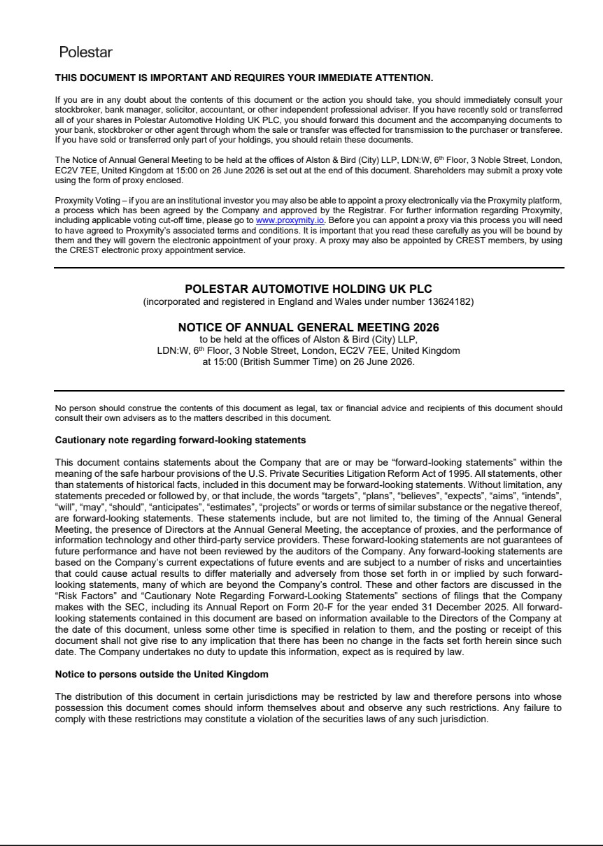

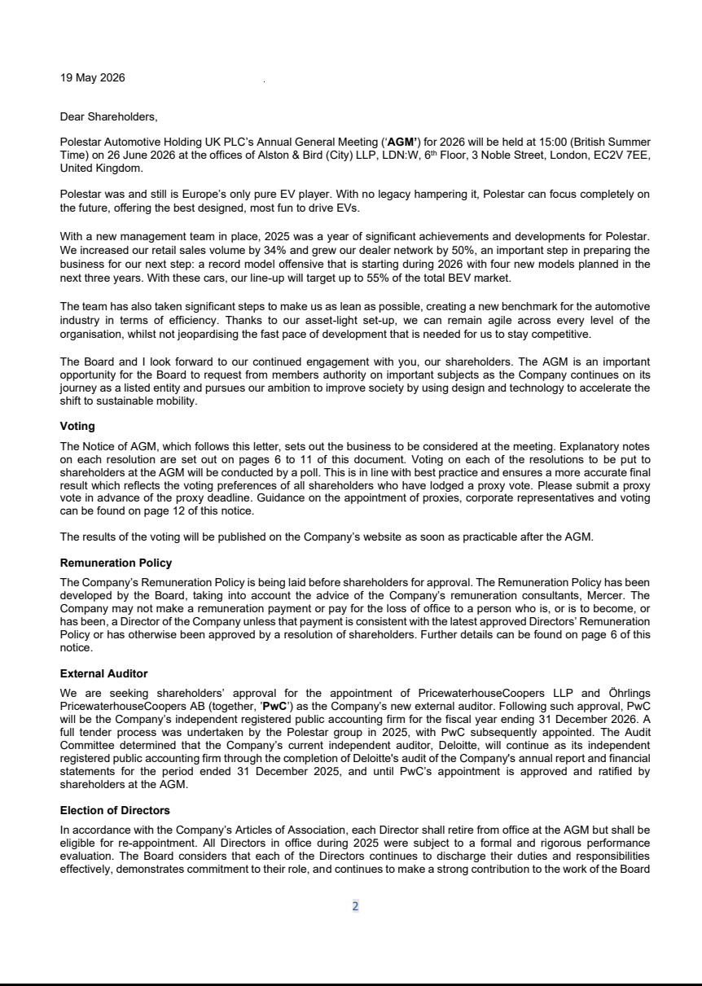



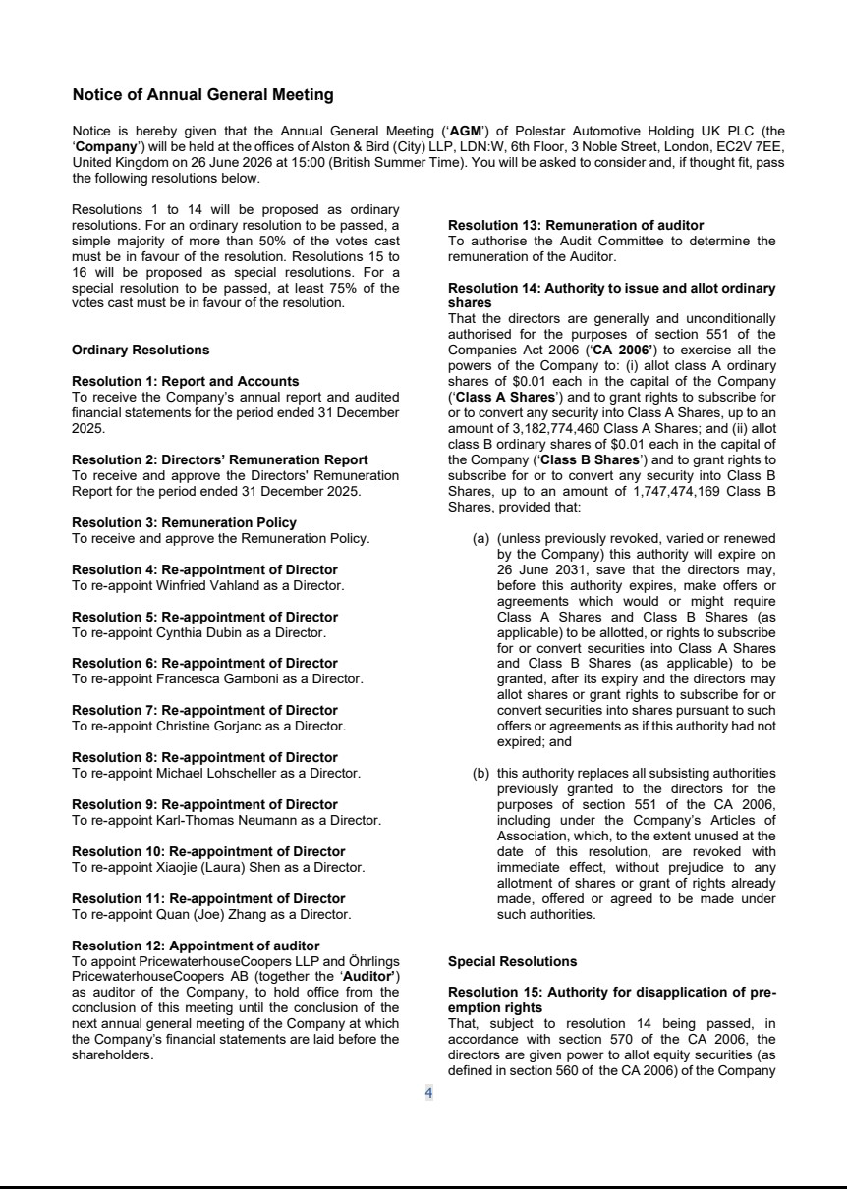



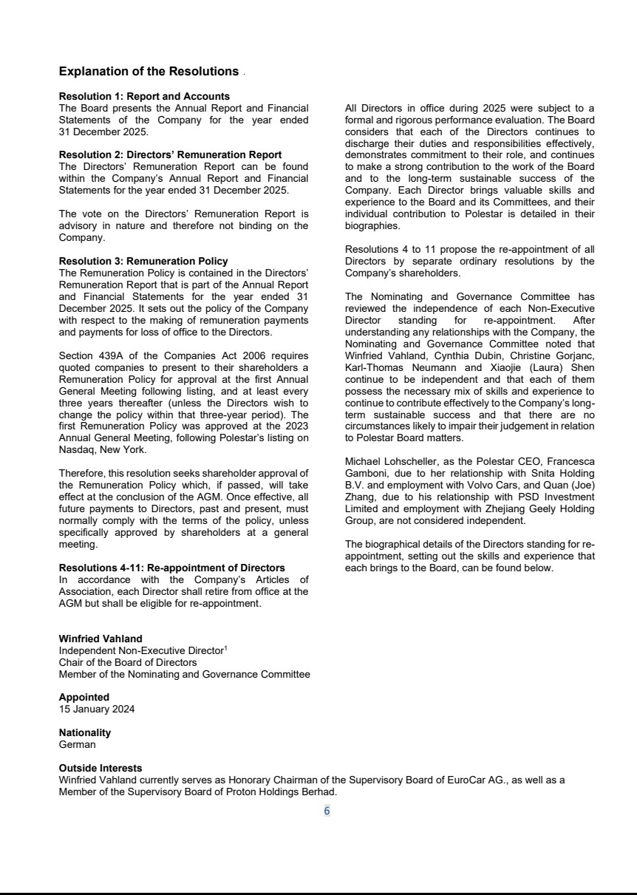

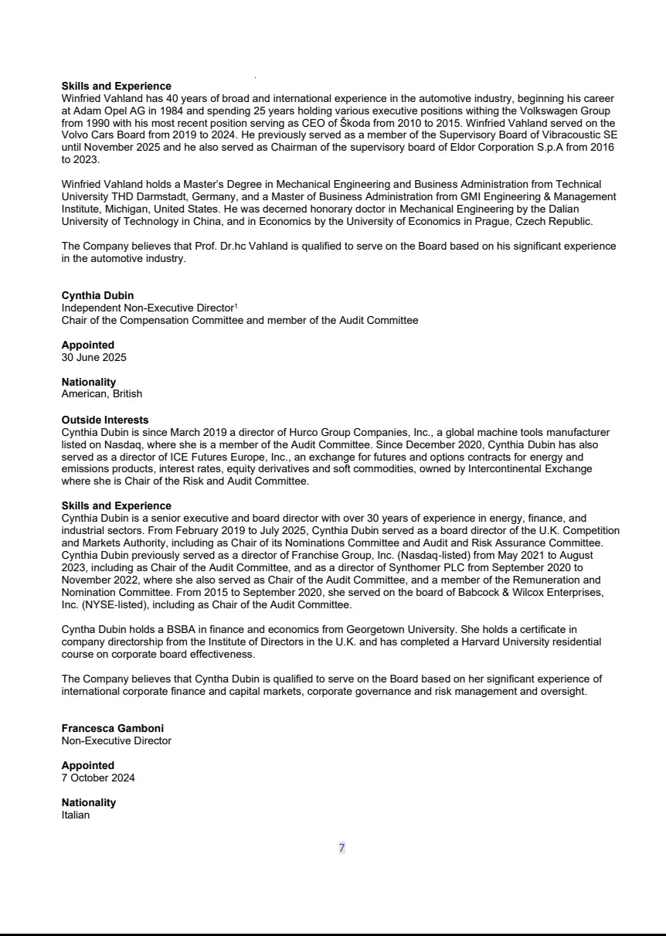

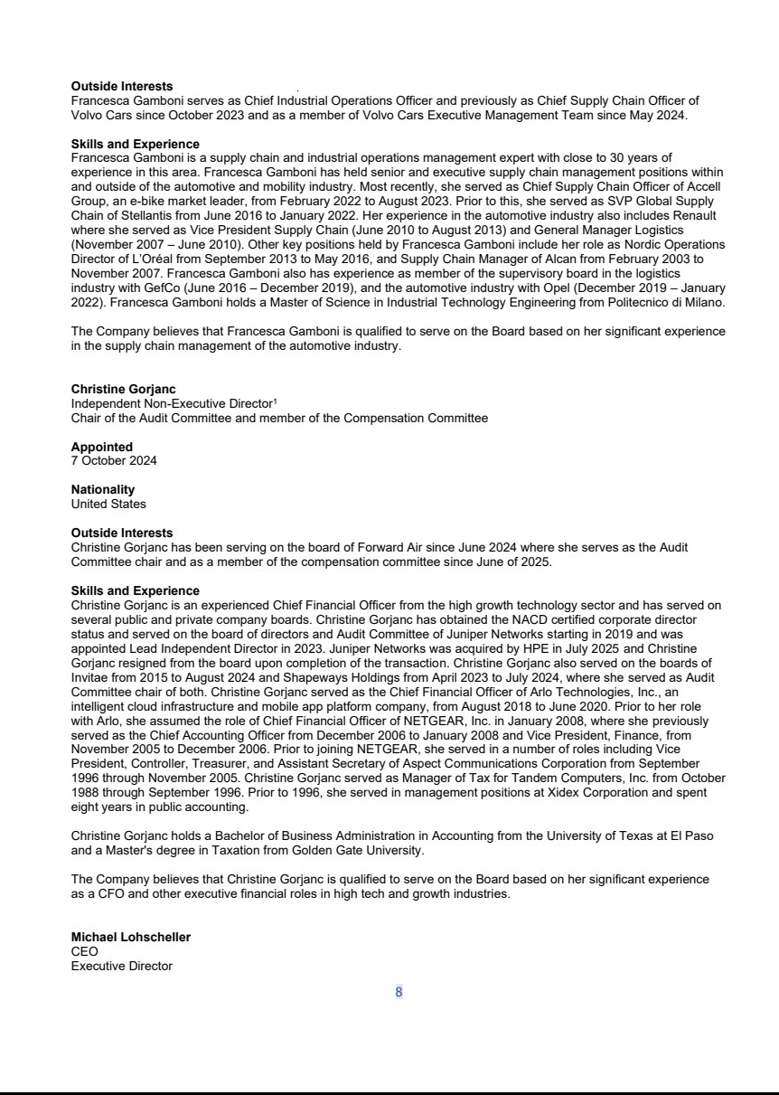

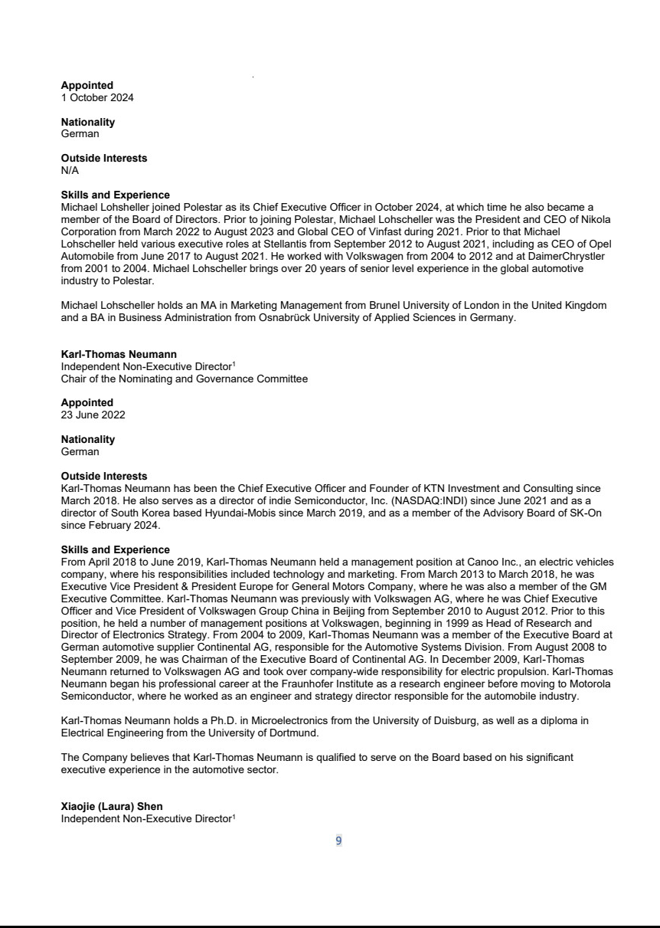

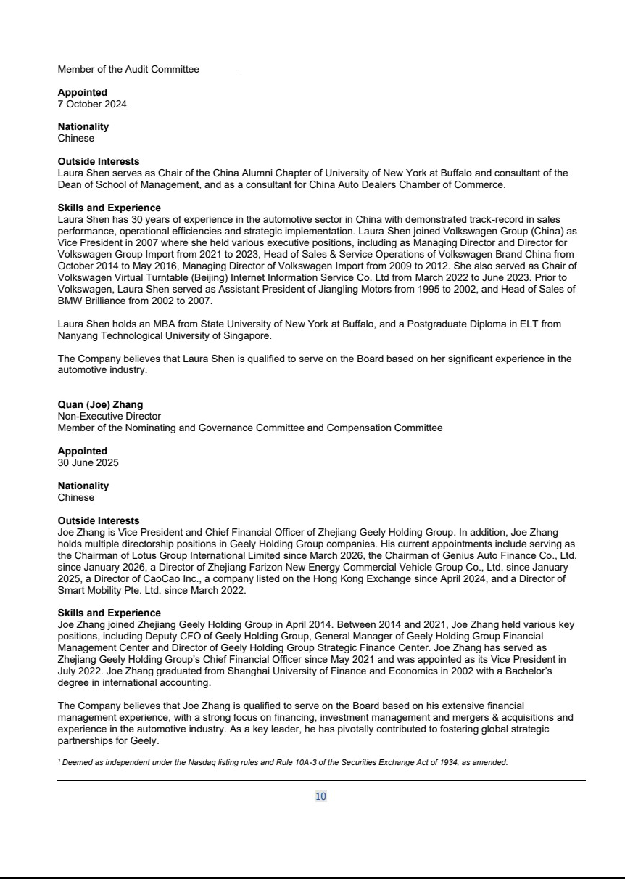

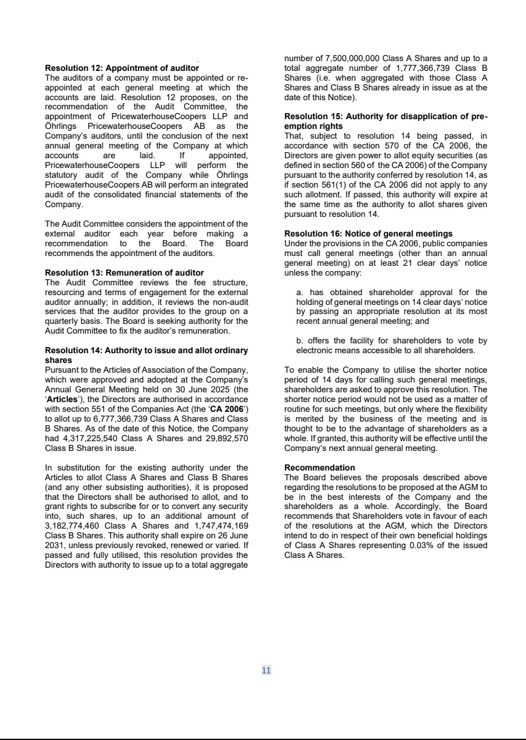

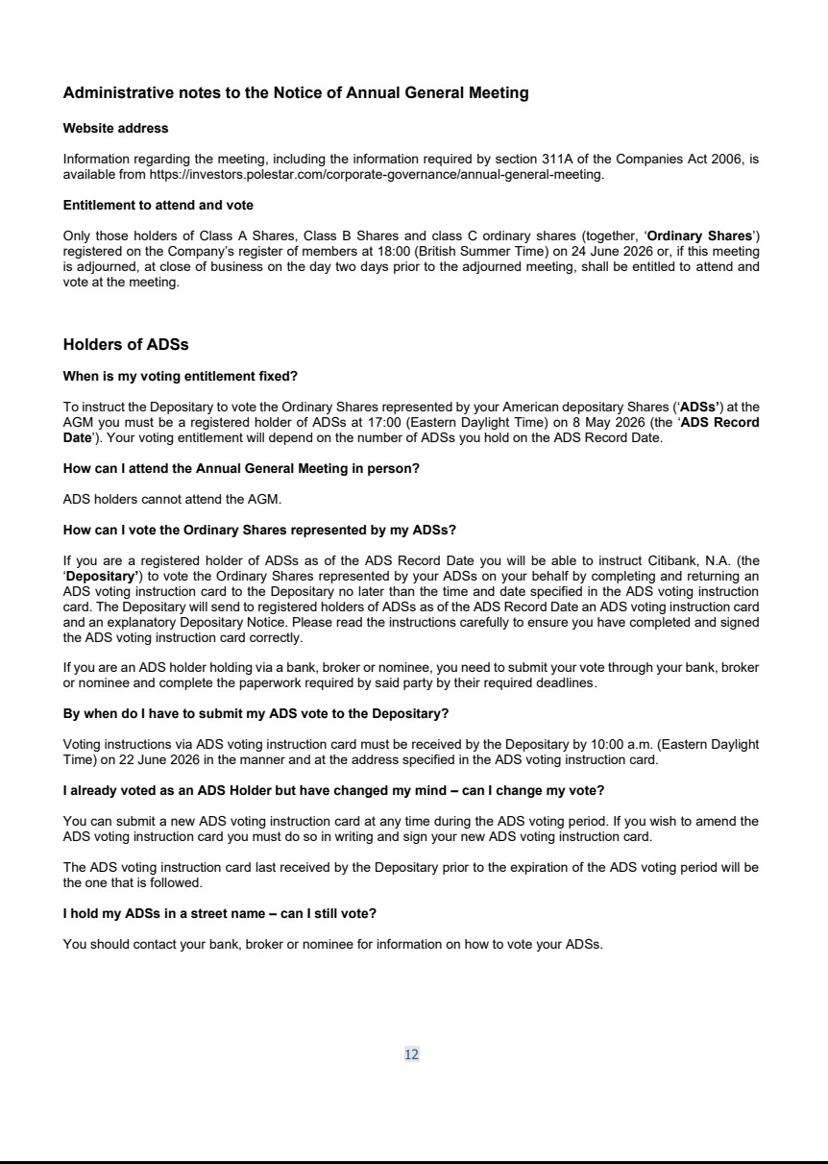

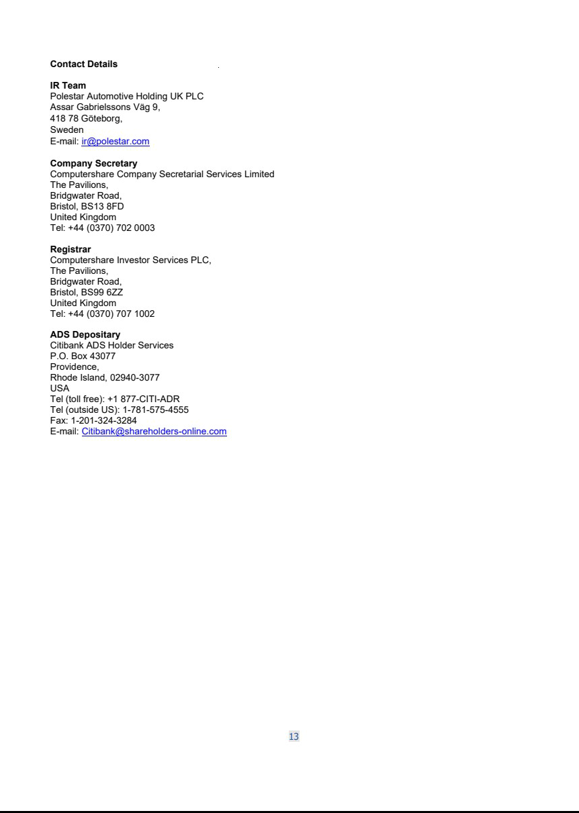

Exhibit 99.2
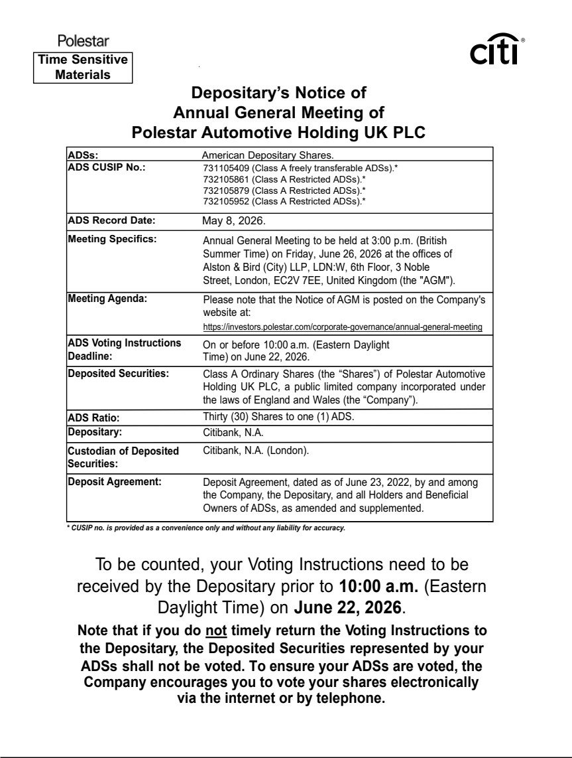

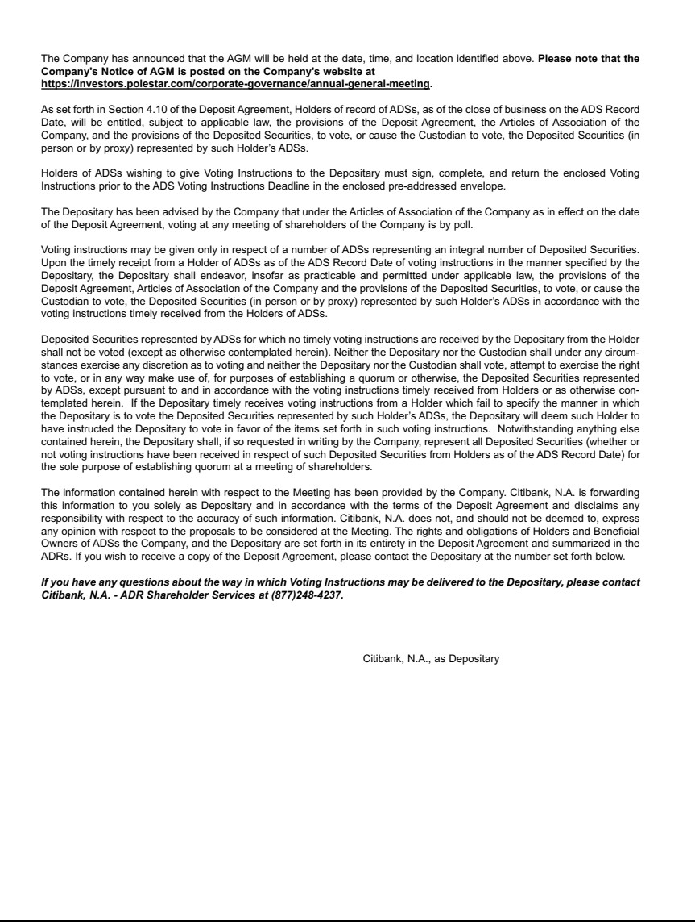

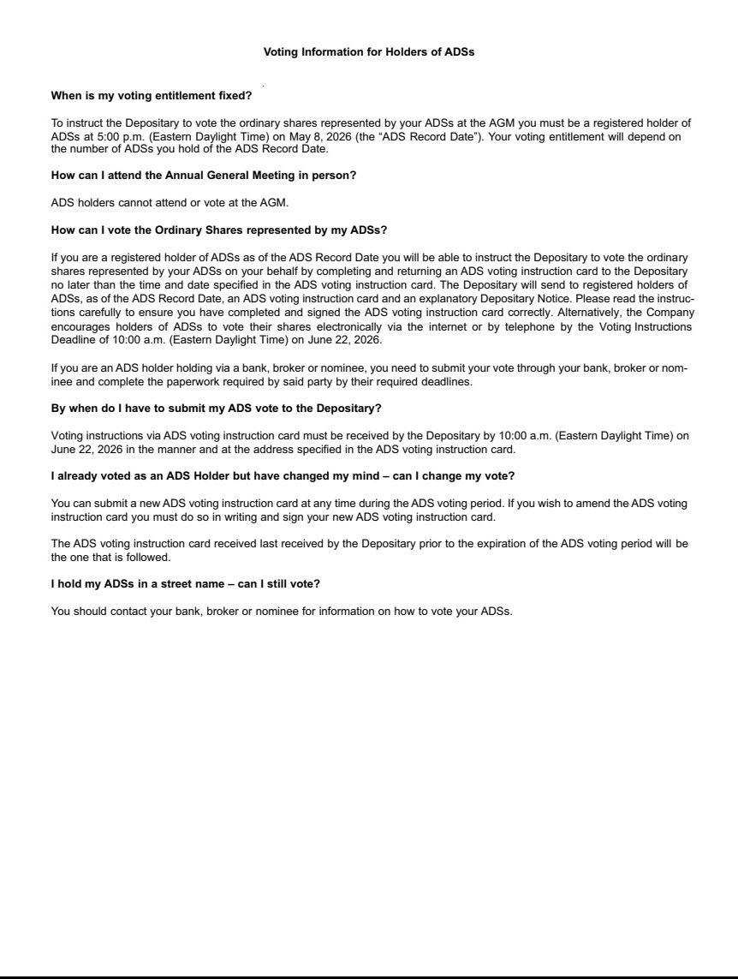

Exhibit 99.3
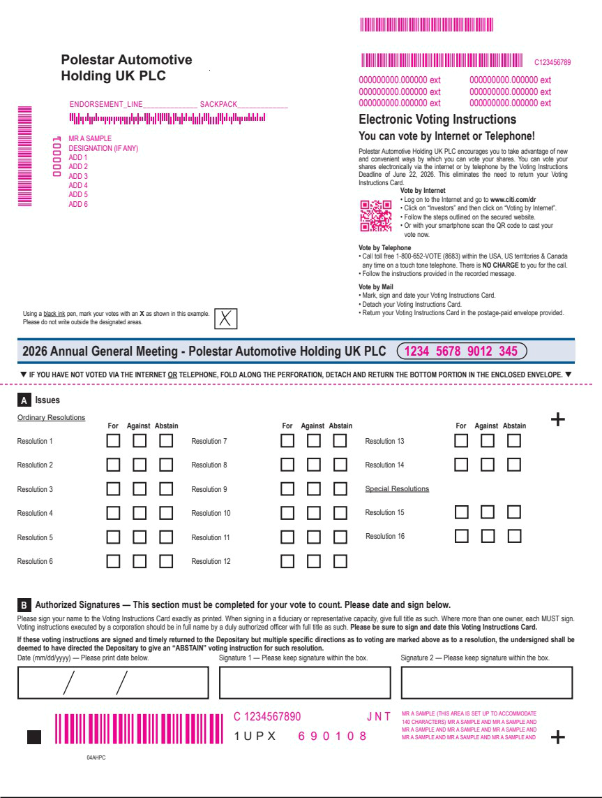

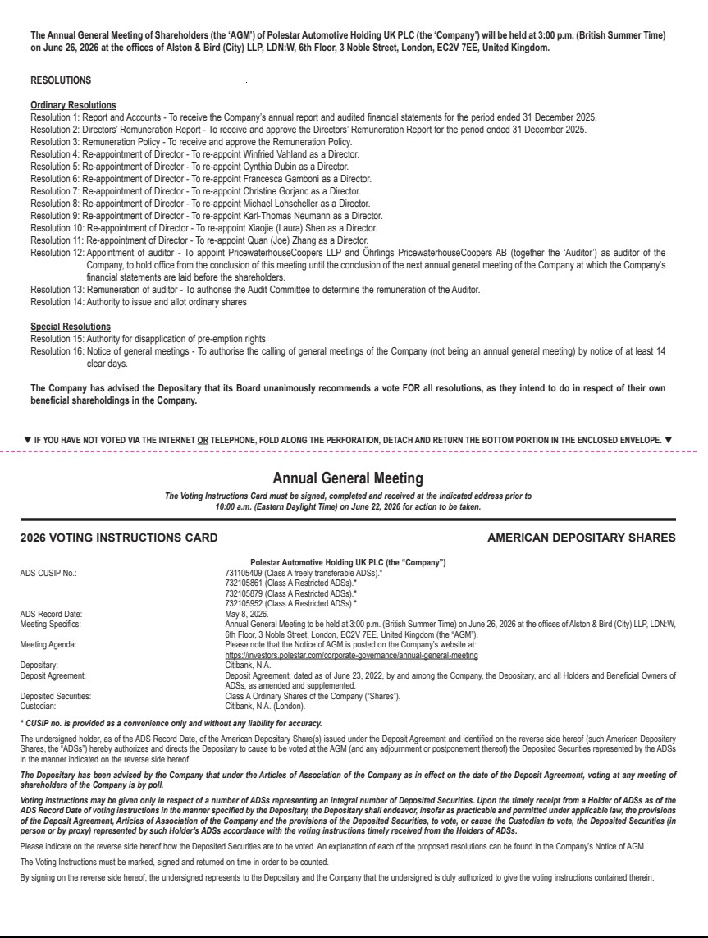

Exhibit 99.4

Polestar sets date for AGM

GOTHENBURG, SWEDEN – 19 May 2026. Polestar (Nasdaq: PSNY) announces that its Annual General Meeting (AGM) is to be held in London on 26 June 2026.

Full details of the AGM and proposed resolutions are available on the Company’s Investor Relations website: https://investors.polestar.com/corporate-governance/annual-general-meeting

The meeting will be voting for the re-appointment of all Directors and the appointment of PricewaterhouseCoopers as Auditors.

Ends.

Contacts

Anna Gavrilova

Head of Investor Relations

anna.gavrilova@polestar.com

Theo Kjellberg

Head of Corporate Communication

theo.kjellberg@polestar.com

About Polestar

Polestar (Nasdaq: PSNY) is the Swedish electric performance car brand with a focus on uncompromised design and innovation, and the ambition to accelerate the change towards a sustainable future. Headquartered in Gothenburg, Sweden, its cars are available in 28 markets globally across North America, Europe, and Asia Pacific.

Polestar has four models in its line-up: Polestar 2, Polestar 3, Polestar 4, and Polestar 5. Planned models include Polestar 4 new variant (to be introduced in the last quarter of 2026), Polestar 2 successor (to be launched early in 2027), Polestar 7 compact SUV (to be introduced in 2028) and the Polestar 6 roadster. With its vehicles currently manufactured on two continents, North America and Asia, Polestar is diversifying its manufacturing footprint further, with production of Polestar 7 planned in Europe.

Polestar has an unwavering commitment to sustainability and has set an ambitious roadmap to reach its climate targets: halve greenhouse gas emissions by 2030 per-vehicle-sold and become climate-neutral across its value chain by 2040. Polestar’s comprehensive sustainability strategy covers the four areas of Climate, Transparency, Circularity, and Inclusion.

Forward-Looking Statements

This press release contains statements that are not historical facts, but rather forward-looking statements within the meaning of Private Securities Litigation Reform Act of 1995. Such forward-looking statements include those that address activities, events or developments that Polestar or its management believes or anticipates may occur in the future. All forward-looking statements are based upon, as applicable, our current expectations, various assumptions and data available from third parties. Our expectations and assumptions are expressed in good faith and we believe there is a reasonable basis for them. However, there can be no assurance that such forward-looking statements will materialize or prove to be correct as forward-looking statements are inherently subject to known and unknown risks, uncertainties and other factors which may cause actual future results, performance or achievements to differ materially from the future results, performance or achievements expressed in or implied by such forward-looking statements. Numerous risks, uncertainties and other factors may cause actual results to differ materially from those set out in the forward-looking statements, including those risks and uncertainties set forth in the sections entitled “Risk Factors” and “Cautionary Note Regarding Forward-Looking Statements” in Polestar’s Form 20-F, and other documents filed, or to be filed, with the U.S. Securities and Exchange Commission by Polestar. For any forward-looking statements contained in this or any other document, we claim the protection of the safe harbor for forward-looking statements contained in the Private Securities Litigation Reform Act of 1995, and we assume no obligation to update publicly or revise any such statements in light of new information or future events, except as required by law.

