UNITED STATES

SECURITIES AND EXCHANGE COMMISSION

WASHINGTON, D.C. 20549

FORM 6-K

REPORT OF FOREIGN PRIVATE ISSUER

PURSUANT TO RULE 13a-16 OR 15d-16

UNDER THE SECURITIES EXCHANGE ACT OF 1934

For the month of June 2025

Commission File Number: 001-41431

Polestar Automotive Holding UK PLC

Assar Gabrielssons Väg 9

405 31 Göteborg, Sweden

(Address of principal executive office)

Indicate by check mark whether the registrant files or will file annual reports under cover of Form 20-F or Form 40-F.

Form 20-F ☒ Form 40-F ☐

Indicate by check mark if the registrant is submitting the Form 6-K in paper as permitted by Regulation S-T Rule 101(b)(1): ☐

Indicate by check mark if the registrant is submitting the Form 6-K in paper as permitted by Regulation S-T Rule 101(b)(7): ☐

INFORMATION CONTAINED IN THIS REPORT ON FORM 6-K

On June 3, 2025, Polestar Automotive Holding UK PLC (“Company”) distributed a notice of annual general meeting to be held at the offices of Alston & Bird (City) LLP, LDN:W, 6th Floor, 3 Noble Street, London, EC2V 7EE, United Kingdom at 3:00 pm (British Summer Time) on June 30, 2025 (the “AGM”) to the holders of the Company’s ordinary shares in connection with the Company’s AGM. The notice of AGM is furnished as Exhibits 99.1 to this report on Form 6-K.

On or about June 3, 2025, Citibank, N.A., in its capacity as the depositary bank (the “Depositary”) for the Company’s American Depositary Shares (“ADSs”), commenced mailing notice materials and voting instruction cards to ADS holders to enable ADS holders of record as of May 19, 2025, to instruct the Depositary to vote the ordinary shares represented by their ADSs. The Depositary’s notice of AGM to ADS holders and the ADS voting instruction card are furnished as Exhibits 99.2 and 99.3, respectively, to this report on Form 6-K.

The Company has published its U.K. annual report and accounts for the year ended December 31, 2024 on its website at:

https://investors.polestar.com/corporate-governance/annual-general-meeting

Finally, on June 3, 2025, the Company issued a press release announcing proposed changes to its Board of Directors. A copy of the press release is attached hereto as Exhibit 99.4.

The information contained in this report on Form 6-K, including Exhibits 99.1, 99.2, 99.3 and 99.4, is being furnished and shall not be deemed “filed” for purposes of Section 18 of the Securities Exchange Act of 1934, as amended (the “Exchange Act”) or otherwise subject to the liabilities of that section, nor shall it be deemed incorporated by reference in any filing under the Securities Act of 1933 or the Exchange Act.

2

 |  |  |  |  |  | EXHIBIT INDEX
Exhibit No. |  |  |  | Description of Exhibit
 | 99.1 |  |  | Notice of Annual General Meeting.
 | 99.2 |  |  | Depositary’s Notice of Annual General Meeting
 | 99.3 |  |  | American Depositary Share Voting Instruction Card.
 | 99.4 |  |  | Press Release of Polestar Automotive Holding UK PLC, dated June 3, 2025.
 |  |  |  | 3

SIGNATURES

Pursuant to the requirements of the Securities Exchange Act of 1934, the registrant has duly caused this report to be signed on its behalf by the undersigned, thereunto duly authorized.

 | POLESTAR AUTOMOTIVE HOLDING UK PLC
Date: June 3, 2025 | By: | /s/ Michael Lohscheller
 | Name: | Michael Lohscheller
 | Title: | Chief Executive Officer
Date: June 3, 2025 | By: | /s/ Jean-François Mady
 | Name: | Jean-François Mady
 | Title: | Chief Financial Officer
 | 4

Exhibit 99.1
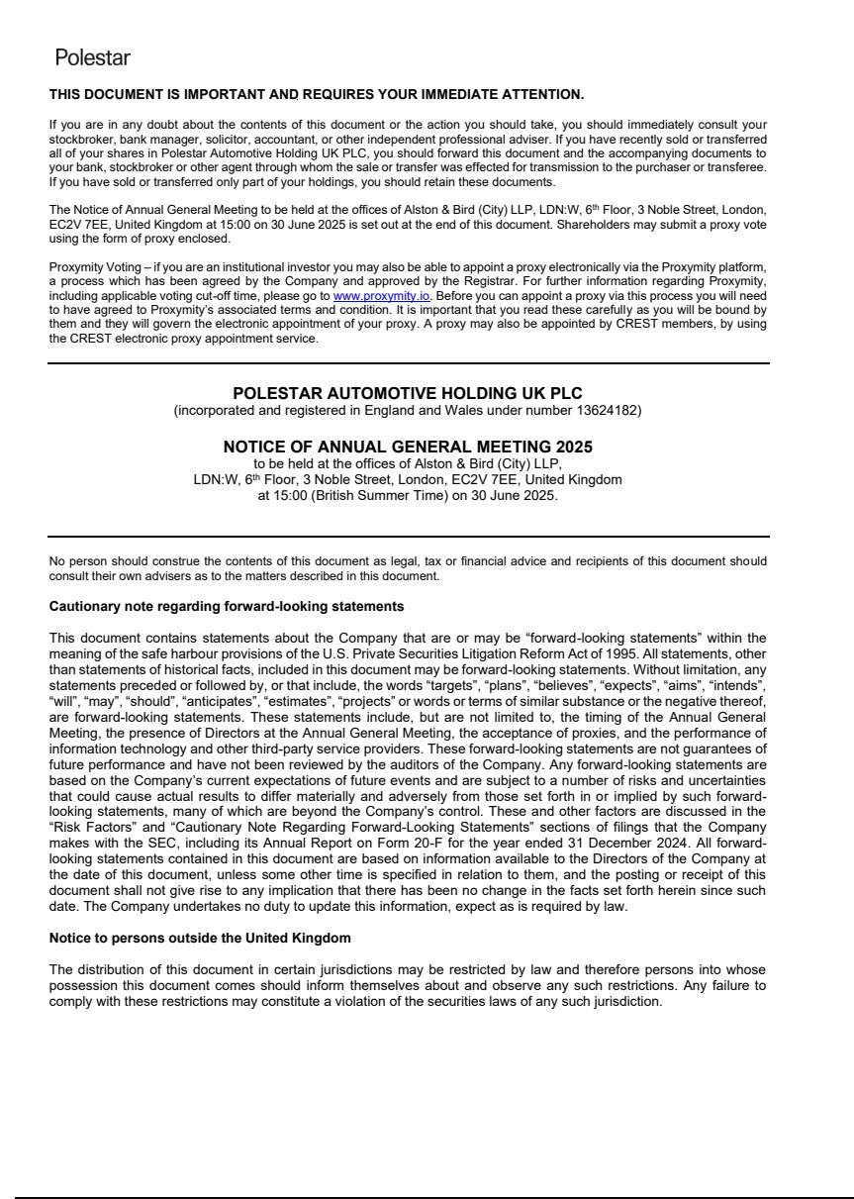

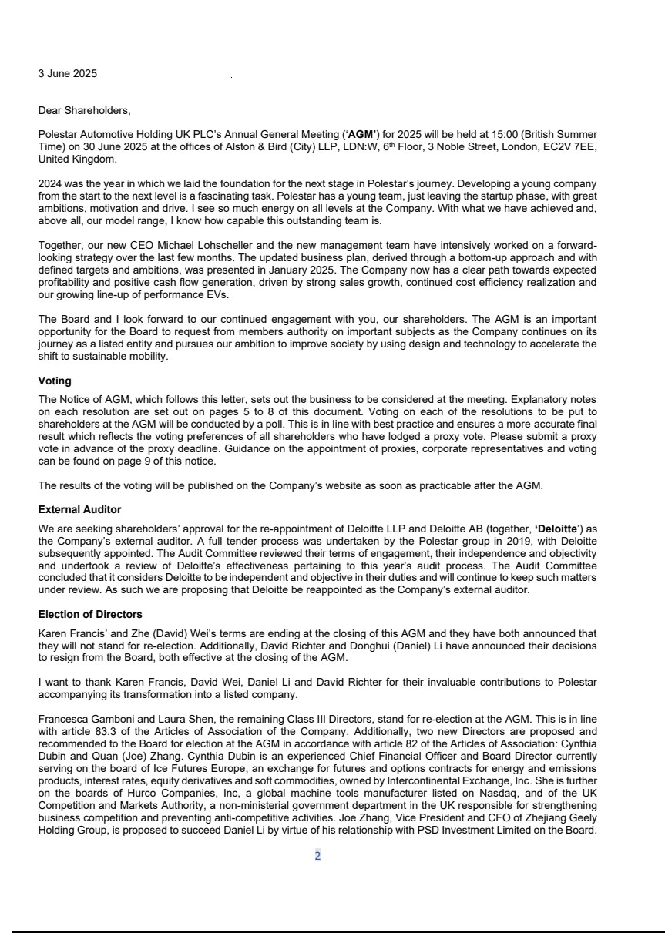

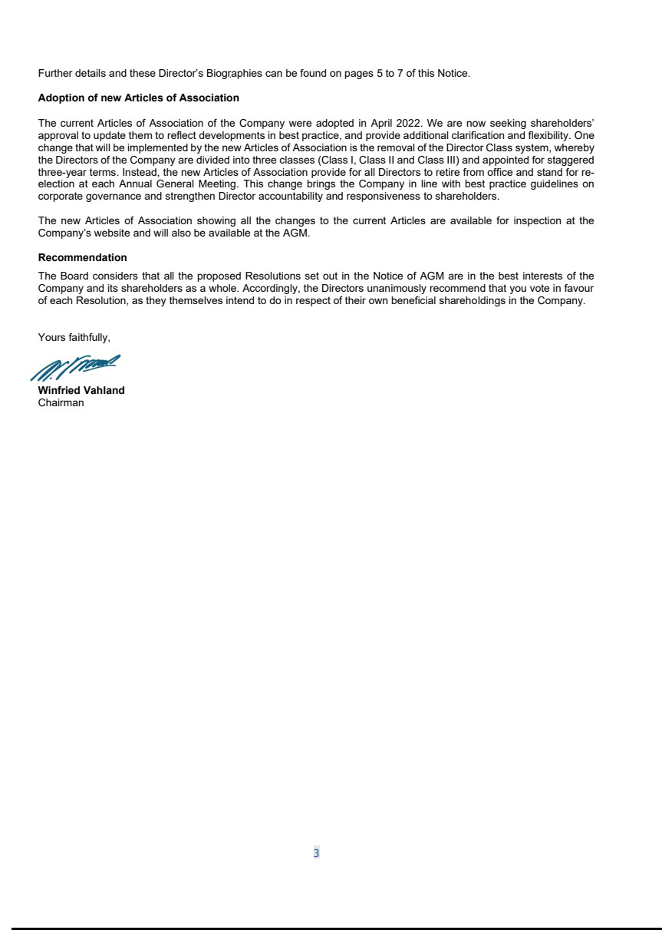

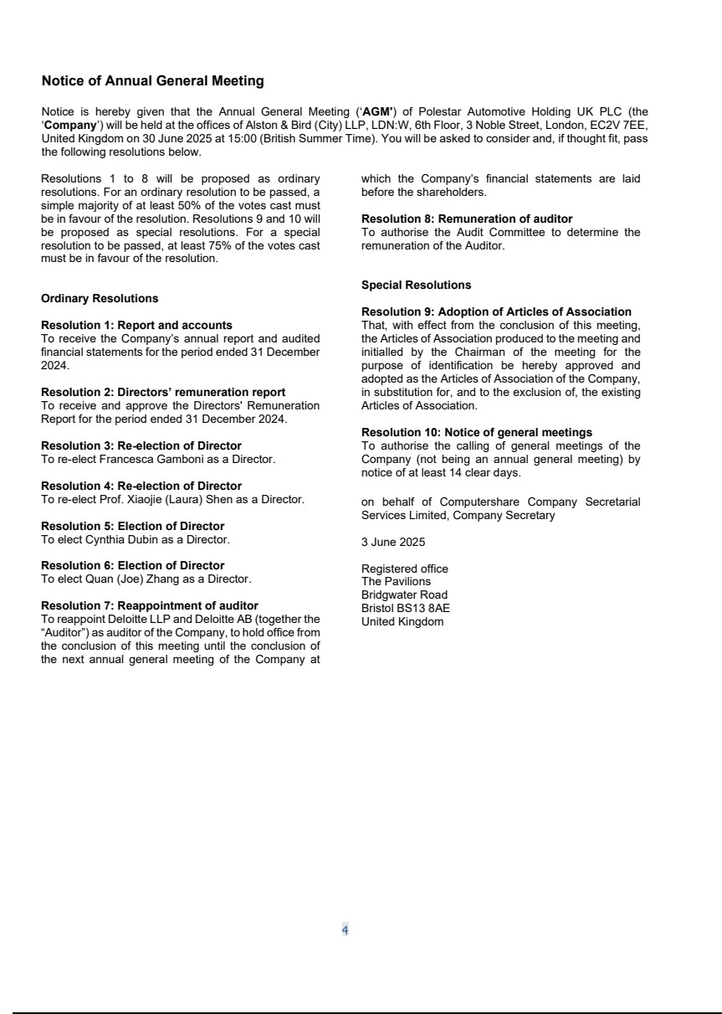

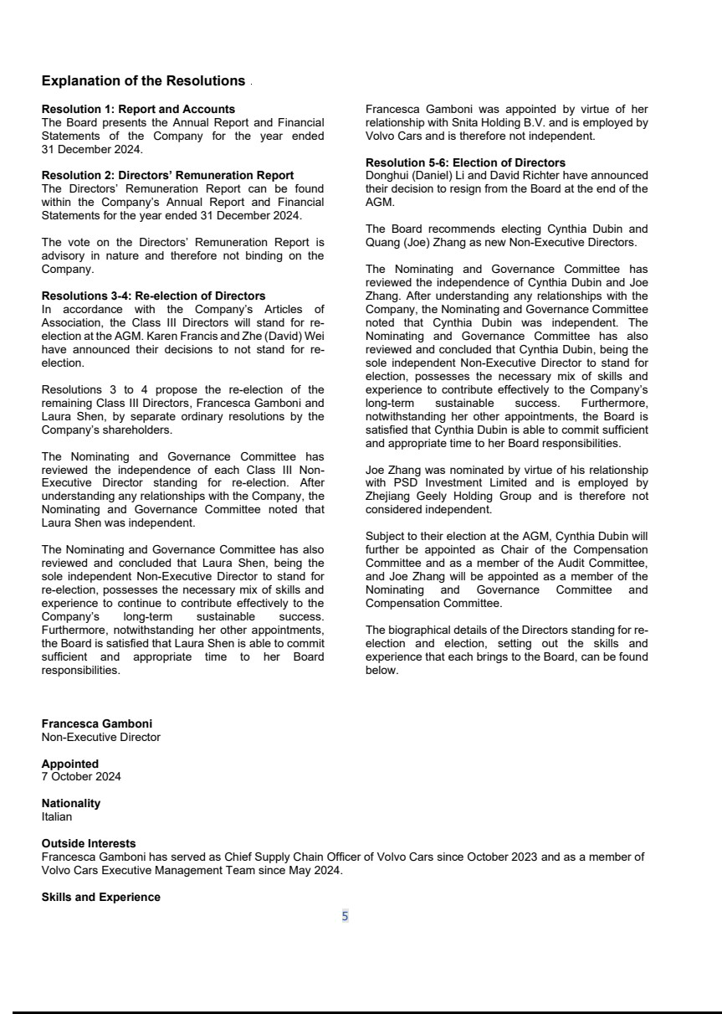

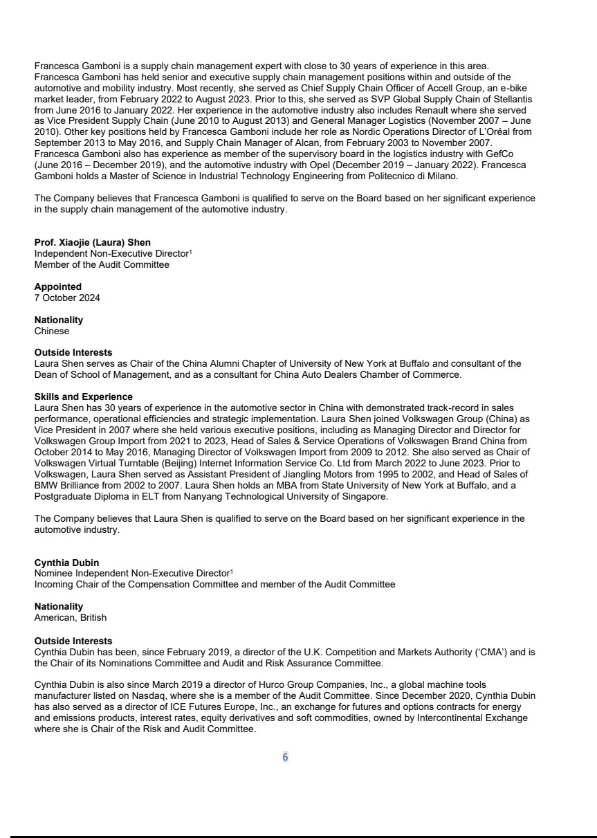

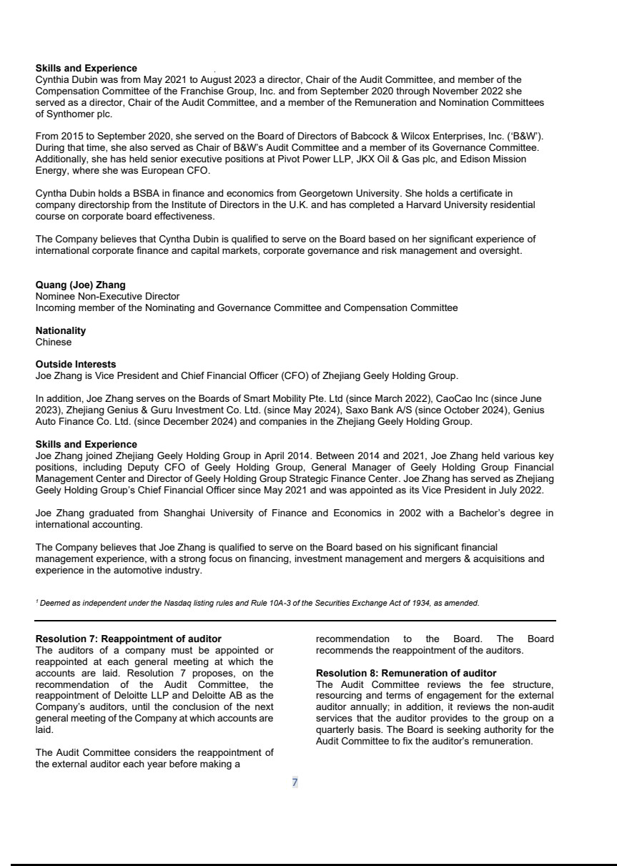

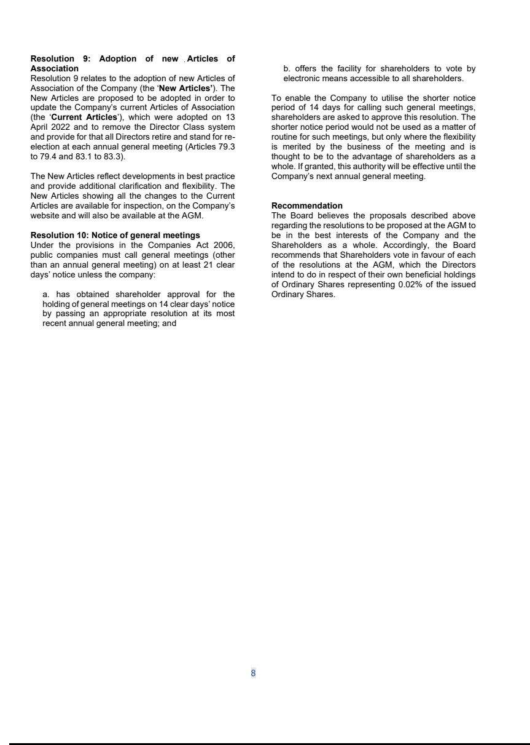

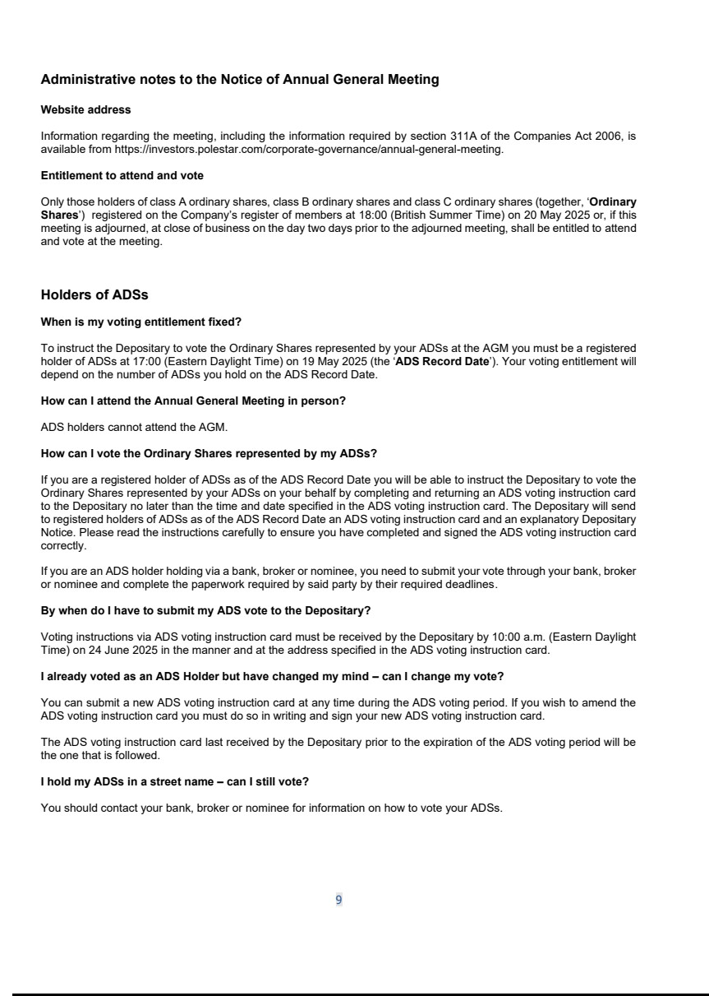

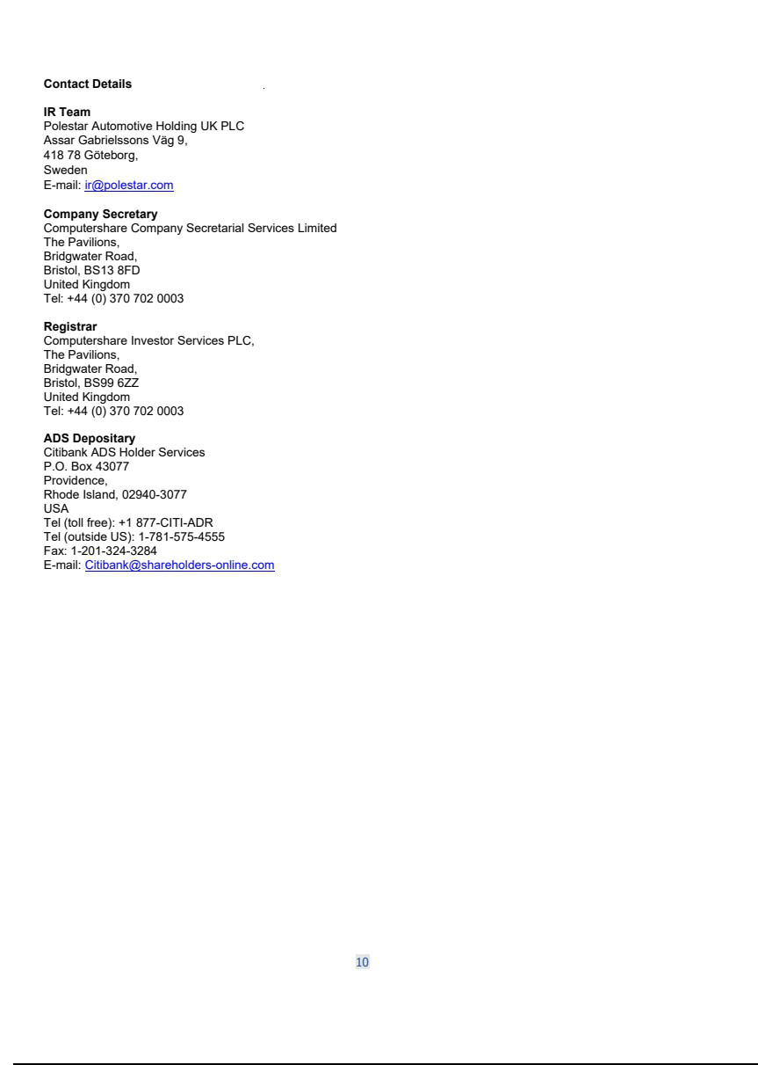

Exhibit 99.2
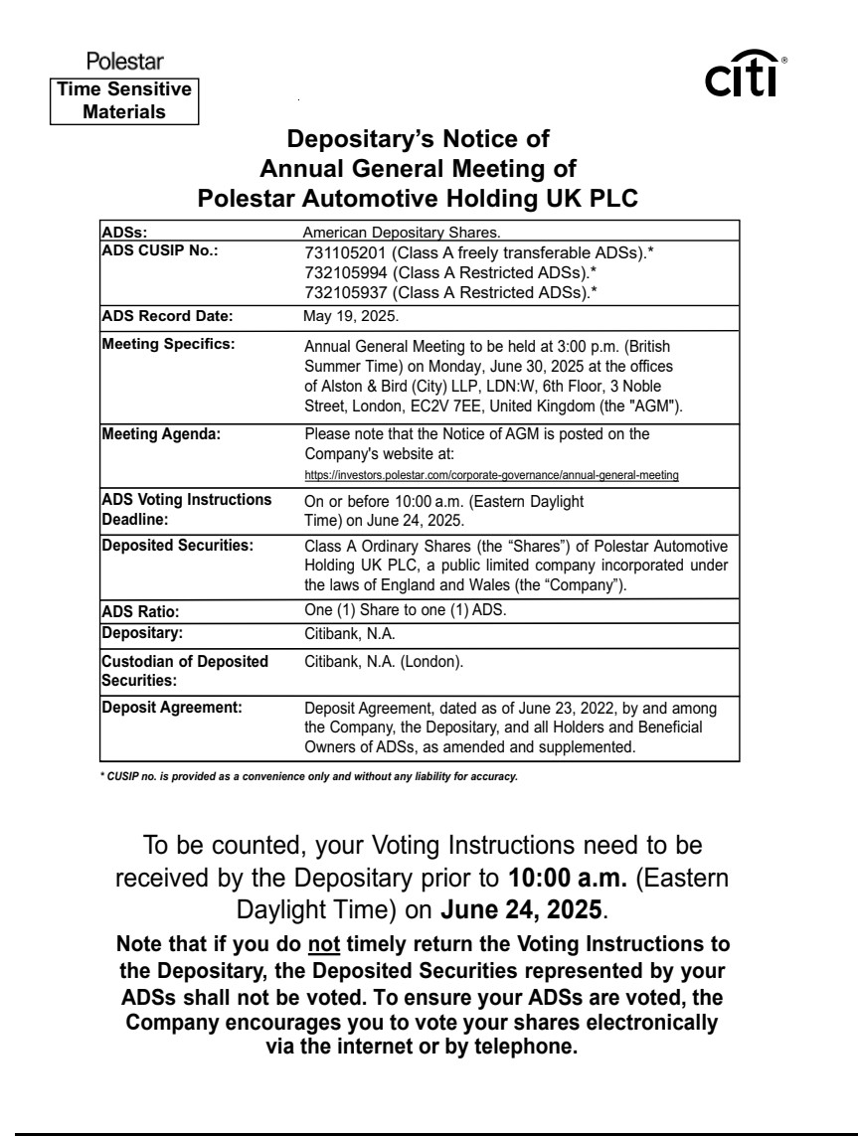

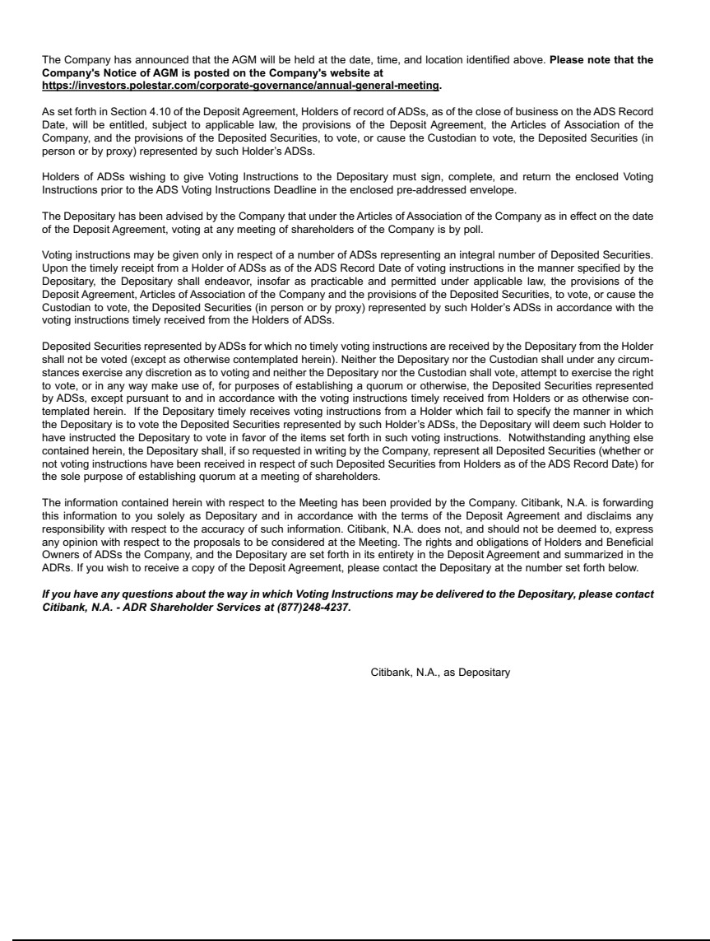

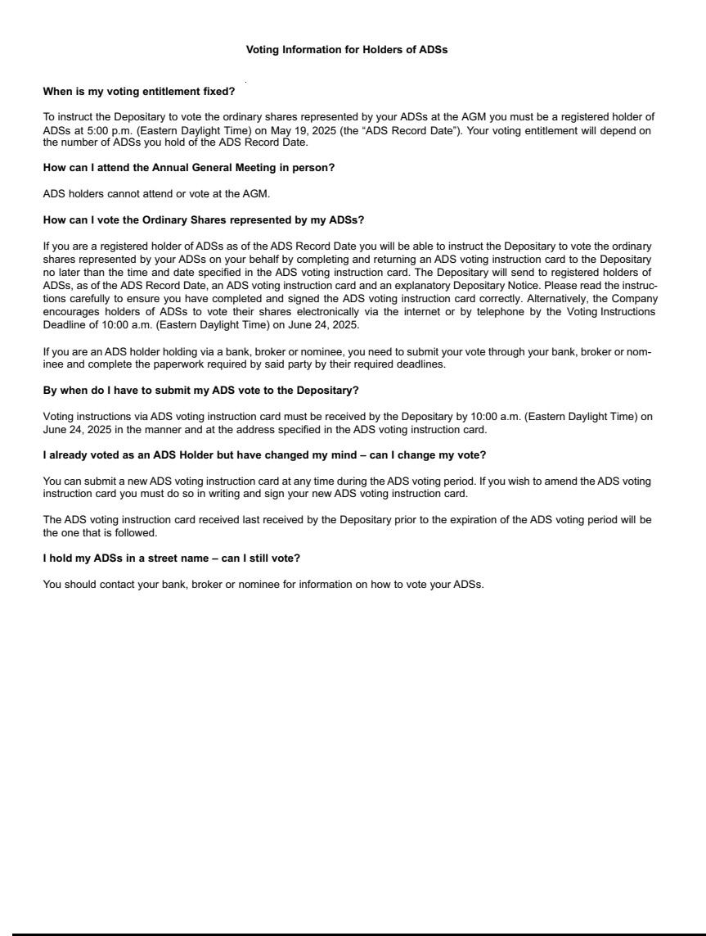

Exhibit 99.3
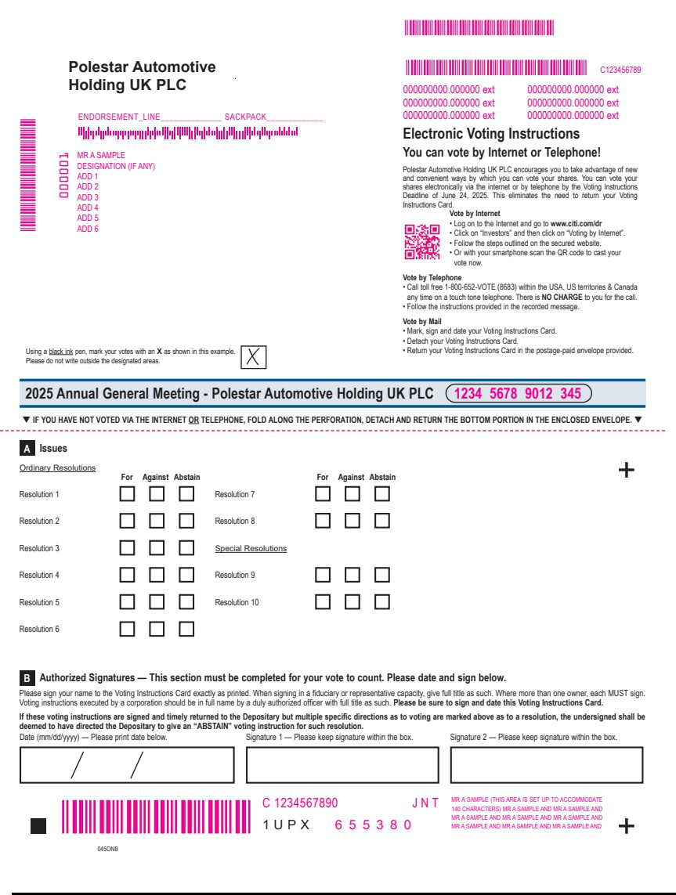

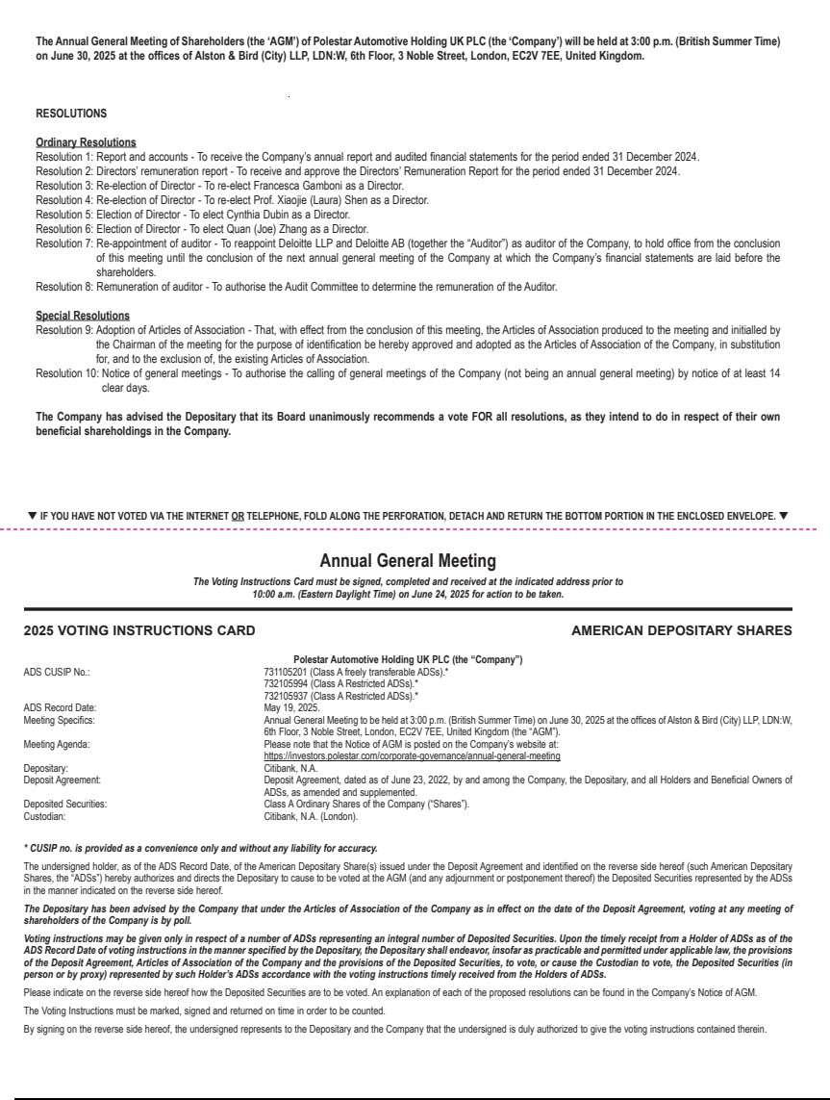

Exhibit 99.4

Polestar sets date for AGM and announces Board changes

GOTHENBURG, SWEDEN – 3 June 2025 – Polestar (Nasdaq: PSNY) announces that in conjunction with its Annual General Meeting (AGM) to be held in London on 30 June 2025, certain changes to the Company’s Board of Directors are being submitted for shareholder approval. Full details of the AGM are available on the Company’s Investor Relations website: https://investors.polestar.com/corporate-governance/annual-general-meeting

Karen Francis’ and Zhe (David) Wei’s terms are ending at the closing of this year’s AGM and they have both announced that they will not stand for re-election.

Additionally, David Richter and Donghui (Daniel) Li have announced their decisions to resign from the Board, both effective at the closing of this year’s AGM.

Francesca Gamboni and Laura Shen are standing for re-election at the AGM. Additionally, two new Directors are proposed and recommended for election: Cynthia Dubin and Quan (Joe) Zhang.

Winfried Vahland, Polestar Board Chair, says: “I want to thank Karen Francis, David Richter, David Wei and Daniel Li for their invaluable contributions to Polestar and the roles they played in transforming it into a listed company. I’m pleased to welcome Cynthia Dubin and Joe Zhang to the Board, whose valuable experience will be of great benefit to Polestar.”

Cynthia Dubin is an experienced Chief Financial Officer and Board Director currently serving on the board of Ice Futures Europe, an exchange for futures and options contracts for energy and emissions products, interest rates, equity derivatives and soft commodities, owned by Intercontinental Exchange, Inc.. She is further on the boards of Hurco Companies, Inc., a global machine tools manufacturer listed on Nasdaq, and of the UK Competition and Markets Authority.

Joe Zhang, Vice President and Chief Financial Officer of Zhejiang Geely Holding Group, is proposed to succeed Daniel Li on the Board.

Ends.

Contacts

Anna Gavrilova

Head of Investor Relations

anna.gavrilova@polestar.com

Theo Kjellberg

Head of Corporate Communication

theo.kjellberg@polestar.com

About Polestar

Polestar (Nasdaq: PSNY) is the Swedish electric performance car brand with a focus on uncompromised design and innovation, and the ambition to accelerate the change towards a sustainable future. Headquartered in Gothenburg, Sweden, its cars are available in 27 markets globally across North America, Europe and Asia Pacific.

Polestar has three models in its line-up: Polestar 2, Polestar 3, and Polestar 4. Planned models include the Polestar 5 four-door GT (to be introduced in 2025), the Polestar 6 roadster and the Polestar 7 compact SUV. With its vehicles currently manufactured on two continents, North America and Asia, Polestar plans to diversify its manufacturing footprint further, with production of Polestar 7 planned in Europe.

Polestar has an unwavering commitment to sustainability and has set an ambitious roadmap to reach its climate targets: halve greenhouse gas emissions by 2030 per-vehicle-sold and become climate-neutral across its value chain by 2040. Polestar’s comprehensive sustainability strategy covers the four areas of Climate, Transparency, Circularity, and Inclusion.

Forward-Looking Statements

This press release contains statements that are not historical facts, but rather forward-looking statements within the meaning of Private Securities Litigation Reform Act of 1995. Such forward-looking statements include those that address activities, events or developments that Polestar or its management believes or anticipates may occur in the future. All forward-looking statements are based upon, as applicable, our current expectations, various assumptions and data available from third parties. Our expectations and assumptions are expressed in good faith and we believe there is a reasonable basis for them. However, there can be no assurance that such forward-looking statements will materialize or prove to be correct as forward-looking statements are inherently subject to known and unknown risks, uncertainties and other factors which may cause actual future results, performance or achievements to differ materially from the future results, performance or achievements expressed in or implied by such forward-looking statements. Numerous risks, uncertainties and other factors may cause actual results to differ materially from those set out in the forward-looking statements, including those risks and uncertainties set forth in the sections entitled “Risk Factors” and “Cautionary Note Regarding Forward-Looking Statements” in Polestar’s Form 20-F, and other documents filed, or to be filed, with the U.S. Securities and Exchange Commission by Polestar. For any forward-looking statements contained in this or any other document, we claim the protection of the safe harbor for forward-looking statements contained in the Private Securities Litigation Reform Act of 1995, and we assume no obligation to update publicly or revise any such statements in light of new information or future events, except as required by law.

