Filed by Polestar Automotive Holding UK Limited

Pursuant to Rule 425 under the Securities Act of 1933

and deemed filed pursuant to 14a-12 under the

Securities Exchange Act of 1934

Form F-4 File No. (333-260992)

Subject Companies:

Polestar Automotive Holding UK Limited

Gores Guggenheim, Inc.

(Commission File No. 001-40265)

Cheddar – December 2, 2021

By Kristen Scholer

Polestar CEO on New EV Offerings, Separating

Itself From Competitors Like Tesla
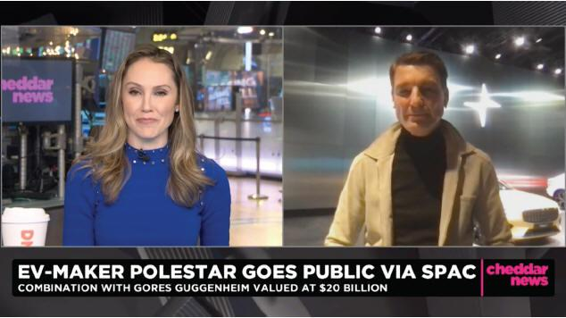

Interview Transcription:

Kristen Scholer: Welcome back to Cheddar News everyone. As the EV space continues to grow one brand co-founded by a legacy automaker is going public and kicking off a multi-year expansion plan. We’re talking about Polestar. Founded back in 2017 by Volvo and global mobility technology group, Geely, it is making its public debut via a SPAC. The company has two models in production currently active in 14 markets around the world, and does plan to roll out several new models in the next two years and expand into more than 30 markets. Investors include actor and activist Leonardo DiCaprio. It doesn’t get much bigger than Leo, and joining me now is Thomas Ingenlath, CEO of Polestar. Thomas, thanks so much for joining. I think you’re at a showroom here at the Classic Car Club here in Manhattan, so it’s great to have you on the scene here. Talk to me about why you wanted to take this company public through the SPAC route now.

Thomas Ingenlath: Yeah hi, good morning. Indeed, the Classic Car Club here in Manhattan. We’re having a show here with our cars that we have in production already today, and of course what we will be brining to production in the next three years. And it’s a big expansion happening. I mean we have been building the company so far and now the next three years with three new cars coming out will of course be an exciting time with lots of growth, new markets coming and access to the capital market is crucial for this period.

Kristen Scholer: Let me ask you this Thomas. We know the EV market is hotter than ever right now. How do the models with Polestar differ from what is on the market, because consumers now have a plethora of options to choose, so why should they one of your vehicles?

Thomas Ingenlath: We are a company that have design and sustainability very strong in our agenda. Our cars are gorgeous, great looking cars. We definitely don’t make any compromise in that Scandinavian cool design. And, of course, the road to zero emissions is something that we take very, very seriously in each and every step that we do, and I think that the consumers experience that. Our interiors have marvelously nice innovative materials that are more sustainable, circular principles behind it, and this resonates with our customers.

Kristen Scholer: So, I see the starting price point on the Polestar 1 is $155,000, but for the Polestar 2, which is on the screen right now, it looks like that starts at a lower price, right? $38,400, that’s after the federal tax credit is applied, just confirm those numbers for me, and talk to me about who the demographic is that you’re trying to target with each of these vehicles.

Thomas Ingenlath: Well, it is the premium luxury segment. The 2 that you just showed indeed is what we call the entry ticket to our brand. We will be adding next year our first SUV, a car that will launch around $80,000, and that’s definitely what you see as a price span. $150,000 is at the top. $40,000 is the entry ticket, and that’s the price span for the brand Polestar.

Kristen Scholer: In terms of other vehicles in the pipeline and other models, Thomas, what else could consumers expect?

Thomas Ingenlath: Well, we brought here to New York the Precept. Really, really beautiful exciting 4-seater aero sedan. It is definitely a car that we had planned as a show car when we got this incredible feedback people loved that car we found a way and the big will as well to put it into production. So, 2024 the beautiful Precept will come out as a the Polestar number 5, and that number tells you that next year with the Polestar 3 coming, 2024 the Polestar 5 coming, obviously there is a Polestar 4 in between, and that is car number 3 in this new lineup. We have, indeed, this ambitious time ahead, three cars in three years. I think nobody else has done that before, and we are really determined to bring that to life and make that happen.

Kristen Scholer: Thomas, let me ask you this. The infrastructure consistently seems to be the biggest question for potential buyers out there, certainly here in the US, maybe in Europe it is different, and if so please get me up to speed there. But how crucial is it, these new public charging stations that the Biden administration is pushing through, spending billions of dollars to make sure that you can take these electric vehicles, these new electric vehicles that are better for the environment on longer, on faster trips by adding the infrastructure that is needed.

Thomas Ingenlath: It is absolutely crucial to have a sufficient charging infrastructure. It is one of the biggest hinderers electrification the range anxiety. The range anxiety, yes you can work on it with capacity and size of the battery that you put in, but the much better way of reacting onto that is just to provide a sufficient charging infrastructure.

Kristen Scholer: How is your company navigating the chip shortage, because I know automakers in this EV space like General Motors and Ford they are still feeling the crunch of the chip shortage, and just this year expect to cut $210 billion in sales off of automakers around the world.

Thomas Ingenlath: Well, it’s indeed a very unique situation that we are in. I mean production numbers today are not connected to demand. It’s really connected to how you manage to maneuver in the supply shortage that have. We had to learn to really be much more flexible, much more short-term solutions and really week after week make sure we keep production up and running. Our 29,000 cars that we have as a target this year for Polestar 2 deliveries, definitely this is a number that is connected to how we could work with the supply chain and really make sure we have this number of cars produced.

Kristen Scholer: Alright, Thomas Ingenlath, CEO of Polestar joining us from the Classic Car Club in Manhattan, I’ve been there before and it is very nice, we really appreciate you coming on the show.

Article Transcription:

As the Leonardo DiCaprio-backed, pure-play electric vehicle company Polestar plans to close a SPAC IPO with Gores Guggenheim, CEO Thomas Ingenlath talked to Cheddar about how the company positioned itself to be able to go public. With competition tightening in the electric vehicle sector, Ingenlath noted what differentiates his cars from the competitors. “Scandinavian cool design and of course the road to zero emissions is something that we take very, very seriously,” he said.

